

BERRY BUS

Installation manual

Berry Bus is an interactive bus tracking app that makes real-time campus bus information available online for Berry students. Berry buses are displayed on a detailed map, using the power of GPS and Google Maps.

Contents

System Requirements 3

Hardware 3

Software 3

API Dependencies 3

Server Setup 4

Getting Started 4

Installing Files 4

Database Setup 5

Getting Started 5

Database 5

Tables 5

Intial Data 5

Updating Files 6

Changing Image Markers 6

Changing Map Center 6

Contact Information 7

# System Requirements

## Hardware

* Apache Server
* Internet connection

## Software

* PHPMyAdmin
* MySQL

## API Dependencies

* Google Maps
* Bootstrap
* Javascript
  + AJAX/JQuery
* PHP
* HTML5

That’s it! You are ready to install Berry Bus.

# Server Setup

## Getting Started

Once the required server hardware and software is up and running you can begin to add the necessary files and directories for Berry Bus.

## Installing Files

Download the Berry Bus repository as a zip file from GitHub. Unzip the folder into the desired directory on the server. The repository will be set up in the correct directories and subdirectories so there is no need to rearrange the files or folders in the repository. Once the files are downloaded you will be able to access the home page of Berry Bus at “server address”/berrybus.

# Database Setup

## Getting Started

Once the required database hardware and software is up and running you can begin to setup the Berry Bus database.

## Database

Begin by logging into PHPMyAdmin on the server and creating a specific Berry Bus database named “berrybus”.

## Tables

After the Berry Bus database has been created, select that database and begin adding tables. First begin by creating an “Alert Message” table. This alert message table should have one column per entry labeled “Message”. This column should be of type varchar and have a max length of 100 characters. The default can be set to none. The following is an image of the tables’ structure in PHPMyAdmin:

C:\Users\Cal\Desktop\snips\alertStructure.PNG

The next table that can be created is the “Credentials” table. This table should have two columns per entry, one labeled “Username” and the other labeled “Password”. They should both be of type varchar and have a max length of 50 characters. The following is an image of the tables’ structure in PHPMyAdmin:

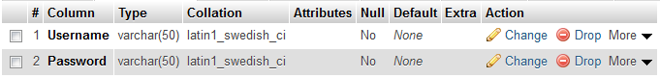

The last table that needs to be created is the “Coordinates” table. The following is an image of the tables’ structure in PHPMyAdmin:

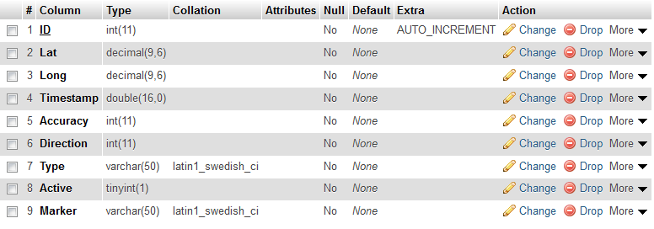

## Initial Data

In all of these tables the default values for the columns can be set to none. The only exception is the ID column in the “Coordinates” table should be set to auto-increment. Once these tables are created two sets of username and password combinations should be added to the “Credentials” table; one for the drivers and one for the administrators. WARNING: When adding passwords make sure the ‘Function’ drop down is set to MD5 so the passwords are encrypted correctly. In the “Alert Message” table an empty row should be inserted. The following images are the way the tables should look once completed and initialized with all of the required data:

Alert Table:

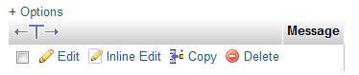

Coordinates Table:



Credentials Table:

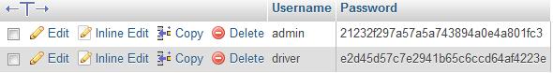

Finally, when all the tables are completed the “berrybus” database should look like this:

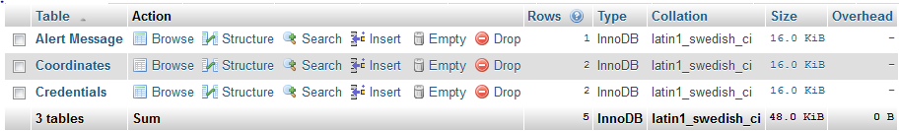

# Updating Files

## Changing Image Markers

An admin can change the image marker of a bus by changing the marker field in the respective bus row in the coordinates table on the database to the corresponding marker file name they would like to be displayed. The admin then must put that marker file under the berrybus/src/client folder.

## Changing Map Center

An admin can change where the map is initially centered on the client facing map by editing the file called showGPS.php under the berrybus/src/client folder. Once in this file the admin should find two variables at the top of the file labeled centerLatitude and centerLongitude. The admin can fill in the desired latitude next to the word centerLatitude and the desired longitude next to the word centerLongitude. This will center the map initially on the latitude and longitude desired. The following image shows the code that should be changed:

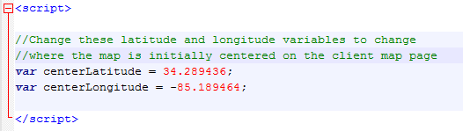

# Contact Information

Adam Gillfillan  
[adam.gillfillan@vikings.berry.edu](mailto:adam.gillfillan@vikings.berry.edu)

--

Cal Supik   
[cal.supik@vikings.berry.edu](mailto:cal.supik@vikings.berry.edu)