

Software requirements Specification

Berry Bus Application



April 30, 2013

Berry College

Dr. Nadeem Hamid

Adam Gillfillan, Cal Supik

#### High Level Product Description

The Berry Bus application is a shuttle tracking system that allows a user to monitor the real-time position of every transportation vehicle available to students on campus. The Berry Bus app allows for another level of convenience not previously attainable by Berry students. With Berry Bus, students will be able to check the app on their smart phones and decide if it is worth waiting for the closest bus en route or to hurry to their next classes anyway. This convenience factor is particularly beneficial on a rainy day when not all students wore their proper rain attire. A student can easily wait in a study hall until the display on Berry Bus shows them a shuttle is just outside. This is all possible without needing to step outside and look for a bus—a truly useful feature for the student who is running late and needs to decide which exit of the building will lead him to the nearest shuttle.

Although transit monitoring systems have been around in major cities and large universities for years, the market for small towns and college transportation remained largely uncaptured. Berry Bus aims to accomplish on a smaller scale what government funded public transit tracking systems do for cities and universities. There are currently many devices available on the market that allow for GPS tracking and real-time display on a web application. These devices, however, generally cost hundreds of dollars each and include software that is not implemented in to a mobile application available to hundreds of users. The current market for GPS tracking devices is either too broad or too narrow; Berry Bus aims to capitalize on the in-between.

This system consists of a few components that will make it function properly. The Berry Bus application is an app that can be developed during our allotted timeframe—the entire semester. The resources and technology Berry Bus uses are accessible to everyone. The system will include the use of a tracker cell phone placed on each Berry bus, students’ cell phones, GPS services, and a server for the cell phones to communicate with. Berry Bus will use the GPS services of a cell phone on a bus to provide a server with its location. The following diagram displays the communication flow in a clear way:

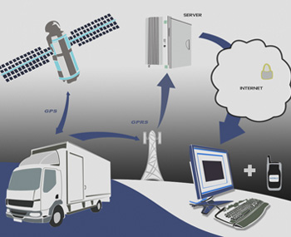

This project is interesting to a Berry student because the most important element is an item that every student uses—a cell phone. Furthermore, it is appealing because it helps people with Berry busses—campus shuttles that students also use daily. The GPS services that make this system work appear ‘magical’ and very interesting to the user.

As a group we have decided to use HTML 5, JavaScript and possibly PHP as the programming languages of choice. The language we choose will be largely dependent upon the quality of the GPS communication libraries.

The primary challenge of implementing Berry Bus is figuring out how to enable communication between the server holding the GPS information and the client. The solution may lie in an implementation of web services using SOAP (Simple Object Access Protocol).

#### Users and Use Cases

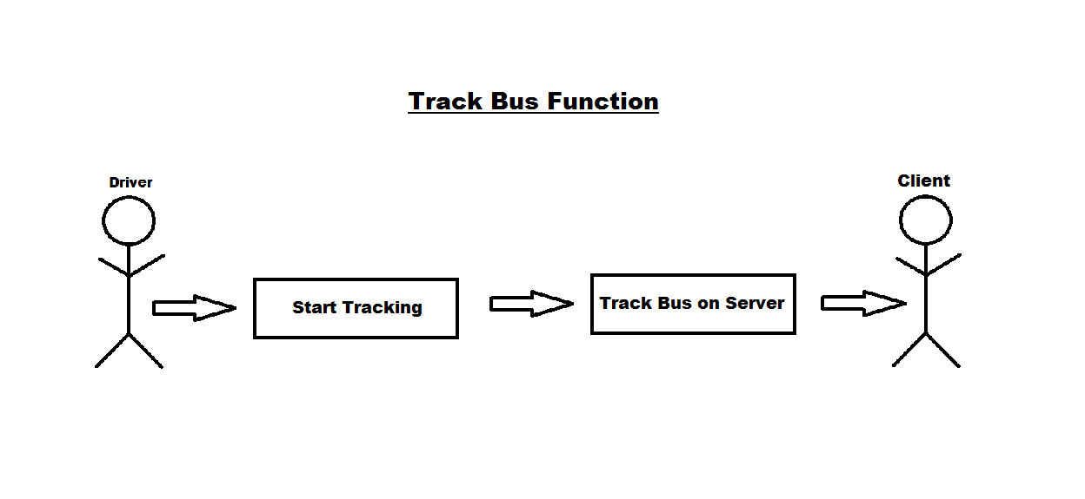The track bus function with begin with the bus driver notifying the server to start tracking the bus. The server would then track the bus and display the bus’ location on the client web application for the client to view.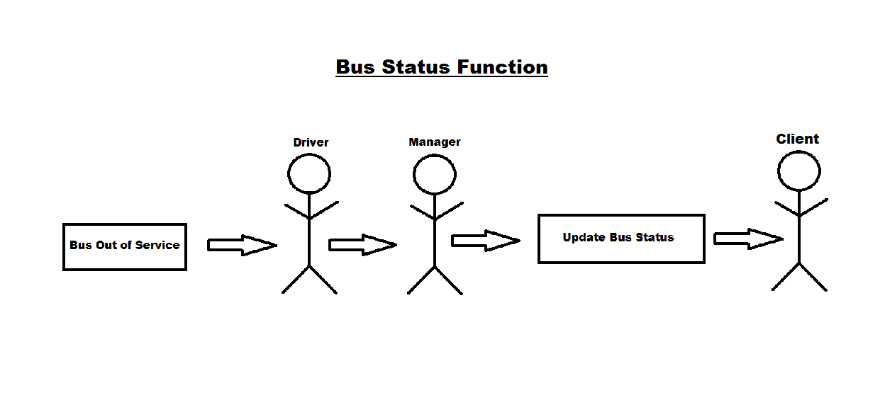The bus status function would begin with the bus being out of service. The driver would then notify their manager and the manager would update the bus’ status on the server. The server would then display the status of the bus on the client web application for the client to view.

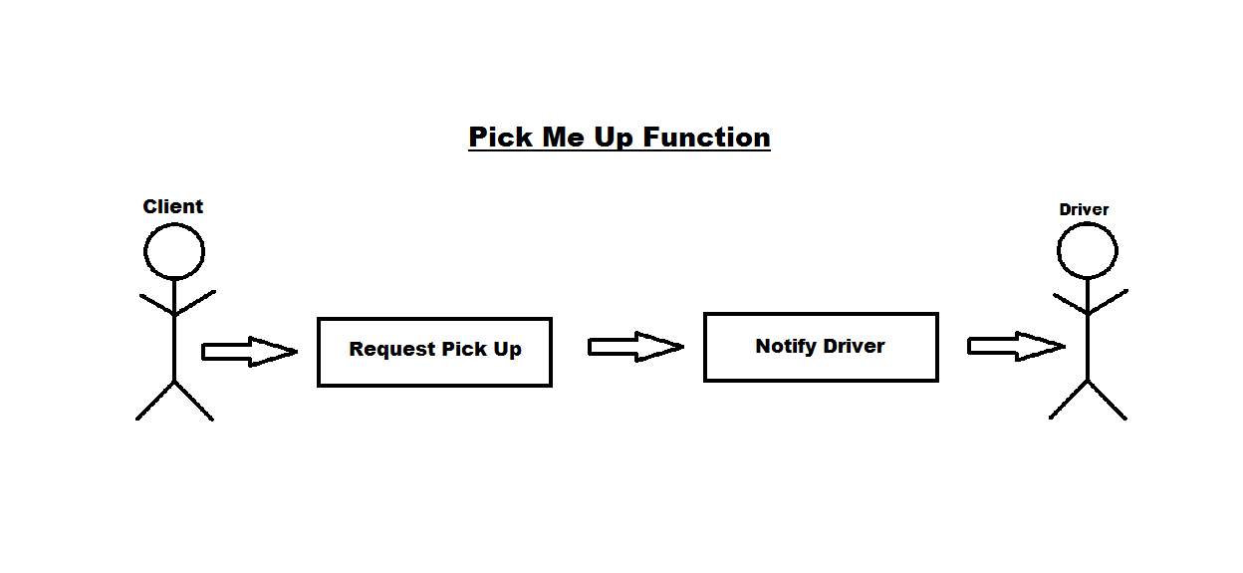The ‘pick me up’ function would begin with the client pressing a button on the client side web application. This would then update the server that a client needs to be picked up. The server would then notify the bus driver that a client needs to be picked up and where the client needs to be picked up.

#### Feature Specification

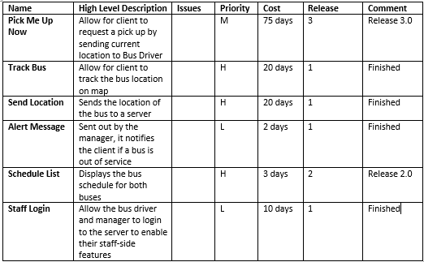

The Track Bus feature allows for the client to view the bus location on the map of the Berry Bus web application. This feature will take the bus coordinates from the server and update the position of the bus on the map using Google Maps tools. This feature is labeled as high priority as it is essential to the Berry Bus user experience.

The Send Location feature sends the GPS coordinates of the bus to a server. This can be accomplished through a simple script using HTML5 and JavaScript. The Send Location feature is labeled as high priority as it is fundamentally important to the success of Berry Bus application.

#### UI Diagrams/User Experience/User Design

The Client UI and Map:

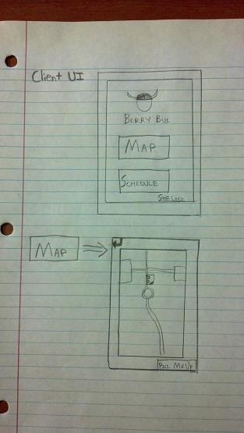

The arrow in the top left is a “back” button to go back to the previous screen. The “Pick Me Up” feature sends the Bus Driver the current GPS coordinates of the client. The Bus Driver’s map will display the spot of the user with a small blinking dot.

The Schedule and Staff Login for a Bus Driver Display:

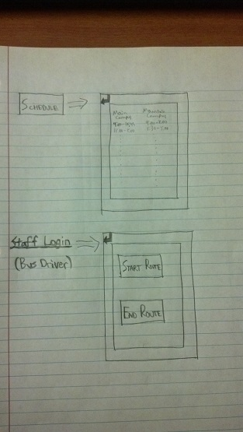

Start Route Feature:

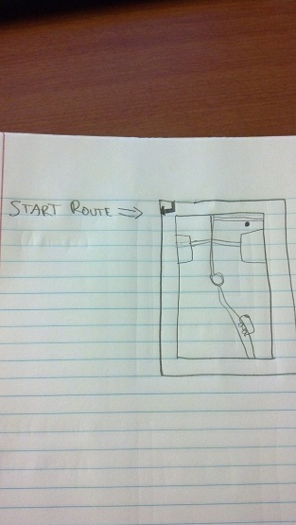

The Staff Login for a Manager:

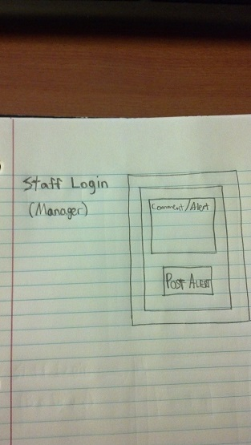

#### Product Deliverables

The product will be a client facing web application that will be accessible on both Apple and Android smartphones. Since this is a web application it will be able to run on most or all of the main internet browsers (i.e. Internet Explorer, Mozilla Firefox, Safari, Google Chrome). It will be written using HTML 5, JavaScript and possibly PHP.