

BERRY BUs

User’s manual

Berry Bus is an interactive bus tracking app that makes real-time campus bus information available online for Berry students. Berry buses are displayed on a detailed map, using the power of GPS and Google Maps.

Contents

[About Berry Bus 2](#_Toc354435299)

[System Requirements 3](#_Toc354435300)

[As a Student 4](#_Toc354435301)

[Getting Started 4](#_Toc354435302)

[Finding a bus on the map 4](#_Toc354435303)

[Different Bus Types 5](#_Toc354435304)

[Legend 5](#_Toc354435305)

[Alert Message 6](#_Toc354435306)

[As a Driver 7](#_Toc354435307)

[Getting Started 7](#_Toc354435308)

[Login 8](#_Toc354435309)

[Start Route 8](#_Toc354435310)

[Running 9](#_Toc354435311)

[End Route 9](#_Toc354435312)

[As an Admin 10](#_Toc354435313)

[Getting Started 10](#_Toc354435314)

[Login 11](#_Toc354435315)

[Stop a Bus 12](#_Toc354435316)

[Create a Bus 12](#_Toc354435317)

[Remove a Bus 13](#_Toc354435318)

[Alert Message 13](#_Toc354435319)

[Changing Passwords 14](#_Toc354435320)

[Contact Information 15](#_Toc354435321)

# About Berry Bus

Berry Bus is an interactive bus tracking app that makes real-time campus bus information available online for Berry students. Berry buses are displayed on a detailed map, using the power of GPS and Google Maps. Stuck waiting in Krannert for the bus because it’s raining? Want to save time finding the bus from anywhere on campus? Use your smartphone or computer to instantly check the bus location.

No installation is required to start using Berry Bus.  
Simply go to [https://webby.cs.berry.edu/berrybus](http://webby.cs.berry.edu/berrybus) and begin finding buses on the **Map.**

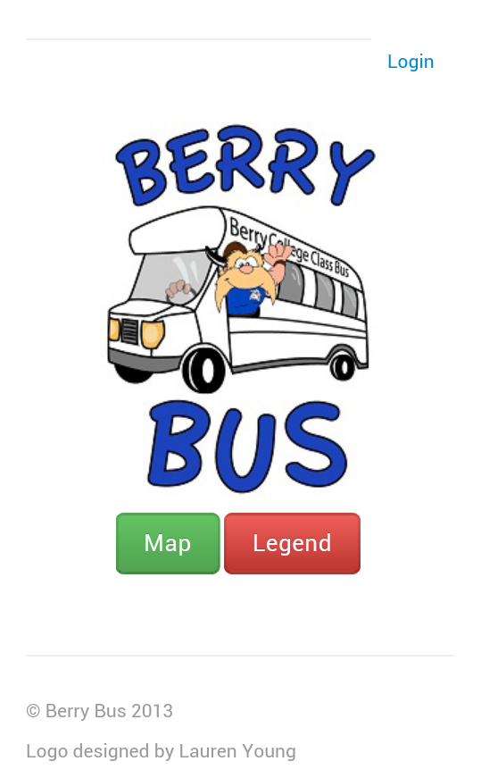

From the **Map**, you can find where Berry’s buses are at. You no longer have to run across campus with arms flailing, waving down a bus. Instead, use Berry Bus to plan accordingly!

Simply put, Berry Bus saves you time and energy!

# System Requirements

In order to use Berry Bus, you will need one of the following:

* A smart phone, laptop, or desktop computer
* Internet connection
* A web browser with JavaScript enabled

That’s it! You are ready to access berry bus.

# As a Student

## Getting Started

To use Berry Bus, simply go to <https://webby.cs.berry.edu/berrybus>

## Finding a bus on the map

To find a bus, press **Map** on the home page.

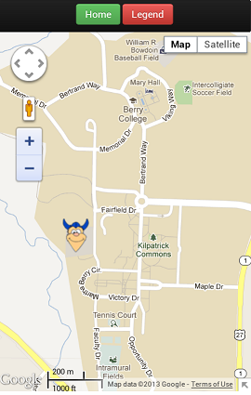

This is where you will find the location of buses on campus. The map updates every 5 seconds so you are able to see the real-time location of the buses.

By default, the Map centers in on Berry’s Main Campus when you first load the map. You may need to use the zoom features on your browser in order to more easily find a bus that may not be visible at first.

To go back to the home screen, simply press **Home**.

## Different Bus Types

There are two types of buses:

C:\Users\adamg_000\Desktop\main.png C:\Users\adamg_000\Desktop\mountain.png

Main Campus Bus Mountain Campus Bus

Main Campus buses take about 15 minutes to complete their route. They begin and end in front of Krannert, driving near all academic buildings and dormitories.

The Mountain Campus bus schedule is posted in Krannert.

## Legend

If you forget what picture goes with a bus, you can press **Legend** on the home page or on the map.

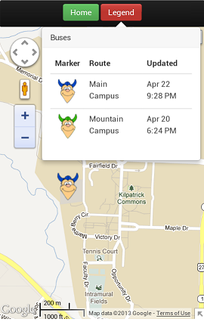

## Alert Message

Occasionally, the Administrator will post a message notifying you of a bus alert. The administrator may post such a message if a Bus is down or if a bus needs maintenance.

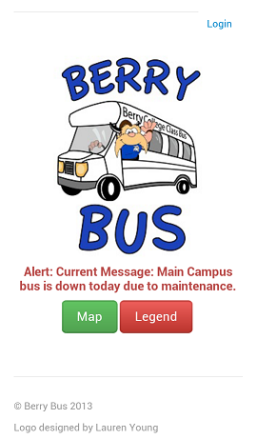

The alert message will show at the top of the **Map** and on the **Home** page

# As a Driver

As a driver, your steps to running a bus are:

1. Login
2. Select your route & Press **Start**
3. Run the route page on your phone until your shift ends
4. Once your shift is over, press **End Route**
5. Sign out and turn off the phone

Detailed steps will follow.

## Getting Started

To use Berry Bus as a driver, simply go to <https://webby.cs.berry.edu/berrybus>/src.

Press **Login** on the **Home** page.

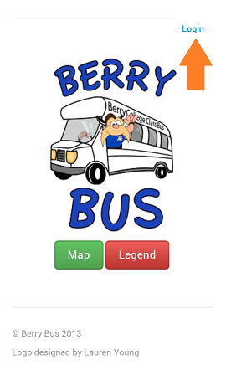

## Login

Enter your **username** and **password** and press **Login**. Your **username** and **password** are provided to you by the administrator.

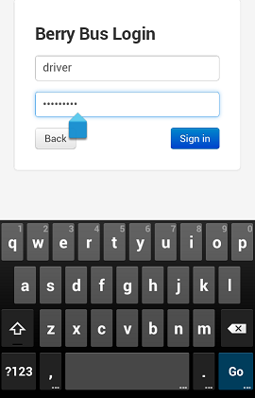

## Start Route

To start a route, select your Bus Type from the drop down menu. Once selected, press **Start Route**.

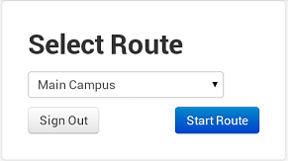

## Running

If **Start Route** was successful, your page will look similar to this:

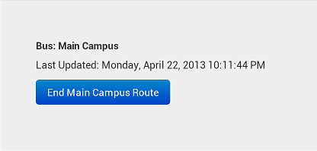

That’s it! You are now successfully sending your location to Berry Bus servers. Students should be able to see your location on the **Map**.

Warning: Do not leave this window or let your phone display turn off. Keep the phone plugged in to the charger.

## End Route

When you are ready to end your route, simply press **End Route**.  
That’s it! Your shift is over.

# As an Admin

## Getting Started

To use Berry Bus as an admin, simply go to <https://webby.cs.berry.edu/berrybus>.

Press **Login**.



## Login

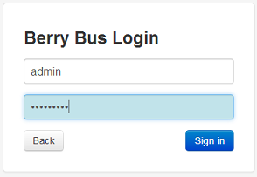

Enter your **username** and **password** and press **Login**. Your **username** and **password** are provided to you by the system administrator.

Welcome to the admin page.

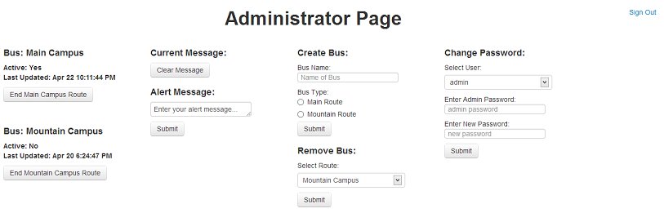

## Stop a Bus

Occasionally a bus driver may forget to end his route on the phone on the Bus. For this reason, the admin has the ability to end the route from the admin page.

To **Stop a Bus** from sending its location, press **End [bus type] Route** found below the bus you want to end.

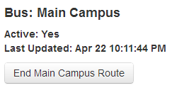

## Create a Bus

Perhaps Berry is adding a new bus to its fleet. This feature gives you the ability to create a new bus to be used by the bus drivers.

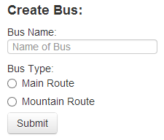

To **Create** **a Bus**, enter the **Bus Name**. Select a **Bus Type**. Press **Submit**.

The **Bus Name** is the name you want to give the bus. This name will display for the driver when selecting his or her route.

The **Bus Type** determines what picture to use to display the bus. Main Campus and Mountain Campus buses use different marker icons.

## Remove a Bus

The **Remove Bus** feature gives you the ability to delete a bus from the list of buses, permanently. This is useful if you need to remove a bus because Berry has lost a bus from its fleet.

You may only **Remove a Bus** if the bus is inactive. To ensure the Bus you want to remove is inactive, see **Stop a Bus** above.

To **Remove a Bus**, select the bus you want to remove and press **Submit**.

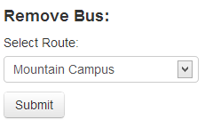

## Alert Message

As an admin, you have the ability to create an **Alert Message**. Perhaps you want to notifystudents that the Main Campus bus will be down for the day.

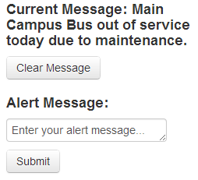

To create an **Alert Message**, enter your message and press **Submit.**

Your current message is displayed by **Current Message.** To clear this Alert message, simply press **Clear Message**.

## Changing Passwords

As an admin, you have the ability to change the driver password and the admin password. This is useful if you suspect someone unauthorized might know the admin or driver password.

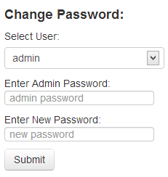

Choose to change either the driver or admin password in the drop down menu. Confirm you are the admin by entering the current admin password in the **Enter Admin Password** field. Enter the new password in the **Enter New Password** field. Press **Submit**.

# Contact Information

Adam Gillfillan  
adam.gillfillan@vikings.berry.edu

--  
Cal Supik   
[cal.supik@vikings.berry.edu](mailto:cal.supik@vikings.berry.edu)