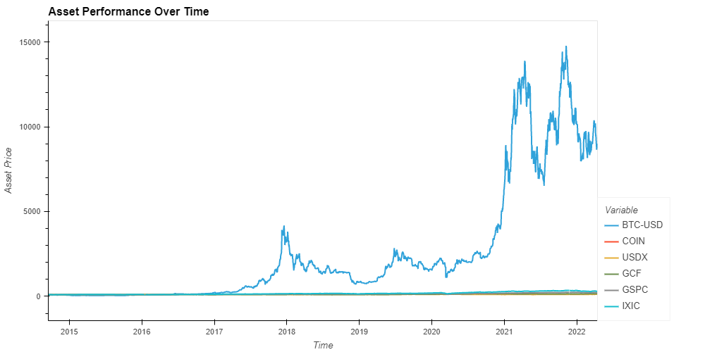

**SCARCITY**

- GOLD shares the similar characteristic with BTC that both have scarcity in supply

- GOLD has limited resources whilst BTC has a fixed number of 21 million coins.

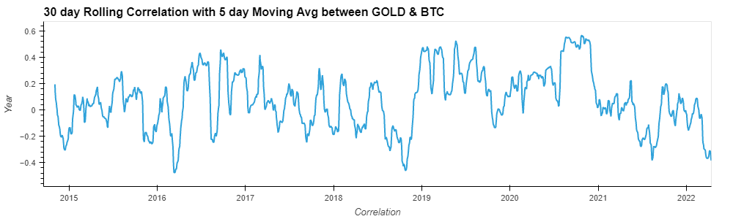

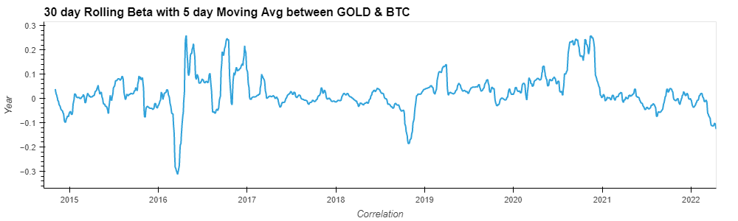

**Decentralized vs. Centralized**

- DXY is a basket of fiat currencies. Issued by centralized institutions.  
Its value can be manipulated through money printing or policy mishaps.

- BTC is not valued by any centralized institutions.  
Its value derived from whatever the market think its worth.

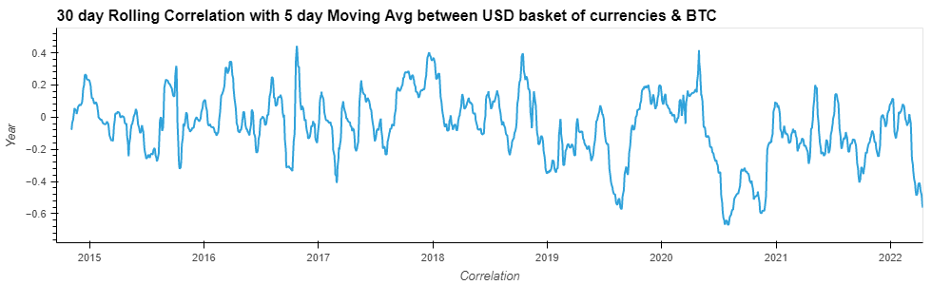

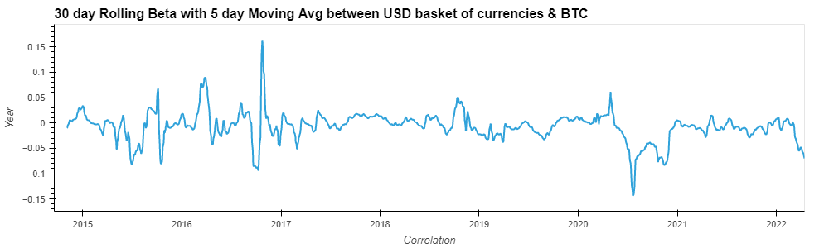

**High Volatile Assets:**

- Equity and BTY have high volatility compared to other assets

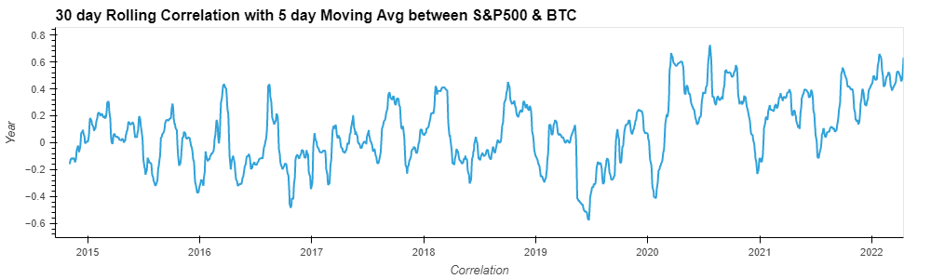

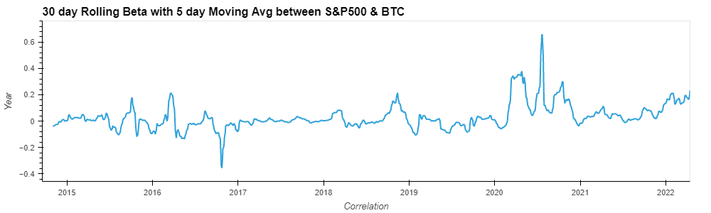

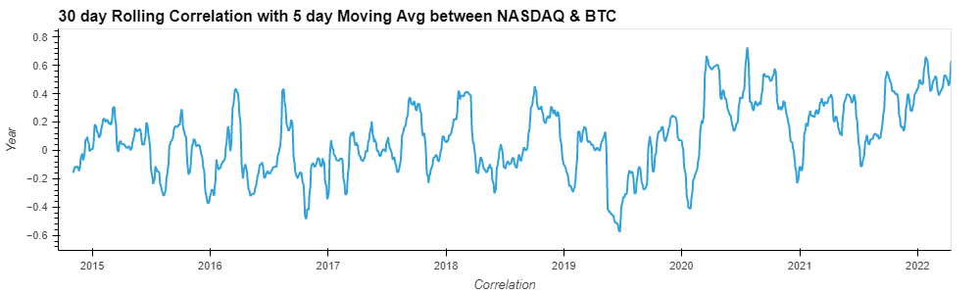

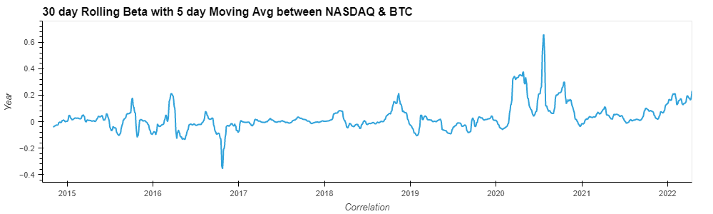

**BTC vs. its Peers**:

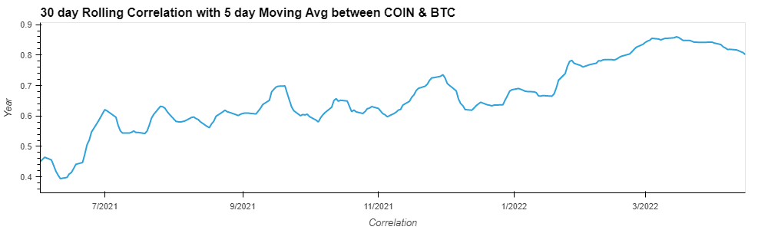

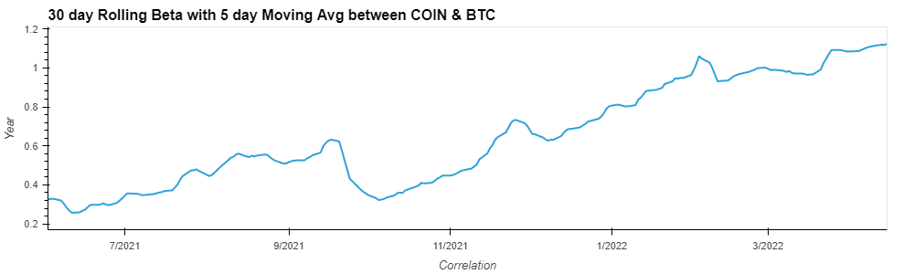

**BTC as a hedging instrument?**

**-** When hedging needed the most BTC & Equity correlation turns positive.

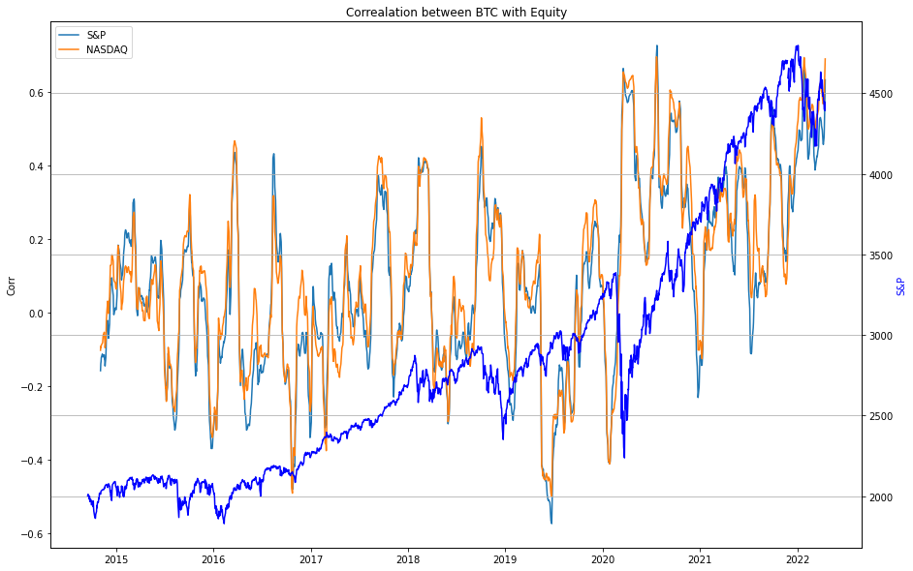

**Annualized Statistics**:

|  |  |  |  |  |
| --- | --- | --- | --- | --- |
| Assets | return | standard deviation | sharpe | beta |
| BTC | 0.85 | 0.7336 | 1.17 | 1 |
| COIN | -0.58 | 0.6431 | -0.91 | 0.52 |
| USD-DXY | 0.025 | 0.0675 | 0.37 | -0.003 |
| GOLD | 0.07 | 0.1499 | 0.48 | 0.0144 |
| S&P 500 | 0.11 | 0.1806 | 0.66 | 0.0396 |
| NASDAQ | 0.16 | 0.2082 | 0.78 | 0.0499 |