Python I Assessment:

Task: Let’s pretend that you have just landed a job as a hot-shot salesperson at Large Firm X. The commission for an individual salesperson is dependent on their monthly billed revenue. For example, a salesperson that records $50,000 in revenue for a particular month will receive a percentage of their sales as a commission check. Your goal is to create a simple program that accepts user salary input and calculates the commission check to be paid based on the following scheme:

- Sales revenue up to $50,000 earns %2 commission
- Sales revenue between $50,000 and $100,000 earns %3 commission
- Sales revenue greater than $100,000 earns %5 commission

Your program should display the user name, salary, and commission to be paid. Implement a looping mechanism so that the user can decide whether or not to calculate additional commissions.

Output:
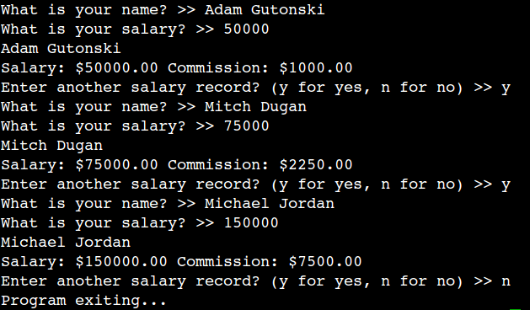
Python II Assessment:

Task: In this task you will modify your program from the Python I assessment. Your goal again is to create a simple program that accepts user salary input and writes this information to a text file. Then, read from the same text file to calculate the commission per user entry. Your program should again display the user name, salary, and commission to be paid. You should also alert the user when data has been written to the file. Also, do not hard code any values for user name or salary. The only constants that you should have in the program are the salary thresholds and commission rates (these values should be consistent with the Python I task).

Output:
