Python Comprehensions

- Borrowed from functional programming → mapping operations over iterables and collecting results
- results are collected in a list (or dictionary/set) that must be assigned to a variable for us to continue using the data
- The formal comprehension syntax:
  - [ expression for target in iterable ]
- We can chain for loops and conditions inside of a comprehension
  - [ expression for target1 in iterable1 if condition1
for target2 in iterable2 if condition2
for target3 in iterable3 if condition3 ]

For loops to comprehend:

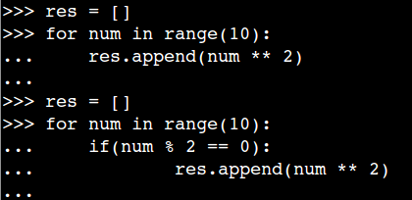

Answers:

