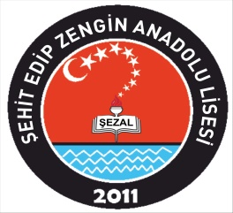 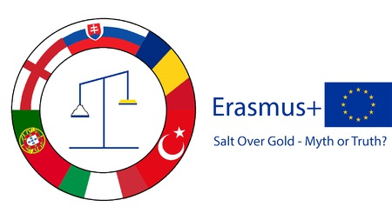

**PROGRAMME- TÜRKİYE- 24-28 October 2022**

**MONDAY- 24TH OCTOBER 2022**

* **09:30** Welcoming partners at the school
* **10:00-10:30** School tour - (Ice Breakers Activitiy)
* **11:00-12:30** Students presentations ( My School,Town, Country)
* **13:00** Lunch at İskele Park Restaurant
* **14:30- 16:00** Darıca Sight seeing

**TUESDAY- 25TH OCTOBER 2022**

* **09:00** Pick up at the hotel- Cultural DaY Trip to Istanbul

( Taksim Square, Istiklal Street, Galata Tower, Bosphorus Boat Cruise Tour)

-Lunch in Taksim

**WEDNESDAY- 26TH OCTOBER 2022**

* **09:30** Arriving School
* **10:00- 11:00** Workshop at school “Making Science Engaging” Demo Lectures by Math, Chemistry and Physics Teachers.
* **11:00-12:00** Gym Curling Activity
* **12:30-13:30** SEMINAR – “SALT AND TECHNOLOGY” at Gebze Technical University.

**THURSDAY- 27TH OCTOBER 2022**

* **09:00** Pick Up at the hotel- CulturalDay trip to Istanbul Old Town

( Sultanahmet Area, Blue Mosque, Hagia Sophia, Topkapi Palace, Grand Bazaar)- Lunch in Sultanahmet Koftecisi

**FRIDAY- 28TH OCTOBER 2022**

* **09:30** Arriving School
* **10:00- 12:30** Workshop- Designing A Documentary Filmabout a Salt Mine ( Turkish Students)
* Salt Drama by Turkish Students
* Teachers Evaluation Meeeting – Quiz Time For students
* Certificates Ceremony
* **12:30 – 14:30** Lunch at school ( Kebab Barbeque)
* **18:30- 22:00** Farewell Dinner Party in Eskihisar Sahil Sofrası Restaurant