Analyzing Post-fire Conifer Regneration in the Klamath National Forest

Report Prepared for Andrew Mueller, USFS Ecologist, Klamath National Forest
Adam Hanbury-Brown, Rachel Ward, Millie Chapman, Elif Tasar
May, 2020

Background

The Klamath ecoregion, hereafter referred to as “the Klamath”, is a forested, fire-prone,
ecosystem in Northern California and southern Oregon comprising 2.94 million hectares (Serra-
Diaz et al. 2018). Prior research suggests that some areas of the Klamath’s mixed conifer forests (MCFs) are in disequilibrium with the current climate (Serra-Diaz et al. 2018) and that conifer regeneration is declining here and in many western states (Stevens-Rumann et al. 2019). Empirical evidence and model testing indicate that increasing fire size and burn severity (Steel, Koontz, and Safford 2018) combined with increased soil moisture deficit has the potential to convert drier parts of Klamath MCFs to hardwoods and/or shrubland (Tepley et al. 2017, Serra-Diaz et al. 2018). Changes to the disturbance regime and climate appears to alter the competitive dynamics between regenerating conifers and shrubs, resulting in reduced conifer regeneration in drier parts of the Klamath (Tepley et al. 2017). Despite the import role of forest management in influencing conifer regeneration, many studies exclude managed areas from analysis and don’t include management options in predictive models of regeneration outcomes (Tepley et al. 2017, Young et al. 2019, Shive et al. 2019). Therefore, managers and ecologists lack insight into the past and future efficacy of reforestation practices, especially in the context of a changing climate. Furthermore, few studies observe regeneration outcomes on a long enough timescale to determine if successful conifer seedling establishment (natural or artificial) translates into future conifer canopy dominance in mature size classes.

In the five years following a fire, the United States (USFS) often permits salvage logging, prepares burned areas for planting, plants conifer seedlings, and performs stocking surveys to check seedling establishment success. Some planted seedlings will be marked for subsequent analysis of survivorship and reforestation success. Not all areas that burn receive reforestation management due to limited resources and because some areas are designated wilderness. This provides a mosaic of variable management histories to test the effects of management and environmental variables on regeneration outcomes.

We investigated how management, climate, site variables, and fire characteristics explained variation in conifer forest regeneration outcomes after fire. Our overarching motivation was to understand how climate, topography, and post-fire management affects conifer regeneration outcomes in the Klamath National Forest, and to provide insights that support future post-fire management.

Specific questions and hypotheses
“+/-” denotes a positive or negative relationship was expected
Q1. What variables predict the probability that a management unit gets certified as experiencing natural regeneration within 10 years of a fire? We hypothesized that this probability is a function of site potential (+), burn severity (-), distance to low burn severity zone (-), slope (-), elevation (+/-), climate water deficit at the site (-), solar load index, and site preparation (+).

Q2. What variables influence the survivorship of planted seedlings? We hypothesized that seedling survivorship of planted trees, across all conifer species, is a function of site potential (+), slope (-), elevation (+/-), long-term climate water deficit (-), solar load index, and site preparation (+).

Q3. What variables influence the probability that conifers will dominate the canopy 30 years after a fire? Are the environmental variables of importance here the same ones that predict shorter term natural seedling regeneration? We hypothesize that the probability that conifers dominate the canopy 30 years after a fire is a function of management actions and the same variables that predict the shorter-term certification of natural regeneration.

Methods

We focused our analysis on a cluster of large, severe fires occurring within the Klamath National Forest in 1987 (add fire names and sizes here). Focusing on the 1987 fires allowed us to observe long term (30+ years) regeneration outcomes which would be impossible for more recent fires.

INSERT MAP OF STUDY AREA HERE

The unit of analysis for Q1 and Q2 was a USFS management unit, or “subunit” (SUID), because this is the spatial scale at which management actions and regeneration outcomes were reported. All explanatory variables were averaged to the level of a SUID. The unit of analysis for Q3 was a 30 m pixel, but some independent variables used to test this hypothesis occur at the level of a SUID.

The USFS provided excel files with data on post-fire reforestation management actions and seedling regeneration observations. We matched these records to spatially explicit SUID polygons and used Google Earth Engine to overly climate, topography, and burn severity layers. All spatially explicit data was transformed and re-projected to a UTM Zone 10 coordinate system (EPSG: xxxxx), sampled to points at 30 meter spatial resolution and imported into R for statistical analysis (link to github). Table 1 provides details on the variables and data sources used in this analysis.

Table 1. Data summary (dependent variables are in bold) [fill in rest of table]

Variable Name | Variable Code | Units | Spatial Res. (m) | Source
Dependent Variables
Certified natural regeneration |  | T/F | SUID | USFS FACTS
Seedling survival |  | NA | SUID | USFS FACTS
Canopy dominance 30 yrs after fire |  |  | 30 m | Landfire
Independent Variables
Elevation |  | m | 30 | SRTM
Slope |  | % grade | 30 | SRTM
northness |  | [-1,1] | 30 | SRTM
eastness |  | [-1,1] |  | SRTM
Seed availability proxy |  |  |  | MTBS
Burn severity |  | Low / med / high |  | MTBS
Climate water deficit |  | Mm |  | CA Climate Commons
Solar Load Index
Mean T |  | Deg. C |  | PRISM
Mean ppt. |  | mm |  | PRISM
Site preparation |  | Categorical |  | USFS FACTS
Planting density |  | Trees / acre |  | USFS FACTS
Stocking density (planted) |  | Trees / acre? |  | USFS FACTS
Stocking density (natural) |  | Trees / acre? |  | USFS FACTS
planted |  | T/F |  | USFS FACTS
“certified planted” |  | T/F |  | USFS FACTS

Statistical Analysis (section under development)

- All statistical analyses were done in R using the lme4 and GAM packages.
- We tested for co-linearity of the predictor variables for dimensionality reduction.

- H1: We modeled the probability that a SUID receives certification of natural regeneration within 10 years using a binomial regression with logit link function
  - assumptions met
  - model selection process (back / forward selection),AIC/BIC

- H2: We modeled mean seedling survivorship using a GLMM
  - assumptions met
  - tested normality of seedling survivorship
  - model selection process

- H3: We modeled the probability that conifers dominate the canopy 30 years using a binomial regression
  - assumptions met
  - model selection process (back / forward selection),AIC/BIC

Results (figures and section content under development)

Figure 1. How does forest regeneration correlate with fire and landscape characteristics?

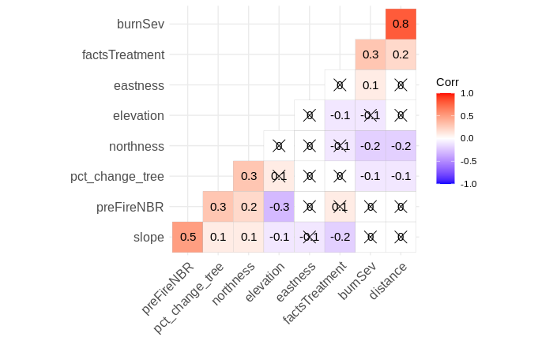

Figure 2. Does planting seedlings affect the future vegetation composition 30 years after a fire?

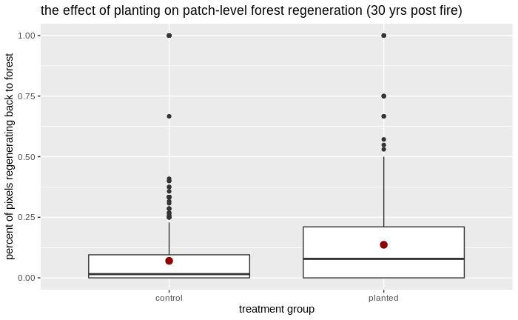

Figure 3. Where does planting make the most difference?

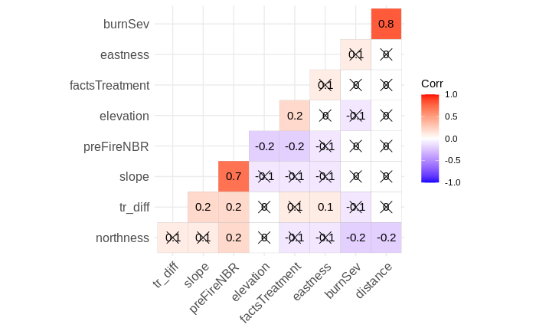

- Q1
  - show best model with AIC score compared to candidate models
  - show table of model coefficients in best model
  - show figure
- Q2
  - show best model with AIC score compared to candidate models
  - show table of model coefficients in best model
  - show figure
- Q3
  - show best model with AIC score compared to candidate models
  - show table of model coefficients in best model
  - show figure

Potential Management Implications
*Section under development

Future tests
H4. Does seedling establishment predict future canopy dominance? The short-term success of seedling establishment predicts the longer-term success of conifer canopy dominance 30 years after a fire.

