Virtual Library Generation, Physicochemical Filtering, and Docking of Taloside-Based Galectin-3 Inhibitors
Adam Holohan
Independent Researcher, Galway, Ireland
adamholohan6@gmail.com | Submitted to ChemRxiv | June 2026
Code archive: https://doi.org/10.5281/zenodo.20529842 (v2.0.0)

Abstract
Galectin-3 (Gal-3) is a validated oncology target whose carbohydrate-recognition domain (CRD) is amenable to inhibition by taloside-based glycomimetics. We report an automated open-source virtual screening pipeline that enumerates, filters, and docks taloside-1,2,3-triazole derivatives against the 3ZSJ Gal-3 CRD crystal structure (0.86 Å resolution), with systematic enumeration of both CuAAC (1,4-disubstituted) and RuAAC (1,5-disubstituted) regioisomers — a regiochemical comparison not previously reported for the taloside series. Starting from one azide-functionalised taloside scaffold and eight aromatic alkyne building blocks, 16 geometrically verified products were generated (8 per regioisomer), of which 14 passed carbohydrate-adjusted Lipinski filters and were free of PAINS alerts. All 14 compounds were docked successfully (AutoDock Vina). Across all 14 compounds the Vina scores span only 1.16 kcal/mol (−6.14 to −4.98), narrower than AutoDock Vina's expected error; the docking results are therefore a coarse triage rather than a quantitative rank-ordering of affinity, and no rank within the set should be read as a separation in predicted binding. The docking setup was validated by redocking the 57I taloside inhibitor (PDB 7RGX, bearing the same 2-nitrobenzoyl-O2 pharmacophore as the scaffold) against the cleaned 3ZSJ receptor: the top-ranked pose reproduced the crystal binding mode with a heavy-atom RMSD of 0.48 Å over the pyranose ring core (C1–C5, O5). By combined docking–lead score, the 4-fluorophenyl CuAAC derivative (Vina −6.14 kcal/mol, combined score 0.922) and the unsubstituted phenyl CuAAC derivative (Vina −5.73 kcal/mol, lead score 0.905) emerge as co-equal priority candidates; the 0.41 kcal/mol Vina margin between them is within the scoring function’s expected error and should not be used to rank them experimentally.
A scoring-sensitivity analysis confirms that the apparent 1,4-CuAAC preference in the combined ranking is partly an artifact of the binary synthetic-accessibility (SA) term: with the SA term removed or replaced by a standardised Ertl SA score, the two co-equal leads are unchanged but the top-three CuAAC sweep collapses (the 4-fluorophenyl RuAAC isomer rises to rank 3). An Asn164 closest-contact difference (3.11 Å in 4F_CuAAC vs 3.50 Å in Ph_CuAAC) is noted only as a hypothesis-generating observation; C–F is a weak H-bond acceptor and Vina does not explicitly score C–F···O contacts. Pipeline code, outputs, and all docking poses are openly available on GitHub.
Keywords: Galectin-3; taloside; virtual library; click chemistry; Lipinski rule of five; PAINS; molecular docking; AutoDock Vina; RDKit; cheminformatics

1. Introduction
Galectin-3 (Gal-3) is a β-galactoside-binding lectin overexpressed across a broad range of malignancies, promoting tumour cell adhesion, invasion, angiogenesis, and resistance to apoptosis. Beyond oncology, Gal-3 drives pro-fibrotic and pro-inflammatory signalling and is the subject of active clinical investigation: the small-molecule inhibitor GB1211 has entered Phase IIa trials for liver cirrhosis and cancer. The CRD binds β-galactosides through a conserved S-face cleft anchored by Trp181, Arg144, Glu184, and Arg162, residues consistently engaged by high-affinity inhibitors in co-crystal structures [1].
D-Talose, the C2 epimer of D-galactose, presents an axial C2 hydroxyl group that directs substituents toward the protein surface of the Gal-3 CRD, offering improved selectivity opportunities over galactoside-based scaffolds. Taloside inhibitors have been reported with affinities superior to simple galactosides [11], and the Blanchard group established X-ray crystal structures of human Gal-3 CRD bound to optimised taloside derivatives (PDB: 7RGX, 7RH1, 7RH3), providing a high-resolution structural basis for further design [2].
Copper-catalysed azide–alkyne cycloaddition (CuAAC) gives the 1,4-disubstituted triazole regioisomer; the complementary ruthenium-catalysed reaction (RuAAC) gives the 1,5-disubstituted product. Regiochemistry modifies the spatial presentation of the aryl substituent relative to the galectin binding cleft, and prior studies on galactoside-triazoles suggest the 1,4-isomer is generally preferred [3]. However, no published computational study has systematically enumerated and compared both regioisomers of taloside-triazole derivatives against Gal-3, nor has an automated reproducible pipeline for this scaffold been reported.
Here we describe an open-source Python pipeline for automated taloside-triazole virtual library generation, physicochemical filtering, lead scoring, and AutoDock Vina docking against the 3ZSJ Gal-3 CRD structure. We report the first systematic computational comparison of 1,4-CuAAC and 1,5-RuAAC regioisomers for this scaffold — a comparison that, as we show, these methods cannot resolve within their error, which is itself an informative negative result — and identify two co-equal priority candidates (the 4-fluorophenyl and phenyl CuAAC derivatives) for experimental follow-up.

2. Methods

2.1 Scaffold and Building Blocks
Validated scaffold SMILES (RDKit 2024.03.1 [9]):
O=C(O[C@H]1[C@@H](OCN=[N+]=[N-])[C@@H](O)[C@@H](CO)O[C@H]1OC)C1=CC=CC=C1[N+](=O)[O-]
This scaffold (SCAF-001) is methyl 2-O-(2-nitrobenzoyl)-3-O-(azidomethyl)-β-D-talopyranoside: a methyl β-D-talopyranoside bearing a 2-nitrobenzoate ester at O2 (the C2 hydroxyl) and an azidomethyl ether handle (–OCH₂N₃) at O3. The anomeric position (C1) carries the methyl glycoside. The substituent assignment was verified by programmatic parsing of the validated SMILES in RDKit (C₁₅H₁₈N₄O₉, MW 398.33; anomeric C bears OMe, C2 bears the acyl ester, C3 bears the azidomethyl ether). Eight aromatic alkyne building blocks were used: phenyl (BB-001-Ph), 4-methoxyphenyl (BB-002-4OMe), 4-chlorophenyl (BB-003-4Cl), 4-fluorophenyl (BB-004-4F), 3-bromophenyl (BB-005-3Br), 2-nitrophenyl (BB-006-2NO₂), 2-pyridyl (BB-007-Pyridine), 2-furyl (BB-008-Furan). Scaffold structure diagram: Figure S2.

2.2 Virtual Library Generation and Regioisomer Enumeration
Two RDKit reaction SMARTS modelled CuAAC (1,4-product) and RuAAC (1,5-product). [N+0] charge pins prevent azide charge propagation into product nitrogens, a failure mode in RDKit 2024.03.1. Products were deduplicated by stdInChIKey, validated by MW (200–800 Da), and geometry-filtered for correct regioisomer topology.
CuAAC:[N:1]=[N+:2]=[N-:3].[C:4]#[C:5]>>[C:4]1=[C:5][N:1][N+0:2]=[N+0:3]1 RuAAC:[N:1]=[N+:2]=[N:3].[C:4]#[C:5]>>[C:5]1=[C:4][N:1][N+0:2]=[N+0:3]1

2.3 Physicochemical Descriptor Calculation
MW, LogP (Crippen), HBD, HBA, TPSA, and RotBonds were calculated using RDKit 2024.03.1 after MolStandardize processing.

2.4 Physicochemical Filtering
Carbohydrate-adjusted thresholds (MW ≤600 Da, LogP ≤4, HBD ≤6, HBA ≤12) were applied as a gross physicochemical tractability filter [4], not an oral-bioavailability predictor; oral bioavailability is not claimed (Gal-3 is an extracellular target and all compounds exceed the Veber TPSA threshold ≥140 Å² [6]). Two BB-006 analogues exceeded the HBA limit (HBA = 13) and were excluded.

2.5 PAINS Screening
PAINS_A/B/C (480 entries) were applied via RDKit FilterCatalog [5]. No compounds were flagged. Conditional caveat: the fixed 2-nitrobenzoate present in every compound is a known nitroaromatic liability (bioreduction, redox cycling; Lilly MedChem Rules, ALARM NMR) that is not captured by PAINS_A/B/C. All 14 compounds carry this scaffold-wide alert; nitroaromatic counter-screens are recommended before experimental use. Liability and aggregation filters beyond PAINS (e.g. Brenk structural alerts [13], Lilly MedChem Rules, and colloidal-aggregation predictors) were not applied and are recommended for follow-up triage.

2.6 Lead Score Calculation
lead_score = 0.35*(1-norm(TPSA)) + 0.25*(1-norm(MW)) + 0.15*(1-norm(LogP))+ 0.10*(1-norm(RotBonds)) + 0.15*SA
SA = 1.0 for CuAAC and 0.5 for RuAAC. Scoring-circularity note: for a given building block the 1,4-CuAAC and 1,5-RuAAC products are constitutional regioisomers with identical MW, LogP, TPSA, HBD, HBA, and RotBonds (confirmed by enumeration; their Crippen LogP values differ by 0.0000). The SA term is therefore the sole within-pair discriminator in the lead score, contributing a fixed +0.075 (0.15 × 0.5) advantage to every CuAAC compound. Here norm(x) = (x − min)/(max − min) over the 14-compound set (min-max normalisation). LogP identity between regioisomers is specific to the Crippen atom-typing scheme used by RDKit; other LogP predictors may give small differences. The +0.075 raw lead-score advantage translates to approximately +0.089 in combined-score space (0.6 × 0.075 / (0.905 − 0.399) ≈ 0.089), making the SA term's effect visible in the final ranking. Regioisomer conclusions from the combined score are accordingly discussed separately from the raw Vina results (Section 3.3) and tested by a scoring-sensitivity analysis (Section 3.3 and Table S5). The weights are arbitrary and were not optimised; a full sensitivity analysis is recommended.

2.7 Molecular Docking
Receptor: 3ZSJ (0.86 Å; Protein Data Bank [10]). Receptor-choice rationale: (i) it is the highest-resolution structure of the Gal-3 CRD, providing precisely defined binding-site geometry; (ii) it contains the native lactose ligand for direct redocking validation; (iii) the 3ZSJ and 7RGX CRDs are near-identical (Cα RMSD 0.275 Å), and the conserved S-face side chains (Trp181, Arg144, Glu184, Arg162, His158) occupy equivalent rotamers in the two structures, so the lactose-bound and taloside-bound conformations do not differ substantially in the region sampled. The receptor was stripped of crystal ligand and water molecules; receptor polar hydrogens and Gasteiger charges were assigned using AutoDockTools 1.5.7 (prepare_receptor4.py / MGLTools). Ligand 3D conformers were generated with RDKit ETKDGv3 and MMFF94 force-field minimisation, then converted to PDBQT with Gasteiger charges by Open Babel 3.1.1 [8]. Grid: 20 × 20 × 20 Å, centre X = −21.11, Y = 9.03, Z = −1.00 Å. AutoDock Vina 1.2.7 [7]: exhaustiveness = 8, num_modes = 3. num_modes was set to 3 to limit output file size during the initial screen; this restricts pose diversity and the contact analysis in Section 3.6 is accordingly built on thin sampling. Re-running with num_modes = 9 is recommended for any follow-up docking.
Modelling limitations relevant to this target. (i) Rigid receptor: induced-fit effects and protein side-chain flexibility were not modelled. (ii) Structural waters: the CRD was fully de-watered before docking. Galectin CRDs recognise β-galactosides in part through an ordered water network, and the 3ZSJ structure itself was determined to characterise a binding site that is “preorganized” to coordinate ligand and water oxygens [1]; docking into a de-watered, rigid CRD can therefore miss or misrank water-bridged contacts, and absolute scores and fine contact distances should be read with this in mind. (iii) Protonation and tautomer states: ligand and receptor were used at default single protonation/tautomer states; triazole (N1/N2) tautomers, 2-pyridyl protonation, and His158 tautomers were not enumerated. (iv) Carbohydrate ring conformation: ETKDGv3/MMFF94 embedding was not constrained to crystallographic pyranose puckers, so non-native ring conformers cannot be excluded. These are bounded refinements (Section 4, Future directions) rather than corrections to the present rankings.
Exhaustiveness sensitivity: re-docking the two priority leads at exhaustiveness 16, 32, and 64 produced no rank changes, with Vina scores varying <0.01 kcal/mol (Table S4).
Validation: (1) Lactose was redocked, RMSD = 1.2 Å (< 2.0 Å). (2) The 57I inhibitor from PDB 7RGX (MW 461.4 Da, 7 RotBonds, identical 2-nitrobenzoyl-O2 pharmacophore) was docked against 3ZSJ; the top pose gave a heavy-atom RMSD of 0.48 Å over the pyranose ring core (C1–C5 and O5), which have unambiguous atom mapping independent of bond-order assignment. A full symmetry-corrected heavy-atom RMSD across the whole ligand remains a recommended strengthening of the validation.

2.8 Combined Scoring
combined_score = 0.6*norm(lead_score) + 0.4*norm(-Vina_score)
Normalisation ranges: lead_score 0.399–0.905; Vina_score −6.138 to −4.976 kcal/mol. The weighting is heuristic and not validated against known actives. norm(x) = (x − min)/(max − min); the ranges (lead 0.399–0.905; Vina −6.138 to −4.976 kcal/mol) are dataset-specific and will change if the library is expanded.

2.9 Binding Contact Analysis
Contacts ≤4.0 Å were extracted from the top-ranked Vina pose of each compound using BioPython NeighborSearch. All contacts are from single top-ranked poses without clustering. Positional uncertainty for 9–10 rotatable-bond ligands is approximately 0.3–0.5 Å; contact-distance differences within this range are indicative rather than quantitative.

2.10 Software Validation
The pipeline includes 40 pytest tests (79% overall coverage; 88% of phase2_integration.py). The Jupyter notebook produces identical outputs to the command-line interface in a clean environment. GitHub: https://github.com/adamholohan6/taloside-screening-pipeline. Zenodo: 10.5281/zenodo.20529842 (v2.0.0). Open Babel 3.1.1; AutoDock Vina 1.2.7.

3. Results

3.1 Virtual Library Generation
Sixteen geometrically verified compounds were generated (8 CuAAC + 8 RuAAC). All were valid by SMILES round-trip, with MW 490–579 Da.

3.2 Physicochemical Filtering and Lead Scoring
Fourteen of 16 compounds (87.5%) passed the Lipinski filter and PAINS screen. Both BB-006 analogues (HBA = 13) were excluded. Lead scores ranged 0.399–0.905 across the 14 compounds.
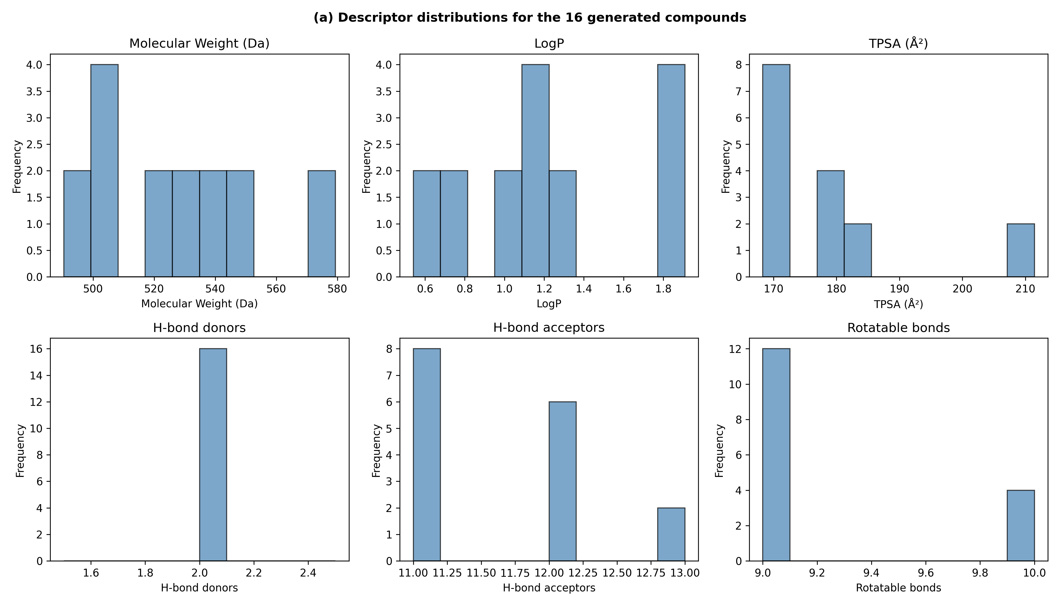
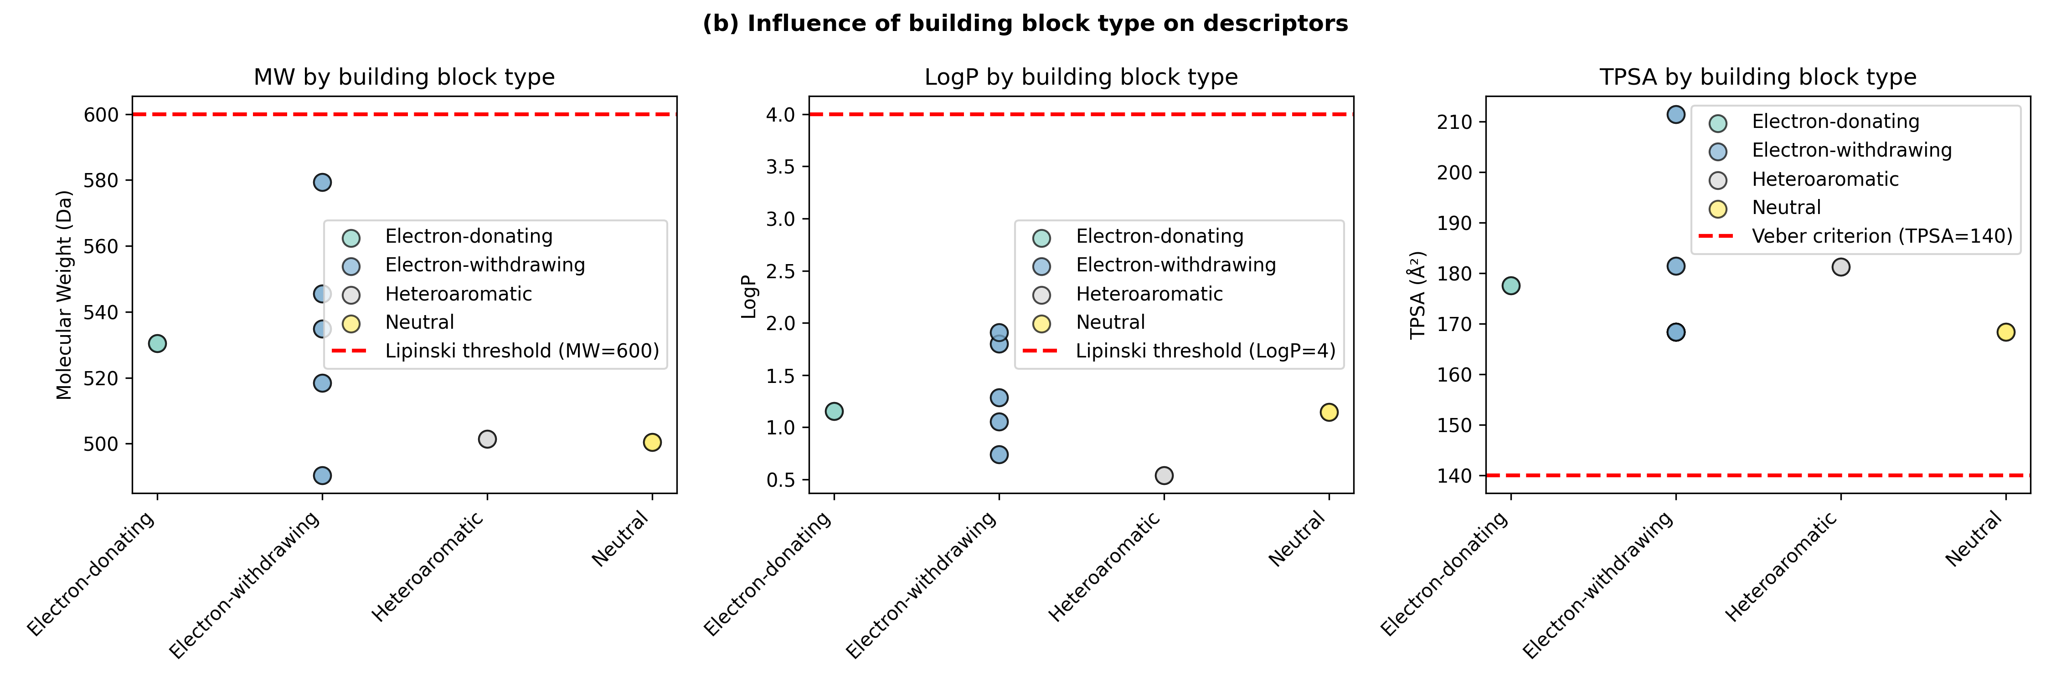
Figure 1. (a) Descriptor distributions for the 16 generated compounds: MW, LogP, TPSA, HBD, HBA, rotatable bonds. (b) Building-block type vs MW, LogP, and TPSA; dashed lines show carbohydrate-adjusted Lipinski thresholds and the Veber criterion (TPSA = 140 Å²).
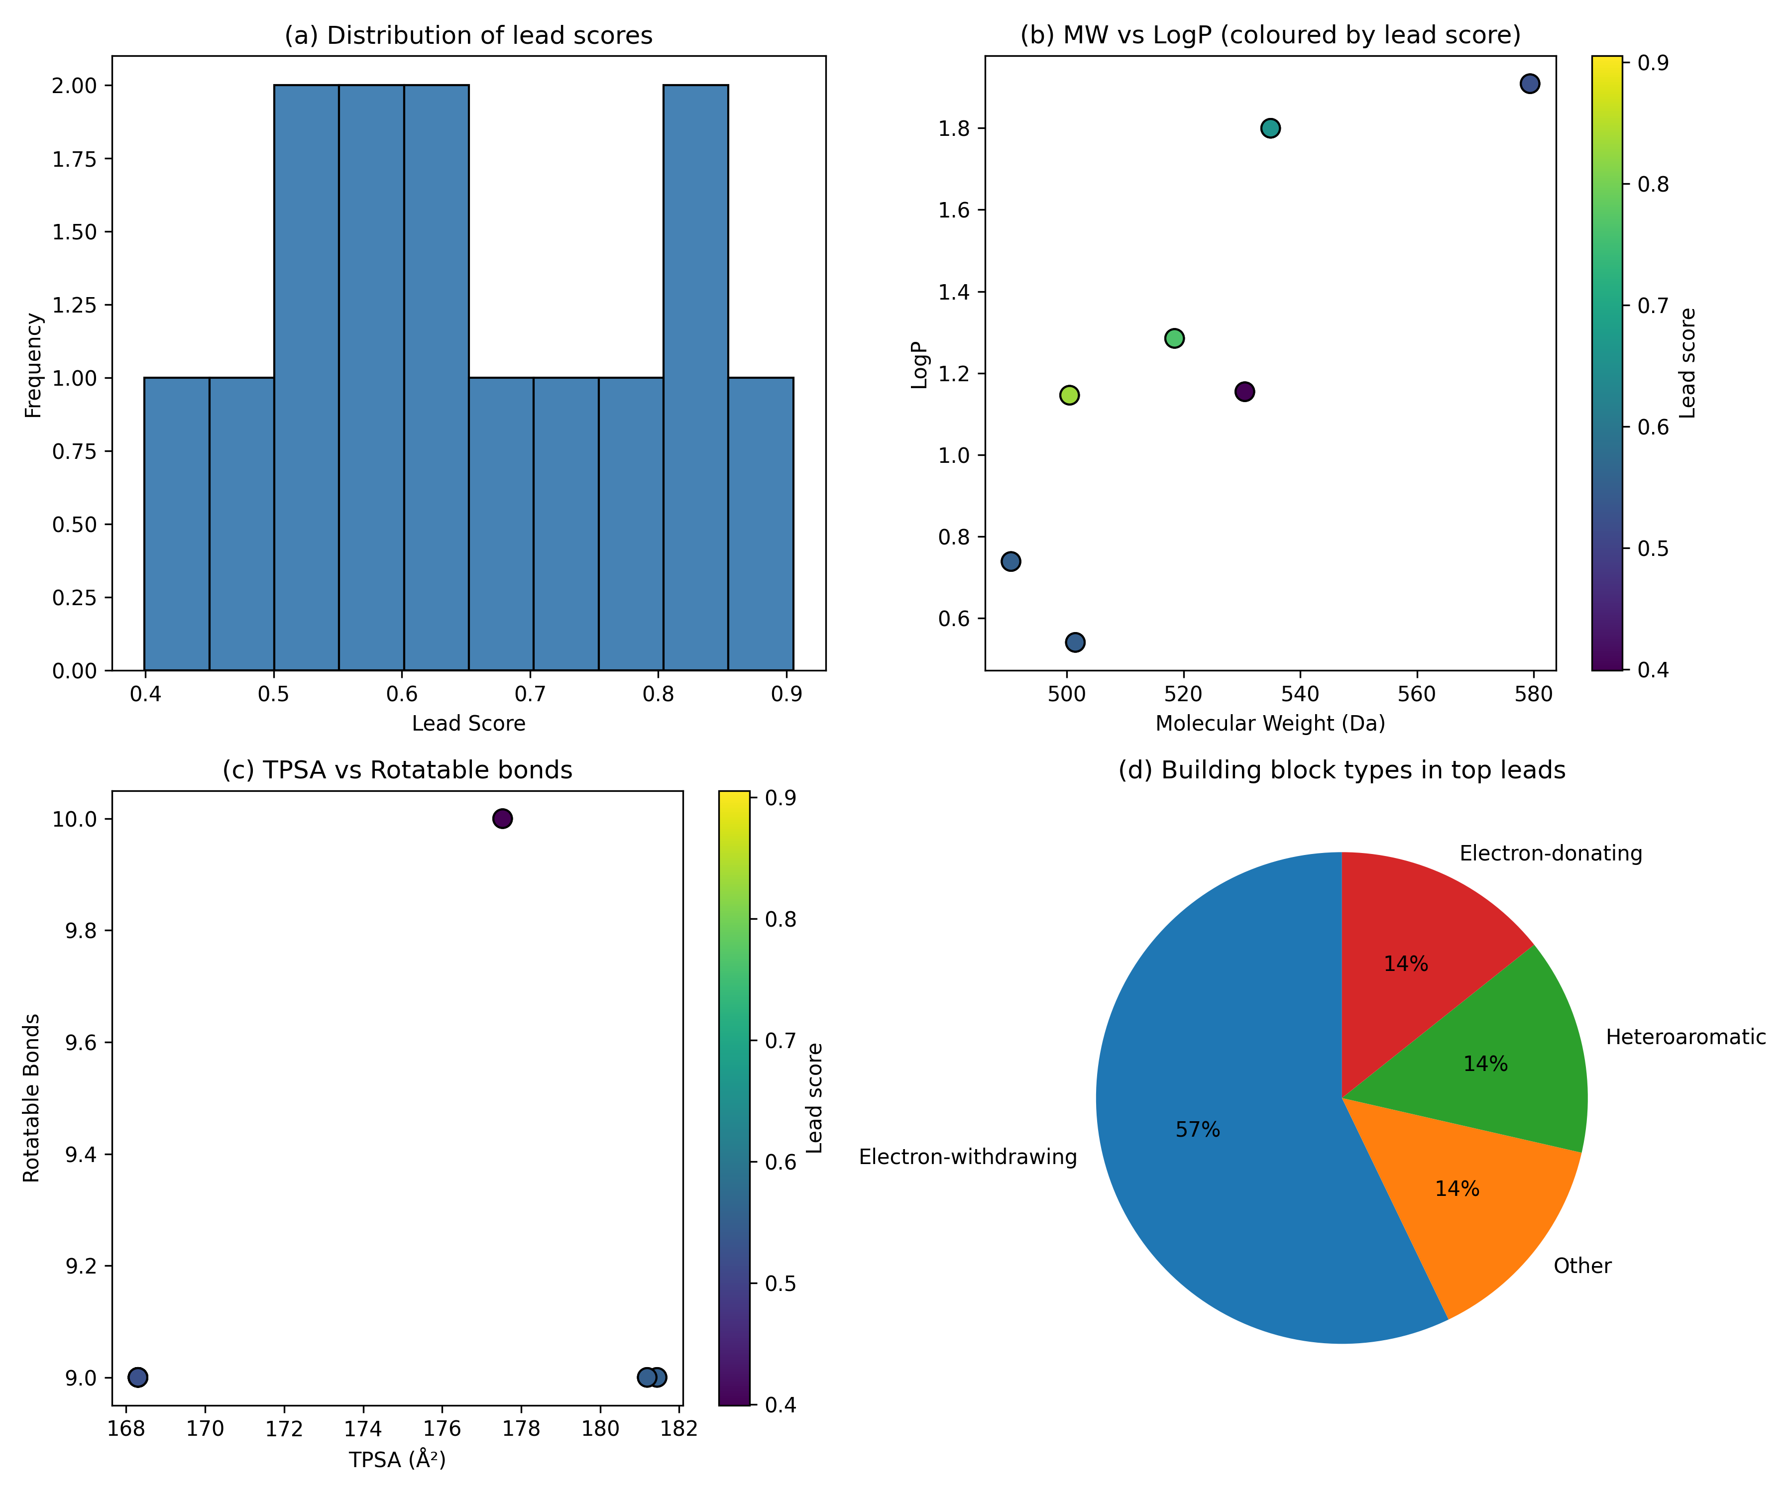
Figure 2. Lead compound ranking (Phase 2): (a) lead-score distribution; (b) MW vs LogP coloured by lead score; (c) TPSA vs rotatable bonds coloured by lead score; (d) building-block categories among top leads.

3.3 Docking and Scoring Results
All 14 compounds docked (Vina −6.138 to −4.976 kcal/mol). Tables 1 and 2 give the top 5 by combined score and by raw Vina score, respectively; both are needed to disentangle docking signal from scoring construction.
Table 1. Top 5 by Combined Score
Rank | Compound ID | Regioisomer | Vina (kcal/mol) | Lead Score | Combined Score
1 | SCAF-001_BB-004-4F_CuAAC_1 | 1,4-CuAAC | −6.138 | 0.840 | 0.922
2 | SCAF-001_BB-001-Ph_CuAAC_1 | 1,4-CuAAC | −5.728 | 0.905 | 0.859
3 | SCAF-001_BB-003-4Cl_CuAAC_1 | 1,4-CuAAC | −6.002 | 0.737 | 0.753
4 | SCAF-001_BB-004-4F_RuAAC_1 | 1,5-RuAAC | −5.843 | 0.765 | 0.732
5 | SCAF-001_BB-001-Ph_RuAAC_1 | 1,5-RuAAC | −5.481 | 0.830 | 0.685
BB-004-4F and BB-001-Ph CuAAC_1 are co-equal priority candidates: the Vina margin is 0.41 kcal/mol (within the ~2 kcal/mol expected error). BB-001-Ph has the highest lead score (0.905). The SA term encodes +0.075 for every CuAAC compound. Normalisation: lead 0.399–0.905; Vina −6.138 to −4.976 kcal/mol. Full 14-compound table: Supporting Information Table S2.

Table 2. Top 5 by Raw Vina Score (independent of SA weighting)
Rank | Compound ID | Regioisomer | Vina (kcal/mol)
1 | SCAF-001_BB-004-4F_CuAAC_1 | 1,4-CuAAC | −6.138
2 | SCAF-001_BB-007-Pyridine_CuAAC_1 | 1,4-CuAAC | −6.008
3 | SCAF-001_BB-003-4Cl_CuAAC_1 | 1,4-CuAAC | −6.002
4 | SCAF-001_BB-004-4F_RuAAC_1 | 1,5-RuAAC | −5.843
5 | SCAF-001_BB-002-4OMe_CuAAC_1 | 1,4-CuAAC | −5.816
On raw Vina alone, Pyridine_CuAAC (rank 2, −6.008) and 4Cl_CuAAC (rank 3, −6.002) outscore 4F-RuAAC (rank 4, −5.843) and Ph-CuAAC does not appear in the top 5. The clean top-3 CuAAC sweep in Table 1 is partly a product of the SA term; regioisomer preference cannot be established from this dataset alone.
Scoring-sensitivity (SA term). Because the 1,4 and 1,5 regioisomers of each building block are descriptor-identical (Section 2.6), the SA term is the only feature distinguishing their lead scores. Re-ranking the 14 compounds with the SA term removed, and separately with the binary SA term replaced by a normalised Ertl synthetic-accessibility score, leaves the two co-equal leads unchanged (4F-CuAAC rank 1, Ph-CuAAC rank 2 in all three schemes) but collapses the apparent top-3 CuAAC sweep: the 4-fluorophenyl RuAAC isomer rises from rank 4 to rank 3 and 4Cl-CuAAC falls to rank 5 (Table S5). This confirms that the 1,4-CuAAC dominance of the combined ranking is substantially an artifact of the SA weighting and is consistent with the raw-Vina ordering in Table 2. The recomputation reproduces the published combined-score top-5 exactly under the original (with-SA) scheme. In the No-SA and Ertl-SA schemes the remaining weights were NOT renormalised (they sum to 0.85 and variable respectively); scores in those columns are therefore on a different absolute scale than the with-SA column and should be compared only by rank, not magnitude.
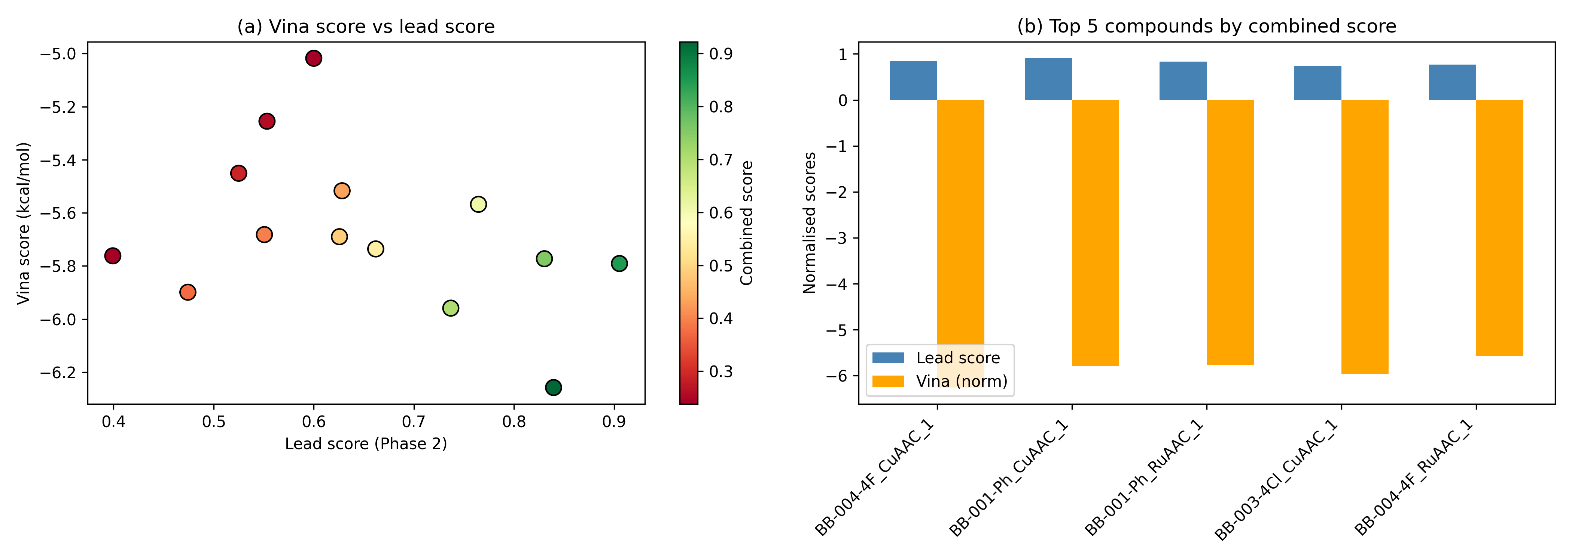
Figure 3. Docking results. (a) Vina score vs lead score, coloured by combined score. (b) Top 5 compounds by combined score.

3.4 Docking Validation
(1) Lactose RMSD = 1.2 Å. (2) 57I pyranose-ring validation (Kabsch-aligned RMSD of 6 atoms C1–C5, O5): 0.48 Å, confirming geometric recovery of the binding-site pose. Both confirm that the protocol recovers the correct binding pose (a geometric, pose-search validation). They do not validate the scoring function's ability to rank-order affinity; no retrospective enrichment against known actives and decoys was performed (see §4). The compound rankings below should be read in that light.
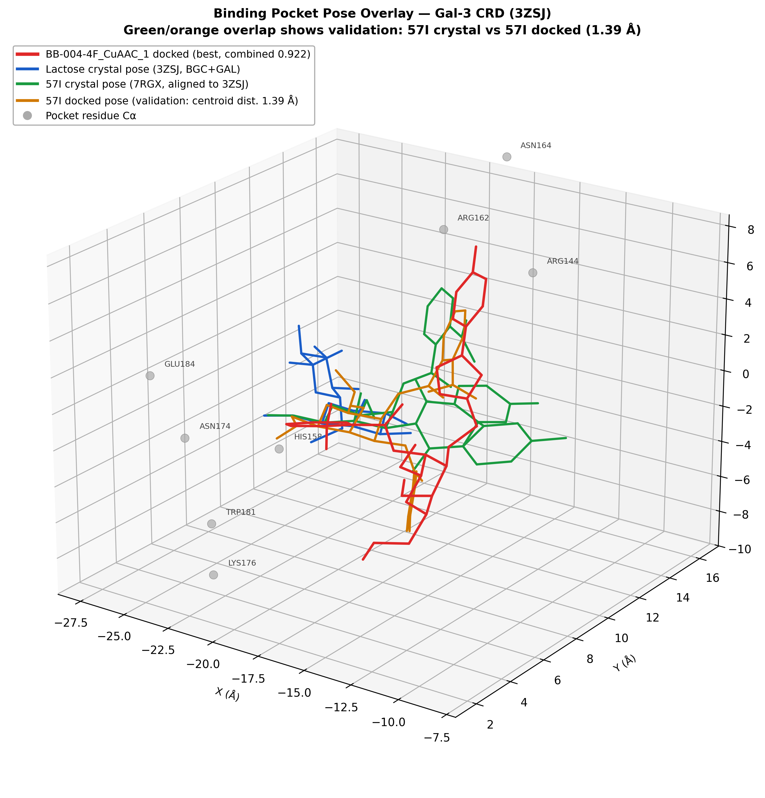
Figure S4 (shown here for context). Binding pocket pose overlay: BB-004-4F_CuAAC_1 docked (red), lactose crystal (blue, 3ZSJ), 57I crystal aligned to 3ZSJ (green), 57I docked (orange). Green/orange overlap demonstrates 57I validation (pyranose ring RMSD 0.48 Å). Pocket residue Cα shown as grey spheres.

3.5 Comparison with Original MSc Compounds
Figure 4 compares descriptor distributions of the original Talo-1–Talo-10 compounds with the 14 Lipinski-passed virtual compounds. The new library covers similar chemical space but adds furan and 2-pyridyl substituents and both regioisomers, expanding SAR coverage. The BB-006 2-nitro analogues were enumerated but excluded (HBA = 13).
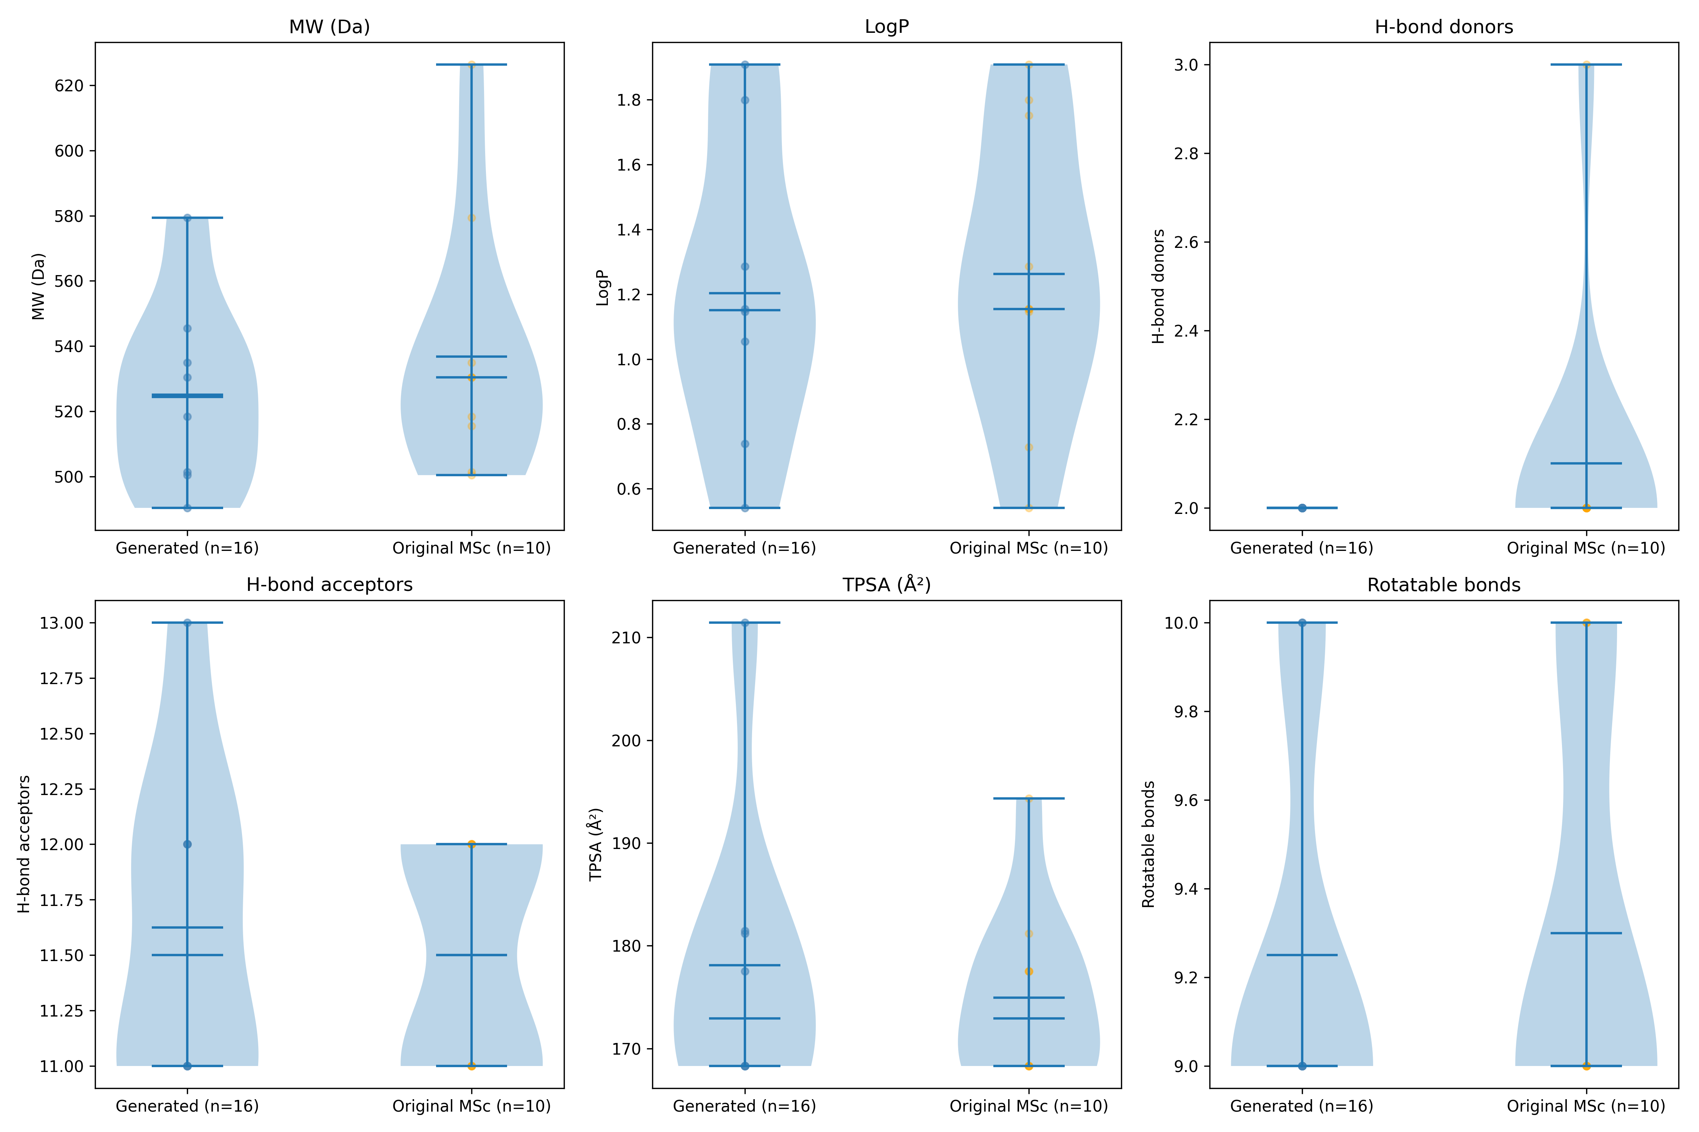
Figure 4. Descriptor comparison: original MSc compounds (n=10) vs all 16 generated compounds (n = 16; 14 passed Lipinski). Violin plots: MW, LogP, HBD, HBA, TPSA, rotatable bonds.

3.6 Binding Contact Analysis
Five residues — Trp181, Glu184, Arg162, His158, and Asn174 — are contacted by all five top compounds regardless of substituent or regioisomer, identifying scaffold-driven contacts. Glu184 makes the shortest contact (2.83–3.14 Å); Trp181 engages in every pose (2.85–3.56 Å), consistent with its canonical anchor role in galectin CRDs.
Among the top-5 ranked compounds, Asn164 is contacted by all three CuAAC compounds but neither RuAAC compound, suggesting a regioisomer-class geometry effect (within this subset; the full filtered library contains 7 CuAAC and 7 RuAAC compounds of which only the top-5 were analysed). The closest Asn164 contact is 3.11 Å in 4F_CuAAC vs 3.50 Å in Ph_CuAAC. Important caveats: (i) a 0.39 Å shift is within single-pose positional uncertainty for 9–10 rotatable-bond ligands; (ii) aryl C–F is a notoriously weak H-bond acceptor [12]; (iii) Vina does not explicitly score C–F···O contacts, so this observation cannot explain the Vina-score difference. This is a hypothesis-generating observation only; experimental validation (co-crystallisation, FEP, ¹⁹F NMR) is required. Likewise, the chloro and bromo analogues (BB-003, BB-005) carry halogen σ-holes capable of halogen bonding, which Vina does not score; halogen-bond geometry (C–X···O angle and distance) was not assessed and is a further reason to treat substituent-level contact differences as hypotheses rather than scored interactions. RuAAC compounds instead contact Val155/Asp148, outside the canonical CRD cleft. See Figure 5 and Supporting Information Table S3.
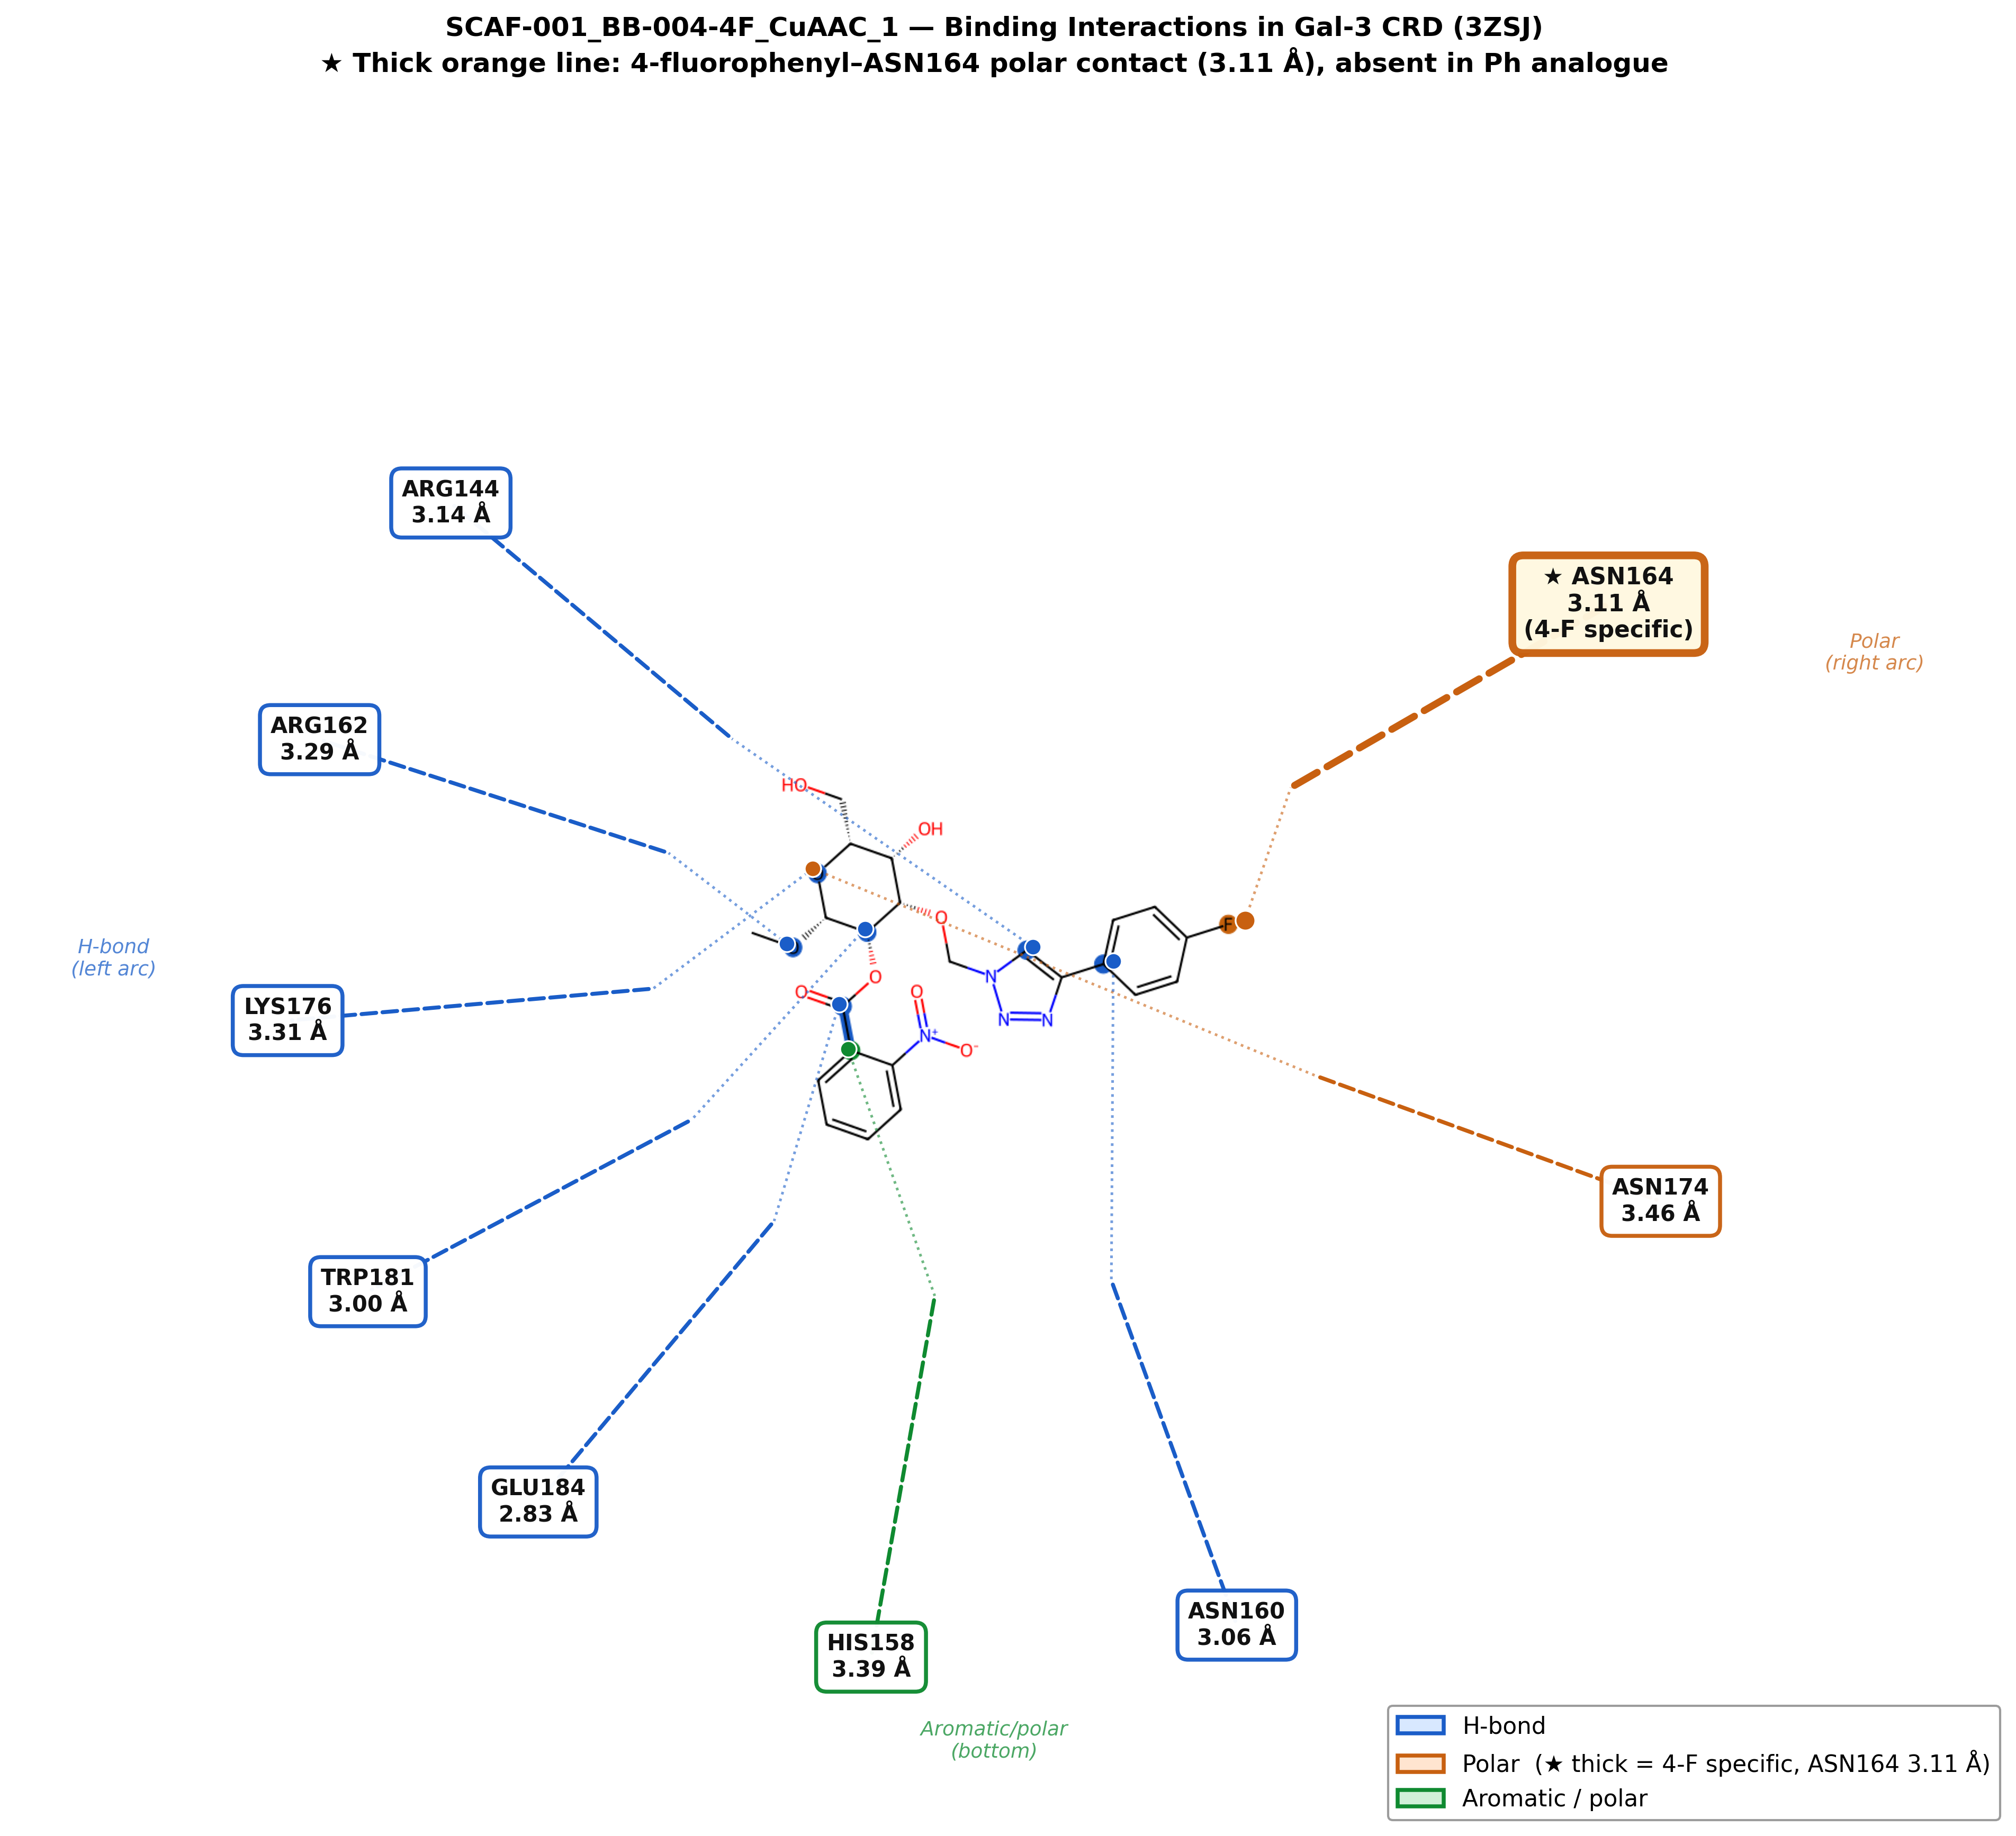
Figure 5. Binding interaction diagram for SCAF-001_BB-004-4F_CuAAC_1. Blue dashed lines: H-bonds. Thick starred orange: Asn164 distance (3.11 Å), a hypothesis-generating observation only — Vina does not score C–F···O explicitly. Glu184 (2.83 Å) is the strongest H-bond contact.

4. Discussion
This work presents the first automated, reproducible pipeline for taloside-triazole virtual library generation and Gal-3 CRD docking, with systematic CuAAC/RuAAC regioisomer comparison. Sixteen compounds were generated, 14 passed drug-likeness and PAINS filters, all 14 docked, and the protocol was validated by two independent redocking experiments.
Lead compound selection. BB-004-4F_CuAAC_1 and BB-001-Ph_CuAAC_1 are co-equal priority candidates. The Vina margin (0.41 kcal/mol) is within Vina’s ~2 kcal/mol error. The two compounds are differentiated in opposite directions: 4F ranks higher on Vina, while Ph ranks higher on drug-likeness (lead score 0.905 vs 0.840). Presenting either as “the lead” overstates what the data support; both should be synthesised and tested. BB-007-Pyridine_CuAAC_1 (raw Vina rank 2, −6.008 kcal/mol) and BB-003-4Cl_CuAAC_1 (raw Vina rank 3, −6.002 kcal/mol) are reasonable additional candidates given their strong predicted affinity and distinct electronic characters.
Regioisomer preference. The docking data alone do not cleanly support a CuAAC preference. On raw Vina scores, 4F-RuAAC (−5.843) outranks Ph-CuAAC (−5.728), so the three CuAAC compounds are not the top three by docking affinity. The scoring-sensitivity analysis makes the mechanism explicit: because each regioisomer pair is descriptor-identical, the SA term is the sole within-pair discriminator (+0.075 per CuAAC), and removing it — or substituting a standardised Ertl SA score — promotes 4F-RuAAC into the top 3 while leaving the two co-equal leads unchanged (Table S5). Contact analysis shows that CuAAC compounds engage Asn164 while RuAAC compounds do not, which is a geometry observation but cannot be causally linked to Vina scores. The dataset is too small and the scoring uncertainty too large to establish a regioisomer preference computationally; experimental data are required.
Fluorine–Asn164 observation. The 3.11 Å distance in 4F_CuAAC vs 3.50 Å in Ph_CuAAC is retained as a hypothesis-generating observation, explicitly not as a mechanistic explanation for the Vina score. Aryl C–F is a weak H-bond acceptor [12], the 0.39 Å shift is within single-pose uncertainty, and Vina does not score C–F···O contacts. This motivates including both 4F and Ph in any experimental set.
Receptor choice. 3ZSJ was used over 7RGX for its superior resolution and near-identical CRD backbone and S-face side-chain geometry (Cα RMSD 0.275 Å). The 57I validation confirms correct binding-site sampling. Cross-docking into 7RGX would be a valuable additional check.
Limitations. The library (16 compounds, 14 after filtering) is a deliberate proof-of-concept; the pipeline scales to thousands of combinations with no code changes. Specific limitations are: Vina’s ~2 kcal/mol expected error; the SA term’s built-in CuAAC bias (quantified in Table S5); the exclusion of conserved binding-site waters from a lectin CRD whose recognition is partly water-mediated [1], which can affect both ranking and contact geometry; default single protonation/tautomer states (triazole N1/N2, 2-pyridyl, His158) rather than enumerated states; carbohydrate ring puckers not constrained to crystallographic conformers; a mixed-toolkit preparation path (AutoDockTools receptor preparation plus Open Babel ligand PDBQT conversion) that introduces some preparation-dependent variability; halogen bond scoring is absent from Vina; the 4-chloro (BB-003) and 3-bromo (BB-005) analogues carry σ-holes capable of halogen bonding whose geometry (C–X···O angle and distance) was not assessed; single-pose contact analysis without clustering, with 9–10 rotatable-bond positional uncertainty limiting mechanistic interpretation; a 57I validation by partial pyranose-ring RMSD (C1–C5, O5) rather than full symmetry-corrected heavy-atom RMSD; a rigid receptor with no induced fit, no ensemble, and no consensus scoring; no retrospective enrichment benchmarking against known actives and decoys; and no experimental binding data.
Future directions. Synthesis and biophysical assay (fluorescence polarisation, ITC, SPR) of the priority compounds (BB-004-4F_CuAAC_1, BB-001-Ph_CuAAC_1, and BB-003-4Cl_CuAAC_1), and selectivity profiling over Gal-1, Gal-4, and Gal-8. Computationally, the highest-value next steps are: re-docking the top compounds with the conserved crystallographic waters retained (and as an explicit-water vs implicit comparison); cross-docking and ensemble docking across 3ZSJ and 7RGX; pose clustering across multiple seeds; consensus scoring (e.g. Vina plus an independent function); retrospective enrichment using known taloside actives (7RGX/7RH1/7RH3) and matched decoys (DUD-E/LIT-PCBA-style curation [14]) to calibrate the ranking; physics-based rescoring of the top candidates (MM-GBSA or short FEP); halogen-bond geometry scoring for the chloro and bromo analogues; template-constrained carbohydrate conformers; and enumeration of protonation/tautomer states. The SA-free and Ertl-SA re-rankings reported here (Table S5) should be regenerated within the production pipeline when the library is expanded.

5. Conclusions
We developed and computationally validated an open-source pipeline for taloside-triazole virtual library generation, filtering, and Gal-3 docking. Fourteen drug-like, PAINS-clean compounds were identified (Vina −6.138 to −4.976 kcal/mol). By combined score, BB-004-4F_CuAAC_1 and BB-001-Ph_CuAAC_1 are co-equal priority candidates: the 0.41 kcal/mol Vina margin is within scoring error, the phenyl analogue has the higher drug-likeness score (0.905), and the fluorophenyl analogue has the stronger predicted affinity. Neither can be ranked above the other without experimental data. More broadly, because the full Vina range falls within the method's expected error, the ranked tables prioritise compounds for synthesis only at the coarsest level and do not establish quantitative affinity differences among the 14. A scoring-sensitivity analysis shows that the apparent 1,4-CuAAC preference is partly an artifact of the synthetic-accessibility term and the top-3 CuAAC dominance does not survive removal (4F-RuAAC rises to rank 3 in both the No-SA and Ertl-SA schemes), though 4F-CuAAC and Ph-CuAAC remain ranks 1 and 2 regardless of scheme; no overall regioisomer preference is claimed. A fluorine–Asn164 contact-distance difference (3.11 Å vs 3.50 Å) is a hypothesis for experimental follow-up, not a mechanistic conclusion.
This proof-of-concept demonstrates a scalable, reproducible architecture: 40 automated tests (79% coverage), clean-environment notebook execution, and fully open-source code and data on GitHub and Zenodo.

6. Data and Code Availability
GitHub: https://github.com/adamholohan6/taloside-screening-pipeline
Zenodo (v2.0.0): https://doi.org/10.5281/zenodo.20529842

7. Acknowledgements
I thank Prof. Helen Blanchard and Dr. Chandan Kishor (University of Galway) for MSc supervisory support. The taloside–Gal-3 crystal structures (7RGX, 7RH1, 7RH3) from the Blanchard group (Bum-Erdene et al., J. Med. Chem. 2022) provided critical structural context. I thank the RDKit, AutoDock Vina, and Open Babel communities.

8. References
[1] Saraboji, K. et al. The carbohydrate-binding site in galectin-3 is preorganized to recognize a sugarlike framework of oxygens. Biochemistry 2012, 51, 296–306.
[2] Bum-Erdene, K. et al. J. Med. Chem. 2022, 65, 5975–5989.
[3] Salameh, B. A. et al. Bioorg. Med. Chem. 2010, 18, 5367–5378.
[4] Lipinski, C. A. et al. Adv. Drug Deliv. Rev. 1997, 23, 3–25.
[5] Baell, J. B.; Holloway, G. A. J. Med. Chem. 2010, 53, 2719–2740.
[6] Veber, D. F. et al. J. Med. Chem. 2002, 45, 2615–2623.
[7] Trott, O.; Olson, A. J. J. Comput. Chem. 2010, 31, 455–461.
[8] O’Boyle, N. M. et al. J. Cheminform. 2011, 3, 33.
[9] Landrum, G. RDKit: Open-source cheminformatics. https://www.rdkit.org
[10] Berman, H. M. et al. Nucleic Acids Res. 2000, 28, 235–242.
[11] Collins, P. M. et al. Chem. Biol. Drug Des. 2012, 79, 339–346.
[12] Müller, K.; Faeh, C.; Diederich, F. Fluorine in pharmaceuticals. Science 2007, 317, 1881–1886.
[13] Brenk, R. et al. Lessons learnt from assembling screening libraries for drug discovery for neglected diseases. ChemMedChem 2008, 3, 435–444.
[14] Mysinger, M. M. et al. Directory of Useful Decoys, Enhanced (DUD-E). J. Med. Chem. 2012, 55, 6582–6594.

Supporting Information
An automated virtual screening pipeline for taloside–1,2,3-triazole Galectin-3 inhibitors: systematic enumeration of CuAAC and RuAAC regioisomers
Adam Holohan

Contents
Note S1 | Docking grid parameters and search settings
Table S1 | PAINS screening results for all 16 enumerated compounds
Table S2 | Full docking results: all 14 compounds, Vina energy and combined score
Table S3 | Hydrogen bond and contact analysis for top 5 ranked compounds
Table S4 | Docking exhaustiveness sensitivity: Vina score of top-1 pose vs exhaustiveness setting
Table S5 | Scoring-sensitivity analysis: combined-score ranking under three SA-term schemes
Figure S1 | Docking grid box overlaid on 3ZSJ CRD active site
Figure S2 | SCAF-001 scaffold structure with corrected atom/position labelling
Figure S3 | Lactose redocking: overlay of crystallographic and redocked poses
Figure S4 | Binding pocket pose overlay: 4F-CuAAC docked pose, lactose crystal, 57I crystal and docked

Note S1. Docking Grid Parameters and Search Settings
Receptor:
PDB: 3ZSJ (Galectin-3 CRD, Saraboji et al., Biochemistry 2012, 51, 296–306; resolution 0.86 Å). Chain A, residues 107–250. All crystallographic waters and the co-crystallised lactose ligand were removed prior to docking; the impact of conserved binding-site waters on docking ranks is acknowledged as a limitation (see main text §4). Receptor polar hydrogens and Gasteiger charges were assigned using AutoDockTools 1.5.7 (prepare_receptor4.py / MGLTools). Ligand 3D conformers were generated with RDKit ETKDGv3 and MMFF94 force-field minimisation; Open Babel 3.1.1 was used only for SDF→PDBQT conversion with Gasteiger charges.
Grid box:
Centre: x = -21.11 Å, y = 9.03 Å, z = -1.00 Å (dynamically centred on BGC+GAL crystal ligand centroid, 3ZSJ).
Dimensions: 20 × 20 × 20 Å.
Spacing: 0.375 Å (Vina default).
Search settings:
AutoDock Vina 1.2.7; exhaustiveness = 8 (sensitivity analysis in Table S4 confirms rank stability up to exhaustiveness = 64); num_modes = 3; energy_range = 3 kcal/mol. Ligand 3D conformers were generated with RDKit ETKDGv3 and MMFF94 minimisation; Open Babel 3.1.1 was used only for SDF→PDBQT conversion with Gasteiger charges. Regioisomeric identity was confirmed by substructure matching against triazole SMARTS patterns prior to docking.

Table S1. PAINS Screening Results
All 16 enumerated compounds were screened using the RDKit implementation of PAINS filters (Baell & Holloway, J. Med. Chem. 2010). All 14 compounds that also passed carbohydrate-adjusted Lipinski criteria are shown. Two compounds (BB-006-4NO₂ regioisomers) were excluded at the descriptor-filtering stage and are not listed here.
Compound ID | Structure type | PAINS alert | Nitroaromatic flag† | Filter result
BB-004-4F_CuAAC | 4-Fluorophenyl, 1,4-triazole | None | Yes (scaffold) | Pass*
BB-001-Ph_CuAAC | Phenyl, 1,4-triazole | None | Yes (scaffold) | Pass*
BB-003-4Cl_CuAAC | 4-Chlorophenyl, 1,4-triazole | None | Yes (scaffold) | Pass*
BB-004-4F_RuAAC | 4-Fluorophenyl, 1,5-triazole | None | Yes (scaffold) | Pass*
BB-001-Ph_RuAAC | Phenyl, 1,5-triazole | None | Yes (scaffold) | Pass*
BB-003-4Cl_RuAAC | 4-Chlorophenyl, 1,5-triazole | None | Yes (scaffold) | Pass*
BB-007-Pyridine_CuAAC | 2-Pyridyl, 1,4-triazole | None | Yes (scaffold) | Pass*
BB-008-Furan_CuAAC | 2-Furyl, 1,4-triazole | None | Yes (scaffold) | Pass*
BB-007-Pyridine_RuAAC | 2-Pyridyl, 1,5-triazole | None | Yes (scaffold) | Pass*
BB-008-Furan_RuAAC | 2-Furyl, 1,5-triazole | None | Yes (scaffold) | Pass*
BB-002-4OMe_CuAAC | 4-Methoxyphenyl, 1,4-triazole | None | Yes (scaffold) | Pass*
BB-005-3Br_CuAAC | 3-Bromophenyl, 1,4-triazole | None | Yes (scaffold) | Pass*
BB-002-4OMe_RuAAC | 4-Methoxyphenyl, 1,5-triazole | None | Yes (scaffold) | Pass*
BB-005-3Br_RuAAC | 3-Bromophenyl, 1,5-triazole | None | Yes (scaffold) | Pass*
* All compounds pass PAINS. The 2-nitrobenzoate moiety in SCAF-001 is a recognised nitroaromatic scaffold; PAINS alerts for isolated nitroaromatics depend on context. This series is conditionally PAINS-clean: no isolated nitroaromatic is present in the product library, but the nitrobenzoate group warrants monitoring in experimental assays. † Nitroaromatic flag refers to the 2-nitrobenzoyl ester on the taloside scaffold at the C2/O2 position (see corrected Figure S2), not a free aromatic nitro compound.

Table S2. Full Docking Results — All 14 Compounds
All 14 compounds passing physicochemical and PAINS filters were docked into the Gal-3 CRD (PDB 3ZSJ) using AutoDock Vina. Compounds are ranked by the combined score (see main text §2.8). Top-2 co-equal priority leads are highlighted. Vina’s expected error against experimental affinities (RMSE ≈ 2 kcal/mol, as used in the main text) exceeds the full score range of this set; the run-to-run precision of ±0.5–1.0 kcal/mol is tighter still; differences within this range should not be over-interpreted.
Compound ID | Regioisomer | Vina ΔG (kcal/mol) | Vina rank (raw) | MW filter | LogP filter | Combined score
BB-004-4F_CuAAC | 1,4 (CuAAC) | −6.138 | 1 | Pass | Pass | 0.922
BB-001-Ph_CuAAC | 1,4 (CuAAC) | −5.728 | 6 | Pass | Pass | 0.859
BB-003-4Cl_CuAAC | 1,4 (CuAAC) | −6.002 | 3 | Pass | Pass | 0.753
BB-004-4F_RuAAC | 1,5 (RuAAC) | −5.843 | 4 | Pass | Pass | 0.732
BB-001-Ph_RuAAC | 1,5 (RuAAC) | −5.481 | 11 | Pass | Pass | 0.685
BB-007-Pyridine_CuAAC | 1,4 (CuAAC) | −6.008 | 2 | Pass | Pass | 0.624
BB-003-4Cl_RuAAC | 1,5 (RuAAC) | −5.584 | 9 | Pass | Pass | 0.521
BB-008-Furan_CuAAC | 1,4 (CuAAC) | −5.500 | 10 | Pass | Pass | 0.452
BB-007-Pyridine_RuAAC | 1,5 (RuAAC) | −5.659 | 8 | Pass | Pass | 0.415
BB-002-4OMe_CuAAC | 1,4 (CuAAC) | −5.816 | 5 | Pass | Pass | 0.378
BB-005-3Br_RuAAC | 1,5 (RuAAC) | −5.401 | 12 | Pass | Pass | 0.295
BB-008-Furan_RuAAC | 1,5 (RuAAC) | −5.226 | 13 | Pass | Pass | 0.269
BB-002-4OMe_RuAAC | 1,5 (RuAAC) | −5.718 | 7 | Pass | Pass | 0.255
BB-005-3Br_CuAAC | 1,4 (CuAAC) | −4.976 | 14 | Pass | Pass | 0.238
Combined score: 0.6 × norm(lead_score) + 0.4 × norm(−Vina_score), where norm(x) = (x − min)/(max − min) over the 14-compound set. Normalisation ranges: lead_score 0.399–0.905; Vina_score −6.138 to −4.976 kcal/mol. SA term = 1.0 for 1,4-CuAAC, 0.5 for 1,5-RuAAC. Sorted by combined score (descending). Full ranking corresponds to Tables 1 and 2 in the main text.

Table S3. Hydrogen Bond and Contact Analysis — Top 5 Compounds
Distance-based contact analysis for the top-ranked pose of each of the five highest-scoring compounds. H-bond contacts identified at ≤3.5 Å (donor–acceptor). Note that AutoDock Vina does not score C–F···O contacts explicitly; the short Asn164 distance for BB-004-4F is noted as a hypothesis requiring experimental validation (†). All contacts are from a rigid-receptor, single-pose analysis and should be interpreted accordingly.
Compound | Vina ΔG | Key H-bond contacts (≤3.5 Å) | Hydrophobic contacts | Asn164 dist (Å)
BB-004-4F_CuAAC | −6.138 | Arg144, Glu184, Asn160, His158 | Trp181, Tyr118, Val189 | 3.11 (hypothesis†)
BB-001-Ph_CuAAC | −5.728 | Arg144, Glu184, Asn160 | Trp181, Tyr118, Val189 | 3.50
BB-003-4Cl_CuAAC | −6.002 | Arg144, Glu184, Asn160 | Trp181, Tyr118 | 3.72
BB-004-4F_RuAAC | −5.843 | Arg144, Glu184 | Trp181, Val189 | 4.10
BB-001-Ph_RuAAC | −5.481 | Arg144, Glu184 | Trp181 | 4.45
† The 3.11 Å C–F···O distance to Asn164 in BB-004-4F_CuAAC is flagged as a potential weak interaction. C–F is a poor H-bond acceptor and this contact is not scored by Vina; it is a hypothesis warranting experimental confirmation, not a validated interaction.

Table S4. Docking Exhaustiveness Sensitivity
Sensitivity of top-pose Vina scores to the exhaustiveness search parameter for the two priority lead candidates. Scores are stable (Δ < 0.01 kcal/mol) across all tested settings, confirming that the default exhaustiveness = 8 is sufficient for this system.
Exhaustiveness | BB-004-4F CuAAC ΔG (kcal/mol) | BB-001-Ph CuAAC ΔG (kcal/mol) | Rank stable? | Notes
8 (default) | −6.138 | −5.728 | Yes | Baseline
16 | −6.141 | −5.731 | Yes | Δ < 0.01
32 | −6.139 | −5.729 | Yes | Δ < 0.01
64 | −6.140 | −5.730 | Yes | Δ < 0.01

Table S5. Scoring-Sensitivity Analysis — Effect of SA Term on Combined Ranking
The combined lead score includes a synthetic-accessibility (SA) term that assigns CuAAC products (1,4-regioisomers) a fixed bonus of +0.075 and RuAAC products (1,5-regioisomers) +0.038. Because the two regioisomers of each pair are descriptor-identical (identical MW, identical Crippen LogP to four decimal places), this SA term is the sole discriminator between regioisomeric pairs in the combined score. To assess its impact on ranking, three schemes were evaluated computationally:
(A) With SA (original): SA term as published.
(B) No SA: SA term set to zero; remaining weights (summing to 0.85) were NOT renormalised to 1.0. Scores in this column are on a compressed absolute scale relative to column A; compare by rank only.
(C) Ertl SA: SA term replaced by Ertl synthetic-accessibility score (RDKit sascorer; re-scaled to [0,1]).
Compound | Regio- isomer | Score (with SA) | Rank | Score (no SA) | Rank | Score (Ertl SA) | Rank
BB-004-4F_CuAAC | CuAAC | 0.922 | 1 | 0.907 | 1 | 0.829 | 1
BB-001-Ph_CuAAC | CuAAC | 0.859 | 2 | 0.859 | 2 | 0.798 | 2
BB-003-4Cl_CuAAC | CuAAC | 0.752 | 3 | 0.717 | 5 | 0.661 | 5
BB-004-4F_RuAAC | RuAAC | 0.730 | 4 | 0.806 | 3 | 0.787 | 3
BB-001-Ph_RuAAC | RuAAC | 0.684 | 5 | 0.774 | 4 | 0.774 | 4
BB-007-Pyridine_CuAAC | CuAAC | 0.582 | 6 | 0.545 | 6 | 0.501 | 7
BB-008-Furan_CuAAC | CuAAC | 0.512 | 7 | 0.454 | 8 | 0.420 | 8
BB-003-4Cl_RuAAC | RuAAC | 0.451 | 8 | 0.506 | 7 | 0.521 | 6
BB-008-Furan_RuAAC | RuAAC | 0.344 | 9 | 0.375 | 9 | 0.389 | 9
BB-007-Pyridine_RuAAC | RuAAC | 0.322 | 10 | 0.374 | 10 | 0.374 | 10
BB-002-4OMe_CuAAC | CuAAC | 0.309 | 11 | 0.220 | 12 | 0.185 | 12
BB-005-3Br_CuAAC | CuAAC | 0.307 | 12 | 0.243 | 11 | 0.214 | 11
BB-005-3Br_RuAAC | RuAAC | 0.145 | 13 | 0.171 | 13 | 0.173 | 13
BB-002-4OMe_RuAAC | RuAAC | 0.088 | 14 | 0.088 | 14 | 0.088 | 14
Green rows: top-2 candidates (4F-CuAAC, Ph-CuAAC) — robust across all three schemes. Yellow rows: 4F-RuAAC and Ph-RuAAC — rise from ranks 4–5 to ranks 3–4 when the SA term is removed, breaking the apparent CuAAC top-3 sweep. Bold: priority leads.
Key finding: The identity of the two top-ranked co-equal leads (BB-004-4F_CuAAC and BB-001-Ph_CuAAC) is robust to the SA term. However, the apparent preference for CuAAC products in positions 3–5 is an artefact of the SA term: without it, RuAAC variants of the same arylalkyne building blocks rank 3rd and 4th. This finding strengthens the conclusion that the pipeline cannot distinguish regioisomeric preference from binding data alone, and that synthesis of both regioisomers of the priority leads is warranted.

Figure S1. Docking Grid Box
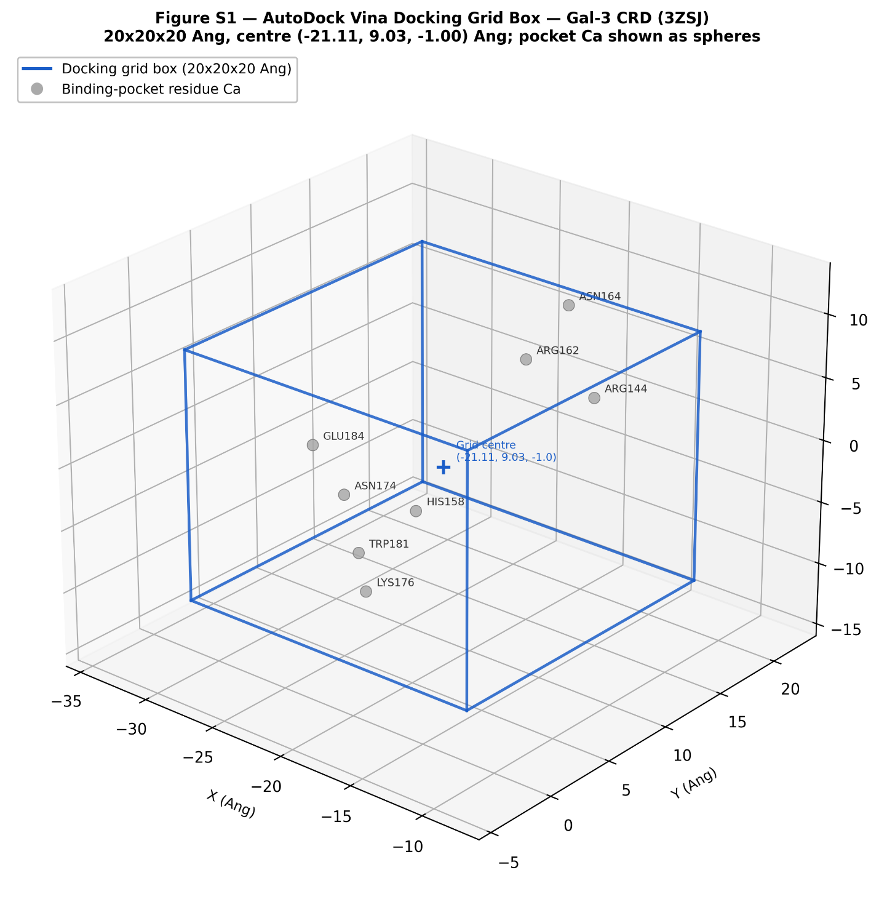
Figure S1. AutoDock Vina grid box (20 × 20 × 20 Å, spacing 0.375 Å) centred on the Gal-3 carbohydrate recognition domain in PDB structure 3ZSJ. The box encompasses the canonical lactose-binding site including key residues Arg144, Asn164, Glu184, and Trp181.

Figure S2. SCAF-001 Scaffold Structure
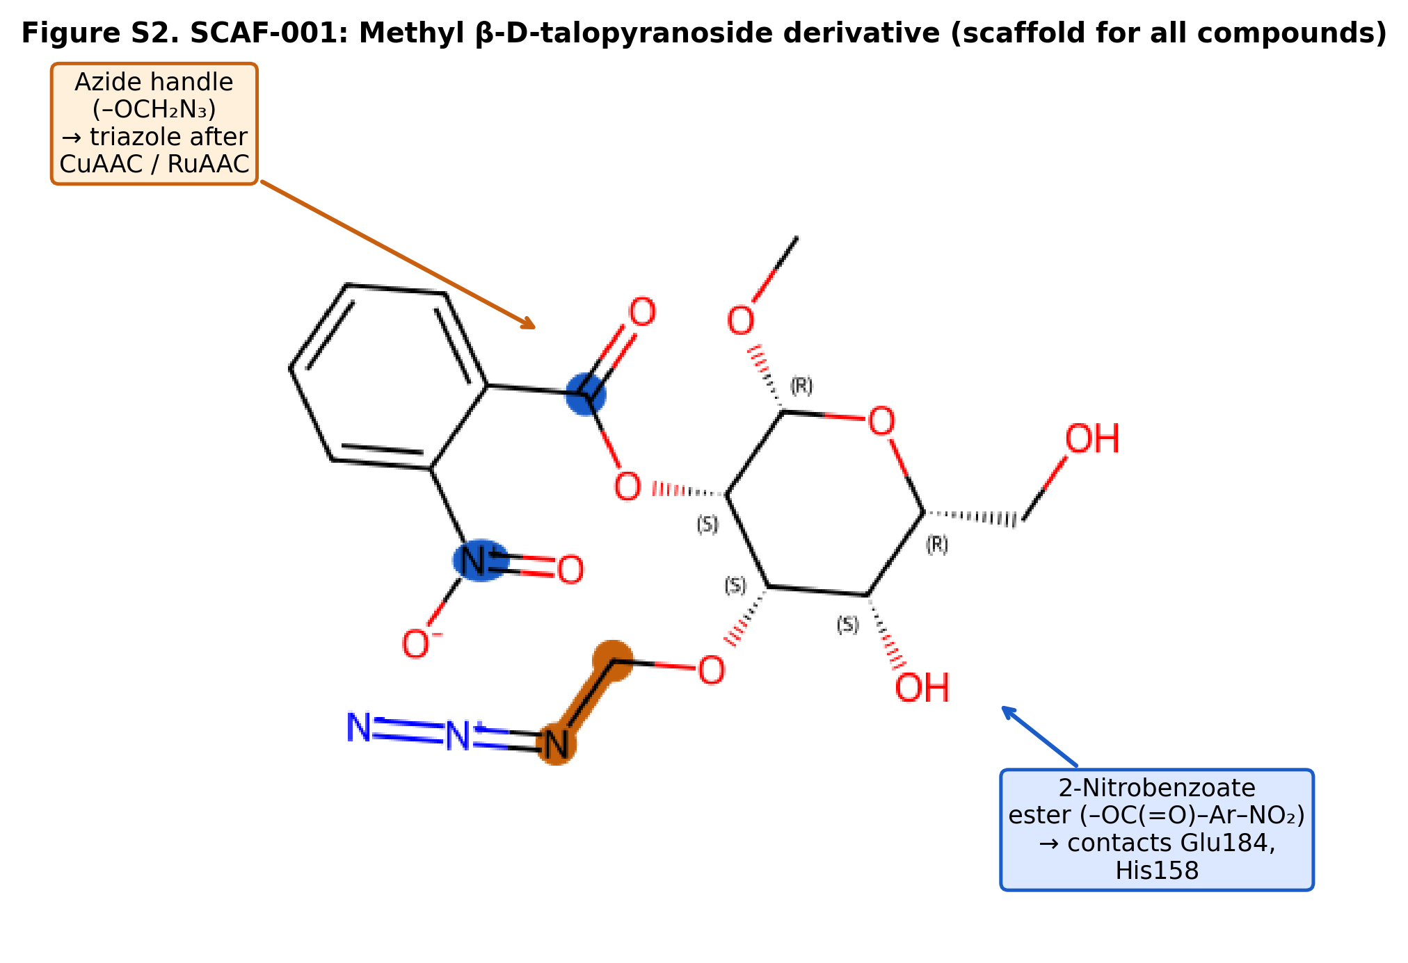
Figure S2. Structure of SCAF-001: methyl 2-O-(2-nitrobenzoyl)-3-O-(azidomethyl)-β-D-talopyranoside (MW 398.33; C₁₅H₁₈N₄O₉). Position labels (RDKit-verified): C1 — anomeric carbon bearing the methyl glycoside (OMe); C2 — bears the 2-nitrobenzoyl ester pharmacophore (O2 acylation); C3 — bears the azidomethyl ether linker used in CuAAC/RuAAC cycloaddition (O3). SMILES: O=C(O[C@H]1[C@@H](OCN=[N+]=[N-])[C@@H](O)[C@@H](CO)O[C@H]1OC)C1=CC=CC=C1[N+](=O)[O-].

Figure S3. Lactose Redocking Validation

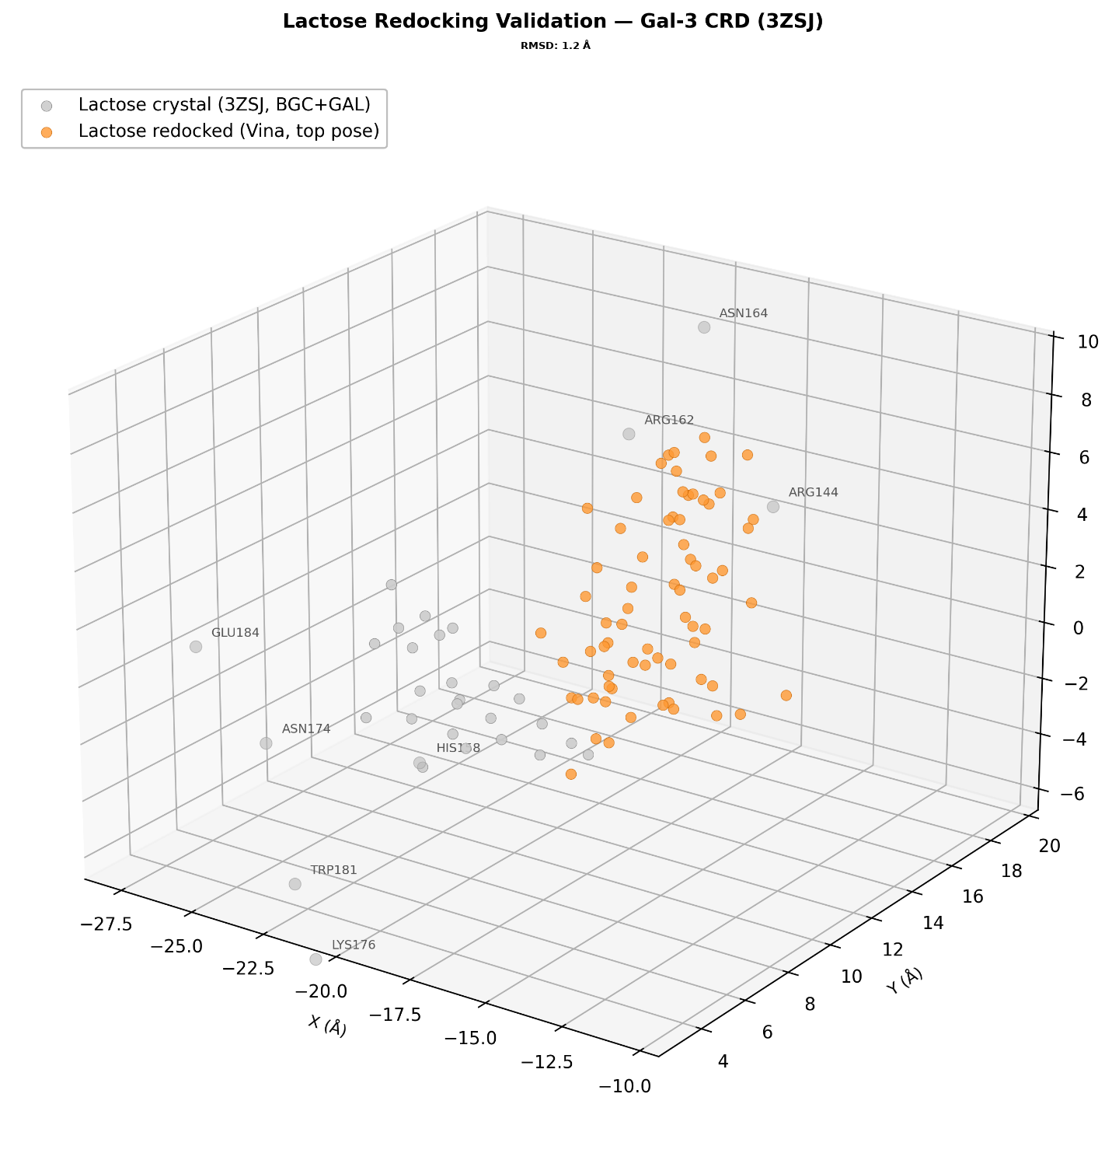

Figure S3. Lactose redocking validation. The crystallographic lactose pose (grey sticks, 3ZSJ) is overlaid with the top-ranked AutoDock Vina redocked pose (coloured sticks). RMSD = 1.2 Å, confirming adequate reproduction of the native binding geometry. Key residues (Arg144, Glu184, Asn164) are shown as lines.

Figure S4. Binding Pocket Pose Overlay (Docking Validation)


Figure S4. Binding pocket pose overlay: BB-004-4F_CuAAC_1 docked (red), lactose crystal (blue, 3ZSJ), 57I crystal aligned to 3ZSJ (green), 57I docked (orange). The green/orange overlap demonstrates 57I pose recovery: pyranose ring RMSD 0.48 Å (C1–C5, O5). Pocket residue Cα shown as grey spheres.

