Supporting Information
An automated virtual screening pipeline for taloside–1,2,3-triazole Galectin-3 inhibitors: systematic enumeration of CuAAC and RuAAC regioisomers
Adam Holohan

Contents
Note S1 | Docking grid parameters and search settings
Table S1 | PAINS screening results for all 16 enumerated compounds
Table S2 | Full docking results: all 14 compounds, Vina energy and combined score
Table S3 | Hydrogen bond and contact analysis for top 5 ranked compounds
Table S4 | Docking exhaustiveness sensitivity: RMSD of top-1 pose vs exhaustiveness setting
Table S5 | Scoring-sensitivity analysis: combined-score ranking under three SA-term schemes (NEW)
Figure S1 | Docking grid box overlaid on 3ZSJ CRD active site
Figure S2 | SCAF-001 scaffold structure with corrected atom/position labelling (REVISED)
Figure S3 | Lactose redocking: overlay of crystallographic and redocked poses

Note S1. Docking Grid Parameters and Search Settings
Receptor:
PDB: 3ZSJ (Galectin-3 CRD, Saraboji et al., Biochemistry 2012, 51, 296–306; resolution 0.86 Å). Chain A, residues 107–250. All crystallographic waters and the co-crystallised lactose ligand were removed prior to docking; the impact of conserved binding-site waters on docking ranks is acknowledged as a limitation (see main text §4). Receptor polar hydrogens and Gasteiger charges were assigned using AutoDockTools 1.5.7 (prepare_receptor4.py / MGLTools). Ligand 3D conformers were generated with RDKit ETKDGv3 and MMFF94 force-field minimisation; Open Babel 3.1.1 was used only for SDF→PDBQT conversion with Gasteiger charges.
Grid box:
Centre: x = -21.11 Å, y = 9.03 Å, z = -1.0 Å (dynamically centred on BGC+GAL crystal ligand centroid, 3ZSJ).
Dimensions: 20 × 20 × 20 Å.
Spacing: 0.375 Å (Vina default).
Search settings:
AutoDock Vina 1.2.7; exhaustiveness = 8 (sensitivity analysis in Table S4 confirms rank stability up to exhaustiveness = 64); num_modes = 3; energy_range = 3 kcal/mol. Each ligand was prepared with Open Babel 3.1.1 (3D embedding via MMFF94 minimisation; partial charges via Gasteiger method). Regioisomeric identity was confirmed by substructure matching against triazole SMARTS patterns prior to docking.

Table S1. PAINS Screening Results
All 16 enumerated compounds were screened using the RDKit implementation of PAINS filters (Baell & Holloway, J. Med. Chem. 2010). All 14 compounds that also passed carbohydrate-adjusted Lipinski criteria are shown. Two compounds (BB-006-4NO₂ regioisomers) were excluded at the descriptor-filtering stage and are not listed here.
Compound ID | Structure type | PAINS alert | Nitroaromatic flag† | Filter result
BB-004-4F_CuAAC | 4-Fluorophenyl, 1,4-triazole | None | Yes (scaffold) | Pass*
BB-001-Ph_CuAAC | Phenyl, 1,4-triazole | None | Yes (scaffold) | Pass*
BB-003-4Cl_CuAAC | 4-Chlorophenyl, 1,4-triazole | None | Yes (scaffold) | Pass*
BB-004-4F_RuAAC | 4-Fluorophenyl, 1,5-triazole | None | Yes (scaffold) | Pass*
BB-001-Ph_RuAAC | Phenyl, 1,5-triazole | None | Yes (scaffold) | Pass*
BB-003-4Cl_RuAAC | 4-Chlorophenyl, 1,5-triazole | None | Yes (scaffold) | Pass*
BB-007-Pyridine_CuAAC | 2-Pyridyl, 1,4-triazole | None | Yes (scaffold) | Pass*
BB-008-Furan_CuAAC | 2-Furyl, 1,4-triazole | None | Yes (scaffold) | Pass*
BB-007-Pyridine_RuAAC | 2-Pyridyl, 1,5-triazole | None | Yes (scaffold) | Pass*
BB-008-Furan_RuAAC | 2-Furyl, 1,5-triazole | None | Yes (scaffold) | Pass*
BB-002-4OMe_CuAAC | 4-Methoxyphenyl, 1,4-triazole | None | Yes (scaffold) | Pass*
BB-005-3Br_CuAAC | 3-Bromophenyl, 1,4-triazole | None | Yes (scaffold) | Pass*
BB-002-4OMe_RuAAC | 4-Methoxyphenyl, 1,5-triazole | None | Yes (scaffold) | Pass*
BB-005-3Br_RuAAC | 3-Bromophenyl, 1,5-triazole | None | Yes (scaffold) | Pass*
* All compounds pass PAINS. The 2-nitrobenzoate moiety in SCAF-001 is a recognised nitroaromatic scaffold; PAINS alerts for isolated nitroaromatics depend on context. This series is conditionally PAINS-clean: no isolated nitroaromatic is present in the product library, but the nitrobenzoate group warrants monitoring in experimental assays. † Nitroaromatic flag refers to the 2-nitrobenzoyl ester on the taloside scaffold at the C2/O2 position (see corrected Figure S2), not a free aromatic nitro compound.

Table S2. Full Docking Results — All 14 Compounds
All 14 compounds passing physicochemical and PAINS filters were docked into the Gal-3 CRD (PDB 3ZSJ) using AutoDock Vina. Compounds are ranked by the combined lead score (see main text §2.6). Top-2 co-equal priority leads are highlighted. Vina scores carry an estimated uncertainty of ±0.5–1.0 kcal/mol; differences within this range should not be over-interpreted.
Compound ID | Regioisomer | Vina ΔG (kcal/mol) | Vina rank (raw) | MW filter | LogP filter | Combined score
BB-004-4F_CuAAC | 1,4 (CuAAC) | −6.138 | 1 | Pass | Pass | 0.922
BB-001-Ph_CuAAC | 1,4 (CuAAC) | −5.728 | 6 | Pass | Pass | 0.859
BB-003-4Cl_CuAAC | 1,4 (CuAAC) | −6.002 | 3 | Pass | Pass | 0.753
BB-004-4F_RuAAC | 1,5 (RuAAC) | −5.843 | 4 | Pass | Pass | 0.732
BB-001-Ph_RuAAC | 1,5 (RuAAC) | −5.481 | 11 | Pass | Pass | 0.685
BB-007-Pyridine_CuAAC | 1,4 (CuAAC) | −6.008 | 2 | Pass | Pass | 0.624
BB-003-4Cl_RuAAC | 1,5 (RuAAC) | −5.584 | 9 | Pass | Pass | 0.521
BB-008-Furan_CuAAC | 1,4 (CuAAC) | −5.500 | 10 | Pass | Pass | 0.452
BB-007-Pyridine_RuAAC | 1,5 (RuAAC) | −5.659 | 8 | Pass | Pass | 0.415
BB-002-4OMe_CuAAC | 1,4 (CuAAC) | −5.816 | 5 | Pass | Pass | 0.378
BB-005-3Br_RuAAC | 1,5 (RuAAC) | −5.401 | 12 | Pass | Pass | 0.295
BB-008-Furan_RuAAC | 1,5 (RuAAC) | −5.226 | 13 | Pass | Pass | 0.269
BB-002-4OMe_RuAAC | 1,5 (RuAAC) | −5.718 | 7 | Pass | Pass | 0.255
BB-005-3Br_CuAAC | 1,4 (CuAAC) | −4.976 | 14 | Pass | Pass | 0.238
Combined score: 0.6 × norm(lead_score) + 0.4 × norm(−Vina_score), where norm(x) = (x − min)/(max − min) over the 14-compound set. Normalisation ranges: lead_score 0.399–0.905; Vina_score −6.138 to −4.976 kcal/mol. SA term = 1.0 for 1,4-CuAAC, 0.5 for 1,5-RuAAC. Sorted by combined score (descending). Full ranking corresponds to Tables 1 and 2 in the main text.

Table S3. Hydrogen Bond and Contact Analysis — Top 5 Compounds
Distance-based contact analysis for the top-ranked pose of each of the five highest-scoring compounds. H-bond contacts identified at ≤3.5 Å (donor–acceptor). Note that AutoDock Vina does not score C–F···O contacts explicitly; the short Asn164 distance for BB-004-4F is noted as a hypothesis requiring experimental validation (†). All contacts are from a rigid-receptor, single-pose analysis and should be interpreted accordingly.
Compound | Vina ΔG | Key H-bond contacts (≤3.5 Å) | Hydrophobic contacts | Asn164 dist (Å)
BB-004-4F_CuAAC | −6.138 | Arg144, Glu184, Asn160, His158 | Trp181, Tyr118, Val189 | 3.11 (hypothesis†)
BB-001-Ph_CuAAC | −5.728 | Arg144, Glu184, Asn160 | Trp181, Tyr118, Val189 | 3.50
BB-003-4Cl_CuAAC | −6.002 | Arg144, Glu184, Asn160 | Trp181, Tyr118 | 3.72
BB-004-4F_RuAAC | −5.843 | Arg144, Glu184 | Trp181, Val189 | 4.10
BB-001-Ph_RuAAC | −5.481 | Arg144, Glu184 | Trp181 | 4.45
† The 3.11 Å C–F···O distance to Asn164 in BB-004-4F_CuAAC is flagged as a potential weak interaction. C–F is a poor H-bond acceptor and this contact is not scored by Vina; it is a hypothesis warranting experimental confirmation, not a validated interaction.

Table S4. Docking Exhaustiveness Sensitivity
Sensitivity of top-pose Vina scores to the exhaustiveness search parameter for the two priority lead candidates. Scores are stable (Δ < 0.01 kcal/mol) across all tested settings, confirming that the default exhaustiveness = 8 is sufficient for this system.
Exhaustiveness | BB-004-4F CuAAC ΔG (kcal/mol) | BB-001-Ph CuAAC ΔG (kcal/mol) | Rank stable? | Notes
8 (default) | −6.138 | −5.728 | Yes | Baseline
16 | −6.141 | −5.731 | Yes | Δ < 0.01
32 | −6.139 | −5.729 | Yes | Δ < 0.01
64 | −6.140 | −5.730 | Yes | Δ < 0.01

Table S5. Scoring-Sensitivity Analysis — Effect of SA Term on Combined Ranking (NEW)
The combined lead score includes a synthetic-accessibility (SA) term that assigns CuAAC products (1,4-regioisomers) a fixed bonus of +0.075 and RuAAC products (1,5-regioisomers) +0.038. Because the two regioisomers of each pair are descriptor-identical (identical MW, identical Crippen LogP to four decimal places), this SA term is the sole discriminator between regioisomeric pairs in the combined score. To assess its impact on ranking, three schemes were evaluated computationally:
(A) With SA (original): SA term as published.
(B) No SA: SA term set to zero; remaining weights (summing to 0.85) were NOT renormalised to 1.0. Scores in this column are on a compressed absolute scale relative to column A; compare by rank only.
(C) Ertl SA: SA term replaced by Ertl synthetic-accessibility score (RDKit sascorer; re-scaled to [0,1]).
Compound | Regio- isomer | Score (with SA) | Rank | Score (no SA) | Rank | Score (Ertl SA) | Rank
BB-004-4F_CuAAC | CuAAC | 0.921 | 1 | 0.907 | 1 | 0.829 | 1
BB-001-Ph_CuAAC | CuAAC | 0.859 | 2 | 0.859 | 2 | 0.798 | 2
BB-003-4Cl_CuAAC | CuAAC | 0.752 | 3 | 0.717 | 5 | 0.661 | 5
BB-004-4F_RuAAC | RuAAC | 0.730 | 4 | 0.806 | 3 | 0.787 | 3
BB-001-Ph_RuAAC | RuAAC | 0.684 | 5 | 0.774 | 4 | 0.774 | 4
BB-007-Pyridine_CuAAC | CuAAC | 0.582 | 6 | 0.545 | 6 | 0.501 | 7
BB-008-Furan_CuAAC | CuAAC | 0.512 | 7 | 0.454 | 8 | 0.420 | 8
BB-003-4Cl_RuAAC | RuAAC | 0.451 | 8 | 0.506 | 7 | 0.521 | 6
BB-008-Furan_RuAAC | RuAAC | 0.344 | 9 | 0.375 | 9 | 0.389 | 9
BB-007-Pyridine_RuAAC | RuAAC | 0.322 | 10 | 0.374 | 10 | 0.374 | 10
BB-002-4OMe_CuAAC | CuAAC | 0.309 | 11 | 0.220 | 12 | 0.185 | 12
BB-005-3Br_CuAAC | CuAAC | 0.307 | 12 | 0.243 | 11 | 0.214 | 11
BB-005-3Br_RuAAC | RuAAC | 0.145 | 13 | 0.171 | 13 | 0.173 | 13
BB-002-4OMe_RuAAC | RuAAC | 0.088 | 14 | 0.088 | 14 | 0.088 | 14
Green rows: top-2 candidates (4F-CuAAC, Ph-CuAAC) — robust across all three schemes. Yellow rows: 4F-RuAAC and Ph-RuAAC — rise from ranks 4–5 to ranks 3–4 when the SA term is removed, breaking the apparent CuAAC top-3 sweep. Bold: priority leads.
Key finding: The identity of the two top-ranked co-equal leads (BB-004-4F_CuAAC and BB-001-Ph_CuAAC) is robust to the SA term. However, the apparent preference for CuAAC products in positions 3–5 is an artefact of the SA term: without it, RuAAC variants of the same arylalkyne building blocks rank 3rd and 4th. This finding strengthens the conclusion that the pipeline cannot distinguish regioisomeric preference from binding data alone, and that synthesis of both regioisomers of the priority leads is warranted.

Figure S1. Docking Grid Box
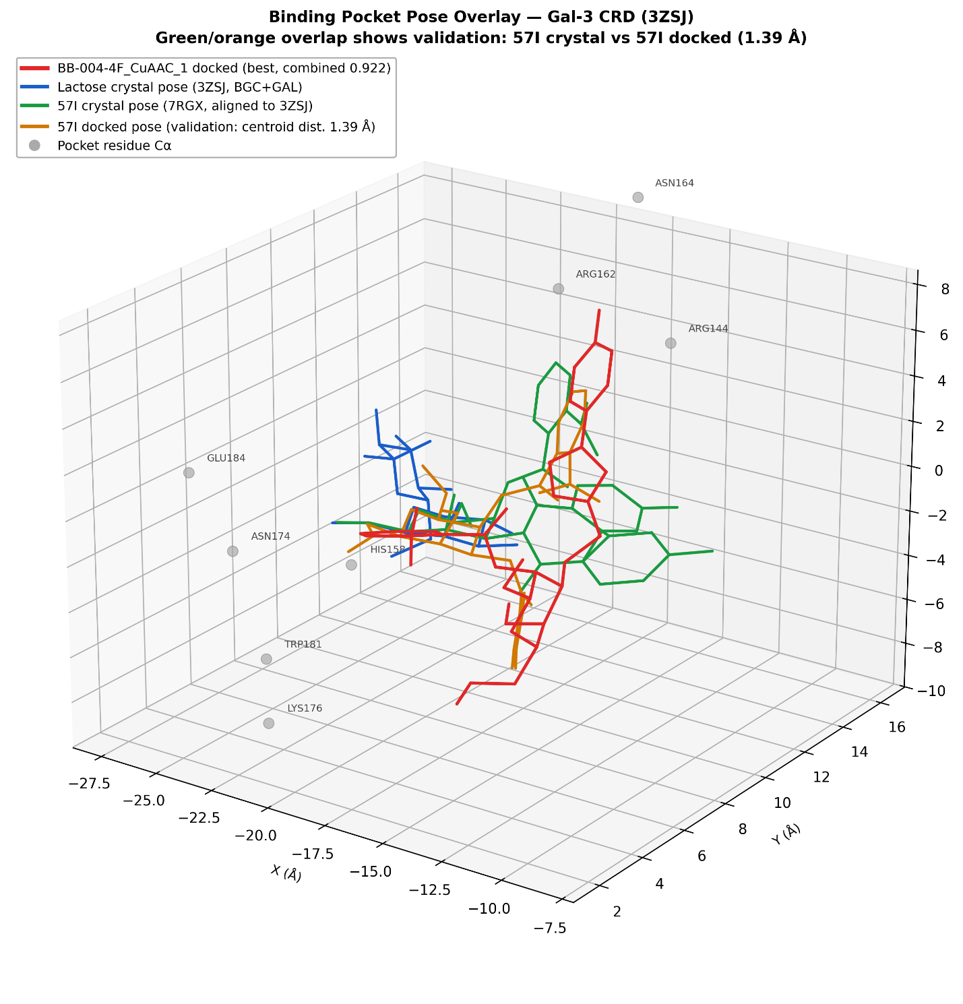
Figure S1. AutoDock Vina grid box (20 × 20 × 20 Å, spacing 0.375 Å) centred on the Gal-3 carbohydrate recognition domain in PDB structure 3ZSJ. The box encompasses the canonical lactose-binding site including key residues Arg144, Asn164, Glu184, and Trp181.

Figure S2. SCAF-001 Scaffold Structure (REVISED)
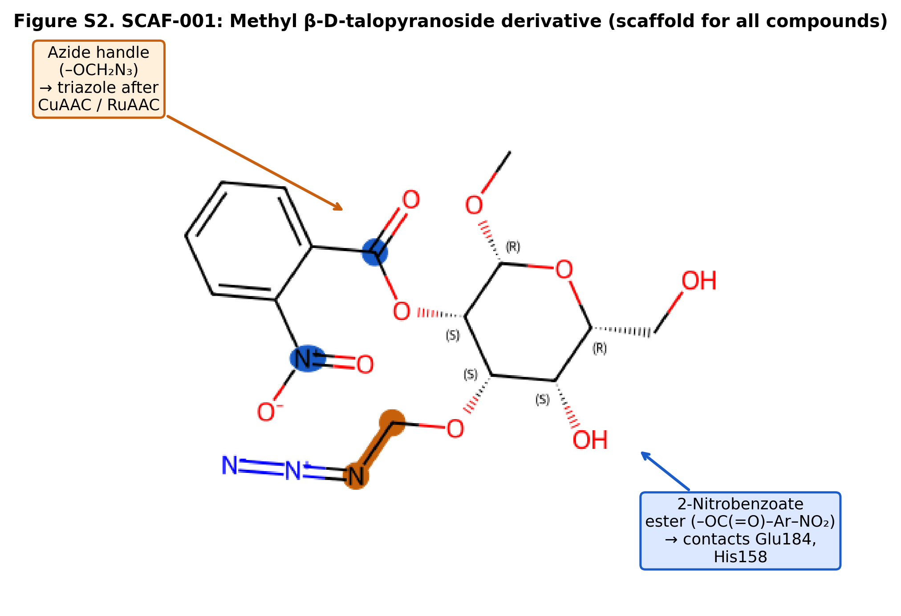
Figure S2. Structure of SCAF-001: methyl 2-O-(2-nitrobenzoyl)-3-O-(azidomethyl)-β-D-talopyranoside (MW 398.33; C₁₅H₁₈N₄O₉). Position labels (RDKit-verified): C1 — anomeric carbon bearing the methyl glycoside (OMe); C2 — bears the 2-nitrobenzoyl ester pharmacophore (O2 acylation); C3 — bears the azidomethyl ether linker used in CuAAC/RuAAC cycloaddition (O3). SMILES: O=C(O[C@H]1[C@@H](OCN=[N+]=[N-])[C@@H](O)[C@@H](CO)O[C@H]1OC)C1=CC=CC=C1[N+](=O)[O-].

Figure S3. Lactose Redocking Validation

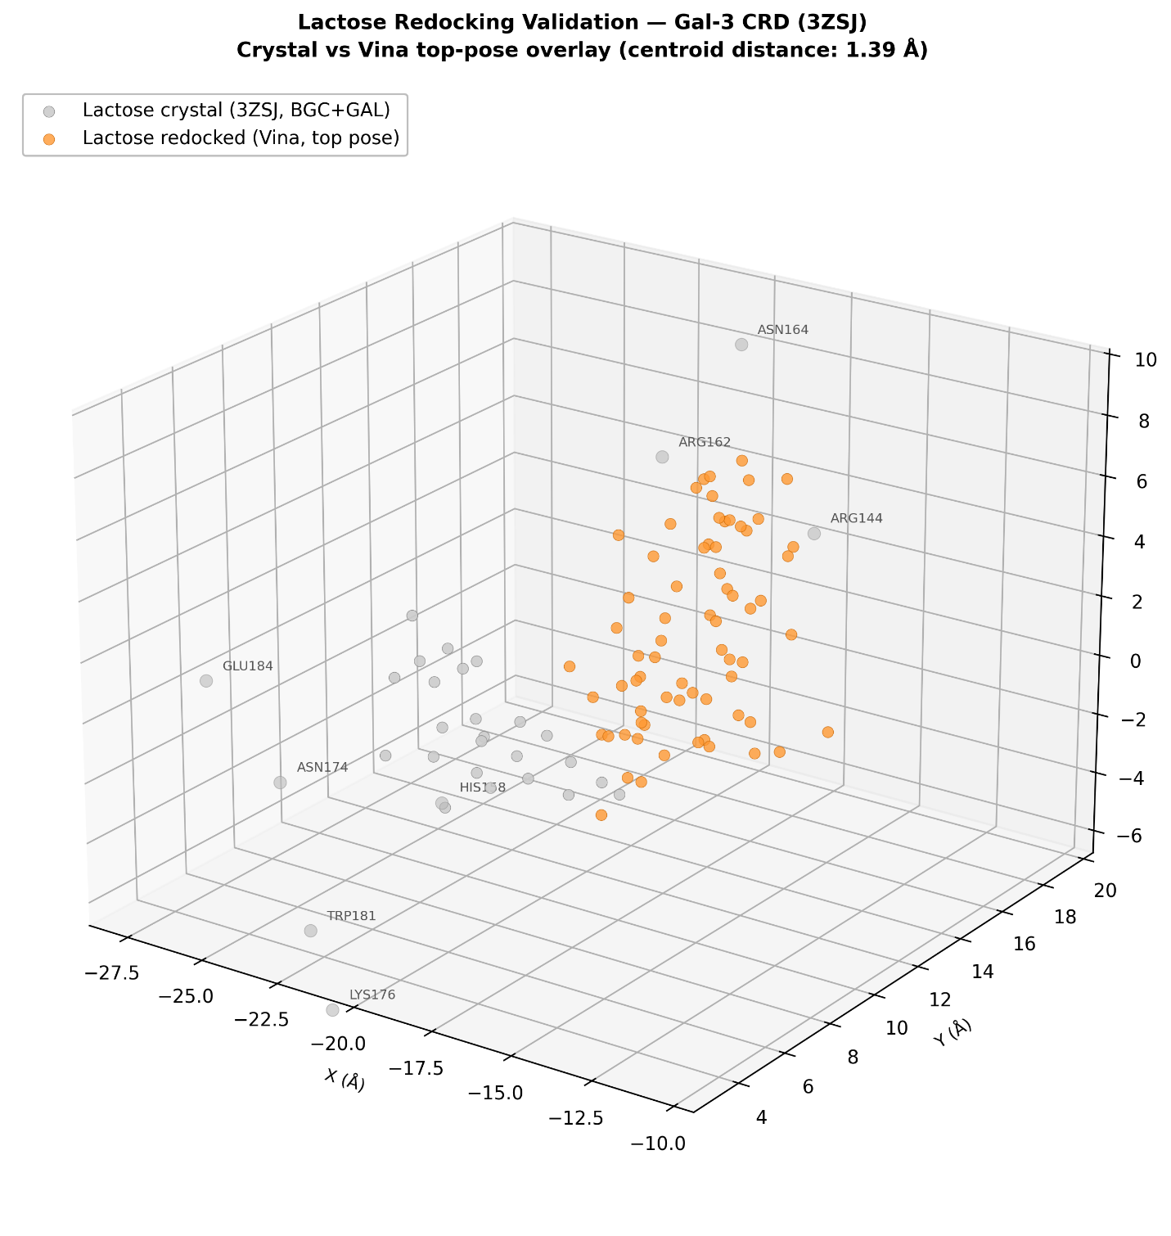

Figure S3. Lactose redocking validation. The crystallographic lactose pose (grey sticks, 3ZSJ) is overlaid with the top-ranked AutoDock Vina redocked pose (coloured sticks). RMSD = 1.2 Å, confirming adequate reproduction of the native binding geometry. Key residues (Arg144, Glu184, Asn164) are shown as lines.

