Re:produce Research Compendium Example Document

Adam H. Sparks

14 November, 2019

## Introduction

We wanted to create an example set of files for use in a hands-on exercise. This RMarkdown document is a part of that.

## Include the Figure

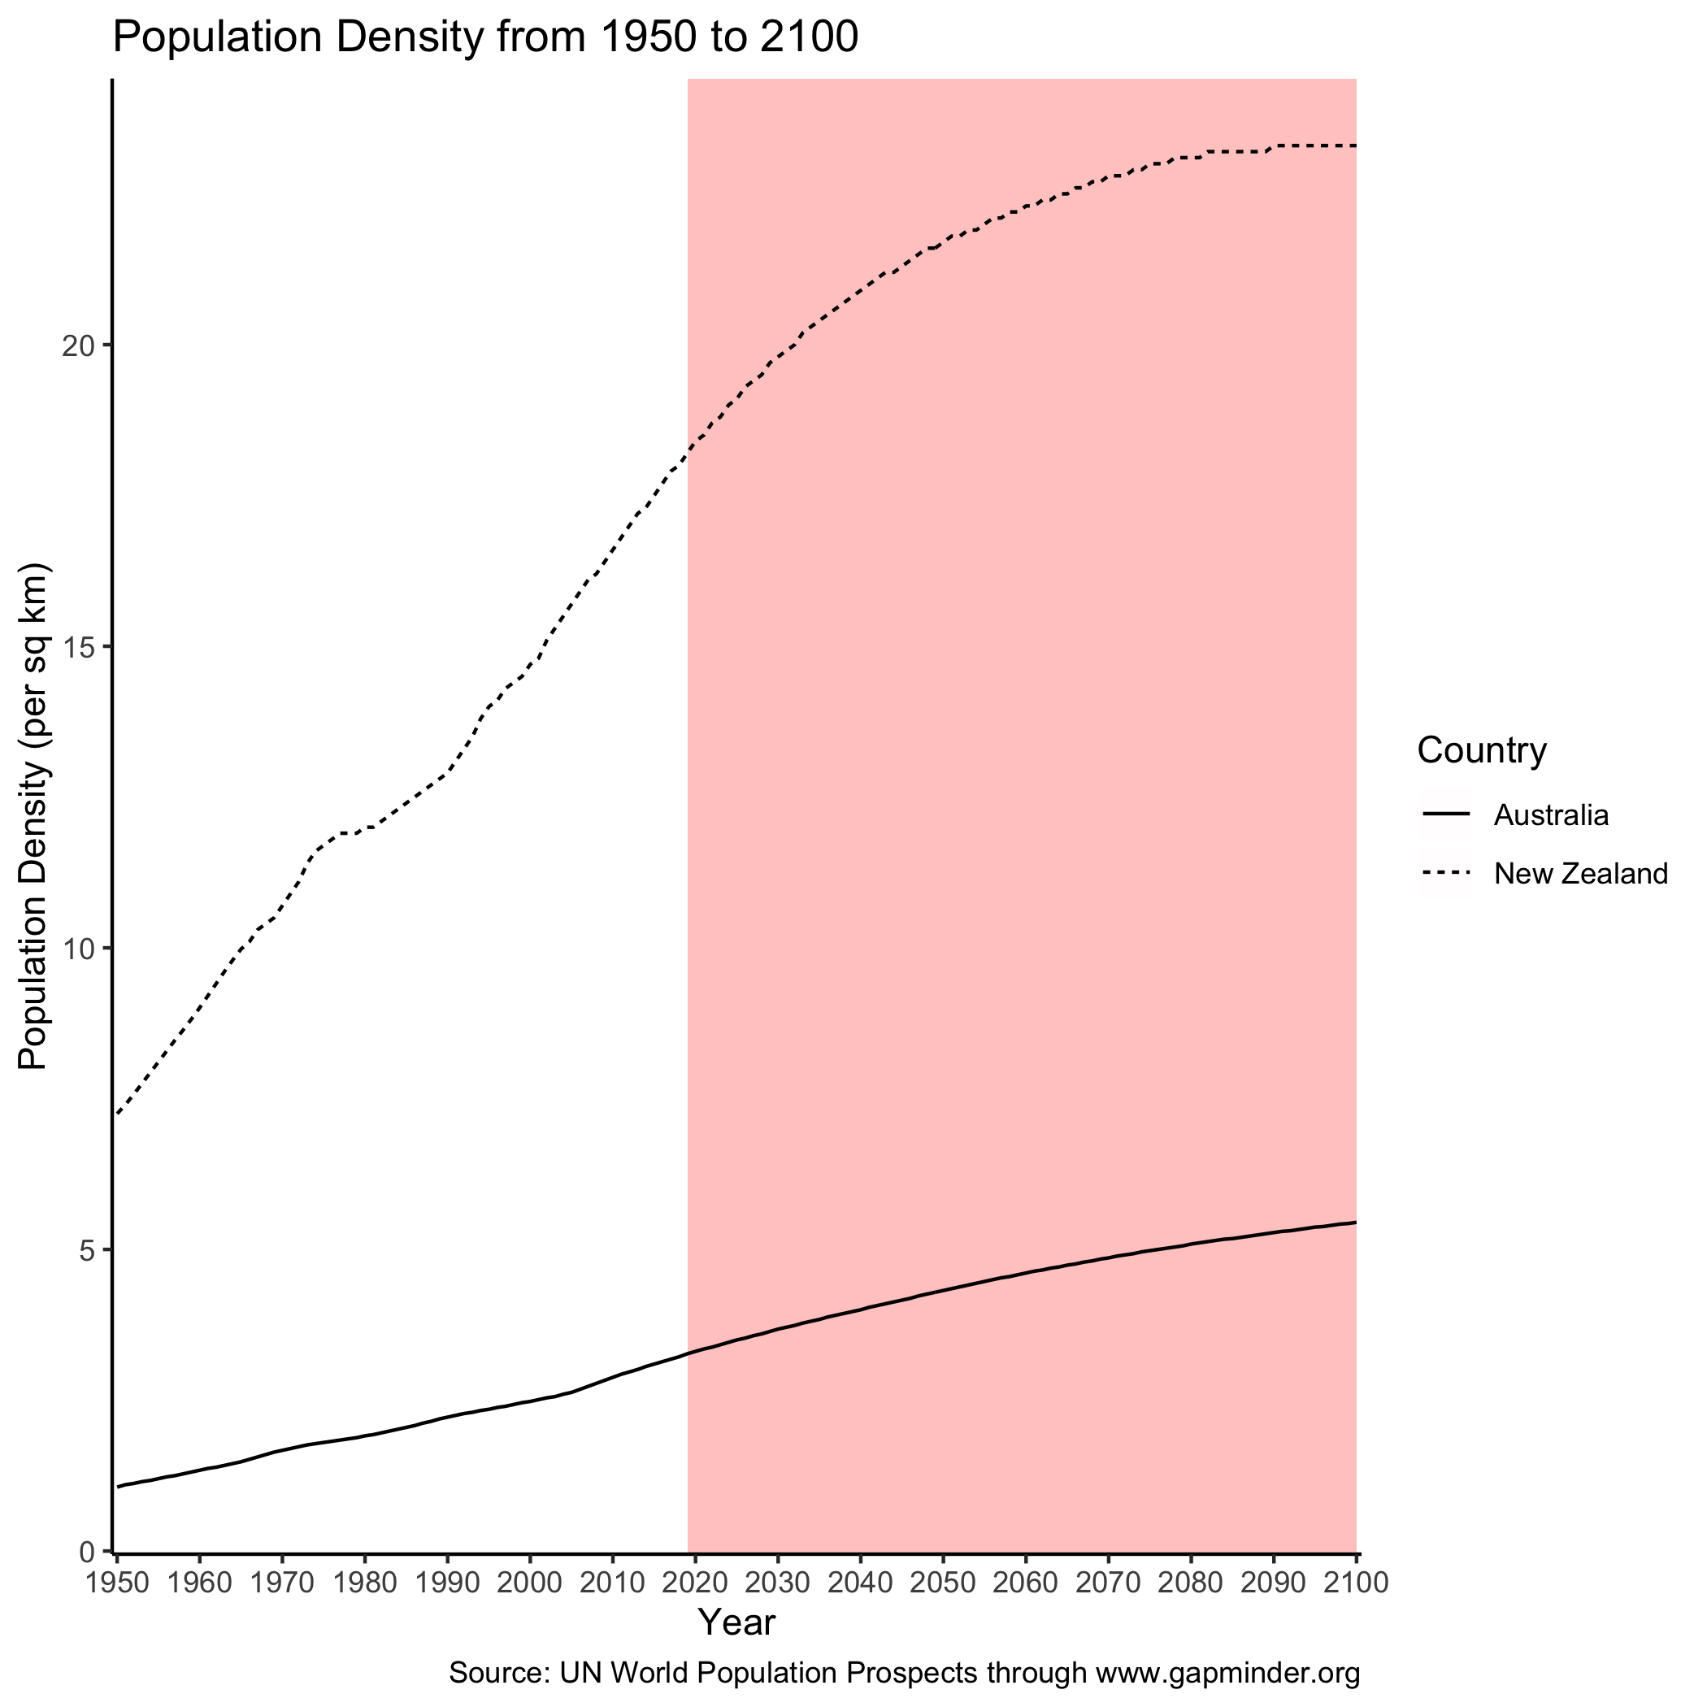

The historic, current and projected population density of Australia and New Zealand.

## Conclusion

It looks like New Zealand has a higher population density than Australia. Thank you for reading.