Part 1a: Linear Model Output

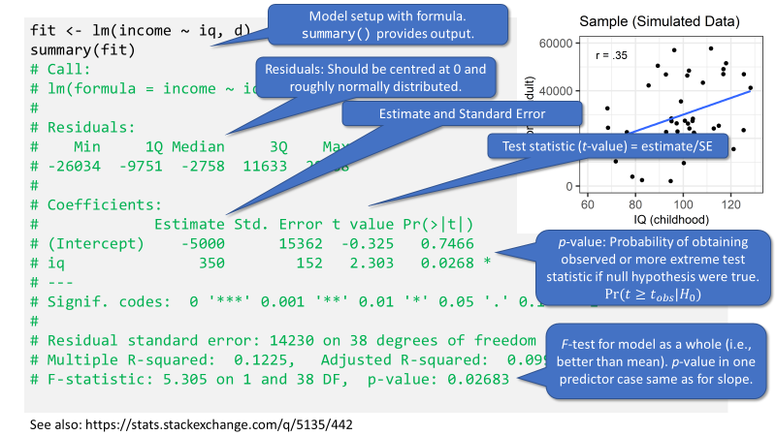

See also: <https://stats.stackexchange.com/q/5135/442>