SKY OUTBOUND CONCEPT
(created by Andreas Glück glueck@ityx.de)

- The business rules are imported and certificated.

2. The client and server must use the file mediatrix-sky.jar.
The jar is to be created from the skyoutbound project.

- The new letters can be created from service center frame. The outgoing channel can be set with the icon combo box. There are two outgoing channels:
1) The default (for initial mails).
2) The letter channel. In this case the pdf is created and inserted as attachment into the mail. The server will receive the sending action after an operator sent the letter(send-Button clicked).

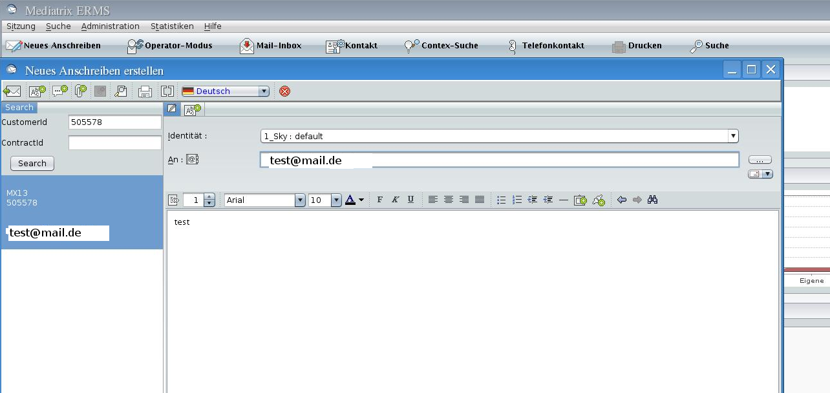
- If the mail is processed from the operator mode or the single mode, the type of the answer can be changed in the icon combo box:
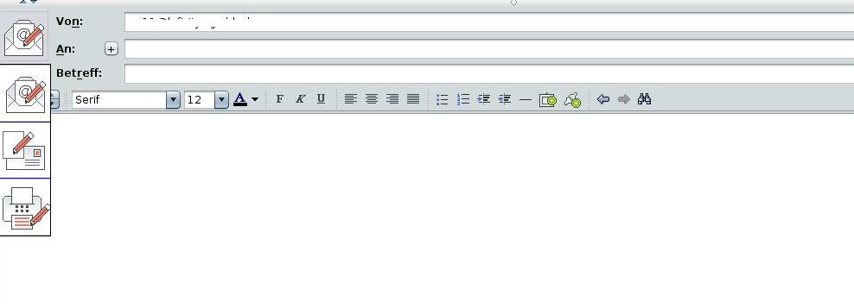

- In the actual version the pdf content is only stored (not sent).
For the archiving the function in the class ServerUtils is to be implemented.
public static void archive(Connection con, Email email) throws SQLException {
if (email instanceof Answer) {
System.out.println("answer sent: " + ((Answer) email).getId());
}
else if (email instanceof Question) {
System.out.println("question sent: " + ((Question) email).getId());
}
}

- The parameter is to be inserted into the file mediatrix.config: sky.template.path = /archive/templates

The parameter shows the path to the pdf templates. The templates are read from the directory.

The format of the templates:
subprojectid_language.pdf (e.g. 123_de.pdf)

- If the template for a subproject doesn't exist, the empty template is generated.

- ...

10.12.2011

