

Requirement Document for a Social Media App

*by*

Adam Jardali-202101194

Ihab Awad-202101195

Sara Ezzedine-202000684

A REPORT

Submitted to Dr. Ibrahim Al Bitar in partial fulfillment of the requirements for the course Software Engineering

Table of Contents

[Introduction 1](#_Toc133610459)

[Product History 1](#_Toc133610460)

[Purpose 1](#_Toc133610461)

[Glossary 2](#_Toc133610462)

[Background 3](#_Toc133610463)

[User Requirements 4](#_Toc133610464)

[Functional Requirements 4](#_Toc133610465)

[Non-functional Requirements 8](#_Toc133610466)

[System Requirement 9](#_Toc133610467)

[Functional Requirements 9](#_Toc133610468)

[Non-functional Requirements 29](#_Toc133610469)

[Requirements Evolution 5](#_Toc133610470)

[Software Architecture 7](#_Toc133610471)

[Software Interaction 9](#_Toc133610472)

[Software Components 12](#_Toc133610473)

[Activity Diagram 12](#_Toc133610474)

[Sequence Diagram 12](#_Toc133610475)

[Software Structure 15](#_Toc133610476)

[15](#_Toc133610477)

[Conclusion 37](#_Toc133610478)

[References 38](#_Toc133610479)

*This page is intentionally left blank.*

# Introduction

## Product History

A young entrepreneur named Jones Ventures had an idea for a social media app that would revolutionize the way people connect and interact online. He wanted to create a platform where users could share their stories, connect with like-minded people, and build a supportive community.

However, Jones Ventures had no technical skills or experience in software development. He decided to seek out a software engineering company that could help him bring his vision to life.

After researching several companies, Jones Ventures finally found one that stood out, ours. He reached out to our team and explained his idea in detail, sharing his passion and enthusiasm for the project.

Our team was immediately intrigued by Jones Ventures's vision and saw his app's potential to positively impact the social media landscape. We listened carefully to his requirements and goals and began to collaborate with him to create a detailed plan for the app's development.

So we created this requirement document to fulfill our client’s needs and requests.

## Purpose

The social media app, named WaveUp, is a platform designed to connect people worldwide. WaveUp is a mobile and web application that allows users to create a profile and connect with friends, family, and new people. The platform provides various features such as messaging, posting and sharing multimedia content such as photos and videos.

WaveUp aims to provide its users with a safe and secure environment by implementing strict privacy policies and advanced security features. The app enables users to control their privacy settings, allowing them to share their content with a selected group of people. Furthermore, WaveUp has a reporting system that enables users to report any inappropriate content or behavior, ensuring a positive experience for all users.

The primary objective of WaveUp is to provide a platform for individuals to connect and share their thoughts, ideas, and experiences with others. The app promotes social interaction and networking by creating a space for users to build and maintain relationships. WaveUp 's secondary objective is to provide an opportunity for businesses and influencers to reach a broader audience by utilizing the platform's features to promote their products, services, and content. The main objectives of the social media app are:

1. Providing users with a platform to share their ideas, opinions, and content with a global audience through different mediums, including text, images, and videos.
2. Offering users, the ability to connect with friends, family, and new people from around the world, making new connections and expanding their social circle.
3. Enabling businesses and organizations to create and manage their online presence, allowing them to interact with their customers and target audience in real-time.
4. Implementing various privacy and security features to ensure that the user's personal information is kept safe and secure.
5. Providing users with innovative and creative tools to express themselves, including filters, stickers, and other interactive features.

In conclusion, WaveUp is a social media app designed to foster meaningful connections between people worldwide while providing a safe and secure environment for its users. The platform seeks to promote social interaction and networking while providing opportunities for businesses and influencers to reach a broader audience.

# Glossary

**Feed**

A feed is a stream of content that you can scroll through. The content appears in similar-looking blocks that repeat one after the other.

**Impression**

Impressions help measure the number of people who have seen a post, even if they didn't click, comment or otherwise engage with that post.

**Customer Users**

Customer users and the end-users of the media app, people from society.

**Business Users**

Business users are the owners of online shops trying to brand and sell their products on the app.

**Reaction**

The reaction is the ability to like, comment, save, and share a post on the news feed.

# Background

After conducting extensive research on similar software on the internet, we have found that Instagram, Facebook, TikTok, and other social media platforms have established a strong presence in the market. However, our social media app aims to differentiate itself from the competition by offering unique features and a more user-friendly interface.

For example, our app will prioritize user privacy by allowing users to control who sees their content and who can follow them. Additionally, we will focus on creating a more immersive and engaging user experience by incorporating features such as live streaming, 3D filters, and augmented reality effects.

Furthermore, our app will provide users with a more diverse range of content by allowing them to discover and explore a wider range of topics and communities. We will also prioritize inclusivity by promoting diversity and representation in our app's content and community.

To find out the real needs of society and what they prefer to have in their media apps and based on the recommendations of our client we collaborated and carried out a survey that was filled out by university students and the results are found in the link below.

Many responses showed that people extremely care about their privacy and would like to have more private space. Also, several responses stated that people would like to know who is stalking their accounts and what they are doing. Other responses showed that people like to have algorithms helping small businesses grow. In general, people were asking to have more control over their media accounts than just being controlled by them.

Based on the results of the survey and many interviews with our client, many of this project’s requirements were drawn out from the actual needs of society. To provide more details:

1. Niche focus: While many social media platforms are general and cater to a broad audience, we can choose to help people with common interests connect. For example, we will create a space on the social media app for pet lovers, foodies, or travelers. This approach will enable us to build a community around a shared interest, which can lead to more engagement and stronger connections among users.
2. Advanced security features: Cybersecurity and online safety are growing concerns for social media users. By implementing advanced security features such as two-factor authentication, biometric verification, and end-to-end encryption, we can provide users with a secure and safe environment to share their content and connect with others.
3. Interactive features: Interactive features such as live streaming, virtual reality, and augmented reality can make WaveUp more engaging and immersive for users. We can offer users a unique and exciting social media experience by leveraging new and emerging technologies.
4. Artificial intelligence: Artificial intelligence (AI) can be used to personalize and improve the user experience on WaveUp. For example, AI algorithms can analyze user data to provide tailored content, recommend new connections, and identify potential safety risks.
5. Social responsibility: Social media platforms have faced criticism for promoting negative behavior such as cyberbullying, hate speech, and misinformation. By taking a social responsibility approach, we can encourage positive behavior and create a platform that fosters kindness, empathy, and respect among users.

Overall, our app seeks to distinguish itself from existing social media platforms by prioritizing user privacy, providing an immersive user experience, offering diverse content, and promoting inclusivity.

# User Requirements

The system has 4 types of users: Top User, Admin User, Customer User, and Business

User. The Top User is the person in charge of the entire system and is can create new Admin Users when needed. Admin Users are below the Top Users; they are assigned specific features to keep control of them. Customer Users and Business Users are the public community using the application. In the upcoming parts, the Top User won’t be mentioned in all parts as he doesn’t directly contribute to the features.

## Functional Requirements

1. Admin Control

• Top User shall be able to create and remove admins and control each admin’s feature access.

1. Sign-up/Login
   * + Top User shall be able to control sign-up and log-in settings. In addition, Top User creates an account for the Admin User.
     + Admin Users shall be to log in to their account which gives them access to features they are assigned to.
     + Customer Users shall be able to create new accounts and log in to their accounts if already exists.
     + Business Users shall be able to create and access their accounts which differ from normal users’ accounts as they are ID-based accounts.
2. Profile
   * + Admin User shall be able to manage profiles of both customers and businesses.
     + Customer Users shall be able to access and edit their profiles (photo, username, description, private information…).
     + Business Users shall be able to access and edit their profiles (photo, name, description, private information…).
3. Connect with Others
   * + Admin User shall be able to keep track and manage of the users’ followers and following.
     + Customer Users shall be able to follow other users and get followed back.
     + Business Users shall not be following other people, but casual people can follow them.
4. Community Creation
   * Admin User shall be able to create communities based on customers’ requests.
   * Customer Users shall be able to request the creation of a community if not available.
   * Business Users shall not be able to request community creation.
5. Niche Communities
   * Admin User shall be able to keep track and manage currently available communities and their members.
   * Customer Users shall be able to look for and join certain communities based on their preferences.
   * Business Users shall be able to find communities interested in their products to promote them. However, they shall not be able to join.
6. Feed
7. News
   * Admin User shall keep the news feed up-to-date and adjust it per user needs.
   * Customer Users shall be able to post their pictures/videos, view their followers’ posts, comment, and react to them.
   * Business Users shall only be able to post their products and view them there as they aren’t following anyone.
8. Community
   * Admin User shall keep the community feeds up-to-date and adjust them per community needs.
   * Customer Users shall be able to post pictures/videos related to the community interest, view the community’s posts, comment, and react to them.
   * Business Users shall only be able to view a community feed by interacting with them.
9. Reaction
   * + Admin User shall allow Customer Users to react and view others’ reactions. Also, Business Users shall be allowed to view reactions only.
     + Customer Users shall be able to react and view others’ reactions.
     + Business Users shall be able to view reactions only.
10. Streaming
    * + Admin User shall allow Customer and Business Users to stream.
      + Customer Users shall be able to stream.
      + Business Users shall be able to stream.
11. Stalking
    * + Admin Users shall be able to track stalkers of customers and business accounts to inform their users.
      + Customer Users shall be able to know who is stalking their accounts.
      + Business Users shall be able to know who is interested in their products to promote them in a better way.
12. Chat
    1. Personal
       * Admin User shall be able to provide end-end encrypted texts.
       * Customer Users shall be able to have private and group chats.
       * Business Users shall be able to have private chats with interested customers. In addition, business owners shall be able to create groups with people to share their products.
    2. Community
       * Admin User shall be able to provide end-end encrypted texts.
       * Customer Users shall be able to access community chat and communicate through it only if they are a part of that community.
       * Business Users shall not have access to the community chats.
13. Search Engine
    1. Personal
       * Admin User shall ensure the people can find their searches under all conditions.
       * Customer Users shall be able to search for other users and business accounts.
       * Business Users shall be able to search for possible target customers and other business accounts.
    2. Community
       * Admin User shall ensure the people can find their searches under all conditions.
       * Customer Users shall be able to search for other users, events, posts, businesses, and other information found in the community.
       * Business Users shall be able to search for communities that might be their target customers.
14. Notification
    1. Personal
       * Admin User shall ensure that customers and businesses receive notifications based on the occurrence of certain events.
       * Customer Users shall be able to receive notifications related to their posts

(comments, reactions, stalkers…), and ads they might be interested in, and receive notifications related to accounts they follow (business products, other users).

* + - Business Users shall be able to notify interested people about their products (they could set a daily notification reminder).
  1. Community
     + Admin User shall ensure that community customers receive notifications based on the occurrence of certain events within the community.
     + Customer Users shall be able to receive notifications related to community events, posts reactions….
     + Business Users shall not be able to interact with community notifications.

1. Advertisements’ Control
   1. Personal
      * Admin User shall be able to manage advertisements based on customer users and business owners.
      * Customer Users shall be able to view advertisements targeted based on their interests and control their frequency and type.
      * Business Users shall be able to promote their products through post ads, and notification ads.
   2. Community
      * Admin User shall be able to manage advertisements based on community users and business owners.
      * Customer Users each community admin(s) shall be able to control advertisements viewed by the community people.
      * Business Users shall be able to promote their products through community ads if they feel a community is interested.
2. Impression
   * + Admin User shall be able to keep track of customers’ impressions to inform business accounts.
     + Customer Users shall be tracked regarding the business posts they view and decide not to react to.
     + Business Users shall be able to know the impressions received on their posts and products.
3. Block & Report
   * + Admin User shall allow Customer and Business Users to block and report other users if needed.
     + Customer Users shall be able to block and report users if needed.
     + Business Users shall be able to block and report users if needed.
4. Black Lists
   * + Admin User shall be able to blacklist certain customers or businesses if they fail to abide by the application rules after receiving warnings.
     + Customer Users shall lose access to their accounts if they misuse the application.
     + Business Users shall lose access to their business accounts if they misuse the application.
5. Reporting & Analytics
   * + Top User shall be able to control all system activity and generate reports regarding all the other users’ activity on the application accordingly.
     + Admin Users shall be able to issue reports related to some features.
     + Business Users shall be able to request reports related to products to improve sales.

## Non-functional Requirements

1. Usability: The app should have a simple and intuitive user interface that is easy to navigate and use.
2. Performance: The app should be fast and responsive, with minimal lag or downtime.
3. Security: The app should provide adequate security measures to protect user data and prevent unauthorized access.
4. Compatibility: The app should be compatible with a wide range of devices and operating systems.
5. Accessibility: The app should be accessible to users with disabilities, including support for assistive technologies.
6. Scalability: The app should be able to handle increasing numbers of users and data without performance degradation.
7. Privacy and security: The app should provide options for users to control their privacy settings and ensure the security of their personal information.
8. Search functionality: The app should have a search function that allows users to find other users, content, and groups based on keywords.
9. Real-time updates: Users should be able to receive real-time updates for new content and interactions on the app.
10. Sign-up/Log-in: The log-in process should be secure and protect users' login credentials from unauthorized access.
11. Feed Security: Users' personal information and data must be protected from unauthorized access, theft, or other security breaches.
12. Feed Scalability: The system should be able to handle a large number of users and feed items without slowing down or crashing.
13. Chat Security: The system must be designed to prevent or detect any attempts to hack into the chat system or manipulate the messages.
14. Report Security: Users' personal information and data contained in reports must be protected from unauthorized access, theft, or other security breaches.
15. Notification Scalability: The system should be able to handle a large number of notifications without slowing down or crashing.

# System Requirement

## Functional Requirements

1. Admin Control
   1. Top User
      * Top User shall be able to remove admins from the system.
      * Top User shall be able to control feature access of each admin, granting or revoking access to certain functionalities or data within the system based on their roles.
2. Sign-up/Login
   1. Top User
      * Top User shall be able to manage Admin, Customer, and Business log-in.
      * Top User shall be to create Admin User accounts with an ID and a password and provide Admin with the credentials.
      * The Top User shall be able to set requirements for passwords, such as minimum length or character types.
      * Top User shall be able to specify user verification and authentication methods; such as email confirmation or two-factor authentication.
   2. Admin User
      * Admin Users shall be able to log in to the system on a page different from that of Customers and Business.
      * The Admin User shall be able to enter their login credentials to access their account.
      * Admin Users shall be able to reset their password if they forget it.
      * Admin Users shall be able to access the features and functions they have been assigned to.
   3. Customer User
      * New Customer Users shall be able to sign-up for the application.
      * Customer Users shall be able to create an account by entering their personal information including name, email address, and password.
      * Customer Users with existing accounts shall be able to log in by entering their email addresses and password.
3. Business User
   * New Business Users shall be able to sign-up for the application.
   * Business User should be able to create an ID-based account by entering their business details, including business name, location, and contact information.
   * Business Users with existing accounts shall be able to log in by entering their ID and password.
4. Overall Requirements
   * The system should provide an option for users to recover their forgotten passwords.
   * The system should be able to track user activities and log them for security and auditing purposes.
   * The system should provide an option for users to log out of their accounts.
   * The system should check for the uniqueness of the users’ usernames.
5. Profile
   1. Admin User
      * Admin User shall be able to view and manage customer and business profiles.
      * Admin User shall be able to deactivate or delete customer and business profiles as necessary.
   2. Customer User
      * Customer users shall be able to access and view their own profiles.
      * Customer users shall be able to edit their own profile information, such as photos, username, description, and private information.
      * Customer users shall be able to change their password or recover their accounts if necessary.
   3. Business User
      * Business Users shall be able to access and view their own profiles.
      * Business Users shall be able to edit their own profile information, such as photos, username, description, and private information.
      * Business Users shall be able to change their password or recover their accounts if necessary.
      * Business Users shall be able to manage additional features related to their business account, such as payment methods, services offered, or product inventory.
6. Connect with Others
   1. Admin User
      * Admin Users shall have access to a dashboard that displays the number of followers and following for each user.
      * Admin Users shall view and manage followers and following for each user, including approving or denying follow requests, removing followers, and adding new followers.
   2. Customer User
      * Customer Users shall be able to follow other users by clicking a follow button on the user's profile.
      * Customer Users shall be able to view their own followers and following lists on their profile.
   3. Business User
      * Business Users shall not be able to follow other users, but shall allow casual users to follow them.
      * Business Users shall be able to view their list of followers on their profile.
7. Community Creation
   1. Admin User

• Admin User shall be able to manage the community creation process, including reviewing the community name and description, and approving or rejecting the community request.

* 1. Customer User

• Customer Users should be able to submit a community name and description, along with other relevant details, when requesting a new community.

* 1. Business User

• Business Users shall not be able to request the creation of a community.

* 1. Overall Requirements
     + The system shall store community creation requests and relevant details in a secure database.
     + The system shall enable the Admin User to manage and prioritize community creation requests.
     + The system shall provide appropriate error messages and handling for failed community creation requests.

1. Niche Communities
   1. Admin User
      * Admin User shall have the ability to moderate the community feed and remove any inappropriate content.
      * Admin User shall have the ability to set up community guidelines and policies for users to follow.
   2. Customer User
      * Customer Users shall be able to request to join a community.
      * Community head(s) shall be able to assign other community heads.
      * Community head shall be able to admit new members to the community.
   3. Business User
      * Business Users shall be able to view community information and statistics such as demographics and engagement rates.
      * Business Users shall be able to request posting sponsored posts or advertisements to be displayed within the community feed.
2. Feed
   1. News

1. Admin User

* + - * Admin User shall be able to create and edit news feed categories.
      * Admin User shall have a dashboard to view and manage all news feed content.
      * Admin User shall be able to monitor the news feed for inappropriate content and remove it as necessary.
      * Admin Users shall be able to manage stories of users and make sure everything is working correctly if anything goes wrong in the system.
  1. Customer User
     + Customer Users shall be able to upload pictures and videos to the news feed.
     + Customer Users shall be able to view posts from the users they follow and their own posts.
     + Customer Users shall be able to see others’ stories or statuses anytime they want before the 24hrs time of the story is gone.
  2. Business User
     + Business Users shall be able to upload product images and descriptions to the news feed.
     + Business Users shall be able to view their own posts on the news feed.
     + Business Users shall not be able to view customers’ posts.
  3. Overall Requirements
     + The system shall allow users to customize their news feed preferences and settings.
     + The system shall be able to remove or add posts instantly based on the users’ choice.
     + The system shall be able to remove the stories of users after 24hrs.

1. Community
   1. Admin User
      * Admin Users shall be able to view the community feed and manage it accordingly in a specific interface.
      * Admin Users shall be able to moderate posts and comments and remove content that violates community guidelines when discovered.
      * Admin Users shall be able to customize the community feed's appearance and layout if needed.
   2. Customer User
      * Customer Users shall be able to view the community feed, see others' content, and the community feed should be updated frequently.

Customer Users shall be able to post on the community feed with media attachments (pictures and videos) as well as text-based posts.

* + - Customer Users shall be able to filter posts by date, the number of reactions, and other options.

1. Business User
   * + - Business Users shall be able to view the community feed of communities in order to decide the best communities to target.
       - Business Users shall not be able to post on the community feed with media attachments (pictures and videos) as well as text-based posts.
       - Business Users shall be able to filter posts by category and date.
2. Overall Requirements
   * + - The system shall provide an interface for the Admin Users to manage and update the community feed.
       - The system shall store user data frequently and in a large database (e.g., posts and other things related to community feed).
       - The system shall provide the ability to share posts for Customer Users and prevent Business Users from posting.
3. Reaction

1. Admin User

* + - * Admin Users shall be able to enable/disable reactions for specific posts or threads.
      * Admin Users shall be able to set permissions for Customer and Business Users to view and react to posts.
      * Admin Users shall be able to view all reactions on posts or threads.
      * Admin Users shall be able to delete any inappropriate reactions.

2. Customer User

* + - * Customer Users shall be able to view reactions on posts or threads.
      * Customer Users shall be able to react to posts with various reaction types.
      * Customer Users shall be able to undo/react again after reacting to a post.
      * Customer Users shall be able to view the number of reactions to a post.

3. Business User

* + - * Business Users shall be able to view reactions on posts or threads.
      * Business Users shall be able to sort posts by the number of reactions.
      * Business Users shall be able to filter posts by specific reaction types.
      * Business Users shall be able to view the number of reactions to a post.

4. Overall Requirements

* + - * The system shall provide clear and recognizable icons for each reaction type.
      * The system shall allow for future customization or expansion of reaction types if needed.
      * The system shall have the ability to track the number of reactions and update them instantly.

1. Streaming

1. Admin User

* + - * Admin User shall provide the capability for Customer and Business Users to stream content.
      * Admin User shall be able to manage and monitor live streams by Customer and Business Users.
      * Admin User shall be able to take action (stop the stream) if any live stream violates the applicable rules or policies.

2. Customer User

* + - * Customer Users shall be able to create and stream their content.
      * Customer Users shall be able to manage and edit their live streams settings.
      * Customer Users shall be able to manage who can attend their streaming.

3. Business User

* + - * Business Users shall be able to create and stream their content.
      * Business Users shall be able to manage and edit their live streams settings.

Business Users shall be able to have an option of promoting their live stream by paying some money using different methods such as credit cards or PayPal.

4. Overall Requirements

• The system shall maintain a history of all incidents related to live streaming, as well as the actions taken by the Admin User.

1. Stalking

1. Admin User

* + - * Admin User shall monitor user activity and identify potential stalkers of customer and business accounts.
      * Admin User shall be notified if there is suspicious activity related to stalking, and provide them with information on how to investigate further.
      * Admin User shall be able to inform affected customers and businesses about the stalking activity, as well as provide them with guidance on how to protect themselves.

2. Customer User

* + - * Customer Users shall be able to view a log of who has viewed their account.
      * Customer Users shall be notified if there is suspicious activity related to stalking on their account and provide them with information on how to investigate further by paying for a pro membership.

3. Business User

* + - * Business Users shall be able to view a log of who has shown interest in their products or services.
      * Business Users shall be able to contact potential customers who have shown interest in their products or services.
      * Business Users shall be notified if there is suspicious activity related to stalking on their account and provide them with information on how to investigate further by making an agreement with the application admins where the app founders would get 5% of business owners' selling’s.

4. Overall Requirements

The system shall maintain a history of all incidents of stalking, as well as the actions that were taken by the Admin User.

1. Chat

1. Personal

* 1. Admin User
     + - Admin Users shall be able to manage encryption keys and security settings and update them whenever needed.
       - Admin Users shall be able to prevent some users from chatting for 24 hours if suspicious content is detected or if the user gets reported multiple times.
  2. Customer User
     + - Customer Users shall be able to navigate to another tab to have private and group chats with other users.
       - Customer Users shall be able to view private and group chats separated from each other to keep everything organized.
       - Customer Users shall be able to share text, images, and other media in private and group chats in addition to being able to record voice notes.
       - Customer Users shall be able to customize their chat settings, including notifications, privacy settings, and blocked users.
  3. Business User
     + - Business Users shall be able to have private chats with interested customers.
       - Business Users must have a separate messaging system for communicating with customers or potential customers.
       - Business Users shall be able to create groups with customers to share their products.
       - Business Users shall be able to manage and configure chatting settings according to their needs also they might have the option to enable AI messaging. This AI shall be able to respond to messages depending on the type of message in order for the customers not to get bored from waiting.

Business Users shall be able to share text, images, and other media in private and group chats with customers. Also, since business Users share too many images related to their product, they should have the option to pack all the images in a specific format (used for organization and keeping the order of the images).

4. Overall Requirements

* + - The system shall be able to store all chat content and user information in a secure and efficient database.
    - The system shall be able to allow users to join chat groups and view them. These groups should be up-to-date and the number of members of each group shall be tracked frequently.
    - The system shall allow users to customize their chat preferences and settings.

1. Community
   1. Admin User
      * Admin Users shall be able to manage encryption keys and security settings set on community chats and update them whenever needed.
      * Admin Users shall be able to prevent some users from chatting for 2 days if suspicious content is detected or if the user gets reported 10 times by different users in the community chat.
   2. Customer User
      * Customer Users shall be able to access community chat only if they are members of that community.
      * Customer Users shall be able to send special text messages in community chat conversations which will have the ability for other users to translate this message into a specific language they want.
      * Customer Users shall be able to share images, videos, and other media in community chat conversations.
      * Customer Users shall be able to customize their community chat settings, including notifications, privacy settings, and other preferences.
2. Business User

The Business Users shall not be able to view chat conversations.

1. Overall Requirements
   * + - The system shall store all community chat content and user information in a secure and powerful database.
       - The system shall allow users to customize their community chat preferences and settings.

L. Search Engine

1. Personal
   1. Admin User
      * Admin Users shall be able to monitor the search feature and ensure it works correctly and efficiently.
      * Admin Users shall be able to access a search feature that enables them to find any user or business account under all conditions.
      * Admin Users shall be able to filter results based on various parameters, such as username, name, category, location, and other profile information.
   2. Customer User
      * Customer Users shall be able to access a search feature that enables them to find other users and business accounts.
      * Customer Users shall be able to filter results based on various parameters, such as username, name, category, location, and other profile information.
      * Customer Users shall be able to view profiles of other users and business accounts directly from the search results page.
   3. Business User
      * Business Users shall be able to access a search feature that enables them to find possible target customers and other business accounts.
      * Business Users shall be able to filter results based on various parameters, such as username, name, category, location, and other profile information.
      * Business Users shall be able to view profiles of target customers and other business accounts directly from the search results page.
      * Business Users shall be able to export search results into a CSV or Excel file for further analysis and marketing purposes.
2. Community
   1. Admin User
      * Admin Users shall be able to monitor the search feature and ensure it works correctly and efficiently.
      * Admin Users shall be able to access a search feature that enables them to find any community under all conditions.
      * Admin Users shall be able to filter results based on various parameters, such as username, name, category, location, and other profile information.
   2. Customer User
      * Customer Users shall be able to search for events, posts, and other information found in the community.
      * Customer Users shall be able to filter search results based on various parameters such as username, name, category, location, tags, and keywords.
      * Customer Users shall be provided autocomplete suggestions to help refine their search queries.
   3. Business User
      * Business Users shall be able to search for communities that might be their target customers.
      * Business Users shall be able to filter search results based on various parameters such as community size, location, interests, and demographics. M. Notification

1. Personal

1. Admin User

* + - Admin User shall be able to create notification rules based on specific events, such as new user sign-ups or posts receiving a certain number of reactions.
    - Admin User shall be able to view real-time reporting on the number and types of notifications sent out.

2. Customer User

Customer Users shall be able to customize their notification settings, including the ability to turn on/off notifications for different types of events (e.g. comments, reactions, followers, and ads).

* + Customer Users shall be able to receive personalized recommendations for products or accounts they might be interested in.
  + Customer Users shall be able to receive real-time notifications when new activity occurs related to their posts, accounts they follow, or other relevant events.
  + Customer Users shall receive notifications when they receive new followers or when their follow requests are approved or denied.
  + Customer Users shall receive a notification system to alert Customer Users when someone comments on or reacts to their posts.
  + Customer Users shall receive a notification when the account got a revocation and provide an opportunity to appeal the decision.
  + Customer Users shall receive a notification if their live stream has been reviewed and any action has been taken by the Admin User.
  + Customer Users shall receive a notification if their accounts are being stalked by other users.

1. Business User
   * Business Users shall be able to send notifications to interested people regarding their products or services, including the ability to set a daily reminder for notifications.
   * Business Users shall receive notifications when they receive new followers.
   * Business Users shall receive a notification if their live stream has been reviewed and any action has been taken by the Admin User.
   * Business Users shall receive a notification if their accounts are being stalked by other users.
   * Business Users shall be able to receive real-time notifications when new activity occurs related to their posts.
2. Overall Requirements

The system shall store user notification settings in a secure database.

* + - The system shall provide push notifications for real-time alerts to users.
    - The system shall provide a mechanism for users to manage their notification preferences, including the ability to opt out of receiving notifications.

1. Community
   1. Admin User
      * Admin User shall be able to create notification rules based on specific events, such as new user sign-ups or posts receiving a certain number of reactions.
      * Admin User shall be able to view real-time reporting on the number and types of notifications being sent out.
   2. Customer User
      * Customer Users shall be able to customize their notification settings, including the ability to turn on/off notifications for different types of events within the community (e.g. new posts, reactions, events).
      * Customer Users shall have real-time notifications when new activity occurs within the community.
      * Customer Users shall receive a notification upon approval or rejection into the community.
      * Customer User shall be notified of the status of their community request, including whether it has been approved or rejected by the Admin User.
      * Community head(s) shall receive notifications upon joining requests to the community.
2. Business User

• Business Users shall not send or receive community notifications.

1. Overall Requirements
   * + The system shall store user notification settings in a secure database.
     + The system shall provide push notifications for real-time alerts to users.

The system shall provide a mechanism for users to manage their notification preferences, including the ability to opt out of receiving notifications.

1. Advertisements’ Control
   1. Personal
      1. Admin User
         * + Admin users shall be able to approve and manage advertisements in the system.
           + Admin Users shall be able to define different advertisement packages for business owners.
           + Admin Users shall be able to view the advertisements posted by business owners and control their frequency and placement.
      2. Customer User
         * + Customer Users shall be able to view the advertisements on the platform.
           + Customer Users shall be able to control the frequency and type of advertisements they receive.
           + Customer Users shall be able to select their interests to receive relevant advertisements.
      3. Business User
         * + Business Users shall be able to promote their products through the platform.
           + Business Users shall be able to post ads and notification ads to attract potential customers.
           + Business Users shall be able to select their target audience based on their interests and preferences.
      4. Overall Requirements
         * + The system shall be able to track the advertisements and their performance.
           + The system shall be able to monitor the frequency and placement of advertisements.

The system shall ensure that the advertisements comply with the platform's policies and regulations.

* 1. Community
     1. Admin User
        + - Admin User shall be able to manage advertisements targeted to community users.
          - Admin User shall be able to approve, edit, and delete advertisements for community users and business owners.
     2. Customer User
        + - Community head(s) shall be able to control advertisements viewed by the community people.
          - Community head(s) shall be able to approve or reject advertisements submitted by business users.
          - Community head(s) shall be able to set guidelines and criteria for advertisements displayed in their community.
     3. Business User

• Business users shall be able to create and submit community ads for approval by the community head(s).

* + 1. Overall Requirements

• The system shall enforce community guidelines and criteria for advertisements displayed in each community.

1. Impression

1. Admin User

* + - * + Admin User shall monitor customer impressions on business posts and products.
        + Admin User shall be able to inform affected businesses about changes in customer impressions, as well as provide them with guidance on how to improve their posts or products.

2. Customer User

• Customer Users shall be tracked for products viewed, but not interacted with. This information should be recorded by the system.

3. Business User

* + - * + Business Users shall be able to view impressions on their feeds.
        + Business Users shall be provided with guidance on how to improve their posts or products based on the impressions they receive.
        + Business Users shall be notified if there is a significant change in customer impressions on their posts or products, and provide them with information on how to investigate further.

4. Overall Requirements

• The system shall maintain a history of all incidents related to customer impressions, as well as the actions that were taken by the Admin User.

1. Block & Report

1. Admin User

* + - * + Admin User shall be able to investigate and take action on reported users, including blocking their access to the system.
        + Admin Users shall be able to receive reports and manage reported or flagged posts that may violate community guidelines and manage them.

2. Customer User

* + - * + Customer Users shall be informed if their reports have been reviewed and acted upon by the Admin User.
        + Customer Users shall be provided with guidance on how to protect themselves from other users they have blocked or reported.
        + Customer Users shall be able to report or flag inappropriate content by pressing a report button and choosing the type of violation violated by the content on news feed and community feed.
        + Customer Users shall be provided with the ability to report inappropriate or offensive advertisements.
        + Customer Users shall be provided with a mechanism for the customers to report any violation of applicable rules by other users.
        + Customer Users shall be able to block other users who have been identified as stalkers.

Customer Users shall be provided with the ability to report inappropriate or offensive private or group chat messages.

Customer Users shall be able to view the accounts they blocked and remove the block if wanted.

3. Business User

* + - * + Business Users shall be informed if their reports have been reviewed and acted upon by the Admin User.
        + Business Users shall not be allowed to report or flag posts or any inappropriate content.
        + Business Users shall be able to report inappropriate private chat content with an option to specify the report's priority.
        + Business Users shall be able to block users for any reason if needed.
        + Business Users shall be able to view the accounts they blocked and remove the block if wanted.

4. Overall Requirements

* + - * + The system shall be able to have a reporting system for users to flag inappropriate content in their chat or community chat.
        + The system shall have a reporting system for users to flag inappropriate content or behavior in community or news feed.
        + The system shall provide an interface for Customer and Business Users to block and report other users.
        + The system shall maintain a history of all incidents related to blocked and reported users and the actions taken by the Admin User.

1. Black Lists

1. Admin User

* + - * + Admin User shall be able to receive and review reports of customer or business user misconduct on the application.
        + Admin User shall be able to issue warnings to customers or businesses that violate application rules.
        + Admin User shall be able to blacklist customers or businesses that have received multiple warnings and continue to violate application rules.

Admin User shall be able to view and manage the blacklisted customers or businesses.

Admin User shall be able to review Customer and Business petitions and decide on removing or keeping warnings.

* + - * + Admin User shall assign a new community head based on the most interactive member if a community head’s account got blacklisted.

2. Customer User

* + - * + Customer users shall be aware of the set of application rules to follow. • Customer users shall lose account access upon continuous rule breaks.
        + Customer users shall be able to submit a petition to review warnings to Admin User.

3. Business User

* + - * + Business Users shall be aware of the set of application rules to follow. • Business Users shall lose account access upon continuous rule breaks.
        + Business Users shall be able to submit a petition to review warnings to Admin User.
        + Business Users shall be able to retain access to any relevant data or information from their account before the account is permanently deleted.

4. Overall Requirements

* + - * + The system shall monitor customer activity and identify any misuse of the application.
        + The system shall issue a warning to the customer if they are found to be violating application rules.
        + The system shall revoke access to the customer's account if they continue to violate application rules after receiving a warning.

1. Reporting & Analytics

1. Top User

* + - * + Top User shall be able to view all system activity, including the activity of other users.
        + Top User shall be able to generate reports on user activity, such as login history, posts or products viewed, etc.

Top User shall be able to generate reports on system performance, such as uptime, user traffic, etc.

Top User shall be able to set permissions for other users to view certain reports.

2. Admin User

Admin Users shall be able to generate reports related to specific features, such as customer support tickets, product inventory, or sales data.

Admin Users shall be able to schedule automated report generation and delivery.

3. Customer User

• Customer User shall not have access to any report tool.

4. Business User

Business Users shall be able to request reports related to product performance, such as sales volume, customer feedback, or inventory levels.

Business Users shall be able to receive reports in a format that is easily understandable, such as charts or graphs.

5. Overall Requirements

The system shall ensure that user data is collected and stored in compliance with privacy laws and regulations.

The system shall provide customizable report templates to allow for flexibility in report generation.

## Non-functional Requirements

1. Usability
   * + Design the user interface to be simple and intuitive, with clear navigation and consistent visual elements.
     + Provide clear and concise instructions and feedback to guide users through the app.
     + Use familiar and commonly used interface elements to minimize the learning curve for users.
2. Performance
   * Optimize the app to be fast and responsive, with minimal lag or downtime.
   * Ensure that the app can handle high volumes of user traffic without slowing down.
   * Monitor the app's performance regularly and address any performance issues promptly.
3. Security
   * Implement robust security measures to protect user data, such as encryption and secure authentication protocols.
   * Regularly audit the app's security and address any vulnerabilities promptly.
   * Provide options for users to control their privacy settings and manage their personal information.
4. Compatibility
   * Develop the app to be compatible with a wide range of devices and operating systems, including mobile and desktop platforms.
   * Test the app on different devices and operating systems to ensure compatibility and address any issues promptly.
5. Accessibility
   * Ensure that the app meets accessibility standards, such as the Web Content Accessibility Guidelines (WCAG).
   * Provide options for users with disabilities, such as support for assistive technologies like screen readers and voice commands.
   * Use clear and concise language and avoid using visual cues alone to convey information.
6. Scalability
   * Design the app to be scalable, with the ability to handle increasing numbers of users and data without performance degradation.
   * Implement a robust infrastructure that can handle high volumes of traffic and data.
   * Monitor the app's scalability regularly and address any performance issues promptly.
7. Privacy and security
   * Provide options for users to control who can see their profile and content.
   * Allow users to report or block other users for inappropriate behavior.
   * Use secure authentication and encryption to protect users' personal information.
8. Search functionality
   * Provide a search bar where users can enter keywords to find other users, content, or groups.
   * Allow users to filter search results by different criteria, such as location or date.
   * The search feature must be designed and developed with a focus on reliability to ensure that it can perform consistently and dependably over time, even under heavy usage and in challenging environments. This includes using robust coding practices, testing the feature thoroughly, and monitoring its performance in realworld usage to ensure that it meets reliability standards.
9. Real-time updates
   * Provide real-time updates for new content or interactions, such as showing new posts or messages without the need for the user to refresh the app.
10. Sign-up/Log-in
    * The system must ensure the security and confidentiality of user login credentials.
    * The system must be able to handle multiple concurrent user logins and sessions.
11. Feed Security
    * The system must ensure the security and confidentiality of all news feed content and user information.
    * The data must be stored in a secure database that is designed to prevent unauthorized access or data breaches.
    * Industry-standard encryption, access control, and authentication measures must be implemented to protect stored data.
    * The system must be designed to handle high volumes of data and user traffic while maintaining the security of stored information.
    * Regular monitoring and auditing must be performed to ensure that the system remains secure and complies with relevant security standards and regulations.
12. Feed Scalability
    * The system must be designed and developed with scalability in mind, able to handle increasing traffic volumes and expanding user bases.
    * The system must use efficient and scalable technologies, including load balancing and horizontal scaling, to ensure that it can handle high volumes of traffic and requests.
    * The system must be able to dynamically allocate resources, such as CPU and memory, to meet changing demands and prevent system slowdowns or failures.
    * The system must be tested and optimized to ensure that it can handle peak traffic volumes without compromising performance or user experience.
    * The system must be monitored continuously to identify and address performance issues that arise, ensuring that it remains scalable and responsive over time.
13. Chat Security
    * The system must implement end-to-end encryption for all text messages exchanged between users, ensuring that only the intended recipients can read the messages.
    * The encryption algorithm used by the system must be strong and meet industry standards for security.
    * The system must be able to encrypt and decrypt messages efficiently and in realtime, without significantly impacting performance or user experience.
    * The system must also implement key management functionality to securely generate, distribute, and store encryption keys for each user and message.
    * The system must be regularly tested and audited to ensure that the encryption implementation is secure and effective, and that there are no vulnerabilities that could compromise user data.
    * The system must also provide users with clear and accurate information about the encryption implementation, including how it works, what data is encrypted, and how users can verify that their messages are being encrypted properly.
14. Report Security
    * + The system must ensure that only authorized users have access to reports containing sensitive or confidential data.
      + Access to reports must be controlled through robust authentication and authorization mechanisms, including user roles and permissions.
      + Reports must be stored securely, using appropriate encryption and access controls, to prevent unauthorized access or data breaches.
      + The system must also ensure the integrity of reports by implementing measures to prevent data tampering, such as using digital signatures and audit trails.
      + Reports must be made available to authorized users in a timely and efficient manner, without compromising the security or integrity of the data.
      + The system must be tested and audited regularly to ensure that it remains secure and complies with relevant security standards and regulations.
      + Users must be provided with clear and accurate information about how to access reports, what data is contained in them, and how to handle sensitive or confidential information appropriately.
15. Notification Scalability
    * + The system should be able to handle a large number of notifications sent to a high volume of users.
      + The system should be able to scale horizontally and vertically to handle the increasing load.
      + The system should have the ability to add additional servers to handle the increased load.
      + The system should be able to handle the increased load without impacting the response time of the system.
      + The system should have the ability to prioritize notifications based on their importance to ensure timely delivery.

# Requirements Evolution

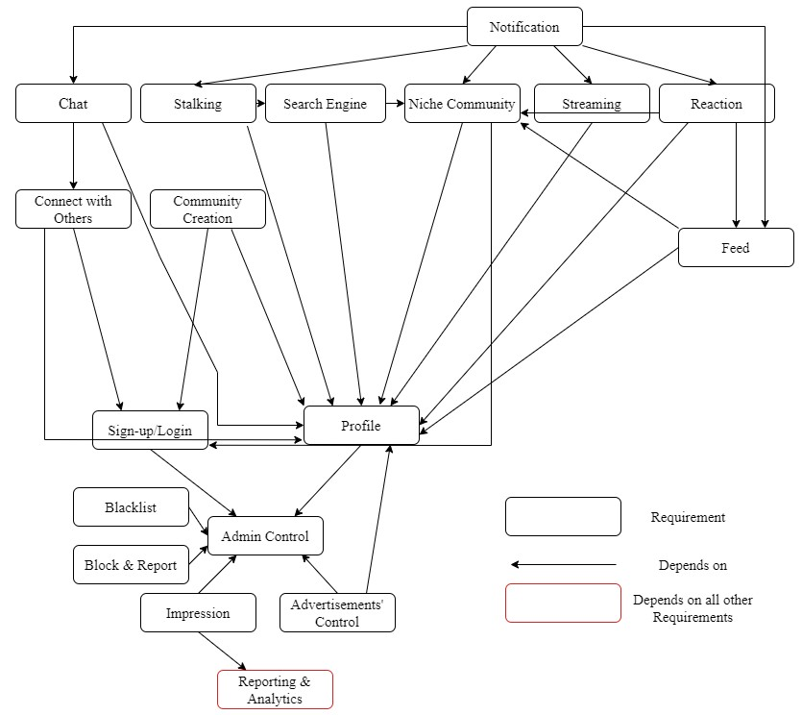

* Admin Control is a fundamental requirement that needs to be established before any other feature can be implemented. It is the foundation of the system that enables the management of the platform and its users.
* Sign-up/Login and Profile are dependent on Admin Control since they require an established platform to function.
* Connect with Others is dependent on Sign-up/Login and Profile, as users need to have a profile and be signed in to connect with others.
* Community Creation and Niche Communities are dependent on Sign-up/Login and

Profile, as users need to have a profile and be signed in to create and join communities.

* Feed is dependent on Profile, and Niche Communities, as it displays the content created by users within the communities/news feed they belong to.
* Chat is dependent on Connect with Others and Profile, as it requires user-profiles and connections between them to function.
* Streaming is dependent on Profile, as it requires user profiles to function.
* Reaction is dependent on Feed, Niche Community, and Profile as it requires user profiles and feed or community between them to function.
* Stalking is dependent on Profile and Search as it requires to have a profile and search for other profiles to stalk and be stalked.
* Search Engine is dependent on Profile and Niche Community as it allows users to search for other users and communities.
* Notification is dependent on Streaming, Chat, Stalking, Reaction, Feed and Niche Community as they notify users of activity related to their connections.
* Advertisements' Control is dependent on Admin Control and Profile, as it requires the ability to manage and measure the impact of advertisements.
* Impression is dependent on Admin Control and Reporting & Analytics, as it requires the ability to manage and measure the impact.
* Block & Report and Black Lists are dependent on Admin Control as they require the ability to manage and monitor user behavior.
* Reporting & Analytics depends on all other requirements as it is affected by other requirements, as it provides insights into user behavior that can inform decisions related to the other requirements.

# Software Architecture

The software architecture diagram for our social media app consists of several key components that work together to provide the functionality required by our users. At the center of the diagram is the core application logic, which serves as the main processing engine for all user interactions. This logic is implemented using a combination of server-side and client-side technologies, including Node.js, React, and Redux.

To provide users with a seamless experience, we've designed our app to be highly scalable and fault-tolerant. To achieve this, we've implemented a microservices architecture, with each service responsible for a specific set of tasks. For example, one service might handle user authentication and authorization, while another handles image uploads and storage.

One of the most critical components of our software architecture is the database. We've chosen to use a NoSQL database like MongoDB to store user data, posts, comments, and other content. This decision was based on the requirements document we produced in phase 1 of the project, which called for a flexible and scalable data storage solution that could handle large amounts of user-generated content.

Another important aspect of our software architecture is the use of APIs to connect different components of the system. We've implemented RESTful APIs to allow the client-side code to interact with the server-side logic and microservices. These APIs ensure that data is transmitted securely and efficiently between the different parts of the app.

Finally, we've included several third-party services and libraries in our software architecture diagram, including cloud-based storage services like Amazon S3 and content delivery networks like CloudFlare. These services help to ensure that our app is fast, reliable, and available to users all over the world.

Overall, our software architecture diagram is designed to meet the requirements set out in our initial requirements document, while also providing a scalable, fault-tolerant, and user-friendly platform for social media interaction.

# Software Interaction

Use case diagrams are a type of visual modeling tool that help to describe the interactions between users and a system. They are typically used during the design phase of software development to define the functional requirements of the system.

Use case diagrams consist of actors, use cases, and relationships between them. Actors are external entities that interact with the system, such as users, other systems, or devices. Use cases describe the specific functionalities or tasks that the system must perform to meet the needs of its users. Relationships between actors and use cases are represented by arrows, which indicate the flow of information or control between them.

Use case diagrams are an important tool for ensuring that the system meets the needs of its users and that all functional requirements are accounted for. They can also help to identify potential areas of confusion or misunderstanding between the users and the system, allowing for these issues to be addressed early on in the development process.

In the use case diagram on the right we included 8 primary actors: unregistered business user, registered business user, logged in business user, top admin, unregistered user, registered user, logged in user, and admin. These are the types of users that will access and use our system.

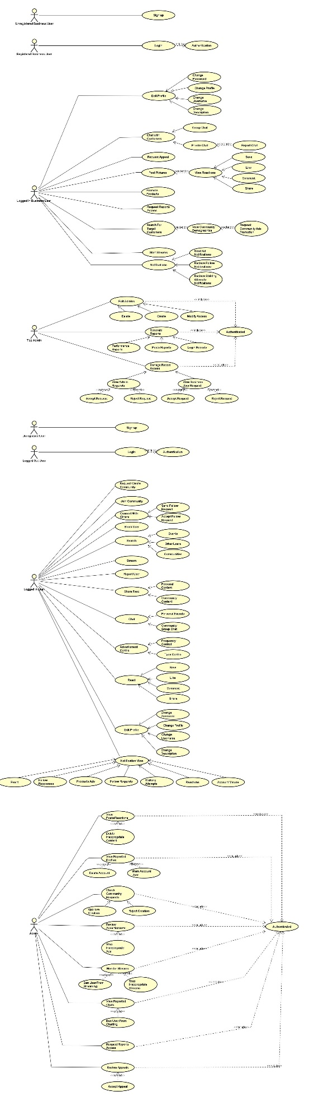Both unregistered business user, and unregistered user can perform a single activity that is signing up for the platform.

Both registered business user and registered user should login to use the system (authenticated).

Logged in business user can edit the profile (change password, profile, username, or description), chat with customers (private or group chats) and can further report any inappropriate chat message, request appeals, post pictures and further view different reactions (like, comment, share, and save), promote products, request reports access, search for target customers (view community demographics, request community ads promotions), start streams, and access notifications (send ad notifications, review follow notifications, and receive stalking attempts).

Logged in user can request community creation, join community, accept and send follow requests, block users, search for events, users, or communities, stream, report user, share personal or community feed, chat with friends or with communities, control advertisements frequency and type, react to posts (like, comment, share, and save), edit profile (change password, profile, username, or description), and view notifications (event, follow requests, follow response, Ads, stalking attempts, reactions and account misuse).

Admin needs to login first then can view posts and delete content if needed, view reported profiles and take further action (delete account, warn account user), check community requests approving or rejecting these requests, review and delete advertisements, monitor streams and stop or ban any if needed, view reported chats and ban users, request reports access, and review appeals.

Finally, Top Admin can perform 3 main activities which are editing admins (deleting, creating, and modifying access), generating reports (performance reports, posts reports, and login reports), and managing report accesses by accepting or rejecting admin and business user requests to access certain reports, all that after logging in to the account.

Below we have attached a link for the pictures as they are not clear on document due to their size.

# Software Components

## Activity Diagram

Activity diagrams are a type of visual modeling tool that describe the flow of activities and actions within a system or process. They are typically used to model business processes or workflows. Activity diagrams consist of nodes, which represent activities, and edges, which represent the flow of control between activities.

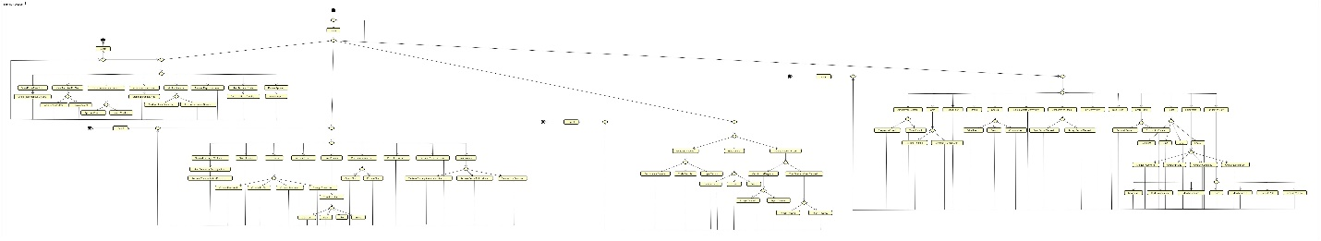

Following the use case diagram, the activity diagram provides more detailed providing more insight on how the system will execute. First the user will login either as a user, admin, top user, or business user. In case the person fails to login the page reloads so that they could try again. After logging in successfully based on type of user the person is offered various actions they might want to take as using the app. Similar to the above explained actions in the use case diagram. After going through any of the options, the user reaches a decision node were they decide to logout of their accounts or go back to choosing another option in the diagram to perform.

## Sequence Diagram

Sequence diagrams are a type of visual modeling tool that describe the interactions between objects or components within a system. They are typically used to model the behavior of a system over time. Sequence diagrams consist of actors, which represent the objects or components involved in the interaction, and messages, which represent the interactions between them.

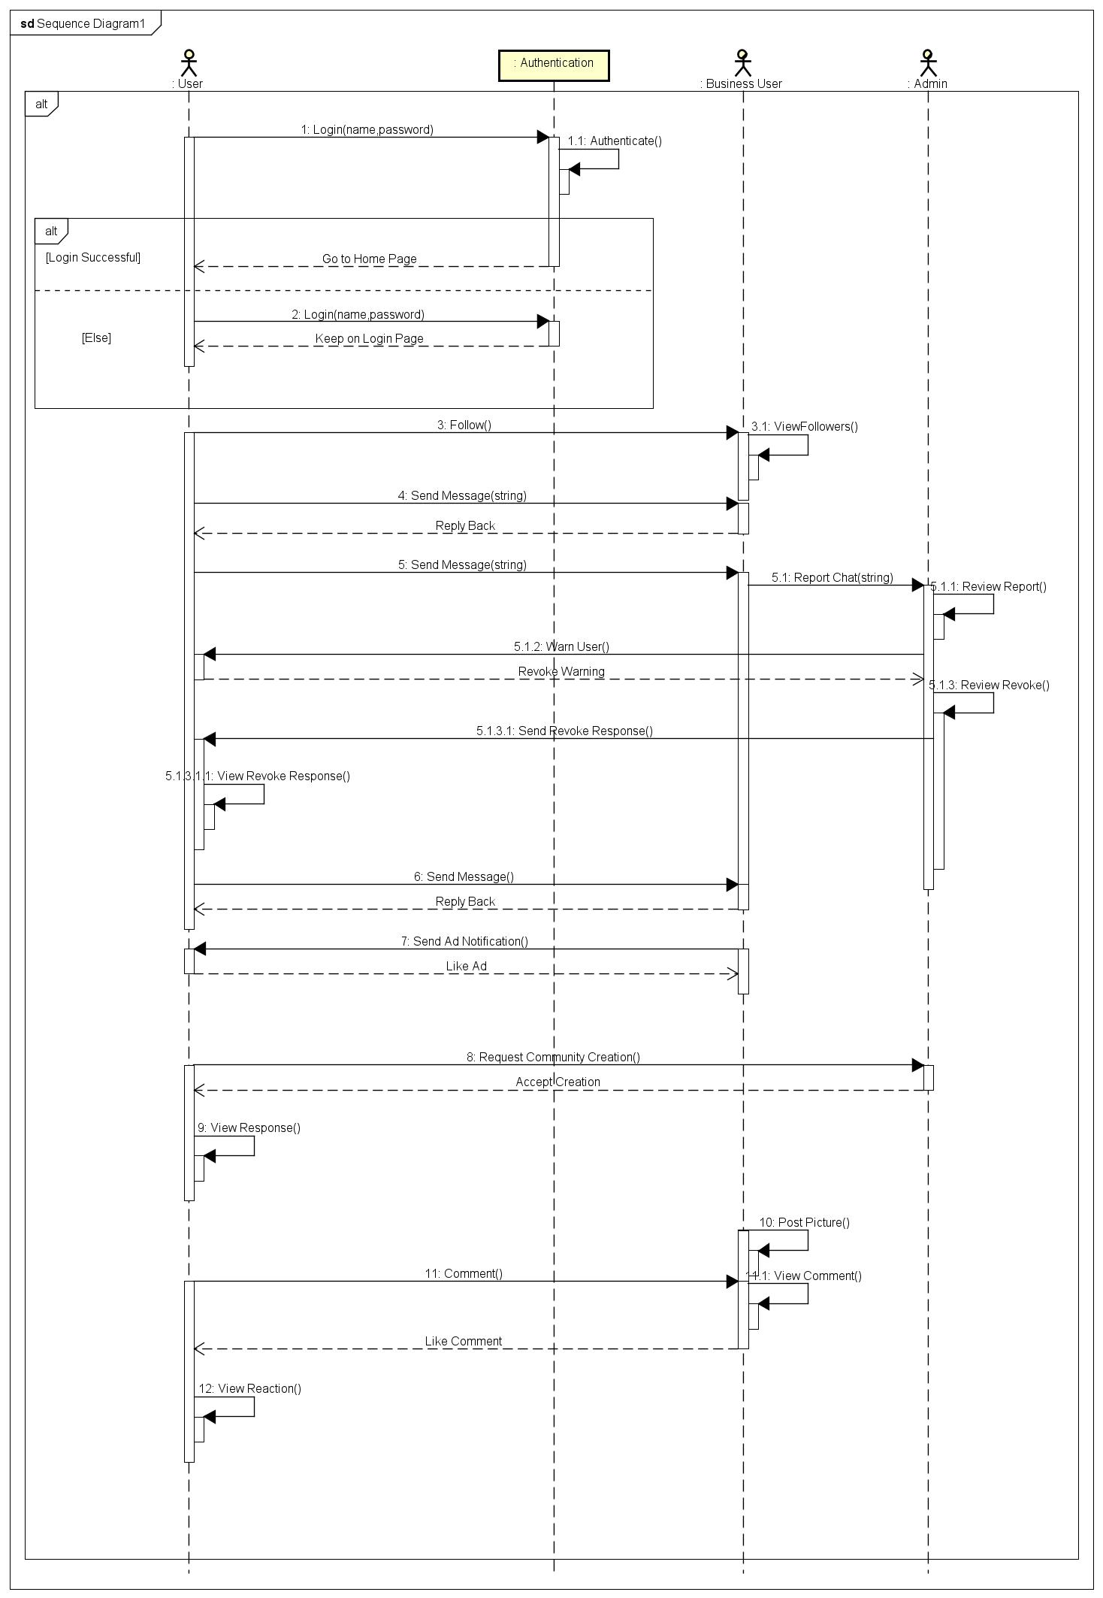\

The above sequence diagram describes the scenario when a user is trying to login to their account, if they manage to authenticate the account, they move to their home page ese the page reloads again. After logging in successfully, the user then follows a business user and initiates a message. Then business user views the follow notification and replies with a response and user sends a message again but this time the business user reports this message to the admin that reviews the report and warn the user regarding their message. The user requests to review the warning and the admin reviews it and send a response to the user that views the response notification. After that the user sends a message again to the business user that replies back. The business user then sends an ad notification which the user likes. The user then requests a community creation that is approved later by the admin. Lastly the business user shares a post the user comments on it and once the business user checks it they send a like reaction which the user will view.

# Software Structure

Class diagrams are a type of visual modeling tool that describe the structure of a system in terms of its classes, attributes, and relationships. They are typically used to model the data and behavior of a system. Class diagrams consist of classes, which represent the objects or entities in the system, attributes, which represent the properties of those objects or entities, and relationships, which represent the associations between objects or entities.

# 

The class diagram above shows the 10 main classes in our system: Message, Notification, Top Admin, Business User, User, Admin, Community, Authentication, Person, and Account. The relationships between classes are described below:

* First an account cannot exist without a person so this leads to a composition relationship between person and account.
* Every Person can have one or more user or business user account, but a person can have only one admin or top admin account. This explains one to many and one to one relationship between different users and Person.
* Any user can request a single authentication at a time so relationship between authentication and users is one to one.
* User and Business User can send or receive many messages so the relationship is many to many.
* User and Business User can receive many notifications so the relationship is many to many.
* One of many users can own and create many communities so the relationship between Community and User is many to many.
* An admin can approve many community creations so the relationship between Admin and Community is one to many.

1. We decided to use FastAPI because: it is a modern, fast (high-performance), web framework for building APIs with Python 3.7+ based on standard Python type hints.

The key features are:

* **Fast**: Very high performance, on par with **NodeJS** and **Go** (thanks to Starlette and Pydantic). [One of the fastest Python frameworks available](https://fastapi.tiangolo.com/#performance).
* **Fast to code**: Increase the speed to develop features by about 200% to 300%. \*
* **Fewer bugs**: Reduce about 40% of human (developer) induced errors. \*
* **Intuitive**: Great editor support. Completion everywhere. Less time debugging.
* **Easy**: Designed to be easy to use and learn. Less time reading docs.
* **Short**: Minimize code duplication. Multiple features from each parameter declaration. Fewer bugs.
* **Robust**: Get production-ready code. With automatic interactive documentation.
* **Standards-based**: Based on (and fully compatible with) the open standards for APIs: [OpenAPI](https://github.com/OAI/OpenAPI-Specification" \t "_blank) (previously known as Swagger) and [JSON Schema](https://json-schema.org/).

1. In this project we used the best practices and design patterns of FastAPI although it would take more time to implement, the code structure will get more complex, but it is efficient for scalability as the project will get bigger

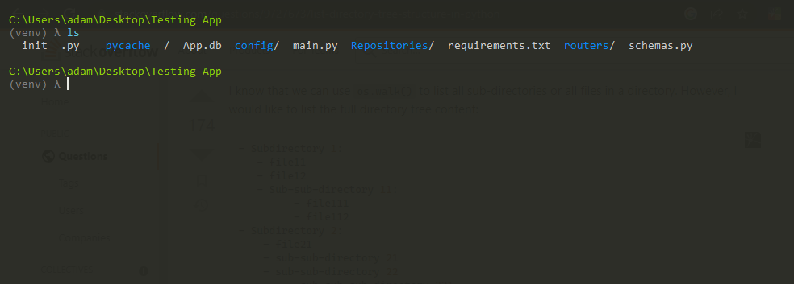

1. For the database we decided to use PostgreSQL for deployment and SQLite for testing. In this picture we are setting the database. As you can see, we are using Environment variables so would keep the database info secret as we publish the project.

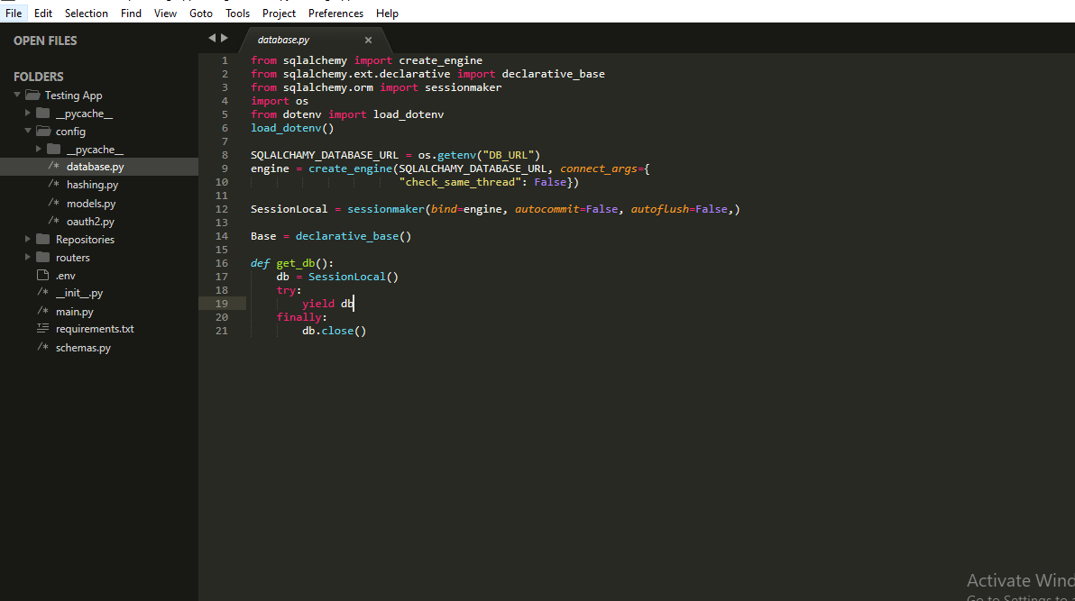

1. We decided to create 3 entities for this demo which are: User, Post, and Like.

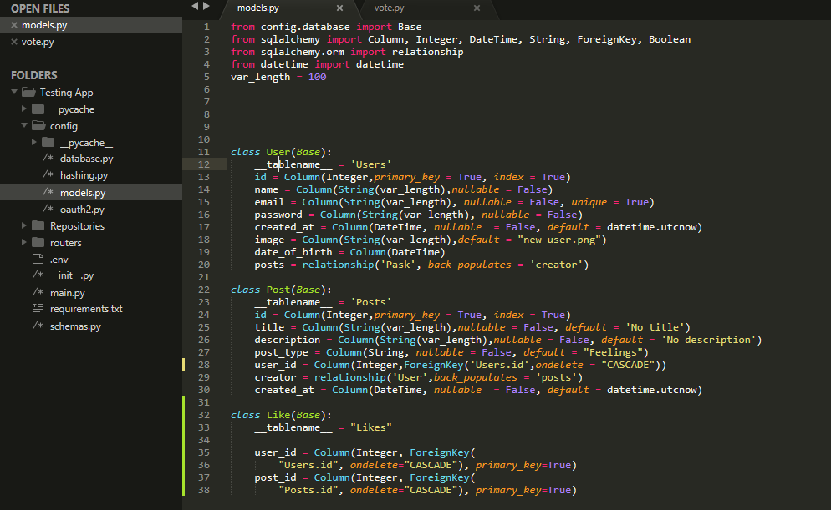

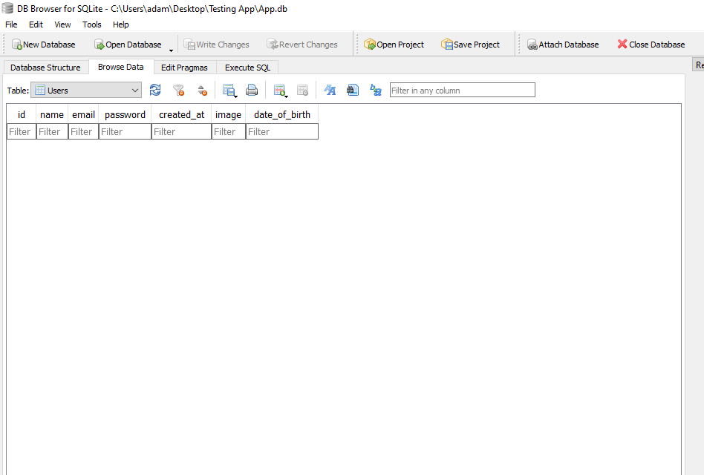

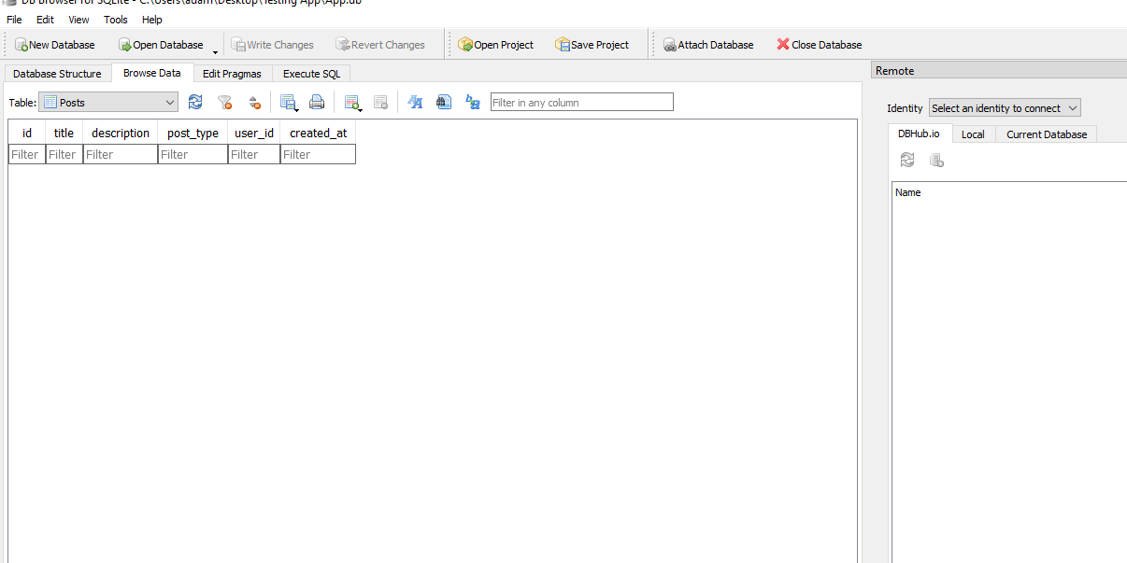

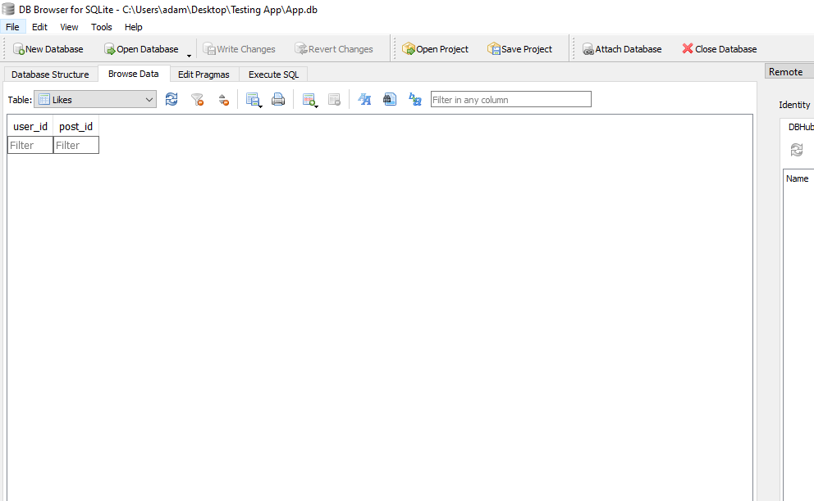

1. Add schemas folder which is responsible for showing the properties of each entity in different situations. For example, when creating a user, the client will see different properties of his account when he decided to make a post.

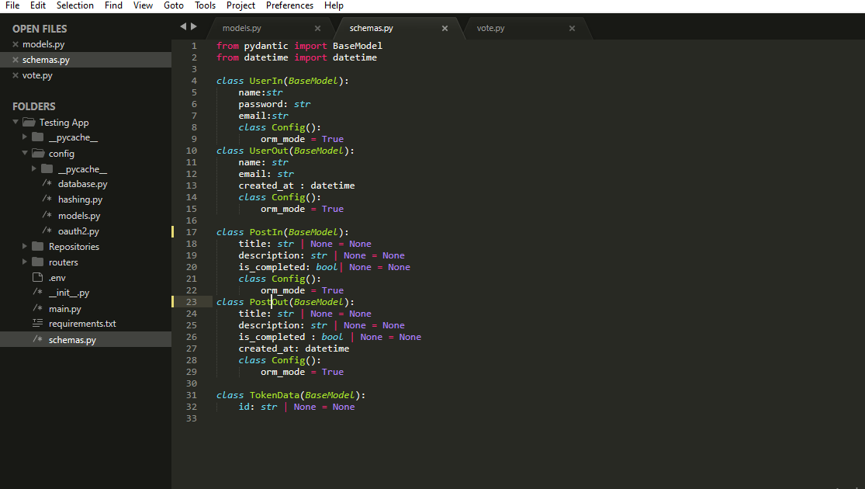

1. Implement the functionality to be able to send the users emails for signing up, password recovery, and changing password by using the SMTP protocol.

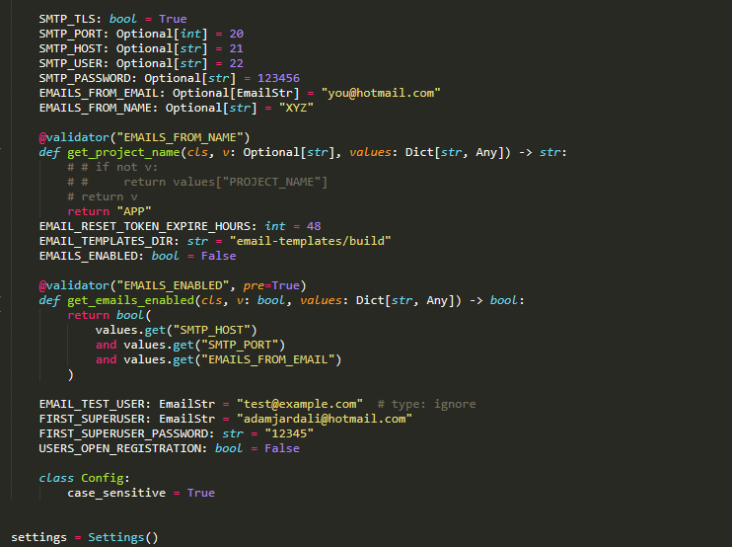

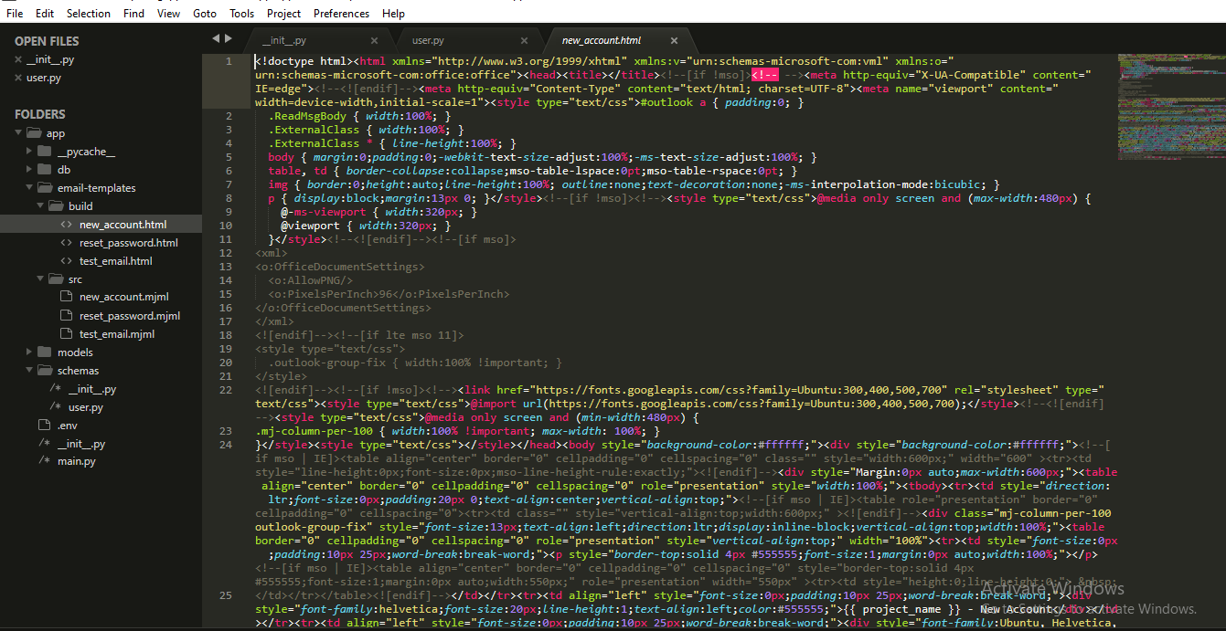

1. Authentication and resource Authorization: we will use JWT (Json Web Tokens) for authentication and resource authorization. There are many steps needed to implement it.
   1. Implement hashing algorithms as in the best practices, the stored password in the database should be hashed.
   2. Use oauth2 methods. Create methods for creating a token and verifying it.
   3. Apply functional dependency

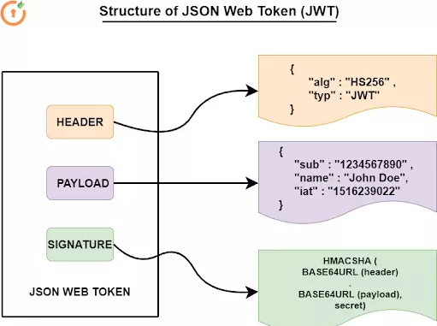

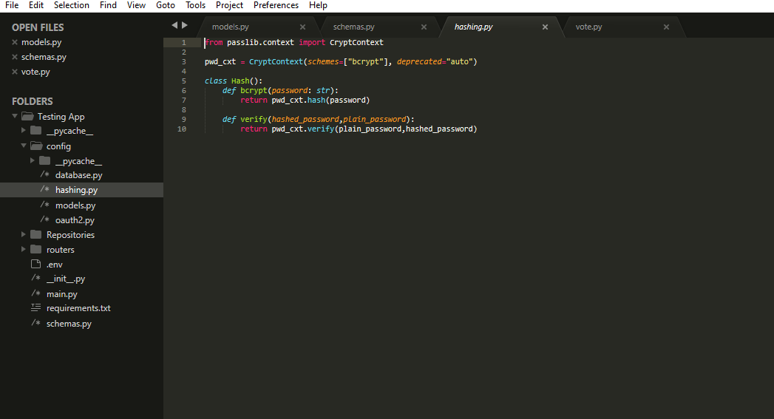

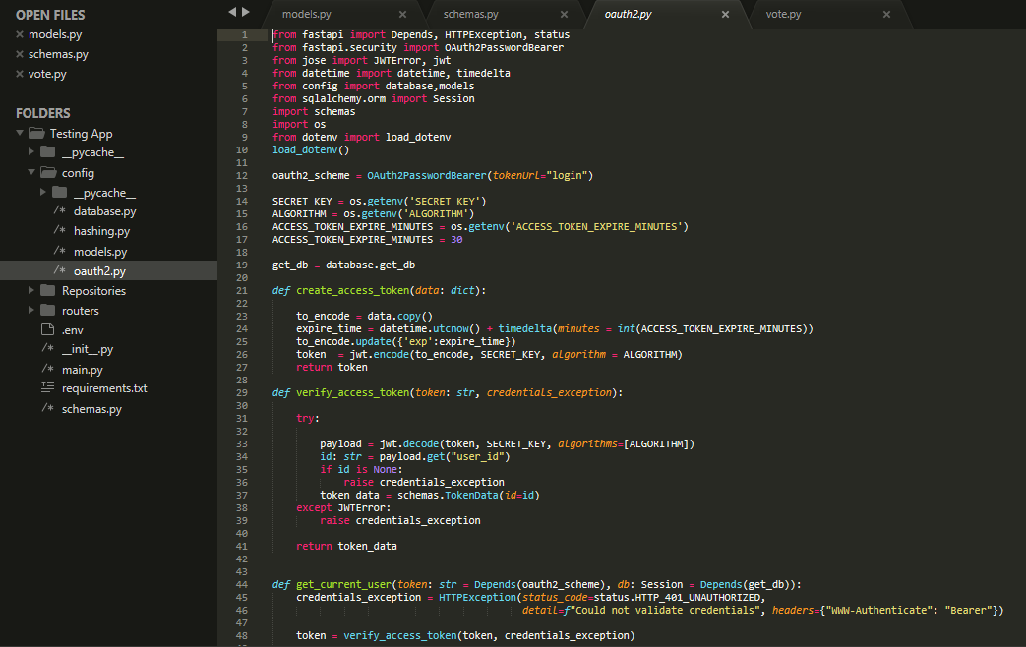

1. Use the repository pattern for implementing each entity functionalities.

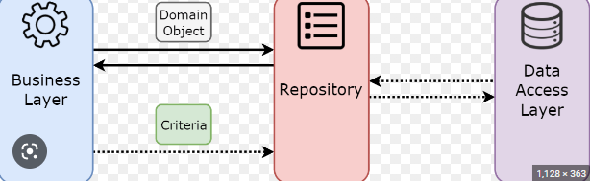

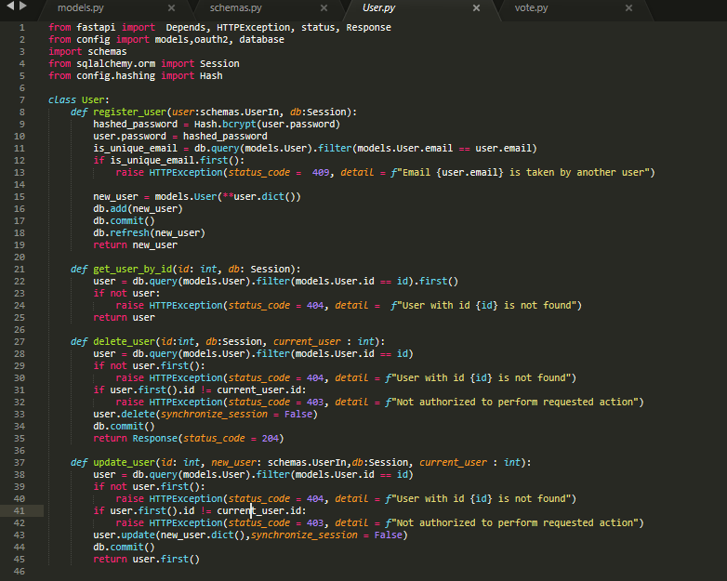

1. Implement the routers of each entity.

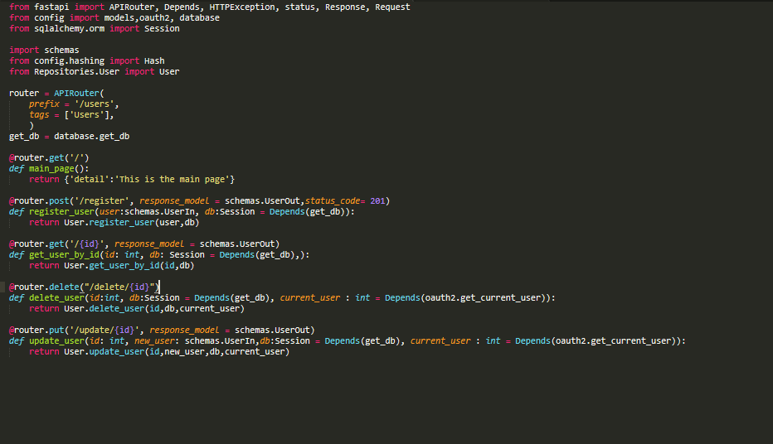

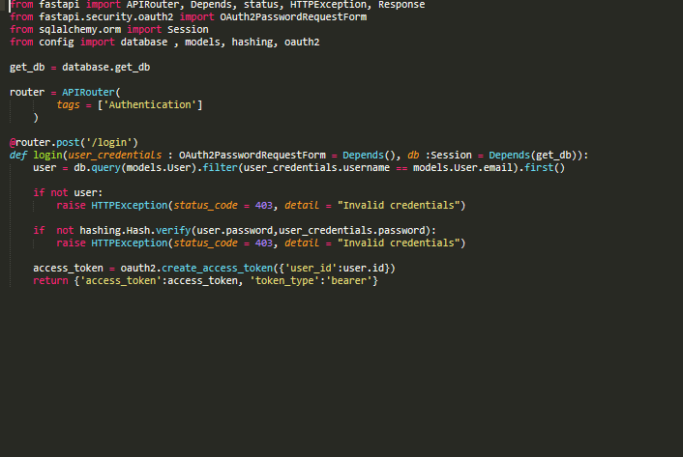

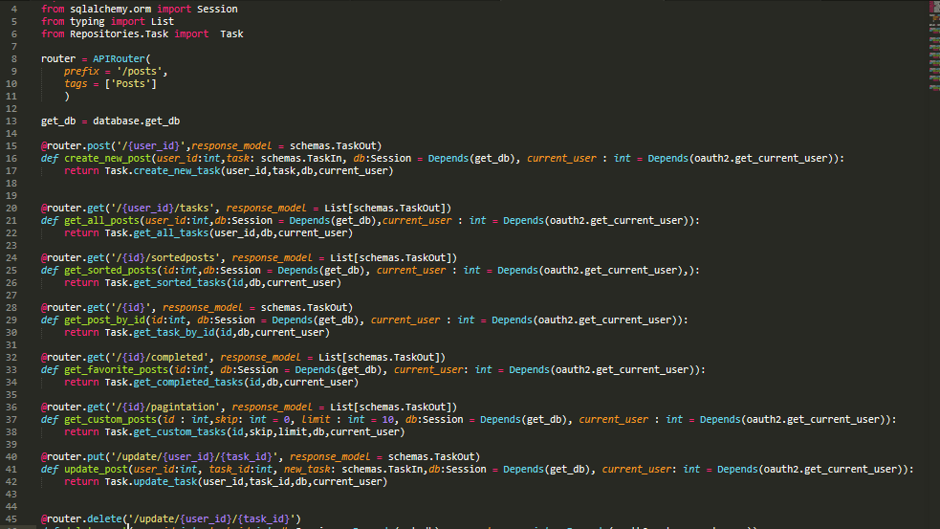

1. Now its time for testing. No need to use postman as FastAPI provides a UI for that purpose.

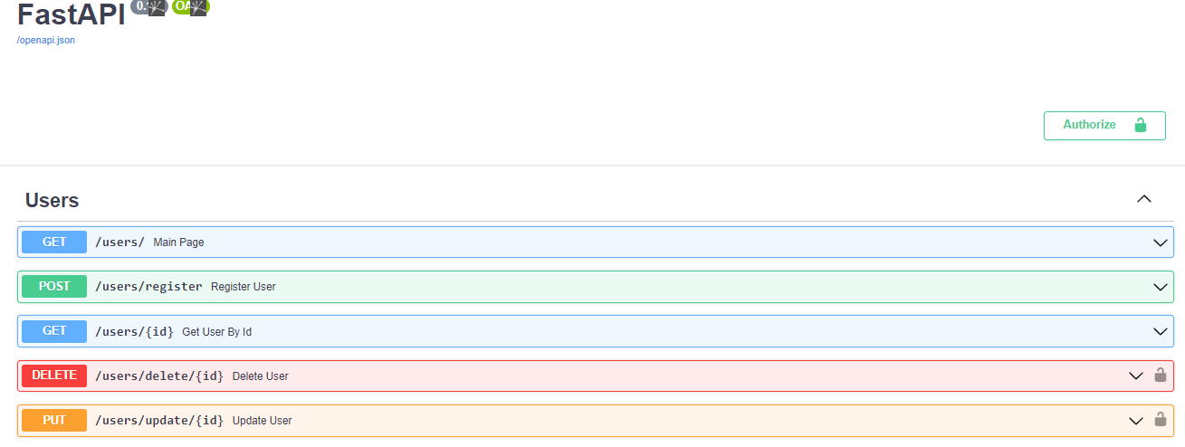



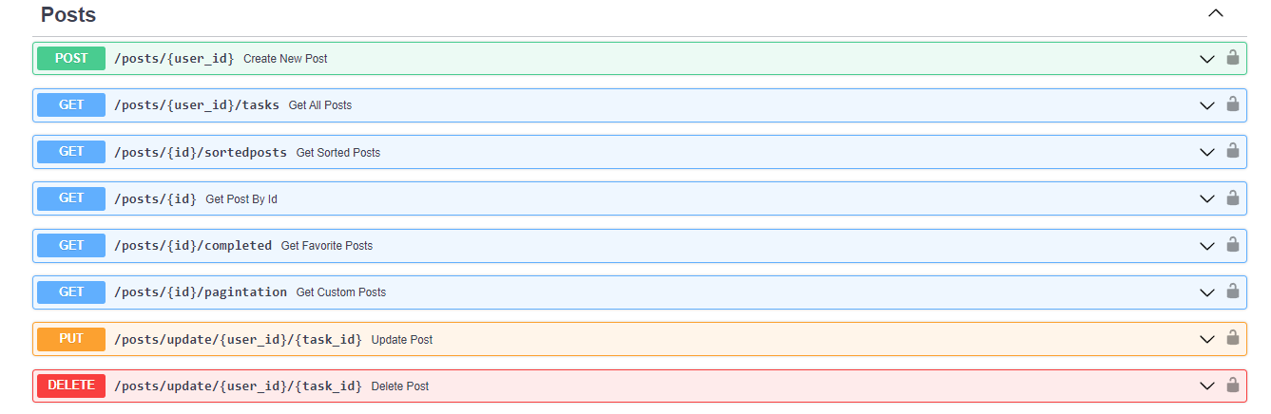

1. After testing creating a new user with different scenarios everything worked fine.

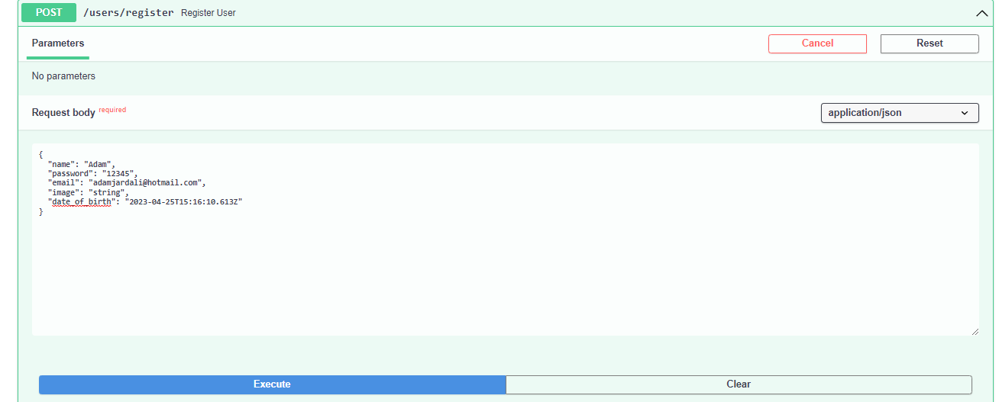

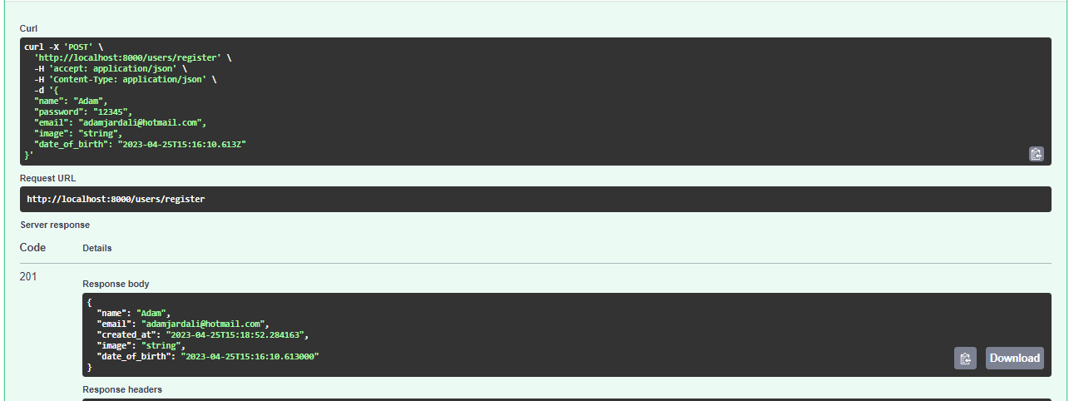

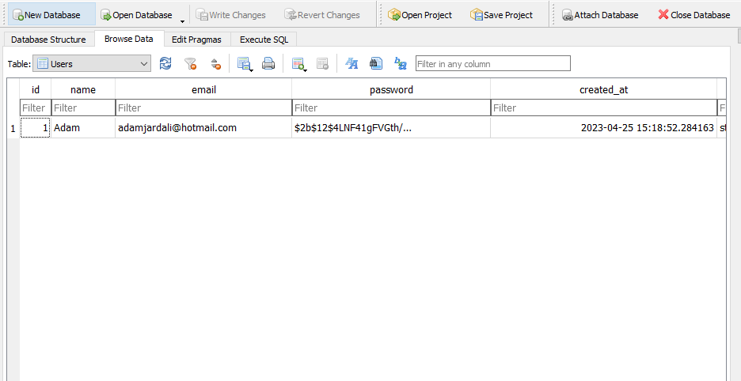

1. Sign in with new user and try wrong inputs to see if it works

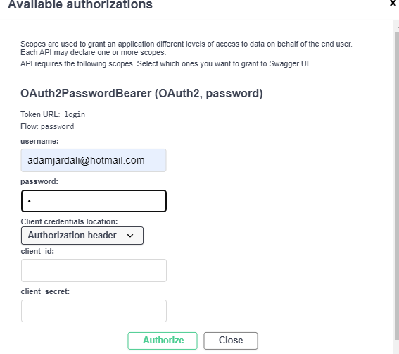

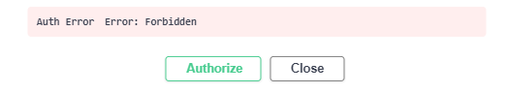

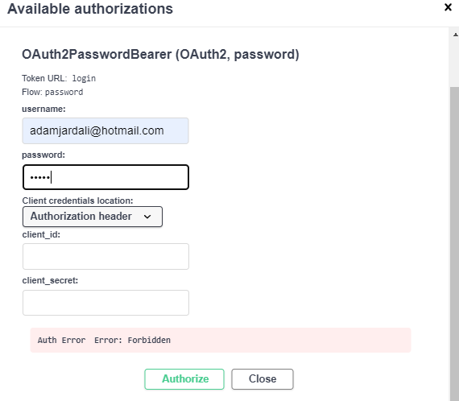

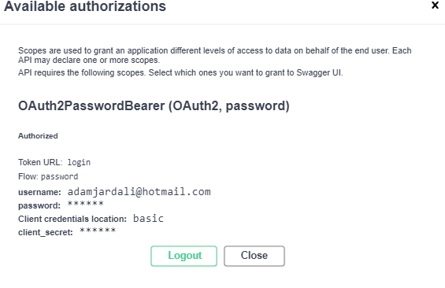

1. Test the functionality to delete an account that you don’t have the privileges to do that.

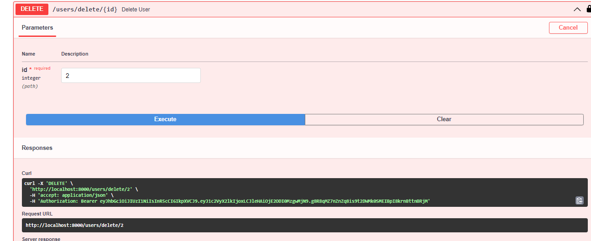

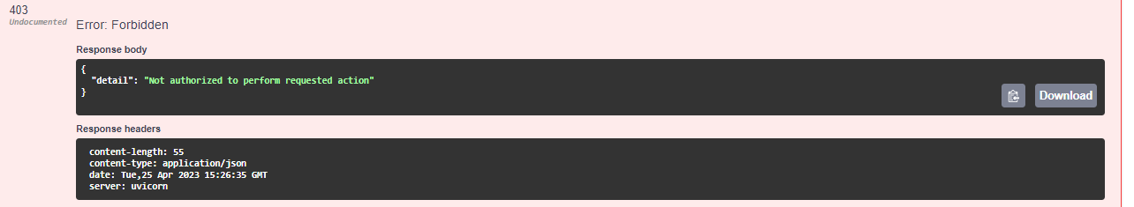

1. Test creating new posts and then list all of them. You should be authenticated to do that.

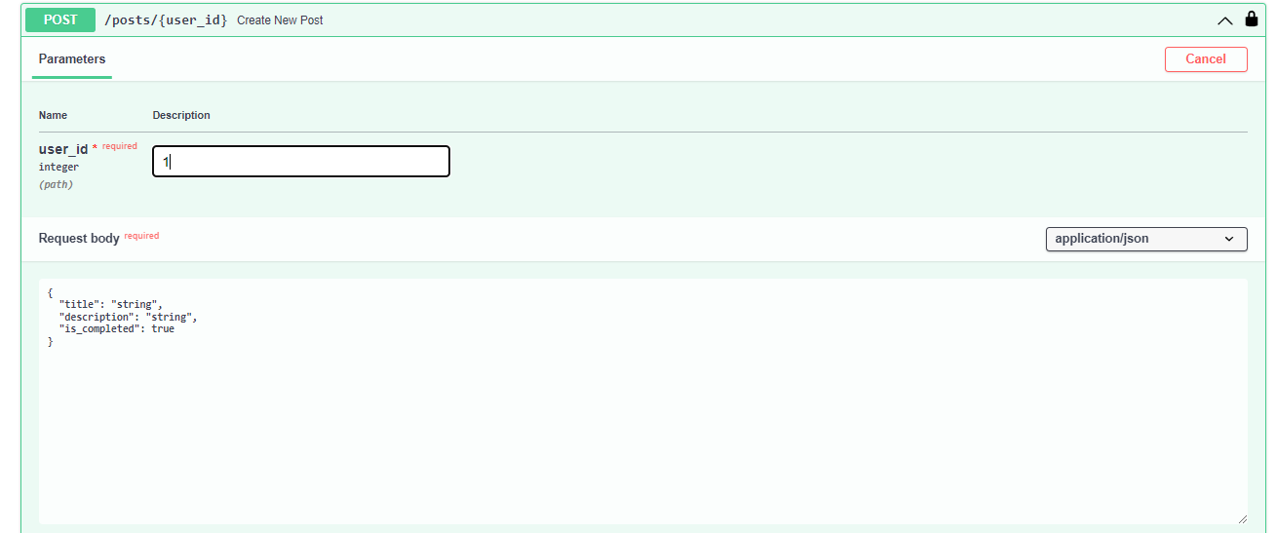



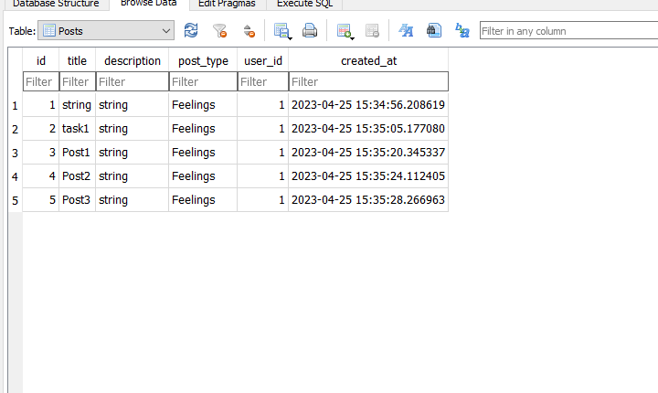

# Conclusion

In conclusion, the design phase of our social media app was a critical step in ensuring that we are able to meet the needs of our users and build a high-quality, scalable, and reliable platform for social media interaction. By carefully considering the requirements set out in our initial requirements document, we were able to create a software architecture diagram that incorporates all of the key components necessary to meet these requirements.

The use case diagrams, activity diagrams, sequence diagrams, and class diagrams that we produced during the design phase were also instrumental in helping us to better understand the behavior and structure of our system, as well as the interactions between different components. This understanding will be invaluable as we move into the implementation phase, where we will be translating our design into actual code.

During the implementation phase, we will be using the design produced during the design phase as a guide to ensure that we are building the system according to the specifications and requirements we set out. We will also be using the various diagrams and models produced during the design phase as a reference to help us make informed decisions about how to structure our code, implement key features, and test our system.

Overall, the design produced during the design phase is a critical foundation for the successful implementation of our social media app. By following this design and incorporating it into our development process, we are confident that we will be able to create a platform that meets the needs of our users and exceeds their expectations.

# References

Survey

[https://docs.google.com/spreadsheets/d/1FrOGuellDNwfJqPWxZ5dMF9z5L\_NYkZYda7OTevtOQ/edit?usp=sharing](https://docs.google.com/spreadsheets/d/1FrOGuellDNwfJqPWxZ5dMF9z5L_NYkZ-Yda7OTevtOQ/edit?usp=sharing)

Diagrams

<https://drive.google.com/drive/folders/1hQJG1FTwe89ogqdfKFmwCKXygrBIduJa?usp=sharing>