# Report 1 - Analysing motor model

## Authors

Stanislav Karpenko s20205  
Adam Jędrzejewski s20335

## Robot

Alpha Bot GANDALF

## Implementation

### Arduino

On Arduino side PWM value is being read from the serial and written to left and right pin, every 5 seconds, the number of interrupts on the left and right pin is written to serial.

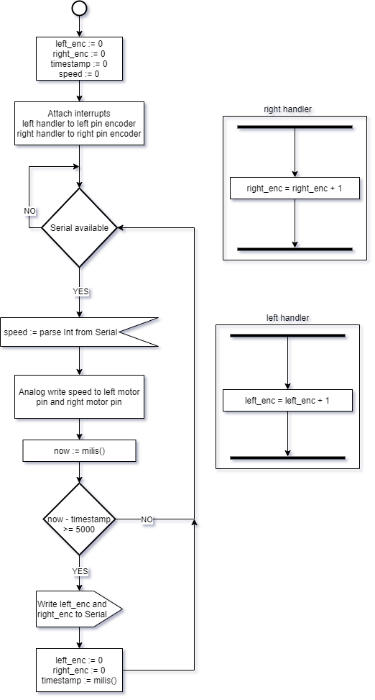

## Python

On Python side PWM value is written to a serial, from 50 to 250 by 10, for each PWM value 6 readings are performed, an average of these readings is recorded for each wheel. After reading gathered averages are saved in CSV file.

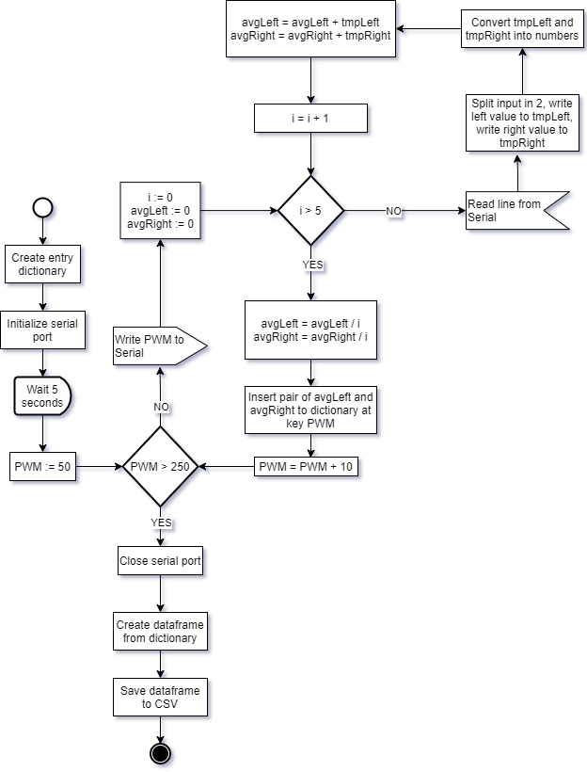

## Results

|  |  |  |
| --- | --- | --- |
| PWM | Left | Right |
| 50.00 | 0.00 | 0.00 |
| 60.00 | 0.00 | 0.00 |
| 70.00 | 0.00 | 0.00 |
| 80.00 | 0.00 | 136.40 |
| 90.00 | 0.00 | 261.60 |
| 100.00 | 0.00 | 293.60 |
| 110.00 | 0.00 | 322.00 |
| 120.00 | 258.40 | 349.20 |
| 130.00 | 278.60 | 369.40 |
| 140.00 | 305.40 | 388.60 |
| 150.00 | 322.40 | 403.40 |
| 160.00 | 341.20 | 417.60 |
| 170.00 | 359.20 | 432.60 |
| 180.00 | 376.00 | 442.60 |
| 190.00 | 391.00 | 452.40 |
| 200.00 | 400.20 | 461.40 |
| 210.00 | 413.40 | 475.80 |
| 220.00 | 422.20 | 488.40 |
| 230.00 | 430.40 | 497.60 |
| 240.00 | 439.40 | 508.20 |
| 250.00 | 447.40 | 519.80 |

### Linearity range

#### Left

#### Right

### Linear regression results

#### Left

$$y=1.4392087912087914*x+104.1178021978023$$

##### Right

$$y= 1.7475954592363252*x+112.79119367045064$$