# Documentation:

## Information about the program:

This program is designed to effectively and efficiently use biometrics to allow a user to vote.

This program is solely to be used to check and save biometric information and should be used in conjunction with another program to save the actual vote. THIS PROGRAM DOES NOT SAVE ANY VOTE.

All faces are stored in the folders: “faces” and “voted”

## Prepare computer to use program:

- Intended for computers running Windows 10/11

- The computer MUST either have a built in camera or just 1 external camera.

- install python 10, python 11 will not work.

- install visual studio community edition and install "Desktop Development with C++".

- click on the file path on the open folder with this file in and type cmd, this will open the folder in cmd.

- run "pip install -r modules.txt", this will install all the relevant modules

- Before using this program the password for the admin should be changed in the source code, in the specific file “face_rec.py” line 92.



* The computer and camera should be set up like this:

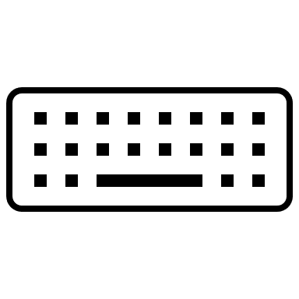

## How to use the program:

- run the “start.py” file

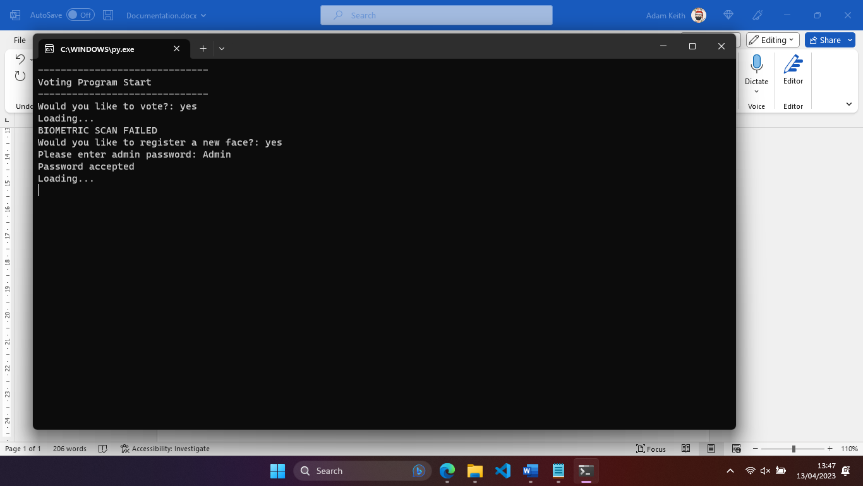

If the user is not registered this screen will appear and an admin password must be inputted to register a face.

When this screen is displayed the user should stay as still as possible and look towards the screen.

This will then be displayed (with the output of the camera in the grey square.)

To take a photo make sure the user is in the frame and press SPACE

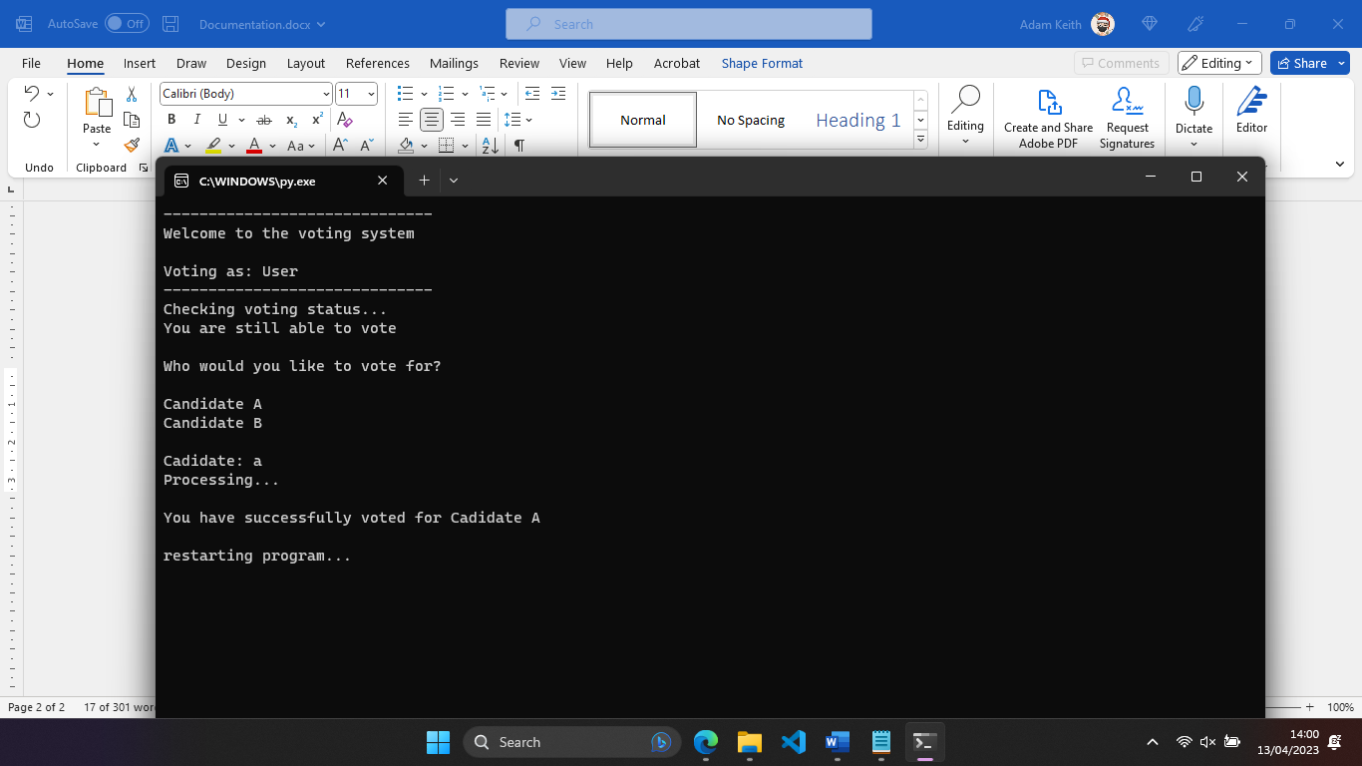

If the user is registered and the user has not voted already then this will be displayed.

After the user inputs the candidate this will be displayed.

Once a photo is taken an input will be promoted, this should be done by an admin who has checked the users ID and input the name.

If the user has voted previously then this will be displayed.

## Closing the program

Simply close the window you opened the program in, e.g. Windows Command Processor.

## Removing the program

The program should be kept in a single folder, this makes it easier to remove. Simply delete the folder all the code is stored in, this will move the folder to the recycle bin where it will be stored temporarily, this can be fully deleted by deleting the folder from the recycle bin or waiting for the recycle bin to delete it in 30 days by default.

#### Development Libraries used

This program was written and designed by Adam Keith using the programming language Python. Some different Python Libraries were used to allow the software to work this are listed below:

* cmake
* dlib
* face_recognition
* numpy
* opencv-python