Lecture 3
Valuation of Contingent Claims and Replicating Portfolios

Definition 1. A contingent claim is a random variable X representing the payoff of a contract at time 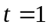.
The question we are addressing is: What is a fair price the buyer of the contract must pay at time  to get the payoff X at time ?
Definition 2. A contingent claim X is attainable or marketable if there is a trading strategy H such that the value of the portfolio at time under that strategy is X.
Recall that 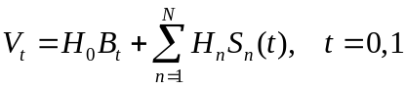. If such a portfolio exists, it is called a replicating portfolio.
Theorem 1. Assume that X is an attainable contingent claim, and the market model is free of arbitrage. Then the price of the contingent claim at time 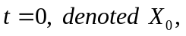 is exactly 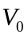.
Proof.
The idea of the proof is to show that in any of the cases in which 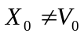, arbitrage opportunities are created.
Let us assume 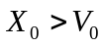. Then, an investor could sell the contingent claim at 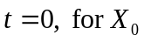, then follow the strategy that replicates the claim, investing . At the replicating portfolio will have the same value as the contingent claim in all states of the system. Therefore the investor has made a riskless profit 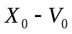 at .
If 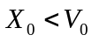, thus 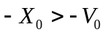. An investor could purchase the contingent claim, follow the strategy 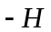, thus collecting , and making a profit 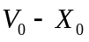.
Therefore the price of the contingent claim at time must be .
QED
Observation 1. One could argue that the replicating portfolio may not be unique, and if 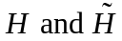 are replicating portfolios such that 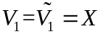, could it be that 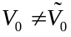? The answer to this question is negative because of the lack of arbitrage assumption, and therefore there is a unique cost for the contingent claim.

The next Theorem gives a computational formula for the cost of an attainable contingent claim without involving the replicating portfolio.
Theorem 2. Assume that X is an attainable contingent claim, and the market model is free of arbitrage. Then, the cost of the contingent claim at time is
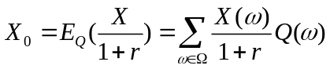,
for any risk neutral probability measure Q.
Proof. Let H be a replicating portfolio for the claim. Then, by Theorem 1, the cost at time is 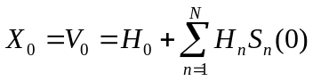. If Q is a risk neutral probability measure, by definition we have 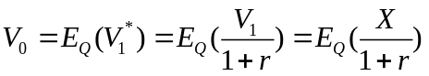.
QED
Example 1. Let , and consider the claim 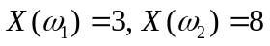. We want to check whether X is attainable. Therefore, we have to solve the system
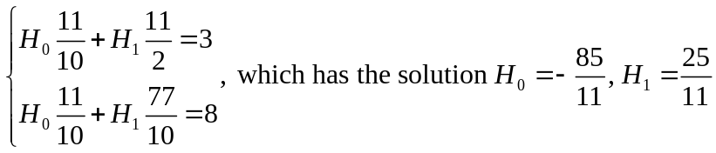.
We saw in Example 6, Lecture 2 that there exists a unique risk neutral probability measure, 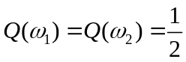. Then, 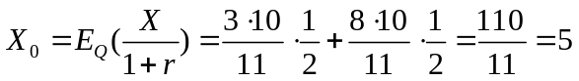.

Let us now have a look at options. Recall that for a call option on a security S, with expiration date , and strike price K, the holder will exercise the option if 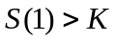. Therefore, the payoff is 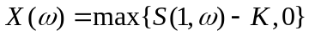. If the contingent claim is attainable, there exists a strategy H, such that
.
Example 2. Consider the data in Example 1, with a call option on S with strike price 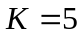. We have 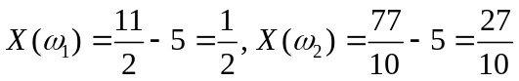.
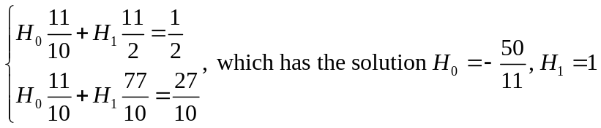. Therefore the call is attainable and its cost is 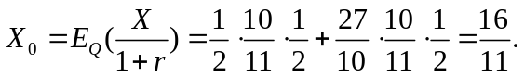 Notice that the time zero value of the portfolio is 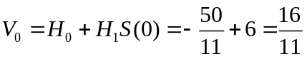.

Let us see now what happens in a more complex model.
Example 3. Let 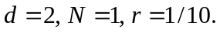
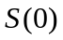 |  | 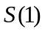
 | 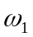 | 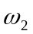 | 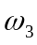
6 | 11/2 | 77/10 | 33/10
Let us see under what conditions is a claim X attainable? We need to solve the system:
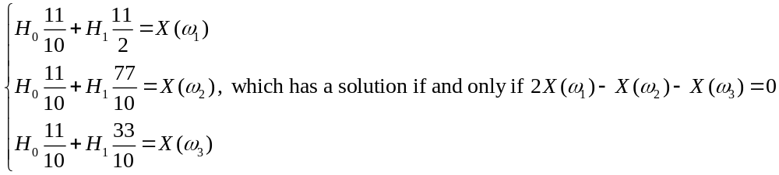Therefore, in this market model, a contingent claim is attainable if and only if 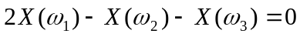.
Example 4. With the data from example 3, consider a put option with strike price 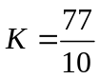. The payoff to the holder of the put is: 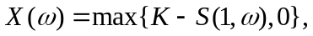 which gives 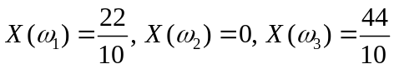, which is attainable. We compute the cost at time zero of the put using Theorem 2. We have from Example 7, Lecture 2, that the market model has infinitely many risk-neutral probability measures, of the form 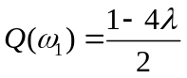
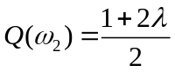, 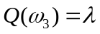. Then
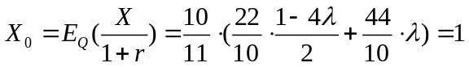.
So from Example 3 we saw that the fact that the model does not have arbitrage opportunities (we saw that there exists at least one risk neutral probability measure) does not guarantee that every claim is attainable.
Moreover, as it could be seen from Example 4, even if the market model has infinitely many risk-neutral probability measures, the cost of an attainable contingent claim is independent of the measure. In fact, we have a stronger result which characterizes the attainable contingent claims in a market model that free of arbitrage.
Theorem 3. Suppose the market model is free of arbitrage. Then, a contingent claim X is attainable if and only if 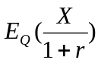takes the same value for all risk neutral probability measures.
Proof. We will only prove one implication, which is immediate. If a claim X is attainable, then 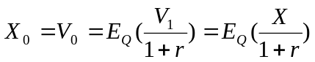, for some replicating portfolio and a risk-neutral probability measure, Q. But since does not depend on the risk-neutral probability measure, it follows that does not depend on Q.
QED

Definition 3. The market model is complete if every contingent claim is attainable. Otherwise, the model is said to be incomplete.
For complete markets we have a very interesting result, pointed out in the next theorem.

Theorem 4. The market model is complete if and only if there exists a unique risk neutral probability measure.
Proof.
One implication follows from Theorem 3. If there exists a unique risk neutral probability measure, then for every contingent claim X, takes a unique value, and by Theorem 3, X must be attainable. Therefore the model is complete.
Assume now that the model is complete, and suppose there exist two distinct risk-neutral probability measures . Define then
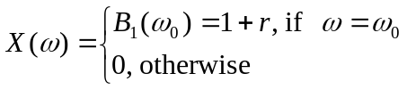
X is a contingent claim, and since the model is complete, X must be attainable. By Theorem 3, 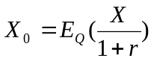 independent of the risk-neutral probability measure Q. In particular we must have 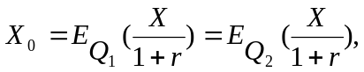 which is equivalent to
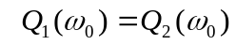, but this contradicts our assumption, and therefore there must be a unique risk neutral probability measure.
QED

EXERCISES
- For the data in Example 1 consider a call option on the risky security with strike price 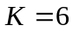. Determine whether the payoff of the option is attainable, and in case it is find its value.
- For the data in Example 1 consider a put option on the risky security with strike price . Determine whether the payoff of the option is attainable, and in case it is find its value.
- Suppose the interest rate is r, and denote by c and p the cost of a call and put options, respectively, on a security S, with the same exercise date and strike price, K. Show that both derivatives are attainable, or neither is attainable. In case they are attainable, use Theorem 2 to prove the put-call parity formula: 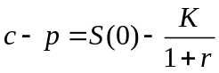, where 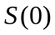is the value of the stock at time zero.

