New York University Abu Dhabi

Decoding Electrical Muscle Stimulation Intensity from Electroencephalography Signals
A Machine Learning Pipeline for a Closed-Loop Neurofeedback System

Researcher: Adam Kablawi
Principal Investigator: Dr. Mohamad Eid
July xth, 2026

1. Introduction and Problem
For electrical muscle stimulation closed loop systems, calibration remains a difficulty for technologies across applications such as neurorehabilitation, physical therapy, and VR/XR. This demanded the design of a complete offline machine-learning pipeline that decodes the perceived intensity of an electrical muscle stimulation (EMS) pulse from a subject's EEG brain response. In the system, on each particular time interval, an EMS device delivers a pulse at one of several pre-set intensities (or none) to the forearm, and a scalp EEG following stimulus onset records the cognitive response; the task is to predict, from a single trial's EEG epoch, which stimulation intensity produced it.
This decoder is the prerequisite for the project's ultimate goal: a closed-loop, discomfort-aware neurofeedback system that reads the cortical response in real time, detects when stimulation becomes intolerable or imperceivable, and adjusts intensity and allowable intensity threshold accordingly. This is a technology with direct therapeutic applications in anxiety treatment and neurorehabilitation. My work specifically covers the offline decoding and modelling stage: preprocessing, feature engineering, model design, validation, explainability, deployable final model, and example live pipeline. This work is intended for publication.
The problem is difficult for three reasons: the discriminative signal is a stimulus-locked evoked response whose neighbouring intensities look similar (errors concentrate between adjacent classes); each subject provides only 160 trials, so high-dimensional feature sets overfit; and there is large inter-subject variability, producing a persistent gap between within-subject and cross-subject accuracy.

2. Data and Preprocessing
The dataset comprises 31 subjects, of which subjects 10 and 24 have been removed due to excessive noise. All data was recorded with a 60-channel EEG montage at a 1000 Hz source rate. The preprocessing pipeline was build to convert each raw recording into modelling-ready epochs: anti-aliased downsampling to 250 Hz, stimulus-locked epoching to a −0.2 s to +1.5 s window (425 samples, retaining a 200 ms pre-stimulus baseline), and a per-subject artifact filter that removes trials with outlier pre-stimulus baseline variance.
From the four original stimulation levels I formulated several class schemes to ask different scientific inquiries: the original 4-class set (no-stim / min / medium / max [40/40/40/40]); a primary 3-class set (no-stim / medium / max, [40/80/40]); a balanced 3-class set (min / medium / max [40/40/40]); and a 2-class (tolerable / intolerable, [120/40]) set that frames the safety-relevant question directly.
Figure 1 below demonstrates the 160 trial average evoked responses (ERPs) of the first 4 subjects’ central and fronto-central dataacross stimulation conditions, visually illustrating the stimulus-dependent neuro-haptic response the machine learning model exploits in the time domain. The full 31 subject diagram is in the appendix.
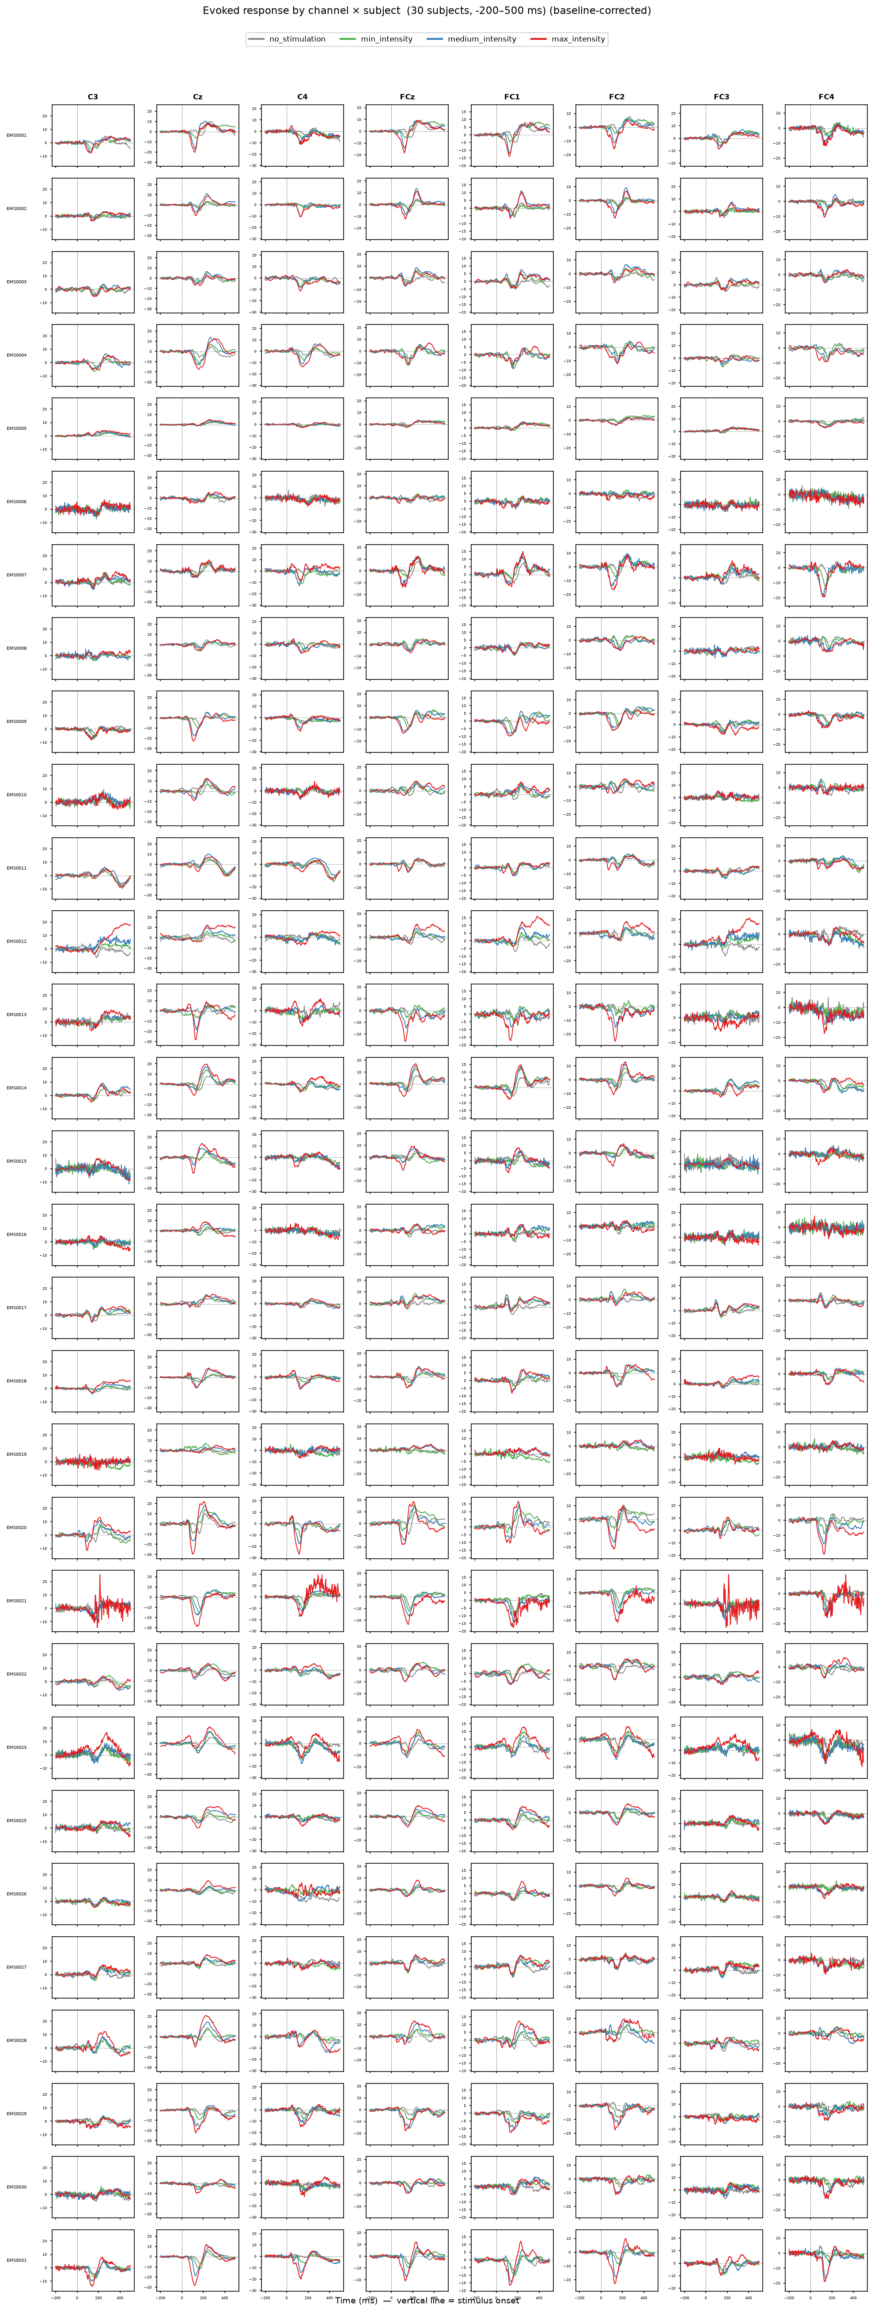

3. Methods
Feature representations.
A modular feature pipeline has been designed in which any set of “feature families” can be combined, each a self-contained, scikit-learn-compatible extractor grounded in a distinct neural phenomenon:
- ERP / SEP (time domain): amplitude and latency features of the somatosensory evoked potential over central and fronto-central channels.
- Band-power (frequency domain): log spectral power per canonical band (delta, theta, alpha, beta, gamma).
- ERD/ERS (time-frequency): Event-related de/synchronization of sensorimotor rhythms.
- Riemannian covariance: channel-channel covariance projected into tangent space.
- Functional connectivity: single-trial phase-locking (PLV / iPLV) between fronto-central, central, and parietal regions.

Classifier and validation.
Each family feeds a shrinkage-regularized Linear Discriminant Analysis (LDA), well suited to high-dimensional, collinear EEG features. Every model is evaluated with two leakage-safe schemes: within-subject repeated stratified k-fold (the ceiling with per-person calibration data) and, most importantly, leave-one-subject-out (LOSO), which measures generalization to a new user. Pipelines are refit inside every fold so no feature or scaler leaks across the train/test boundary.

4. Models and Results
Baselines were initially established, then systematically improved on. A shrinkage-LDA on ERP + band-power features decodes the 3-class task at roughly twice chance (33%), and a from-scratch EEGNet convolutional network learning directly from raw EEG did not beat it. With only 160 trials per subject, the deep network has no data advantage over a well-regularized linear model on efficient, neuroscience backed features.
However, simply concatenating the time-frequency or Riemannian families into one large feature vector fed to the LDA harmed cross-subject accuracy (statistical dilution on limited data), and a nested cross-validation feature-selection search could not beat the ERP + band-power baseline. The lesson was that the path forward was a more “allowing” architecture, rather than more features.
The most significant architectural shift was using a stacking ensemble: training one LDA per feature family and fuse their class-probability outputs with a logistic meta-learner. Each base model stays low-dimensional relative to its own family, and the meta-learner learns how much to trust each. Therefore, complementary-but-individually-weak views add opinion rather than diluting the input vector. This is the only approach that beat the baseline LDA using ERP + BP on both LOSO and within-subject accuracy.

Table 1. Decoding accuracy across main models (within-subject and LOSO accuracy).
Model (3-class unless noted) | Within Accuracy / Bal | LOSO Accuracy / Bal
LDA, ERP + band-power  (baseline) | 71.1 / 70.3 | 62.8 / 59.9
EEGNet  (deep network, raw EEG) | 63.4 / 64.7 | 59.8 / 60.8
Stacking ensemble  (4-family) | 73.0 / 70.2 | 66.7 / 63.0
Stacking ensemble  (5-family) — BEST | — | 68.1 / 64.8
Stacking, 7-channel  X.on montage | 69.1 / 65.4 | 64.0 / 59.8
2-class  tolerable vs intolerable | 87.3 / 86.4 | 79.9 / 79.9

Feature interpretation.
Because the pipeline is linear, reading exactly which neural features drive the decoding was possible. Two convergent analyses (univariate discriminability and fold-stable LDA weights) show the decoder relies on central/fronto-central evoked-potential amplitude plus gamma-band power, and these features scale monotonically with stimulation intensity. There is a genuine dose-response.
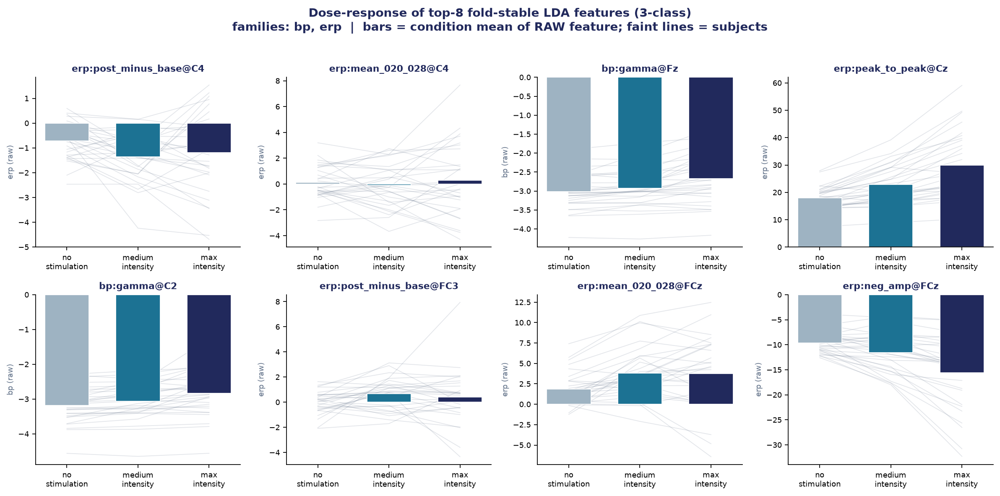
Figure 2. Dose-response of the top decoding features across the three intensity conditions; the features increase monotonically with stimulation level, confirming a real graded neural signal.

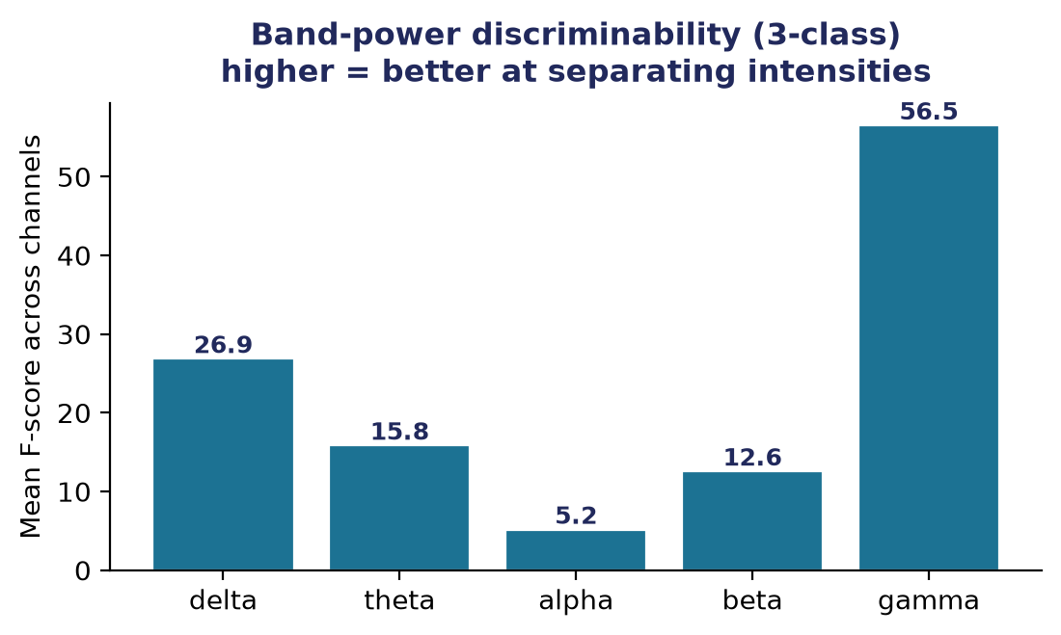
Figure 3. Per-band discriminability of the band-power features. Gamma-band power is the most informative spectral signature of stimulation intensity.
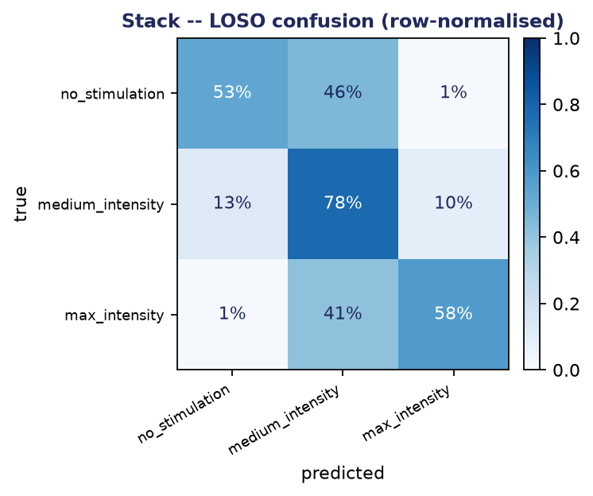
Figure 4. Confusion matrix of the stacking ensemble (LOSO). Errors concentrate between adjacent intensities; the middle class is the hardest to separate.

5. Key Findings
5.1 Functional connectivity between cortical regions.
For further discovery of spatial features, an inquiry was passed on whether the opaque Riemannian covariance feature could be replaced with something more interpretable, so an analysis was conducted upon phase-based functional connectivity between fronto-central, central, and parietal regions. Using phase-locking value (PLV) and its volume-conduction-robust imaginary variant (iPLV), it was found that stimulation intensity dose-dependently modulates inter-region phase coupling: low-frequency (delta/theta/alpha) coupling rises with intensity while gamma coupling falls (significant at p ≈ 0). Stronger EMS drives widespread low-frequency phase synchronization across the network.
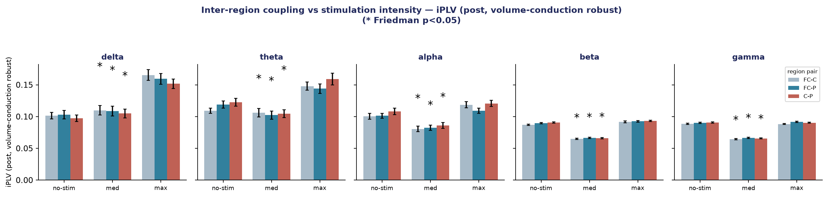
Figure 5. Inter-region phase coupling (iPLV) versus stimulation intensity, per frequency band. Low frequency coupling between regions increases with intensity.

This finding was converted into a per-trial connectivity feature family. It matches Riemannian covariance in the decoder using only 60 interpretable features (versus 1830), and the meta-learner actually trusts it more. Adding both connectivity and Riemannian produced the project's best model: the 5-family stack at 68.1% / 64.8% balanced LOSO accuracy. This confirmed that the two spatial views are complementary.

5.2 Biomarkers of intolerable stimulation.
To serve the clinical goal directly, a reframing of the task as a binary tolerable-vs-intolerable classification with principled class-imbalance handling was conducted. This reached 87.3% within-subject and 79.9% LOSO accuracy (ROC-AUC 0.94 / 0.88) for detecting intolerable stimulation, and, most importantly, surfaced concrete, interpretable biomarkers: elevated fronto-central gamma-band power and a larger central evoked-potential amplitude, both known to scale with stimulus intensity. This gave AIM Lab a physiologically defensible basis for a future discomfort-aware stop trigger.
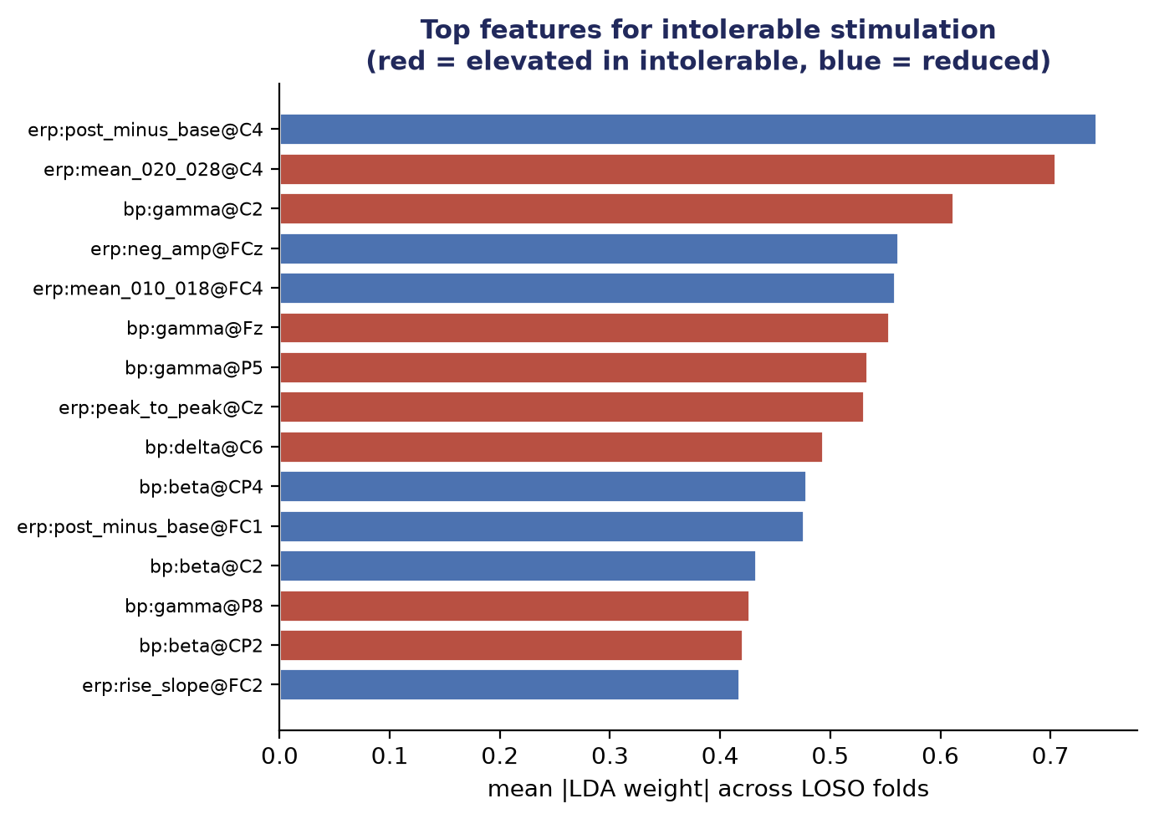
Figure 7. Top features distinguishing intolerable from tolerable stimulation (red = elevated in intolerable). Central evoked-potential amplitude and gamma power dominate.

5.3 A deployable 7-channel montage.
For real-world use, a wearable headset cannot use 60 electrodes. I showed that restricting the same stacking model to a 7-channel montage (the X.on device configuration) retains roughly 96% of the full-cap accuracy (64.0% versus 66.7% LOSO) using a 12x smaller electrode set. This is a practical, deployable result.

6. Explainability and Conclusion
A distinguishing feature of this work is that the final model, despite being an ensemble, remains a fully transparent model. Because it is two stacked linear layers, any prediction can be decomposed exactly, with no black-box approximation, back through the meta-learner's family weights to the individual channels, frequency bands, and evoked-potential components that produced it. It was verified that the meta-learner's weighting choices map onto known intensity-coding physiology (for example, high intensity is read primarily from induced gamma power), so every inference is auditable in neuroscience.
In summary, over two months I built an end-to-end EEG decoding pipeline, designed a stacking-ensemble architecture that outperforms both a strong linear baseline and a deep network, discovered interpretable neural biomarkers of intolerable stimulation, demonstrated a deployable reduced-channel montage, and developed a functional-connectivity feature that both improved the model and made it more interpretable. The result is the decoding foundation for a closed-loop, discomfort-aware EMS system with therapeutic applications in anxiety treatment and neurorehabilitation, and the work is intended for publication.

Appendix

