Decoding EMS Stimulation Intensity from EEG
A Machine-Learning Pipeline for a Closed-Loop Neurofeedback System
Summary of a 2-month research internship · Prepared for NYU

1. Introduction and Problem
Over a two-month internship I built the complete offline machine-learning pipeline that decodes the intensity of an electrical muscle stimulation (EMS) pulse from a subject's EEG brain response. On each trial an EMS device delivers a pulse at one of several pre-set intensities (or none), and the scalp EEG following stimulus onset is recorded; the task is to predict, from a single trial's EEG epoch, which stimulation intensity produced it.
This decoder is the prerequisite for the project's ultimate goal: a closed-loop, discomfort-aware neurofeedback system that reads the cortical response in real time, detects when stimulation becomes intolerable, and automatically stops or modulates it — a technology with direct therapeutic applications in anxiety treatment and neurorehabilitation. My work covers the offline decoding and modelling stage: preprocessing, feature engineering, model design, validation, explainability, and a deployable final model. This work is intended for publication.
The problem is genuinely difficult for three reasons: the discriminative signal is a stimulus-locked evoked response whose neighbouring intensities look similar (errors concentrate between adjacent classes); each subject provides only ~120–160 trials, so high-dimensional feature sets overfit; and there is large inter-subject variability, producing a persistent gap between within-subject and cross-subject accuracy.

2. Data and Preprocessing
The dataset comprises 29 subjects recorded with a 60-channel EEG montage at a 1000 Hz source rate. I built the preprocessing pipeline that converts each raw recording into modelling-ready epochs: anti-aliased downsampling to 250 Hz, stimulus-locked epoching to a −0.2 s to +1.5 s window (425 samples, retaining a 200 ms pre-stimulus baseline), and a per-subject artifact filter that removes trials with outlier pre-stimulus baseline variance.
From the four original stimulation levels I derived several class schemes to ask different scientific questions: a 4-class set (no-stim / min / medium / max, balanced); a primary 3-class set (no-stim / medium / max, 40/80/40); a balanced 3-class set isolating pure intensity; and a 2-class “tolerable vs intolerable” set that frames the safety-relevant question directly.
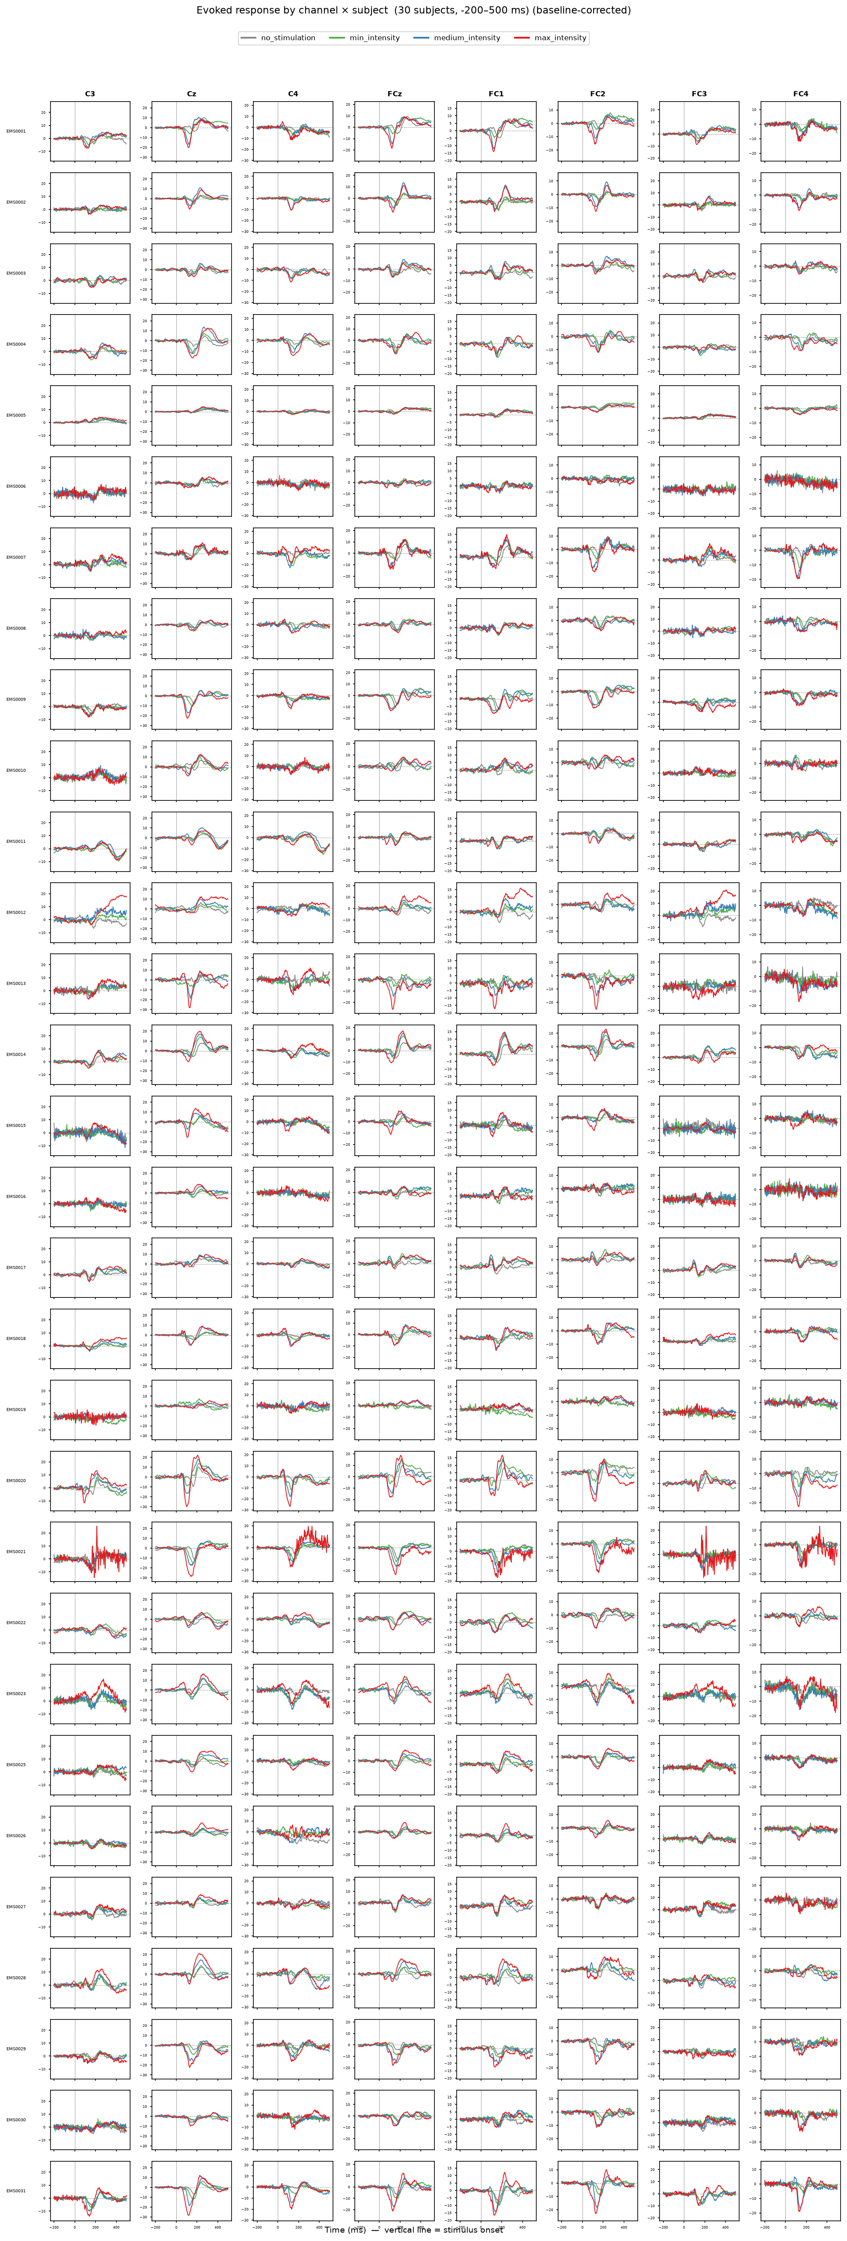
Figure 1. Trial-averaged evoked responses (ERPs) by channel and subject across stimulation conditions, showing the dose-dependent, stimulus-locked cortical response the decoder exploits.

3. Methods
Feature representations.
I designed a modular feature pipeline in which any set of “feature families” can be combined, each a self-contained, scikit-learn-compatible extractor grounded in a distinct neural phenomenon:
- ERP / SEP (time domain): amplitude and latency features of the somatosensory evoked potential over central and fronto-central channels.
- Band-power (frequency domain): log spectral power per canonical band (delta, theta, alpha, beta, gamma).
- ERD/ERS (time-frequency): Pfurtscheller event-related de/synchronization of sensorimotor rhythms.
- Riemannian covariance: trial covariance projected into tangent space — a spatial-coupling representation.
- Functional connectivity: single-trial phase-locking (PLV / iPLV) between fronto-central, central, and parietal regions — a neuroscience-grounded, interpretable spatial feature I developed later in the project.
Classifier and validation.
Each family feeds a shrinkage-regularized Linear Discriminant Analysis (LDA), well suited to high-dimensional, collinear EEG features. Every model is evaluated with two leakage-safe schemes: within-subject repeated stratified k-fold (the ceiling with per-person calibration data) and, most importantly, leave-one-subject-out (LOSO), which measures generalization to a brand-new person — the metric that matters for deployment. Pipelines are refit inside every fold so no feature or scaler leaks across the train/test boundary.

4. Models and Results
I first established baselines, then systematically improved on them. A shrinkage-LDA on ERP + band-power features decodes the 3-class task at roughly twice chance (33%), and a from-scratch EEGNet convolutional network learning directly from raw EEG did not beat it — with only ~120–160 trials per subject, the deep network has no data advantage over a well-regularized linear model on good features.
I documented what did not work as carefully as what did: simply concatenating the time-frequency or Riemannian families into one large feature vector hurt cross-subject accuracy (statistical dilution on limited data), and a nested cross-validation feature-selection search could not beat the ERP + band-power baseline. The lesson was that the path forward was a better architecture, not more features.
The breakthrough was a stacking ensemble: I train one LDA per feature family and fuse their class-probability outputs with a logistic meta-learner. Each base model stays low-dimensional relative to its own family, and the meta-learner learns how much to trust each — so complementary-but-individually-weak views add signal instead of diluting. This is the only approach that beat the baseline, and it does so on the metric that matters (LOSO).
Table 1. Decoding accuracy across the main models (within-subject and cross-subject / LOSO).
Model (3-class unless noted) | Within acc / bal | LOSO acc / bal
LDA, ERP + band-power (baseline) | 71.1 / 70.3 | 62.8 / 59.9
EEGNet (deep network, raw EEG) | 63.4 / 64.7 | 59.8 / 60.8
Stacking ensemble (4-family) | 73.0 / 70.2 | 66.7 / 63.0
Stacking ensemble (5-family) — BEST | — | 68.1 / 64.8
Stacking, 7-channel X.on montage | 69.1 / 65.4 | 64.0 / 59.8
2-class tolerable vs intolerable | 87.3 / 86.4 | 79.9 / 79.9

Feature interpretation.
Because the pipeline is linear, I could read exactly which neural features drive the decoding. Two convergent analyses (univariate discriminability and fold-stable LDA weights) show the decoder relies on central/fronto-central evoked-potential amplitude plus gamma-band power, and these features scale monotonically with stimulation intensity — a genuine dose-response.
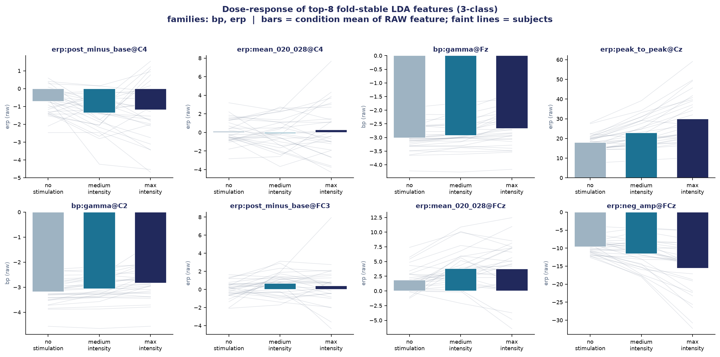
Figure 2. Dose-response of the top decoding features across the three intensity conditions; the features increase monotonically with stimulation level, confirming a real graded neural signal.
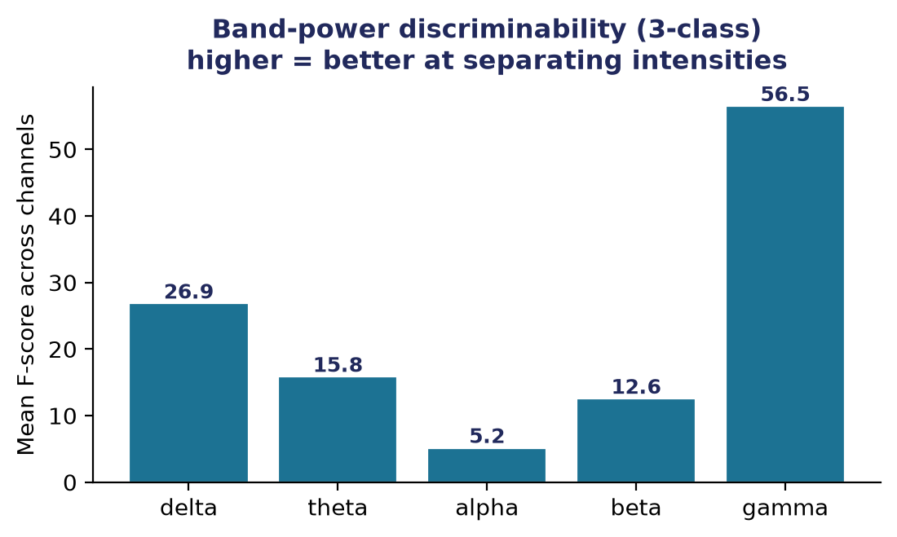
Figure 3. Per-band discriminability of the band-power features. Gamma-band power is the most informative spectral signature of stimulation intensity.
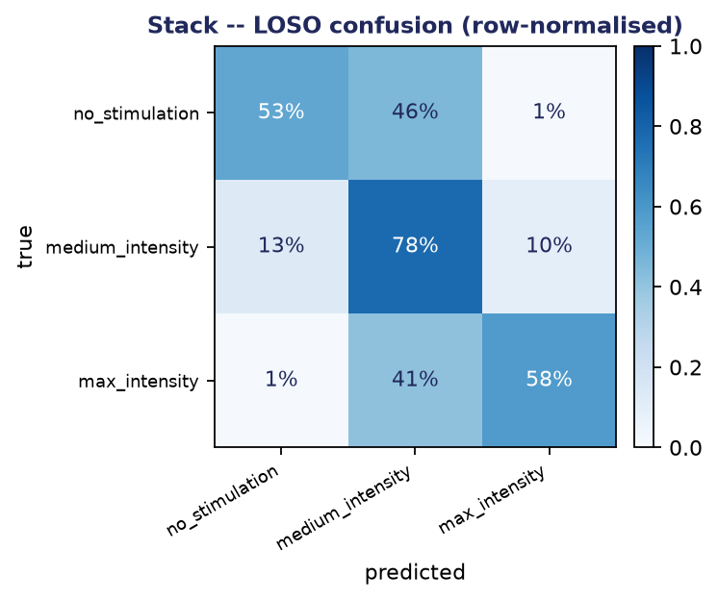
Figure 4. Confusion matrix of the stacking ensemble (LOSO). Errors concentrate between adjacent intensities, the expected ordinal-confusion structure; the middle class is the hardest to separate.

5. Key Findings
5.1 Functional connectivity between cortical regions.
On my own initiative I asked whether the opaque Riemannian covariance feature could be replaced with something more interpretable, so I analysed phase-based functional connectivity between fronto-central, central, and parietal regions. Using phase-locking value (PLV) and its volume-conduction-robust imaginary variant (iPLV), I found that stimulation intensity dose-dependently modulates inter-region phase coupling: low-frequency (delta/theta/alpha) coupling rises with intensity while gamma coupling falls (significant at p ≈ 0). Stronger EMS drives widespread low-frequency phase synchronization across the sensory network.
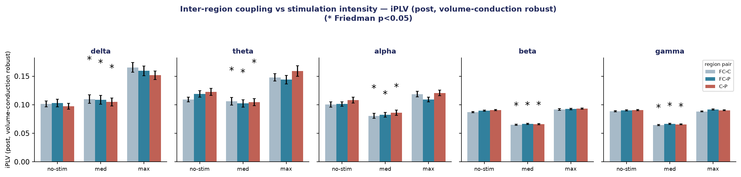
Figure 5. Inter-region phase coupling (iPLV) versus stimulation intensity, per frequency band. Low-frequency coupling between regions increases dose-dependently with intensity.
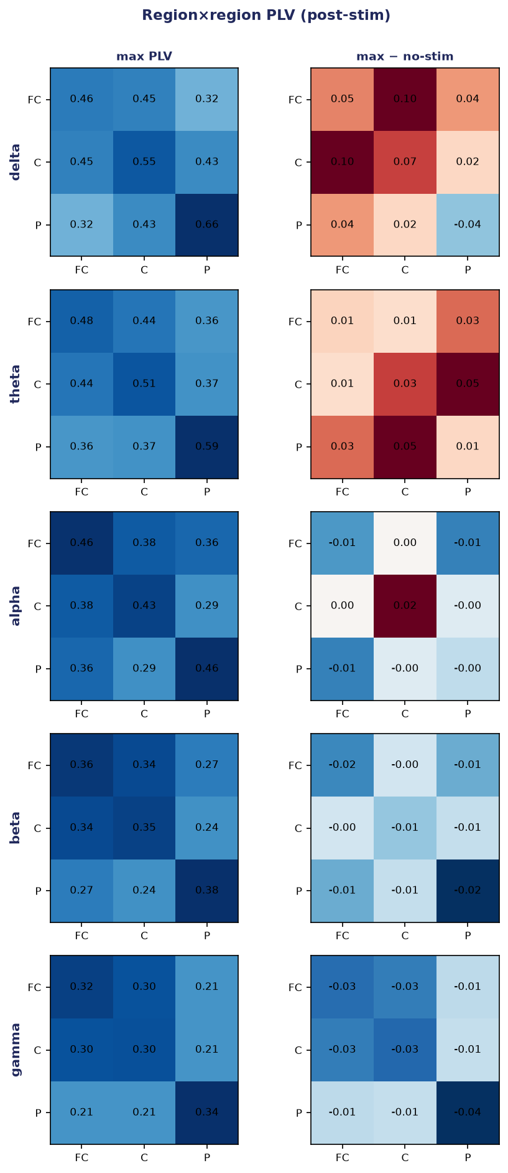
Figure 6. Region-to-region phase-coupling matrices (fronto-central, central, parietal) at maximum intensity and the change from the no-stimulation baseline, per band.
I turned this finding into a per-trial connectivity feature family. It matches Riemannian covariance in the decoder using only 60 interpretable features (versus 1830), and the meta-learner actually trusts it more. Adding both connectivity and Riemannian produced the project's best model — a 5-family stack at 68.1% / 64.8% LOSO accuracy, a marginal but real improvement, confirming the two spatial views are complementary.
5.2 Biomarkers of intolerable stimulation.
To serve the clinical goal directly, I reframed the task as a binary tolerable-vs-intolerable classification with principled class-imbalance handling. This reached 87.3% within-subject and 79.9% LOSO accuracy (ROC-AUC 0.94 / 0.88) for detecting intolerable stimulation, and — most importantly — surfaced concrete, interpretable biomarkers: elevated fronto-central gamma-band power and a larger central evoked-potential amplitude, both known to scale with stimulus intensity. This gives the lab a physiologically defensible basis for a future discomfort-aware stop trigger.
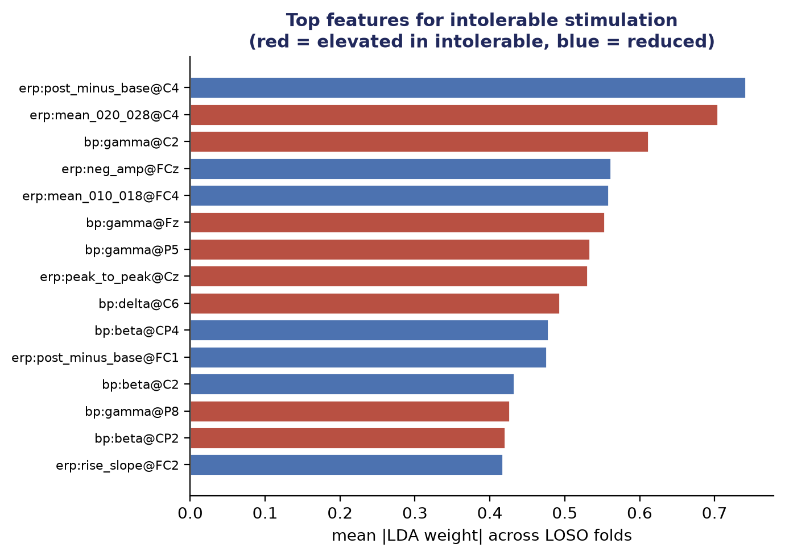
Figure 7. Top features distinguishing intolerable from tolerable stimulation (red = elevated in intolerable). Central evoked-potential amplitude and fronto-central gamma power dominate.
5.3 A deployable 7-channel montage.
For real-world use, a wearable headset cannot use 60 electrodes. I showed that restricting the same stacking model to a 7-channel montage (the X.on device configuration) retains roughly 96% of the full-cap accuracy (64.0% versus 66.7% LOSO) using a 12x smaller electrode set — a practical, deployable result.

6. Explainability and Conclusion
A distinguishing feature of this work is that the final model, despite being an ensemble, remains a fully transparent “glass box.” Because it is two stacked linear layers, any prediction can be decomposed exactly — with no black-box approximation — back through the meta-learner's family weights to the individual channels, frequency bands, and evoked-potential components that produced it. I verified that the meta-learner's weighting choices map onto known intensity-coding physiology (for example, high intensity is read primarily from induced gamma power), so every decision is auditable in neuroscientific terms.
In summary, over two months I built an end-to-end EEG decoding pipeline, designed a stacking-ensemble architecture that outperforms both a strong linear baseline and a deep network, discovered interpretable neural biomarkers of intolerable stimulation, demonstrated a deployable reduced-channel montage, and developed a functional-connectivity feature that both improved the model and made it more interpretable. The result is the decoding foundation for a closed-loop, discomfort-aware EMS system with therapeutic applications in anxiety treatment and neurorehabilitation, and the work is intended for publication.

