Lab 1:

import java.util.Scanner;

class Information{

    public Information(String name, int age, String qualification){

        System.out.println("name: "+name);

        System.out.println("age: "+age);

        System.out.println("qualification: "+qualification);

    }}

public class Main {

    public static void main(String[] args) {

        System.out.println("The program is starting:");

        System.out.println("What is your name?");

        Scanner s1 = new Scanner(System.in);

        String name = s1.nextLine();

        System.out.println("What is your age?");

        Scanner s2 = new Scanner(System.in);

        int age = s2.nextInt();

        System.out.println("What is your Qualification?");

        Scanner s3 = new Scanner(System.in);

        String qualification = s3.nextLine();

        Information i1 = new Information(name, age, qualification);

    }}

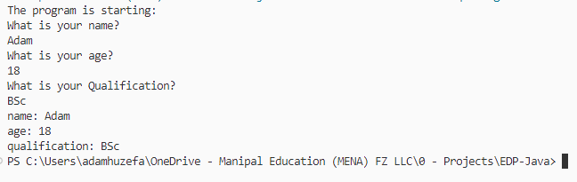Output:

Lab 2:

public class Main {

    public static void main(String[] args) {

        Test t = new Test();

        System.out.println("t is instance of object : " + (t instanceof Object));

    }}

class Test {

}

Output:



Lab 3:

interface FerrariCar{

    int horsepower = 1800;

    String name = "Ferrari Car";

    int seats = 2;

}

interface MercedesCar{

    int horsepower = 1500;

    String name = "Mercedes Car";

    int seats = 4;

}

class MercedesEQS580 implements MercedesCar{

    String fullname = "Mercedes EQS 580";

    int price = 100000;

}

class Ferrari550 implements FerrariCar{

    String fullname = "Ferrari 550 Barchetta Pininfarina";

    int price = 150000;

}

public class Main {

    public static void main(String[] args) {

        System.out.println("Hello world!");

    }

}

Output:

N/A

Lab 4:

interface FerrariCar{

    int horsepower = 1800;

    String name = "Ferrari Car";

    int seats = 2;

}

interface MercedesCar{

    int horsepower = 1500;

    String name = "Mercedes Car";

    int seats = 4;

}

class MercedesEQS580 implements MercedesCar{

    String fullname = "Mercedes EQS 580";

    int price = 100000;

}

class Ferrari550 implements FerrariCar{

    String fullname = "Ferrari 550 Barchetta Pininfarina";

    int price = 150000;

}

public class Qinheritance {

    public static void main(String[] args) {

        MercedesEQS580 c1 = new MercedesEQS580();

        System.out.println(c1.fullname);

    }

}

Output:

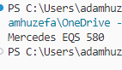

Lab 5:

import java.awt.Rectangle;

import javax.swing.*;

public class Main {

    public static void main(String[] args) {

*// Creating the stuff*

        JFrame f = new JFrame("Title");

        JPanel p = new JPanel();

        JButton b = new JButton("Press me");

        JButton b2 = new JButton("Dont press me");

*// Adding the buttons to the panel and frame*

        b.setBounds(new Rectangle(10,10, 100,50));

        p.setLayout(null);

        p.add(b);

        p.add(b2);

        f.setContentPane(p);

*// Showing the Frame*

        f.setVisible(true);

    }

}

Output:

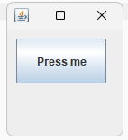

Lab 6:

Example 1:

 public class Main {

    public static void main(String[] args) {

        JFrame frame = new JFrame("My First GUI");

        frame.setDefaultCloseOperation(JFrame.EXIT_ON_CLOSE);

        frame.setSize(300,300);

        JButton button = new JButton("Press");

        frame.getContentPane().add(button); *// Adds Button to content pane of frame*

        frame.setVisible(true);

    }

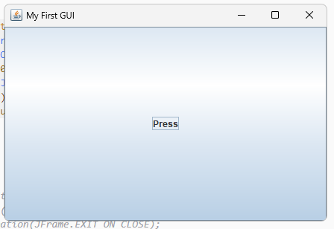}

Output:

Example 2:

 public class Main{

    public static void main(String args[]){

    JFrame frame = new JFrame("My First GUI");

    frame.setDefaultCloseOperation(JFrame.EXIT_ON_CLOSE);

    frame.setSize(300,300);

    JButton button1 = new JButton("Press");

    frame.getContentPane().add(button1);

    frame.setVisible(true);

    }

    }

Output:

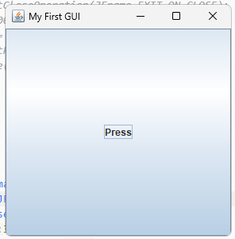

Example 3:

public class Main{

    public static void main(String args[]) {

*//Creating the Frame*

    JFrame frame = new JFrame("Chat Frame");

    frame.setDefaultCloseOperation(JFrame.EXIT_ON_CLOSE);

    frame.setSize(800, 800);

*//Creating the MenuBar and adding components*

    JMenuBar mb = new JMenuBar();

    JMenu m1 = new JMenu("FILE");

    JMenu m2 = new JMenu("Help");

    mb.add(m1);

    mb.add(m2);

    JMenuItem m11 = new JMenuItem("Open");

    JMenuItem m22 = new JMenuItem("Save as");

    m1.add(m11);

    m1.add(m22);

*//Creating the panel at bottom and adding components*

    JPanel panel = new JPanel(); *// the panel is not visible in output*

    JLabel label = new JLabel("Enter Text");

    JTextField tf = new JTextField(10); *// accepts upto 10 characters*

    JButton send = new JButton("Send");

    JButton reset = new JButton("Reset");

    JCheckBox confirm = new JCheckBox("Confirm");

*// adding drop down box*

    String[] request = {"Help Desk", "IT Department", "Transport Department"};

    JComboBox requestlist = new JComboBox(request);

    requestlist.setSelectedIndex(1);

    panel.add(label); *// Components Added using Flow Layout*

    panel.add(tf);

    panel.add(requestlist);

    panel.add(confirm);

    panel.add(send);

    panel.add(reset);

*// Text Area at the Center*

    JTextArea ta = new JTextArea();

*//Adding Components to the frame.*

    frame.getContentPane().add(BorderLayout.SOUTH,

    panel);

    frame.getContentPane().add(BorderLayout.NORTH,

    mb);

    frame.getContentPane().add(BorderLayout.CENTER,

    ta);

    frame.setVisible(true);

    }

    }

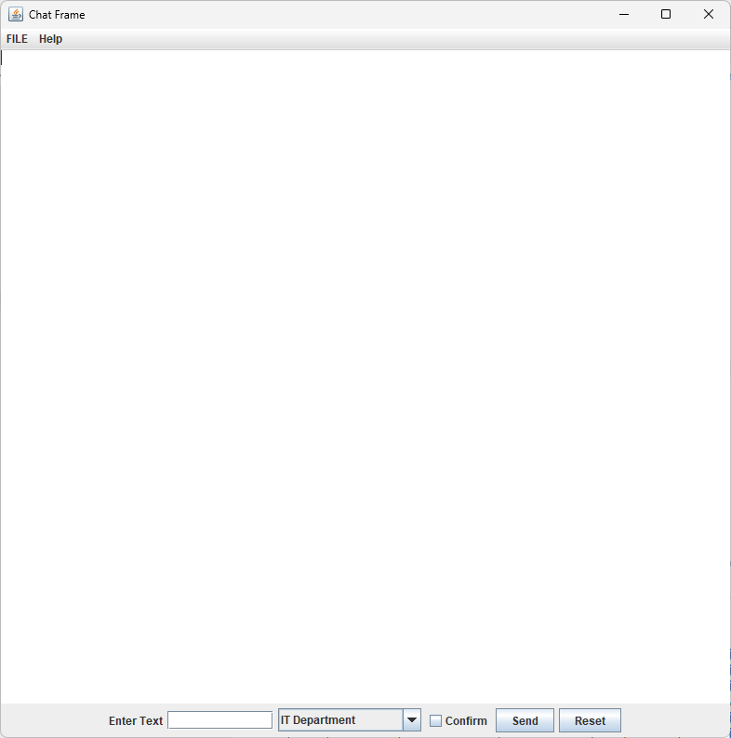Output:

Lab 7:

import javax.imageio.ImageIO;

import javax.swing.*;

import java.io.File;

import java.io.IOException;

import java.awt.BorderLayout;

import java.awt.image.BufferedImage;

 public class Main{

     public static void main(String args[]) {

*//Creating the Frame*

     JFrame frame = new JFrame("Support Chatbox");

     frame.setDefaultCloseOperation(JFrame.EXIT_ON_CLOSE);

     frame.setSize(800, 800);

*//Creating the panel at bottom and adding components*

     JPanel panel = new JPanel(); *// the panel is not visible in output*

     JLabel label = new JLabel("Enter Text");

     JTextField tf = new JTextField(10); *// accepts upto 10 characters*

     JButton send = new JButton("Send");

     panel.add(label); *// Components Added using Flow Layout*

     panel.add(tf);

     panel.add(send);

*// Text Area at the Center*

     JTextArea ta = new JTextArea();

*//Adding Components to the frame.*

     frame.getContentPane().add(BorderLayout.SOUTH, panel);

     frame.getContentPane().add(BorderLayout.CENTER, ta);

     frame.setVisible(true);

     }

     }

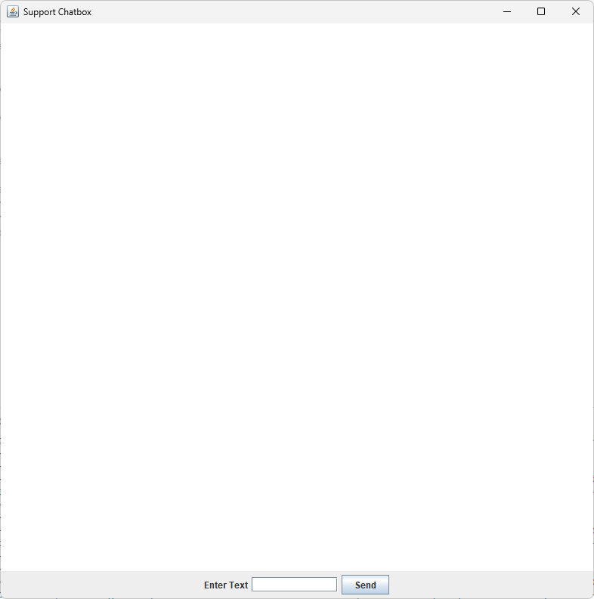Output:

Lab 8:

import javax.swing.*;

import java.awt.*;

import java.util.Calendar;

import java.util.Timer;

import java.util.TimerTask;

public class Main {

    public static void main(String[] args) {

        JFrame frame = new JFrame("Current Time");

        JLabel timeLabel = new JLabel();

        timeLabel.setHorizontalAlignment(SwingConstants.CENTER);

        timeLabel.setFont(new Font("Arial", Font.BOLD, 48));

        timeLabel.setForeground(Color.BLACK);

        timeLabel.setBackground(Color.WHITE);

        timeLabel.setOpaque(true);

        frame.add(timeLabel);

        frame.setSize(400, 200);

        frame.setDefaultCloseOperation(JFrame.EXIT_ON_CLOSE);

        frame.setVisible(true);

        Timer timer = new Timer();

        timer.scheduleAtFixedRate(new TimerTask() {

            public void run() {

                int second, minute, hour;

                Calendar date = Calendar.getInstance();

                second = date.get(Calendar.SECOND);

                minute = date.get(Calendar.MINUTE);

                hour = date.get(Calendar.HOUR_OF_DAY); *// Use HOUR_OF_DAY for 24-hour format*

                String currentTime = String.format("%02d : %02d : %02d", hour, minute, second);

                timeLabel.setText(currentTime);

            }

        }, 0, 1000); *// Update every second*

    }

}

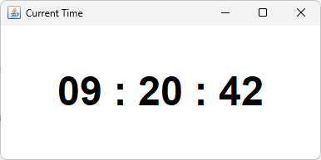Output:

Lab 9:

import java.awt.*;

import java.awt.event.*;

import java.io.File;

import javax.swing.*;

public class SwingControlDemo {

   private JFrame mainFrame;

   private JLabel headerLabel;

   private JLabel statusLabel;

   private JPanel controlPanel;

   public SwingControlDemo(){

      prepareGUI();

   }

   public static void main(String[] args){

      SwingControlDemo  swingControlDemo = new SwingControlDemo();

      swingControlDemo.showImageIconDemo();

   }

   private void prepareGUI(){

      mainFrame = new JFrame("Java Swing Examples");

      mainFrame.setSize(1280,720);

      mainFrame.setLayout(new GridLayout(3, 1));

      mainFrame.addWindowListener(new WindowAdapter() {

         public void windowClosing(WindowEvent windowEvent){

            System.exit(0);

         }

      });

      headerLabel = new JLabel("", JLabel.CENTER);

      statusLabel = new JLabel("",JLabel.CENTER);

      statusLabel.setSize(100,100);

      controlPanel = new JPanel();

      controlPanel.setLayout(new FlowLayout());

      mainFrame.add(headerLabel);

      mainFrame.add(controlPanel);

      mainFrame.add(statusLabel);

      mainFrame.setVisible(true);

   }

 private static ImageIcon createImageIcon(String path, String description) {

    File file = new File(path);

    if (file.exists()) {

        return new ImageIcon(path, description);

    } else {

        System.err.println("Couldn't find file: " + path);

        return null;

    }

}

   private void showImageIconDemo(){

      headerLabel.setText("Control in action: ImageIcon");

      ImageIcon icon = createImageIcon("C:/Users/adamhuzefa/OneDrive - Manipal Education (MENA) FZ LLC/0 - Projects/EDP-Java/imageicontest/src/main/resources/19f6fcb7dd11e27f70df4dc65476413a.png","Java");

      JLabel commentlabel = new JLabel("", icon,JLabel.CENTER);

      int width = commentlabel.getWidth();

      int height = commentlabel.getHeight();

      Image image = icon.getImage();

      Image newimg = image.getScaledInstance(width, height, java.awt.Image.SCALE_SMOOTH);

      icon = new ImageIcon(newimg);

      commentlabel.setIcon(icon);

      controlPanel.add(commentlabel);

      mainFrame.setVisible(true);

}

}

Output:

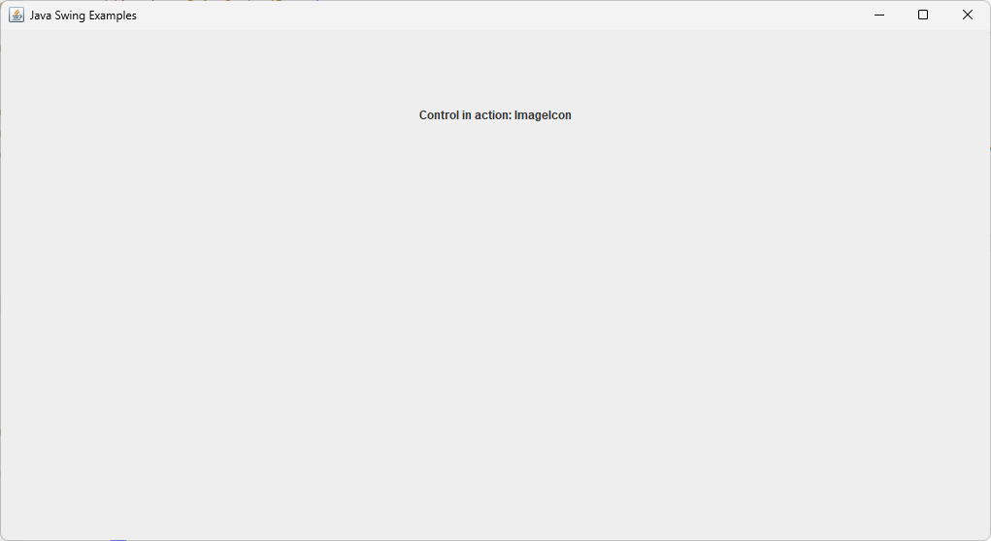

Lab 10:

import javax.swing.*;

import java.awt.Color;

import helper_classes.*;

public class WindowBuilder {

  public static void main(String[] args) {

     JFrame frame = new JFrame("My Awesome Window");

     frame.setDefaultCloseOperation(JFrame.EXIT_ON_CLOSE);

     frame.setSize(886, 479);

     JPanel panel = new JPanel();

     panel.setLayout(null);

     panel.setBackground(Color.decode("#1e1e1e"));

     frame.add(panel);

     frame.setVisible(true);

  }

}

Files (netbeans window builder):

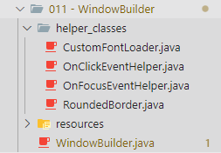

Lab 11:

import java.awt.BorderLayout;

import java.awt.Color;

import java.awt.GridLayout;

import java.awt.event.ActionEvent;

import java.awt.event.ActionListener;

import javax.swing.JButton;

import javax.swing.JCheckBox;

import javax.swing.JFrame;

import javax.swing.JLabel;

import javax.swing.JMenu;

import javax.swing.JMenuBar;

import javax.swing.JMenuItem;

import javax.swing.JOptionPane;

import javax.swing.JPanel;

import javax.swing.JTextField;

public class Main {

    private static int itemCount = 0; *// Variable to track the number of items in the cart*

    public static void main(String args[]) {

        JFrame f = new JFrame("ONLINE SHOPPING");

        f.setDefaultCloseOperation(JFrame.EXIT_ON_CLOSE);

        f.setSize(400, 400);

        JMenuBar mb = new JMenuBar();

        JMenu m1 = new JMenu("Home");

        JMenu m2 = new JMenu("Shop");

        JMenu m3 = new JMenu("Offers");

        mb.add(m1);

        mb.add(m2);

        mb.add(m3);

        JMenuItem mi1 = new JMenuItem("Winter Sale");

        JMenuItem mi2 = new JMenuItem("Festival Sale");

        m3.add(mi1);

        m3.add(mi2);

        f.add(mb, BorderLayout.NORTH);

        JPanel p = new JPanel();

        p.setBackground(Color.BLUE);

        p.setLayout(new GridLayout(0, 1)); *// Vertical layout*

*// User input section*

        JPanel userInputPanel = new JPanel();

        userInputPanel.setLayout(new GridLayout(3, 2)); *// 3 rows, 2 columns*

*// Product section*

        JPanel productPanel = new JPanel();

        productPanel.setLayout(new GridLayout(0, 1)); *// Vertical layout*

        String[] products = {"T-shirt - 15 AED", "Jeans - 25 AED", "Shoes - 30 AED"};

        for (String product : products) {

            JPanel itemPanel = new JPanel();

            JLabel itemLabel = new JLabel(product);

            JButton addButton = new JButton("Add to Cart");

*// Add action listener to the button*

            addButton.addActionListener(new ActionListener() {

                public void actionPerformed(ActionEvent e) {

*//JOptionPane.showMessageDialog(f, "Item added to cart: " + product);*

                    itemCount++;

                    JOptionPane.showMessageDialog(f, "Item added to cart! Total items: " + itemCount);

                }

            });

            itemPanel.add(itemLabel);

            itemPanel.add(addButton);

            productPanel.add(itemPanel);

        }

        p.add(productPanel);

        f.getContentPane().add(p, BorderLayout.CENTER);

        f.setVisible(true);

    }

}

Output:

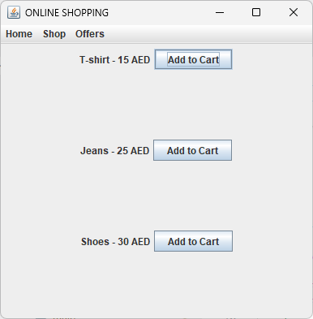

Lab 12:

import javax.swing.*;

import java.awt.*;

import java.awt.event.ActionEvent;

import java.awt.event.ActionListener;

public class Main {

    public static void main(String[] args) {

*// Create the frame*

        JFrame frame = new JFrame("Employee Registration");

        frame.setDefaultCloseOperation(JFrame.EXIT_ON_CLOSE);

        frame.setSize(800, 600);

*// Create a panel to hold the form elements*

        JPanel panel = new JPanel();

        panel.setLayout(new GridLayout(6, 2));

*// Add form elements*

        panel.add(new JLabel("First Name:"));

        JTextField firstNameField = new JTextField();

        panel.add(firstNameField);

        panel.add(new JLabel("Last Name:"));

        JTextField lastNameField = new JTextField();

        panel.add(lastNameField);

        panel.add(new JLabel("Username:"));

        JTextField usernameField = new JTextField();

        panel.add(usernameField);

        panel.add(new JLabel("Password:"));

        JPasswordField passwordField = new JPasswordField();

        panel.add(passwordField);

        panel.add(new JLabel("Contact:"));

        JTextField contactField = new JTextField();

        panel.add(contactField);

*// Add submit button*

        JButton submitButton = new JButton("Submit");

        panel.add(submitButton);

*// Add action listener to the submit button*

        submitButton.addActionListener(new ActionListener() {

            @Override

            public void actionPerformed(ActionEvent e) {

                if (usernameField.getText().isEmpty()) {

                    JOptionPane.showMessageDialog(frame, "Username is required!", "Error", JOptionPane.ERROR_MESSAGE);

                } else {

*// Handle form submission*

                    JOptionPane.showMessageDialog(frame, "Form submitted successfully!");

                }

            }

        });

*// Add panel to frame*

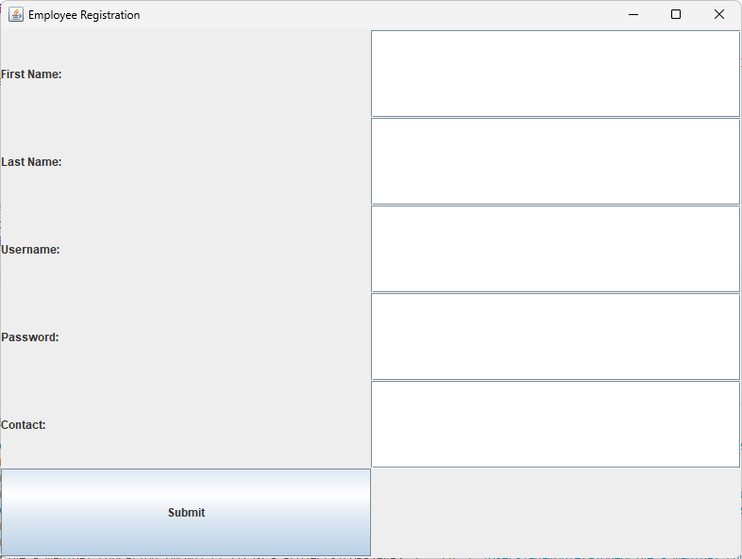        frame.add(panel);

        frame.setVisible(true);

    }

}

Output: