Verbena Farm Stand

Verbena Farm grows herbs and offers them for sale at the Verbena Farm Stand. All herbs are certified organic and are cultivated or ethically wild-harvested on the farm. Whether you seek fresh-picked herbs, dried herbs in compostable bags, or live potted plants for cooking, aromatherapy, or natural medicine, stop by the Verbena Farm Stand on the banks of Carnegie Lake in Princeton, New Jersey.

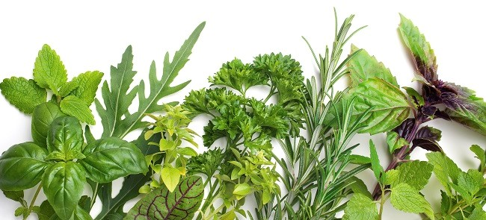

Fresh herbs (available June 1–November 15)

chamomile flower • chives • cilantro • comfrey • dandelion leaf • dill • Echinacea • fennel • flat-leaf parsley • Genovese basil • lavender • lemon basil • lemon verbena • marjoram • marshmallow • nettles • oregano • peppermint • rosemary • sage • spicy globe basil • tarragon • Thai basil • valerian

Live plants (available May 15–October 15)

basil • catnip • chervil • chives • cilantro • dill • elfin thyme • garlic • lavender • lemon balm • lemongrass • lemon verbena • marjoram • mint • nasturtium • oregano • parsley • rosemary • sage

Dried herbs (available year round)

basil • chamomile flower • chervil • cilantro • comfrey • dill • garlic bulbs • lavender • lemon balm • lemon verbena • marjoram • mint • oregano • rosemary • saffron • sage • tarragon • thyme

For special orders, contact [info@verbenafarm.cengage.com](mailto:info@verbenafarm.cengage.com)

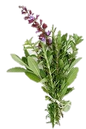

**Verbena Farm Stand**

205 Mapleton Road

Princeton, NJ 08544

(609) 266-1210

[*verbenafarm.cengage.com*](http://www.verbenafarm.cengage.com/)