**Louisville Word Fest**

The Louisville Word Fest is an annual arts festival that brings together poets, writers, and performers for three days in Louisville, Kentucky, during National Poetry Month.

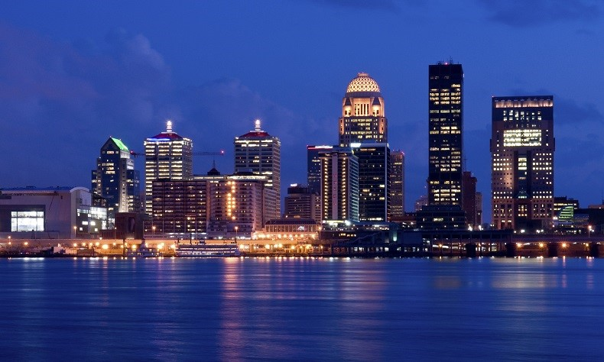

**Friday, April 12 • 12:00 pm–9:00 pm**

The kick-off reception at Wild Rumpus Books features small plates, beverages, and time for book signing and socializing. The finalists of the Kentucky Writers Guild will read their works, followed by a haiku “throw-down” in which two poets armed with 17 syllables battle for the title of Haiku Master. The Word Fest heads over to the Old Town Theatre for panel discussions, breakout workshops, and a special dinner visit by Five-Star Chefs. The evening concludes with an open mic.

**Saturday, April 13 • 10:00 am–7:00 pm**

Readings, workshops, and discussions take place all day at the Louisville Contemporary Art Museum. The Seventh Annual Louisville Word Fest Invitational Slam begins at 7:00 pm at the Old Town Theatre. Word Fest is showcasing competitive bouts with seven teams from around the globe that will rock the poetry world. In the spirit of *joie de vivre* and brevity, the five-minute rule will be strictly enforced.

**Sunday, April 14 • 10:00 am–7:00 pm**

Genre day begins with a roundtable of readings in comedy, science fiction, fantasy, satire, and memoir and features a performance by the Imprecise Improvisations Troupe. Open mic with costumes and props begins at 7:00 pm.

To sign up for the open mics, contact [info@wordfest.cengage.com](mailto:info@wordfest.cengage.com)

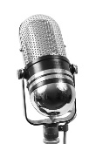

**Louisville Word Fest**

Old Town Theatre • Louisville, KY 40201 • (502) 555-0994 • *wordfest.cengage.com*