

Software Engineering Department
Braude College of Engineering

Final Project – Phase B (61999)

AuraDrive - AI-Driven Real-Time driver fatigue detection system
Capstone Project Phase B – 61999 July 2026

Project code: 26-1-D-10
By:
Maor Tzur | 316313543
Adam Kayal | 215584271

Advisor: Mr. Ilya Zeldner

Link to GitHub: https://github.com/adamkiy/AuraDrive-AI

Table of Contents

Abstract 1
1. Problem Statement and Background 1
1.1 Limitations of existing driver-monitoring systems 1
1.2 False alarms and the case for multimodal temporal reasoning 2
2. General Description 2
2.1 System goals 2
2.2 Target users 2
2.3 What was achieved and system scope 3
2.4 System constraints and scope 3
3. Solution Architecture 3
3.1 Architectural overview: three layers of caution 3
3.2 Deployment and package structure 4
3.3 Concurrent pipeline and data flow 4
3.4 The decision path for one frame 5
3.5 The use case perspective 7
4. Visual Perception and Fatigue Indicators 8
4.1 Perception pipeline 8
4.2 Eye, mouth, and head indicators 8
4.3 Formulas and hysteresis 8
4.4 Mouth aspect ratio and yawn detection 9
4.5 Temporal windows: microsleep, PERCLOS and history 10
4.6 Head pose: pitch and roll 11
5. Deterministic Safety Layer and LLM Agent Design 12
5.1 The deterministic cold engine 12
5.2 The reflex path 12
5.3 The local LLM agent 13
5.4 Prompt engineering: from rule chains to contextual reasoning 13
5.5 Safety arbitration 14
6. Development and Research Process 15
6.1 Methodology and client interaction 15
6.2 Tools and technologies 15
6.3 The engineering pivot from Phase A to Phase B 15
6.4 Testing plan 16
7. Challenges, Results, Conclusions, and Project Metrics 16
7.1 Engineering challenges and solutions 16
7.2 Achievement of project goals and metrics 17
7.3 Conclusions 17
8. Lessons Learned and Retrospective Reflection 17
9. Future Work 18
References 19
Appendix A: User Guide A-1
A.1 What AuraDrive does for you A-1
A.2 Before you start (prerequisites) A-1
A.3 Installing and launching A-1
A.4 The first few seconds: calibration A-1
A.5 Reading the on-screen display A-2
A.6 Understanding the alerts A-2
A.7 Ending a session A-2
A.8 Optional adjustments A-2
Appendix B: Maintenance and Developer Guide B-1
B.1 Operating environment B-1
B.2 Installing the AuraDrive software B-1
B.3 Codebase map B-2
B.4 Configuration reference (environment variables) B-2
B.5 Extending the system safely B-3
B.6 Logs and diagnostics B-3
B.7 Complete Function Reference B-3
Appendix C: Historical Phase A Materials C-1
C.1 Early-Stage Rule-Chain LLM Prompt (Historical) C-1
C.2 Complete Phase A Functional Requirements C-1
C.3 Complete Phase A Non-Functional Requirements C-3
C.4 Phase A Initial Design Concepts C-4

Abstract
Driver fatigue is a major, persistent contributor to road accidents, reducing alertness, slowing reaction time, and impairing judgement. Existing driver-monitoring systems remain limited by rigid, threshold-based logic that struggles to separate genuine fatigue from ordinary behaviour, producing frequent false alarms that erode driver trust.
This project presents AuraDrive, a privacy-preserving prototype that monitors driver fatigue in real time, running entirely on local hardware. A computer-vision perception layer (OpenCV and MediaPipe Face Mesh) extracts five indicators from each camera frame: Eye Aspect Ratio (EAR), Mouth Aspect Ratio (MAR), PERCLOS, blink rate, and head pitch/roll. These feed a hybrid decision architecture: a deterministic, AHP-weighted cold engine and an immediate reflex path guarantee fast, explainable, safety-critical responses, while a locally hosted LLM agent (Llama 3.2 via Ollama) interprets a rolling ten minutes of behavioural context to classify the driver's cognitive state and recommend graded interventions. A safety arbiter enforces a strict floor: the agent may escalate a warning but can never soften a high-risk deterministic verdict, and all processing stays on-device.
The system was validated through a feasibility study confirming reliable EAR-based eye-state classification and through iterative prompt-engineering that produced the project's central conclusion: a small local LLM is unsuitable for exact numerical threshold logic but effective at interpreting temporal, multimodal behavioural trends. AuraDrive therefore demonstrates, at prototype level, that deterministic safety guarantees can be combined with context-aware AI reasoning for edge-deployed automotive safety.
Keywords: Driver fatigue detection, computer vision, edge AI, local LLM inference, real-time systems, automotive safety, multimodal analysis, agentic AI, privacy-preserving AI.

1. Problem Statement and Background
Driver fatigue is a measurable contributor to road trauma. NHTSA attributes on the order of tens of thousands of injuries and hundreds of fatalities each year in the United States to drowsy driving, and reports fatigue as a factor in roughly 1.6–1.8% of fatal crashes. Unlike alcohol, fatigue leaves no roadside test, and it degrades the very faculties a driver needs in order to recognise their own impairment: vigilance, reaction time, and judgement. That combination is what makes early and reliable detection inside the cabin an unsolved safety problem.

1.1 Limitations of existing driver-monitoring systems
Commercial driver-monitoring systems fall into three families that share one root weakness: they act on isolated indicators through fixed thresholds, with no temporal or contextual reasoning. Vehicle-dynamics systems measure the consequence of impaired driving and react only after performance has deteriorated. Fixed-threshold camera systems cannot separate a genuine microsleep from a long blink, a mirror check, or a glance at the dashboard. Attention-enforcement systems verify gaze direction as a binary state and do not model progressive drowsiness, so a driver drifting into microsleep can still satisfy a “looking-at-road” check.
Table 1 — Commercial driver-monitoring system families and their core limitations.
System family | Signal | Core limitation
Vehicle-dynamics (e.g. Volvo DAC) | Lane / steering deviation | Reactive; confuses fatigue with road geometry or crosswind
Fixed-threshold camera (Subaru, Toyota) | Eye closure, head pose | Cannot separate fatigue from normal behaviour; high false-positive rate
Attention enforcement (GM, Tesla, Ford) | Gaze direction (binary) | No physiological trend; misses progressive drowsiness and microsleep

1.2 False alarms and the case for multimodal temporal reasoning
The most damaging shared failure is the problem of false alarms: repeated unjustified warnings train drivers to ignore, mute, or disable the system, destroying its safety value. NHTSA and Euro NCAP both identify the rate of false alarms as a primary determinant of driver trust and adoption. Reducing false positives without sacrificing sensitivity to genuine microsleep is the central engineering tension of the domain. The literature points toward combining complementary indicators and examining their development over time: MAR can signal yawning but must be read together with speaking context; head pitch/roll corroborate postural loss only when evaluated as sustained deviations from a personal baseline. AuraDrive follows this principle throughout: no single measurement decides the outcome. This is the tension the system was built to resolve.

2. General Description

2.1 System goals
AuraDrive continuously observes the driver through a single camera facing into the cabin and, when it detects a pattern consistent with fatigue, issues a graded alert whose urgency matches the assessed state. Its goals are to detect genuine fatigue early by fusing multiple indicators over time; to suppress false alarms by requiring temporal persistence and multisignal or contextual convergence; to guarantee a hard safety floor so that the deterministic engine, not the LLM, owns every life-critical decision; to operate locally, at camera rate, keeping all biometric data in the vehicle; and to actuate clearly through graded, distinguishable audio and an on-screen banner.

2.2 Target users
The direct user is the driver, an operator with no technical background who never touches a keyboard while driving and experiences the system only as visual and audible alerts, whether a private motorist or a professional/fleet driver. A second audience is the fleet safety engineer or integrator who installs, calibrates, and tunes the system for a given vehicle and reads its audit logs. A third is the maintainer/developer who will extend the system (addressed by the Maintenance Guide). A fourth is the academic stakeholder: the advisor and evaluators assessing the work. The interface and alert wording target the first group; the configuration surface and logging target the others.

2.3 What was achieved and system scope
Phase B delivered a complete, running, end-to-end prototype: a perception layer running at camera rate; a deterministic AHP cold engine with a calibration-safe EMERGENCY floor; a local LLM analyst that runs continuously, producing a cognitive state, a failure risk for the coming ten minutes, and a short advisory message under schema validation; a layer of safety arbitration enforcing an inviolable floor; and an asyncio runtime of five tasks with graded audio actuation and audit logging in JSONL. AuraDrive does not control the vehicle and is not a certified automotive safety product or a clinical device; it is a research and demonstration prototype intended to be used alongside, not in place of, an attentive driver.

2.4 System Constraints and Scope

Several constraints shaped AuraDrive’s architecture and define the limits of the claims that can be made about the prototype. Local LLM inference was performed without dedicated GPU acceleration, so a compact 1B model was selected and all thresholding, timing, and safety-critical logic remained in deterministic Python components. Since model inference required several seconds on the development laptop, the system was divided into five asynchronous tasks so that perception and the reflex emergency path would never wait for the agent. No labelled multi-driver fatigue dataset was integrated during Phase B; therefore, validation relied on targeted functional tests, recorded sessions, and audit-log analysis rather than statistical measurements of sensitivity, specificity, or false-positive rate. Testing was also performed while stationary rather than in an instrumented vehicle, leaving road vibration, rapid lighting changes, vehicle-motion effects, and ignition-state integration outside the validated scope. The prototype used a standard visible-light webcam, which provided acceptable results under normal indoor and moderate low-light conditions but did not demonstrate reliable operation in near-dark cabins, making infrared sensing a future extension. Finally, AuraDrive is a software research prototype without GPS, navigation data, physical vehicle controls, or direct access to the vehicle’s systems. Consequently, it can issue visual and audible safety recommendations but cannot identify a specific stopping location, control the vehicle, or implement Phase A requirements such as ignition-based activation and physical driver enable/disable controls.

3. Solution Architecture

3.1 Architectural overview: three layers of caution
The system is organised around one principle: a missed detection is a crash; a false alarm is an inconvenience; and the LLM is the least predictable component. Every structural decision follows from that asymmetry, layering three mechanisms of increasing intelligence and decreasing trust. Layer 1, Reflex: a purely deterministic latch fires an EMERGENCY the instant a continuous eye closure reaches the microsleep threshold (≥ 2 s), bypassing every other layer. Layer 2, Deterministic cold floor: an AHP-based reference engine computes a graded command from the fused metrics and trip context; it is the safety baseline, published immediately, and its context multipliers are bounded by a calibration floor: amplification alone cannot reach EMERGENCY, so context raises caution without manufacturing a crisis from a weak physiological reading. Layer 3, LLM refinement: the reasoning agent interprets the behavioural trajectory and may adjust the baseline, but only through an arbiter that lets it escalate freely while permitting de-escalation of at most one tier, and only when the baseline is already mild. The three views below present this design as structure, data flow, and per-frame behaviour.

3.2 Deployment and package structure
AuraDrive is a single-node edge system: perception, the deterministic engine, the LLM runtime, actuation, and logging all execute on one in-vehicle compute unit (a laptop-class PC in development, an NVIDIA Jetson as the production target). There is no server tier and no network dependency: the camera feeds the process, the process drives the display and speaker, and the local Ollama runtime answers the agent over localhost only. The application is decomposed into cohesive packages with a strict dependency direction, and the shared decision contract is imported by both the engine and the agent so the two can never disagree on what a command means.
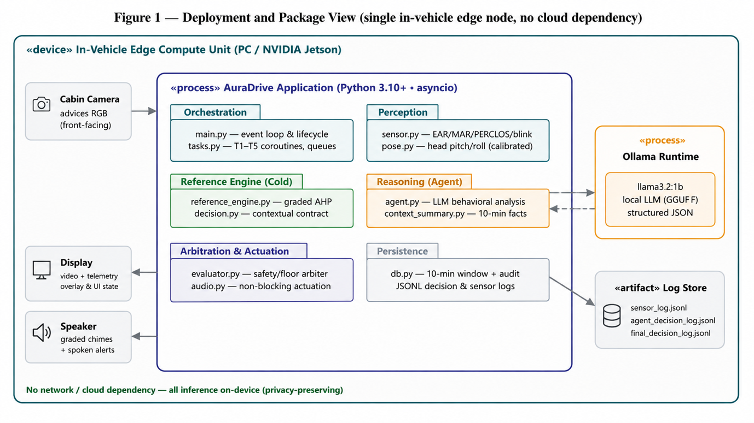
Figure 1 — Deployment and package view. A single in-vehicle edge node hosts the AuraDrive application, a local Ollama model runtime, and the log store; no data leaves the device.

3.3 Concurrent pipeline and data flow
The hardest timing constraint is that local LLM inference is orders of magnitude slower than perception and must never stall the 30 FPS camera loop: on the development laptop the agent's measured round trip has a median of 11.7 s (Section 6.4). AuraDrive satisfies this with five cooperating asyncio tasks connected by queues of capacity one that drain and replace, so the freshest item always wins. T1 (Sensor) captures frames, runs perception, hosts the reflex latch, writes the SensorDB window, and renders the UI. T2 (Cold) produces the graded AHP baseline. T3 (Context) snapshots the retained window for the agent. T4 (Agent) is always ready and runs one inference at a time, taking the local model over the freshest free frame, so perception is never blocked. T5 (Arbiter) publishes the cold baseline immediately, dispatches the agent, and fuses the two under the safety floor; the Publisher then applies temporal smoothing, holds the most recent agent verdict between refreshes (the sticky-agent, with a time-to-live), and actuates audio and UI. A reflex EMERGENCY from T1 bypasses this pipeline and actuates directly.
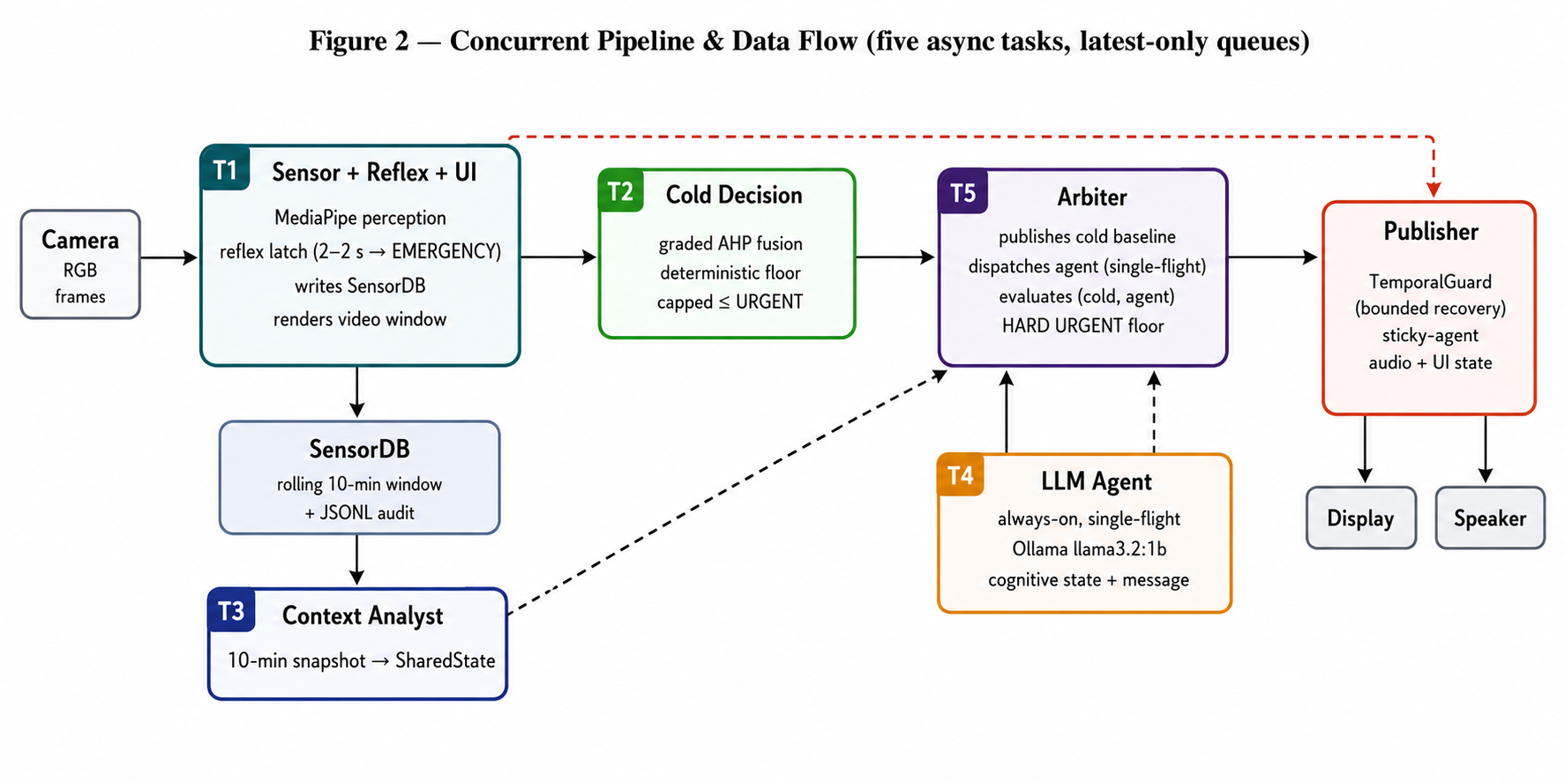
Figure 2 — Concurrent pipeline and data flow. These queues decouple the fast perception loop from slow LLM inference; the reflex path (dashed red) actuates an EMERGENCY directly.

3.4 The decision path for one frame
Figure 3 traces a single frame from capture to actuation, making the three layers explicit as control flow: the reflex check short-circuits to EMERGENCY; otherwise the deterministic cold decision is computed and published as the floor; and only if the agent, when idle is free is the LLM consulted, its verdict passing through the safety-floor arbiter and the temporal guard before it can reach the driver.
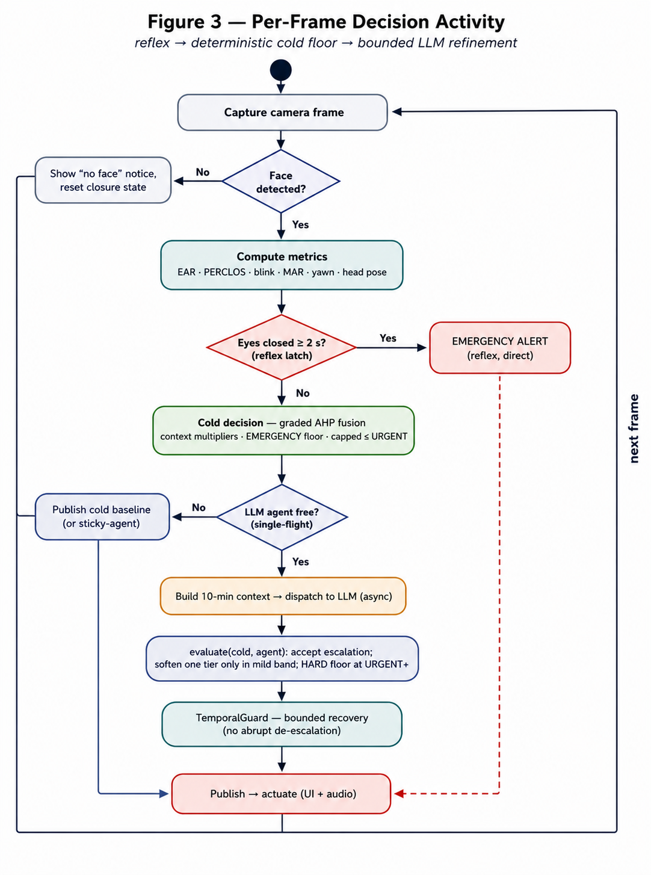
Figure 3 — The decision path for one frame. Reflex → deterministic cold floor → bounded LLM refinement. Off-ramps (no-face, reflex EMERGENCY, agent-busy) resolve without blocking the loop.

3.5 The use case perspective
The architecture in the preceding sections realises two functional subsystems whose actor/goal structure was fixed early in design and has remained stable: a pipeline that turns camera frames into graded alerts, and an LLM reasoning agent that interprets context on top of it. Both views are shown below for traceability between the original use case analysis and the final implementation.
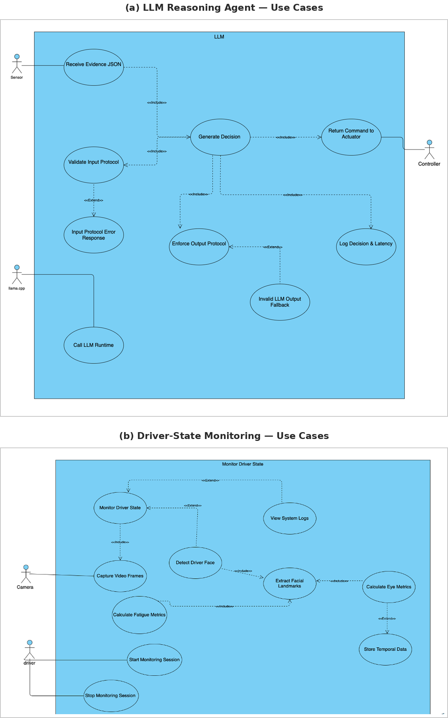
Figure 4 — Use case views of the two functional subsystems: the LLM reasoning agent (top) and the driver-state monitoring pipeline (bottom).

4. Visual Perception and Fatigue Indicators

4.1 Perception pipeline
Perception converts each camera frame into a structured metrics payload and owns every threshold in the eye and mouth state machines, which are deterministic rules that Python rather than the model should decide. OpenCV handles capture and rendering; MediaPipe Face Mesh provides 468 facial landmarks per frame, in three dimensions, fast enough on a commodity CPU to keep up with the camera. From those landmarks the layer derives the eye, mouth, and head-pose signals below, coercing and clamping every numeric input to a valid range before use so that a malformed frame degrades to non-alarming defaults rather than crashing or inventing an alarm.

4.2 Eye, mouth, and head indicators
Eye state uses the Eye Aspect Ratio with hysteresis; the two eyes are averaged for robustness to unilateral landmark failure. PERCLOS is the fraction of the last 60 s the eyes were closed, the single strongest drowsiness measure, and it is computed to include the current ongoing closure so there is no lag. Blink rate counts only closures in the voluntary 60–350 ms range, and eye-closure duration tracks the current continuous closure that the reflex layer watches. Mouth behaviour classifies NORMAL / MOUTH_OPEN / YAWNING from the Mouth Aspect Ratio, disambiguating a yawn from speech through a corroborating signal from the eyes (a yawn narrows the eyes, talking does not), and talking detection (rapid MAR oscillation with stable eyes) suppresses fatigue signals from the mouth while active. Head pose solves for pitch and roll from stable landmarks and compares them against a baseline calibrated for each driver; a sustained head-down posture (the classic nodding off) corroborates fatigue.

4.3 Formulas and hysteresis
The Eye Aspect Ratio compresses six eye landmarks into a single openness value: EAR = ( |p2−p6| + |p3−p5| ) / ( 2·|p1−p4| ), two vertical eyelid distances over twice the eye width, so it is invariant to face scale and camera distance. The Mouth Aspect Ratio is the analogous inner-lip opening over mouth width. Rather than a single fixed threshold, eye state uses hysteresis: the eyes are declared closed below EAR 0.20 but reopened only above 0.23 (Soukupová and Čech). The gap between the two thresholds prevents a value hovering on the boundary from flipping the state rapidly, which would otherwise inflate blink counts and re-trigger alerts.
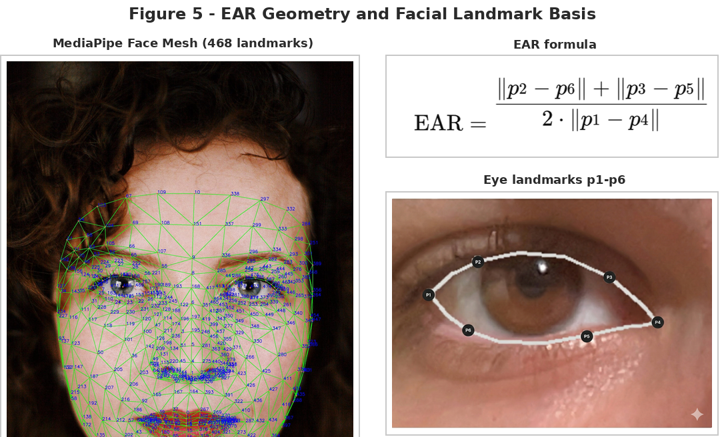
Figure 5 — EAR geometry: the six ocular landmarks behind the formula above, alongside the MediaPipe Face Mesh (468 landmarks) from which they are extracted.
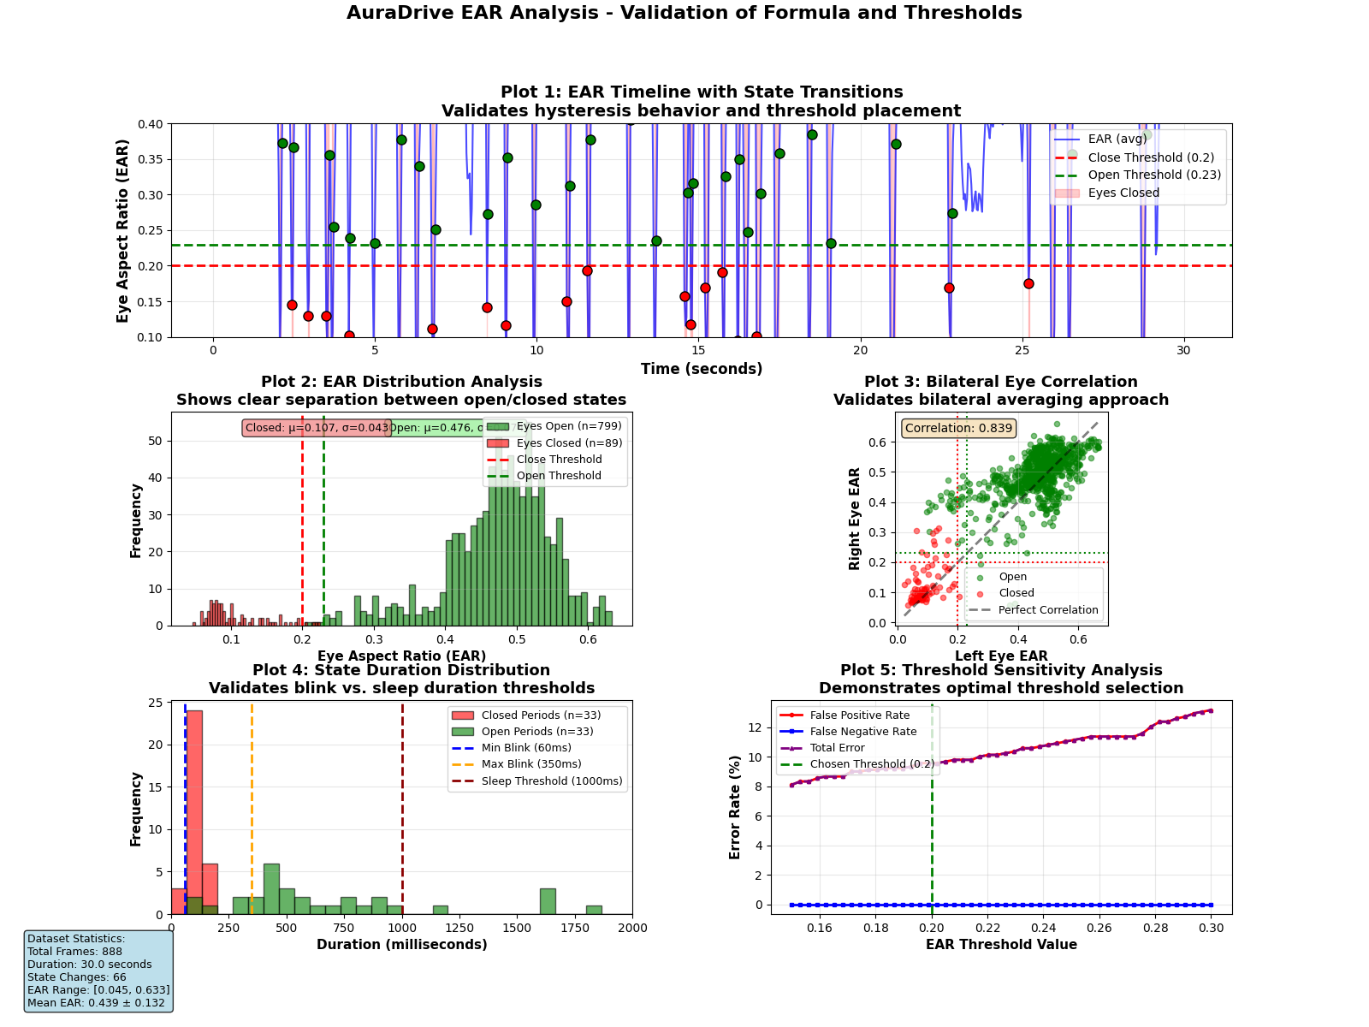
Figure 6 — Empirical EAR trace across an open→closed→open cycle, confirming the 0.20 / 0.23 hysteresis band separates eye states cleanly without rapid flips near the boundary.

4.4 Mouth aspect ratio and yawn detection
The Mouth Aspect Ratio is computed from four true lip landmarks: the vertical inner-lip opening (upper-inner-lip point 13 to lower-inner-lip point 14) divided by the outer mouth width (corner 61 to corner 291), so MAR = dist(13,14) / dist(61,291). Like EAR it is a scale-invariant ratio, running from roughly 0.05 for a closed mouth to about 0.70 for a wide yawn; any value above 1.0 is treated as a landmark-detection failure rather than a real mouth. A mouth is considered open once MAR rises above 0.30.
Detecting a yawn is harder than detecting an open mouth, because talking, singing and speech also raise MAR. AuraDrive resolves this with a dual-signal rule grounded in a physiological fact: a genuine yawn narrows the eyes, whereas talking leaves them at normal openness. During every mouth-open period the sensor tracks the minimum EAR seen so far, and a yawn is only registered when three conditions agree: MAR sustained above the 0.50 yawn threshold, the opening lasting between 1.5 and 6 seconds (shorter is a twitch, longer is likely sustained talking), and the minimum EAR dropping below 0.22 to confirm the eyes narrowed. Talking is classified separately by the opposite signature: elevated MAR mean (≥ 0.25) with high MAR variance (≥ 0.003) over a short ~20-frame window while the eyes stay open, which is rapid oscillation without eye narrowing. When talking is active, fatigue signals from the mouth are suppressed so a chatty driver is not mistaken for a drowsy one.

4.5 Temporal windows: microsleep, PERCLOS and history
A single frame is never sufficient evidence of fatigue: a low EAR for one frame may be a blink, a downward pitch a dashboard glance, and an open mouth speech. Every indicator is therefore evaluated over a rolling time window rather than instantaneously, and the choice of window length is what separates a transient, innocent event from a genuine, developing pattern. That choice is the mechanism that most directly attacks the false alarms of Section 1.2.
The most safety-critical window is the microsleep threshold: a continuous eye closure of 2 seconds or more is treated as a microsleep and fires an EMERGENCY_ALERT directly from Python, bypassing the LLM entirely (the agent is told closures ≥ 2 s are intercepted before it is ever called). Below that, a closure of at least 1 second, confirmed by the smoothed slow-EAR signal, is enough to flag drowsiness. PERCLOS, the single strongest drowsiness measure, is the fraction of the last 60 seconds the eyes were closed; it is computed over a rolling one-minute window of recorded closure intervals and it includes the current ongoing closure so the value never lags reality. Blink rate is counted over the same 60-second window, but only closures lasting 60–350 ms qualify as voluntary blinks: anything shorter is noise, anything longer is a partial closure that belongs to the drowsiness signal instead. Yawns are likewise tallied per minute. Finally, the reasoning agent receives a rolling ten-minute history of the driver's recent state and the system's own recent decisions, giving it the behavioural trajectory it needs to judge whether fatigue is escalating. The table below summarises the windows and thresholds, all owned by Python.

Table 2 — Temporal windows and thresholds, all owned by Python.
Signal / event | Window or bound | Meaning
Microsleep → EMERGENCY | ‎≥ 2 s closed | Continuous eye closure of 2 s fires an emergency directly from Python, bypassing the LLM
Drowsiness confirm | ‎≥ 1 s closed | Closure of 1 s, confirmed by smoothed slow-EAR, flags a drowsy state
Voluntary blink | ‎60–350 ms | Only closures in this range count as blinks; shorter is noise, longer is partial closure
PERCLOS | ‎last 60 s | Fraction of the last minute the eyes were closed, including the current ongoing closure
Blink rate | ‎last 60 s | Blinks per minute; abnormally low or high rates are themselves risk signals
Yawns per minute | ‎last 60 s | Confirmed yawns (wide MAR + eye narrowing) counted over a rolling minute
Head pose (nod-off) | ‎~1.5 s sustained | Sustained pitch/roll deviation from a baseline calibrated for each driver, not a momentary glance
Agent context history | ‎last 10 min | Rolling trajectory of driver state and prior decisions supplied to the LLM
Because every threshold above is deterministic and lives in Python, the same reading always produces the same classification, a property the LLM could not guarantee by its nature, and the reason all timing and counting logic is deliberately kept out of the model.

4.6 Head pose: pitch and roll
Head orientation is the third fatigue channel, capturing the classic nodding off that eye and mouth metrics miss. The system recovers the head's Euler angles by solving the Perspective-n-Point (PnP) problem, fitting the observed 2-D facial landmarks to a canonical 3-D head model to obtain a rotation matrix T. Pitch (nodding, forward/backward) and roll (side-to-side tilt) are then read directly from that matrix: Pitch = arctan( T₂₃ / T₃₃ ) and Roll = arctan( T₂₁ / T₁₁ ).
Raw angles are meaningless without a reference, because drivers sit differently and cameras mount at different heights. Each session therefore establishes a personal calibrated baseline for the driver's neutral head position, and all deviations are measured against it. A fatigue-relevant head event is flagged only when the deviation is both large and sustained: pitch ≥ 20° or roll ≥ 15.4° from the baseline, held for at least 1.5 s (AURADRIVE_PITCH_PERSIST_MS, default 1500 ms). The persistence requirement is what separates a genuine head drop from an ordinary mirror-check or shoulder-glance, keeping this channel, like the others, resistant to the false positives of Section 1.2.
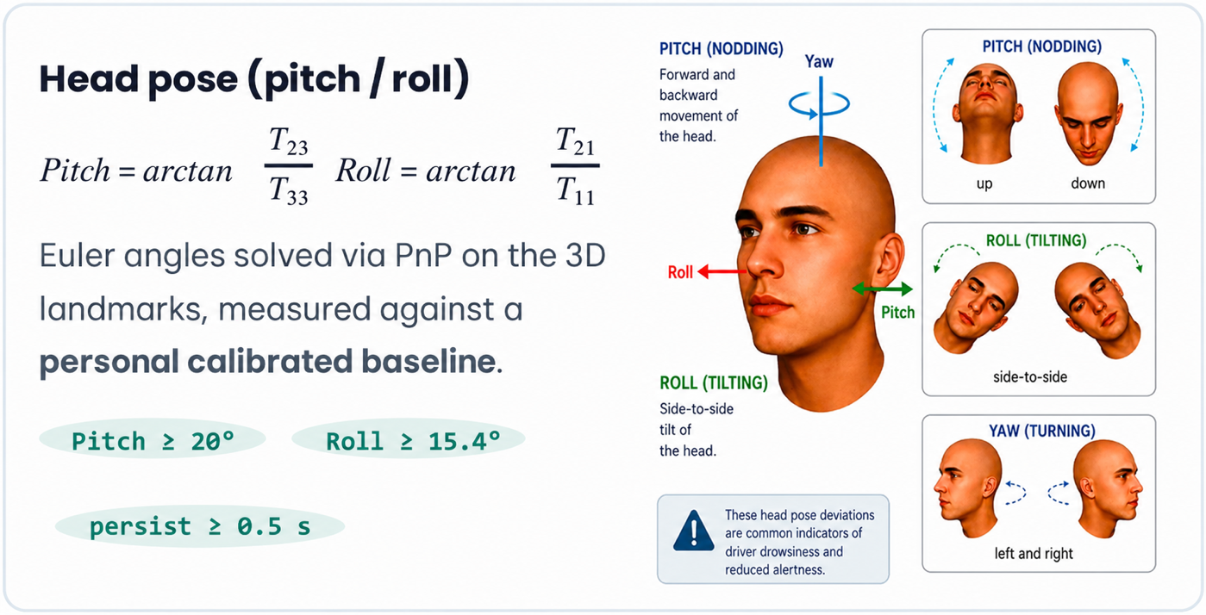

5. Deterministic Safety Layer and LLM Agent Design

5.1 The deterministic cold engine
The cold engine is the system's safety net and its most rigorously justified component. It grades fatigue on a 0–10 scale as a weighted fusion of PERCLOS, closure duration, blink, and yawn scores, then applies bounded context multipliers for time of day and trip duration, with input validation and clamping so it never raises on bad input. The fusion weights are not chosen by feel: they are derived through the Analytic Hierarchy Process from a matrix of pairwise comparisons on Saaty's 1–9 scale, whose normalised principal eigenvector yields PERCLOS 0.51, closure 0.27, yawn 0.12, and blink 0.10, accepted only after the Consistency Ratio (0.006) fell far below Saaty's 0.10 bound. A calibration safeguard ensures context can amplify evidence but never manufacture it: unless the unamplified base score reaches a calibration floor of 5.0 out of 10, which takes real physiological evidence such as PERCLOS at 0.25 on its own, the amplified result is capped at the top of the URGENT band (7.49), so a merely-moderate reading at 03:00 can say “pull over now”, but no multiplier will turn it into a loss-of-consciousness verdict.

5.2 The reflex path
Beneath every probabilistic layer sits a direct safety bypass. Whenever continuous eye closure reaches the microsleep threshold of two seconds, the reflex latch fires an EMERGENCY_ALERT immediately, without waiting for the LLM, the context summary, or the arbiter. A latch mechanism ensures a single continuous closure produces one emergency event rather than a repeated cascade, and the alert is released only when the eyes genuinely re-open. This path guarantees that the most dangerous state is always met with maximum urgency, independent of model availability or latency.

5.3 The local LLM agent
The agent's role is explicitly holistic behavioural analysis, not threshold calculation. Given only Python-computed, validated text evidence (the retained history, a summary of deterministic facts, and the current-frame narrative) plus the cold safety floor, the locally hosted Llama 3.2 model classifies the driver into one of seven cognitive states, predicts the failure risk over the coming ten minutes, and writes a short, personalised intervention message as strict JSON. Measurements reach the model only inside sentences that already carry the conclusion Python drew from them: the driver state, the trend label and the cold command are stated alongside every figure. No verdict therefore depends on the model doing its own arithmetic.
Table 3 — The seven cognitive states the agent may assign, and when.
Cognitive state | When the agent should assign it
Alert | All metrics normal; fully in control
Highway Hypnosis | Subtle consistent micro-signals over time; autopilot
Fighting Sleep | Actively struggling; escalating trajectory
Active Fatigue | Clear multimodal fatigue signals present
Cognitive Overload | High arousal (talking) masking physical fatigue
Post-Microsleep Recovery | Recent confirmed microsleep; high recurrence risk
Unknown | Signals insufficient or contradictory
Because the model is small (1B parameters) and fallible, its output is wrapped in deterministic guards: it is validated against a strict schema; an EMERGENCY from the model is capped to URGENT (only the reflex layer may declare EMERGENCY); the Post-Microsleep-Recovery label is allowed only when the facts contain a confirmed microsleep; and the message is scrubbed of invented navigation specifics. If the model is unavailable or times out, the arbiter falls back to the cold decision, a safe degradation that keeps the system fully protective without any LLM at all.

5.4 Prompt engineering: from rule chains to contextual reasoning
The agent's prompt underwent a decisive evolution that mirrors the whole project. An early open-ended prompt produced inconsistent, unparseable output. A second, strict rule-chain JSON prompt asked the model to execute a fixed IF/ELSE-IF threshold chain and emit a verdict (preserved in Appendix C); in testing the 1B model applied that arithmetic inconsistently and occasionally mislabelled clear states. The final prompt removes the calculations entirely: the model receives validated facts and is asked only to interpret the behavioural trajectory, with every numeric decision already settled deterministically. The same small model that was unreliable as a calculator proved dependable as an interpreter. This is the clearest evidence for the project's central conclusion that Python must own calculation and safety-critical logic while the LLM interprets validated context.
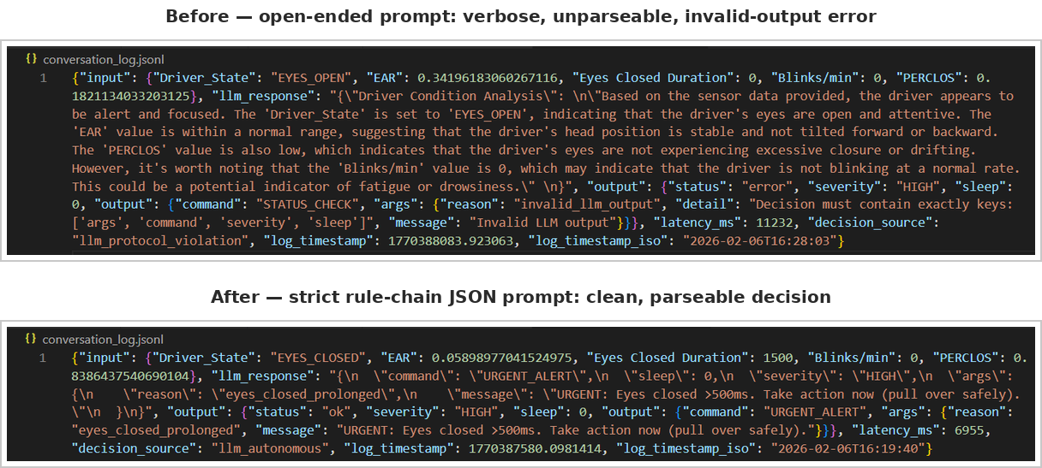
Figure 7 — Prompt evolution: the verbose open-ended prompt (top) produced inconsistent, occasionally unparseable output; the final context-only prompt (bottom) yields a clean, reliably parseable interpretation once Python owns all arithmetic.

5.5 Safety arbitration
Every layer emits the same canonical decision object, and a single command vocabulary orders the system by urgency, which makes the safety floor expressible as one auditable rule.
Table 4 — Canonical command vocabulary, ordered by urgency, with its owning layer.
Command | Severity | Meaning | Owner
NO_ACTION | LOW | Alert, in control | Cold / Agent
GENTLE_ALERT | LOW | Early pattern; low-effort nudge | Cold / Agent
MODERATE_ALERT | MEDIUM | Confirmed fatigue; take a break soon | Cold / Agent
URGENT_ALERT | HIGH | Losing control; pull over now | Cold / Agent (agent capped here)
EMERGENCY_ALERT | HIGH | Microsleep / loss of consciousness | Reflex latch; Cold (calibration floor only)
The arbiter compares the agent's command with the cold baseline. If the agent agrees or escalates, it is accepted outright (large jumps are flagged for audit but still pass, because escalation is always safe). If the agent wants to soften, a hard floor governs: when the baseline is URGENT or above, the agent is ignored and the full cold command stands; when the baseline is mild (NO_ACTION / GENTLE / MODERATE), where deterministic false alarms actually occur, the agent may lower the command by at most one tier, and any larger drop is clamped. The agent can never declare EMERGENCY itself: it is capped to URGENT upstream, so an EMERGENCY reaches the driver only from the reflex latch or from a cold score whose unamplified base already clears the calibration floor of Section 5.1. Finally, a temporal guard prevents abrupt de-escalation: a graded alert recovers one tier at a time, while a point-event reflex EMERGENCY is held briefly and then released directly to the current deterministic truth.

6. Development and Research Process

6.1 Methodology and client interaction
Development followed a tight iterative loop rather than a single up-front design. Each cycle audited the running system for correctness and safety, selected a specific fix or feature, implemented and functionally checked it in isolation, and only then merged it into the integrated build, after which the whole pipeline was exercised on live camera input and recorded scenarios. The academic advisor, Mr. Ilya Zeldner, served as the project's client: his feedback was treated as a formal input, translated into concrete testable changes, and where a literal recommendation conflicted with the safety model the divergence was made explicit and justified rather than silently applied.

6.2 Tools and technologies
Table 5 — Development tools and technologies, and why each was chosen.
Technology | Role in AuraDrive and why it was chosen
Python 3.10+ | Primary language; fast to iterate, rich CV/async ecosystem
Visual Studio Code | Development environment and debugging
OpenCV | Camera capture, frame handling, and on-screen overlay
MediaPipe Face Mesh | 468-landmark facial analysis at camera rate on CPU
NumPy | EAR/MAR geometry, PERCLOS windows, and statistics
Python asyncio | Five-task concurrency; offloads blocking calls without stalling perception
Ollama | Fully offline local LLM runtime with a simple HTTP interface
Llama 3.2 (1B) | On-device behavioural reasoning within resource limits
JSON / JSONL | Structured agent I/O and append-only audit logs
Git / GitHub | Version control and collaboration
winsound / afplay | Nonblocking graded alert tones (Windows / macOS)
System.Speech / say | Spoken alert phrases (Windows PowerShell, macOS say)
subprocess | Long-lived, warm agent process isolating model inference
run.sh, requirements.txt | One-command setup and pinned dependency management

6.3 The engineering pivot from Phase A to Phase B
The most important engineering insight was recognising that the Phase A feasibility design used the LLM incorrectly. In Phase A the model was prompted to act as a deterministic rule-execution engine running a fixed IF/ELSE-IF chain, precisely what a 1B model is worst at and what Python is best at. Phase B inverted the responsibility: the deterministic rules were extracted into the AHP reference engine (fast, exact, auditable), and the LLM was retasked to do the one thing only it can do, which is to read the behavioural trajectory and produce context-aware language, while a hard safety floor guarantees it can never undermine the deterministic verdict. This pivot is what turned the project's thesis into an architecture that actually honours it.

6.4 Testing plan
Beyond the AHP feasibility study, the prototype was exercised against a small manual test matrix covering the conditions most likely to break perception or trigger a false alert. All figures below were measured on the development laptop (Apple Silicon MacBook Air, CPU-only inference) and extracted from the JSONL audit logs of five recorded sessions totalling 10,367 frames; they are indicative of this one machine, not a statistical evaluation across drivers or hardware.
Table 6 — Manual test matrix: conditions, expected behaviour and outcome.
Test | Condition | Expected Behaviour | Result
Glasses Test | Driver wearing prescription or sunglasses | EAR/MAR landmarks remain trackable; no false EMERGENCY triggers from lens glare or frame occlusion | Passed
Yawn Test | Sustained mouth opening (MAR > 0.50) with eye narrowing | YAWN_DETECTED raised and reflected in the PERCLOS / context history sent to the agent | Passed
Lighting Test | Low-light and backlit camera conditions | Face Mesh detection degrades gracefully; no false eye-closure readings | Passed indoors; degrades in near-dark (drives the IR-camera future work)
Occlusion Test | Hand or phone briefly covering mouth or eyes | System falls back to a safe state for a lost face rather than emitting an incorrect verdict | Passed
Latency Test | End-to-end frame-to-alert time on the reflex path | EMERGENCY_ALERT fires within the 2 s eyes-closed threshold, bypassing T2–T4 entirely | Passed
Table 7 — Measured behaviour extracted from the audit logs of five recorded sessions.
Quantity | Measured | Source and note
Sustained perception rate | 30.3 FPS (median 33 ms frame interval); 29.2 FPS mean. | sensor_log.jsonl. Four of five sessions held 29.6–29.8 FPS; the first includes camera start-up.
Agent round trip | median 11.7 s, range 9.1–35.5 s (n = 18) | agent_decision_log.jsonl. llama3.2:1b on CPU; the four slowest calls follow a model reload.
Perception blocked by the agent | 0 frames | The 30 FPS loop is unaffected by an 11.7 s inference. This is what the five-task design buys.
Reflex EMERGENCY events | 5, longest closure 4,097 ms | final_decision_log.jsonl. Every closure past the 2 s threshold latched without an agent call.
Safety floor enforced | 1 arbiter override | One agent verdict was rejected for attempting to soften a protected decision.
Face-loss frames handled | 99 of 10,367 | Each resolved to the neutral state for a lost face, with no false closure on reacquisition.

7. Challenges, Results, Conclusions, and Project Metrics

7.1 Engineering challenges and solutions
Fatigue detection has no single unambiguous signal, which made balancing sensitivity against false positives the central difficulty, and a local LLM in a real-time loop compounded it. Each challenge was met with a specific, deliberate mechanism:
- False positives vs. missed detection: resolved by the governing asymmetry: a deterministic floor that can be raised by context but not lowered by the model, plus temporal windows and multisignal convergence before escalation.
- LLM latency: the async architecture of five tasks, an agent that is always ready and runs one inference at a time, and queues that keep only the newest item; the cold baseline actuates every frame while the model runs on the freshest free frame.
- LLM output inconsistency: a strict output schema, deterministic guards (EMERGENCY cap, microsleep gating, message scrubbing), and a cold fallback on timeout or invalid output.
- Sensor noise and face-tracking loss: hysteresis-based EAR classification and explicit reset of closure state on tracking loss, so a reappearing face cannot trigger a false, inflated microsleep.
- Mouth opening vs. speaking/yawning: MAR evaluated jointly with a corroborating signal from the eyes and a talking detector that suppresses fatigue signals from the mouth during speech.
- Head movement vs. fatigue: pitch/roll judged as sustained deviations from a baseline calibrated for each driver, so glances and posture shifts do not read as nodding off.
- Temporal history without unbounded memory: a rolling window of ten minutes, bounded and mirrored to JSONL, rather than retaining raw frames.
- Safe audio without nagging: nonblocking daemon-thread playback where escalations interrupt but de-escalations stay quiet, and audit rows are written once per change of decision.

7.2 Achievement of project goals and metrics
The project's goals were met at prototype level: AuraDrive is a complete, running, system that runs on the device at camera rate with a layered safety architecture, graceful degradation, and clear graded actuation, in which every decision is traceable to its source. The table below states each target honestly.
Table 8 — Project goals and metrics, with an honest status for each.
Metric / goal | Target | Status | Explanation
Perception rate | ≥ 30 FPS | Achieved (nominal) | 30.3 FPS by median frame interval; 29.2 FPS mean including camera start-up (Table 7)
On-device / offline operation | No cloud | Achieved | Perception, engine, and LLM all run locally via Ollama
Reflex latency independent of LLM | Model-independent | Achieved | 5 reflex EMERGENCY events fired directly from T1, with no agent call (Table 7)
LLM failure fallback | Safe on timeout | Achieved | Arbiter falls back to the cold decision; perception never blocked, even at 11.7 s median inference
Bounded rolling history | No unbounded growth | Partially achieved | Windows bounded; the agent index still needs a hard cap (§9)
Fewer false alarms | Fewer false alarms | Architecturally addressed | By design (temporal + floor); not yet statistically proven
Automotive-grade validation | Certified accuracy | Not achieved | Requires labelled datasets and on-road trials (future work)

7.3 Conclusions
The central conclusion is that a hybrid architecture suits driver-fatigue monitoring better than either a purely deterministic or a purely LLM-based system. Deterministic logic is fast, reproducible, and appropriate for immediate safety decisions but limited at interpreting ambiguous, gradual behaviour; an LLM offers valuable contextual interpretation but is not reliable enough for exact calculation or time-critical emergency handling. The LLM's strongest contribution is interpreting validated evidence over time and generating meaningful, driver-facing interventions, while numerical computation, thresholding, and emergency handling remain deterministic. Clinical or production-level accuracy has not been established and larger-scale validation remains necessary, but the architecture that carries that future work is in place and defensible.

8. Lessons Learned and Retrospective Reflection
Working on a safety-critical system reshaped how we make and defend engineering decisions. Overall we believe we worked in the right direction: we built a real, integrated, running system, grounded its deterministic core in method and literature, used the LLM where it adds value and fenced it where it does not, and can explain and defend every layer. Three lessons stand out, and the main thing we would change is stated in each.

8.1 Use each tool for what it is uniquely good at
Our Phase A instinct, which was to make the impressive new tool (the LLM) do the important job (the decision), was exactly wrong. Deterministic decisions belong to deterministic code, which is faster, exact, and auditable; the LLM earns its place only where contextual, trend-based judgement is genuinely needed, and even there it must be bounded. In hindsight we would have separated these responsibilities from the start, saving a substantial re-architecture.

8.2 Design the safety envelope before the capability
We initially added the LLM's capability and then reasoned about how to make it safe; the order should be reversed. Once the arbiter and temporal guard were in place we could experiment with an unreliable 1B model aggressively, because no experiment could compromise a high-risk decision. In hindsight the inviolable safety boundaries should have been defined first, with the intelligent layer built to operate inside them.

8.3 Iterate against audits, and be honest about what is validated
The audit-select-implement-integrate loop, backed by targeted functional checks and honest tagging of validated versus engineering-chosen thresholds, kept the system trustworthy as it grew. Documenting the residual post-microsleep softening case rather than hiding it is what makes the safety claims credible. If we did the project again we would formalise this discipline earlier, specifying the safety invariants as explicit, repeatable checks before building the features they protect.

9. Future Work
The prototype's next steps fall into three groups. Platform and hardware: migrating to an embedded GPU target such as NVIDIA Jetson would move AuraDrive toward a standalone, production-capable edge unit, requiring CUDA/model acceleration, thermal and power validation, and a Linux audio backend alongside the existing Windows and macOS paths; an infrared camera would extend reliable operation to low-light and night driving. Model and sensing: a larger local model would improve the quality of the advisory refinement and messaging, and optional contactless physiological signals (remote photoplethysmography for heart-rate variability, facial-expression analysis) could add early, independent corroboration of drowsiness. Validation and robustness: rigorous quantitative evaluation is needed: systematic measurement of false alarms, missed events and latency against labelled fatigue datasets across diverse drivers, lighting, camera positions, and eyewear, together with a bounded long-run memory cap and long-term personalised driver calibration.
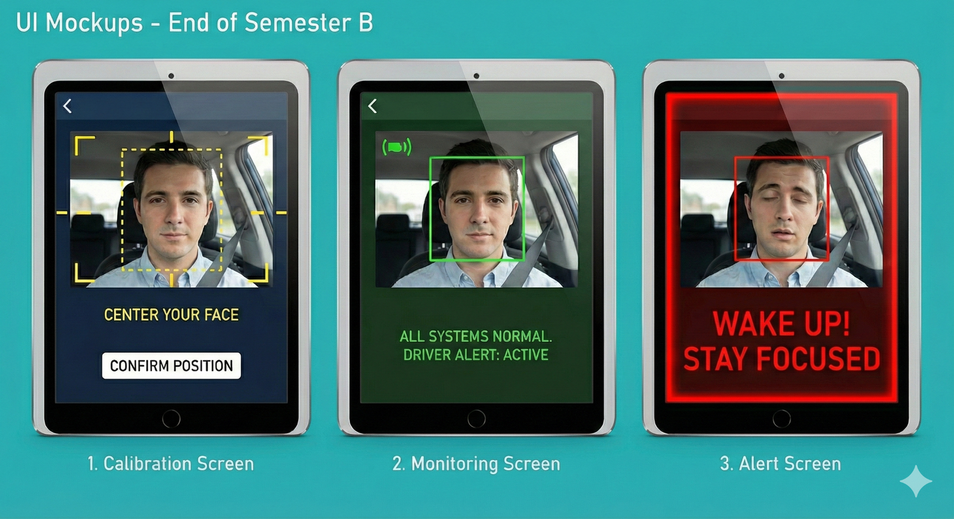
Figure 8 — Target in-cabin UI concept from the original design study. The current prototype renders a functionally equivalent overlay in a plain OpenCV window; a polished cockpit UI remains future work.

References
[1] T. Soukupová and J. Čech, “Real-Time Eye Blink Detection using Facial Landmarks,” in 21st Computer Vision Winter Workshop, 2016.
[2] R. Grace, “Drowsy Driver Monitor and Warning System,” in Proc. Int. Driving Symposium on Human Factors in Driver Assessment, Training and Vehicle Design, 2001.
[3] D. F. Dinges et al., “PERCLOS: A Valid Psychophysiological Measure of Alertness,” Federal Highway Administration, Tech. Rep. FHWA-MCRT-98-006, 1998.
[4] Wei, Chi, and Chen, “A Multi-Feature Fusion and Situation Awareness-Based Method for Fatigue Driving Level Determination,” Electronics, vol. 12, no. 13, art. 2884, 2023.
[5] T. L. Saaty, The Analytic Hierarchy Process. New York: McGraw-Hill, 1980.
[6] S. Abtahi, M. Omidyeganeh, S. Shirmohammadi, and B. Hariri, “YawDD: A Yawning Detection Dataset,” in Proc. 5th ACM Multimedia Systems Conf., 2014, pp. 24–28.
[7] National Highway Traffic Safety Administration (NHTSA), “Drowsy Driving,” 2017–2021. [Online]. Available: nhtsa.gov/risky-driving/drowsy-driving
[8] NHTSA, “Countermeasures That Work: Drowsy Driving,” 2021. [Online]. Available: nhtsa.gov/book/countermeasures-that-work/drowsy-driving
[9] European New Car Assessment Programme (Euro NCAP), “Driver Monitoring — Assessment Protocol,” 2023. [Online]. Available: euroncap.com
[10] Google Research, “MediaPipe: A Framework for Building Perception Pipelines,” 2020. [Online]. Available: mediapipe.dev
[11] V. Bazarevsky et al., “BlazeFace: Sub-millisecond Neural Face Detection on Mobile GPUs,” Google Research, 2019. arXiv:1907.05047.
[12] G. Bradski, “The OpenCV Library,” Dr. Dobb’s Journal of Software Tools, 2000.
[13] C. R. Harris et al., “Array Programming with NumPy,” Nature, vol. 585, no. 7825, pp. 357–362, 2020.
[14] Ollama, “Local Large Language Model Runtime for Edge-Based Inference,” 2024. [Online]. Available: ollama.com
[15] Meta AI, “Llama 3: Open Foundation and Fine-Tuned Chat Models,” 2024. [Online]. Available: ai.meta.com/llama
[16] M. Doudou, A. Bouabdallah, and V. Berge-Cherfaoui, “Driver Drowsiness Measurement Technologies: Current Research, Market Solutions, and Challenges,” Int. J. Intelligent Transportation Systems Research, vol. 18, no. 2, pp. 297–319, 2020.
[17] C. Zhang et al., “A Comprehensive Review of Driver Fatigue Detection Systems,” IEEE Trans. Intelligent Transportation Systems, vol. 23, no. 6, pp. 5290–5307, 2022.

Appendix A: User Guide
This guide describes normal, successful operation of AuraDrive for the person installing and running it in a vehicle or on a workstation. It follows the nominal flow from setup to a live monitoring session and explains what the driver sees and hears. It intentionally does not enumerate error conditions; those are covered by the system's automatic fallbacks and by the Maintenance Guide.

A.1 What AuraDrive does for you
Once running, AuraDrive watches the driver through the cabin camera and shows a live video window with on-screen telemetry. When it detects a pattern consistent with fatigue it raises a graded alert whose urgency matches the driver's state: a distinct tone pattern, a short spoken phrase, and an on-screen banner carrying the system's advisory, from a gentle nudge up to an emergency “pull over now.” No interaction is needed while driving; the driver simply responds to the alerts.

A.2 Before you start (prerequisites)
- A computer running macOS 12 or later (the development and demonstration target) or Windows 10/11, with a working, camera facing the driver.
- Python 3.10 or newer installed and available on the system PATH.
- Ollama installed (from ollama.com), which provides the local reasoning model. AuraDrive will download the model automatically on first run.
- Speakers or the vehicle's audio output, so alerts can be heard.
AuraDrive runs entirely on this device. No internet connection is required during operation, and no camera images ever leave the computer.

A.3 Installing and launching
The project ships with a single launcher that prepares everything and starts the system. On macOS and Linux run it from the project folder as shown below; on Windows, run the equivalent steps from B.2 in PowerShell.
- Step 1. First-time setup (recommended, isolated environment): run ./run.sh --venv. This creates a private Python environment, installs the required libraries, ensures the Ollama service is running, and downloads the reasoning model (a one-time ~1.3 GB download).
- Step 2. Normal start: on subsequent runs simply run ./run.sh. It reuses the installed environment and model and launches the monitor.
When startup completes, the live video window titled AuraDrive appears. The system is now monitoring.

A.4 The first few seconds: calibration
For the first moment of a session the driver should sit normally and face the camera. AuraDrive quietly learns the driver's neutral head posture (used to recognise genuine nodding off later). No action is required beyond facing forward briefly; calibration is automatic and needs only stable, open-eyed frames.

A.5 Reading the on-screen display
During a session the window shows the live camera image with the face mesh drawn on it and a panel of real-time telemetry, including:
- EAR and State: the current eye-openness value and whether the eyes are open or closed.
- PERCLOS: the percentage of the last minute the eyes were closed (a key drowsiness measure).
- Blinks/min, Yawns/min, and Talking: behavioural indicators.
- An EAR timeline plot with the open/close reference lines, so trends are visible at a glance.
When an alert is active, a coloured banner appears along the bottom of the window: green for low-severity, orange for medium, and red for high-severity alerts. If the driver's face is not visible, a neutral banner notes this; it is a sensing message, not a fatigue warning.

A.6 Understanding the alerts
Alerts are graded so the response can match the risk. The driver hears an escalating tone pattern and a short spoken phrase for the alert level, while the reasoning agent's fuller advisory appears in the on-screen banner. Speech is kept deliberately brief, because a driver who is losing alertness needs a clear cue rather than a paragraph; the agent's own wording can be spoken instead through the optional setting in A.8.
Table 9 — Alert levels, meaning, and the suggested driver response.
Alert | What it means | Suggested response
Gentle | Early signs of fatigue | Open a window, adjust posture, stay attentive
Moderate | Confirmed fatigue building | Plan a short break soon
Urgent | Losing alertness | Pull over safely as soon as you can
Emergency | Microsleep detected | Pull over immediately; do not continue
Because the system is designed to avoid nagging, it will not repeat lower-level alerts constantly and stays quiet while the driver recovers. An emergency alert, however, will reannounce until the situation clears.

A.7 Ending a session
To stop monitoring, click the video window and press the q key. AuraDrive shuts down cleanly, stops any sound, releases the camera, and closes the window. The session is complete.

A.8 Optional adjustments
AuraDrive works out of the box, but a few optional settings can tailor it to a particular setup without editing code. These are supplied as environment variables before launch: for example selecting a specific camera, choosing a particular installed voice, muting speech while keeping alert tones, or having the system speak the agent's own advisory in place of the fixed phrase. The full list is in the Maintenance Guide; typical drivers never need them.

Appendix B: Maintenance and Developer Guide
This guide enables a developer to keep AuraDrive running, configure it, and extend it after the project's completion. It describes the operating environment, how to install the software AuraDrive itself provides, the layout of the codebase, the configuration surface, and the safe extension points. Installation of well-known third-party infrastructure (Python, Ollama) is not repeated here beyond what is specific to AuraDrive.

B.1 Operating environment

B.1.1 Hardware
- A compute unit with a CPU capable of sustaining MediaPipe at ~30 FPS (a modern laptop CPU suffices; an NVIDIA Jetson is the intended production target). A GPU is optional and, if present, can host model layers.
- A camera facing the driver accessible through the OS (USB webcam during development; a cabin IR/RGB camera in a vehicle).
- An audio output device.

B.1.2 Software
- Operating system: macOS 12 or later, or Windows 10/11. Audio actuation resolves its backend once at startup: winsound tones with PowerShell System.Speech on Windows, prerendered tone files played through afplay with say on macOS. Perception, engine, reasoning and arbitration are OS-independent, so on Linux the system runs in full but silently and reports the disabled audio channel on stderr (see B.5).
- Python 3.10+ (the codebase uses X | None type syntax).
- Python libraries (pinned in requirements.txt): opencv-python, mediapipe==0.10.14, numpy.
- Ollama runtime with a chat-capable model: llama3.2:1b by default (fallback llama3.2:latest).
No database server is required: history is an in-memory rolling window and audit trails are JSONL files, written by appending only, so there is no external datastore to provision.

B.2 Installing the AuraDrive software
The launcher run.sh performs and verifies the AuraDrive-specific installation; understanding what it does is the fastest path to maintaining it.
- ./run.sh --venv creates an isolated .venv, installs requirements.txt into it, and verifies the install functionally: it does not merely check that MediaPipe imports, it exercises mp.solutions.face_mesh, because a partially-broken MediaPipe can import yet fail at runtime. On failure it retries with a clean reinstall and prints targeted remediation.
- It then ensures Ollama is available: if a server is already running it is left untouched; otherwise the script starts one, waits for readiness, and pulls the model if neither the primary nor fallback model is present. --skip-ollama disables this management (the system then falls back to the deterministic layer if the model is absent).
- ./run.sh --setup performs setup only (dependencies and model pull) and exits without launching, which is useful when provisioning a new device such as the Jetson.
To run without the launcher, install requirements.txt into a Python 3.10+ environment, start ollama serve, ensure the model is pulled, and run python main.py.

B.3 Codebase map
The modules are cohesive and dependency-ordered; the decision contract in decision.py is shared by every layer so severities and commands can never diverge.
Table 10 — Codebase map: one responsibility per module.
Module | Responsibility
main.py | Wires the five asyncio tasks into the event loop; startup and clean shutdown
tasks.py | The T1–T5 coroutines, latest-only queues, reflex latch, Publisher, temporal actuation
sensor.py | Perception: EAR/MAR/PERCLOS/blink/yawn/talking state machines; input validation
pose.py | Calibrated head pose tracker for pitch and roll with persistence gating
reference_engine.py | Deterministic graded AHP cold decision and safety-net fallback
decision.py | Canonical decision contract: command vocabulary, severity/sleep mapping, fail-safe defaults
evaluator.py | Safety-floor arbiter (evaluate) and the bounded-recovery TemporalGuard
agent.py | LLM interaction: prompt, schema validation, deterministic output guards, fallback
context_summary.py | Deterministic text aggregation over the window supplied to the agent
audio.py | Nonblocking graded tones and spoken messages
db.py | Rolling history window and the JSONL audit logs

B.4 Configuration reference (environment variables)
Behaviour is tuned through environment variables read at startup, so no code edit is required. The most useful are listed below; all have safe defaults.
Table 11 — Configuration reference: environment variables and their defaults.
Variable | Default | Effect
AURADRIVE_CAMERA_INDEX | 0 | Selects the capture device
AURADRIVE_MODEL | llama3.2:1b | Primary Ollama model
AURADRIVE_OLLAMA_URL | http://localhost:11434 | Local model endpoint
AURADRIVE_REFLEX_RELEASE_SEC | 2.5 | How long a reflex EMERGENCY is held before release
AURADRIVE_BAND_HYSTERESIS | 0.25 | Downgrade damping margin on the cold score bands
AURADRIVE_STICKY_TTL | 40 | Seconds an agent verdict stands between refreshes
AURADRIVE_PITCH_PERSIST_MS | 1500 | Head-down duration before nodding off is asserted
AURADRIVE_AUDIO / _TTS | 1 / 1 | Enable alert tones / spoken messages
AURADRIVE_PERCEPTION_V2 | 0 | Opt-in 3D landmarks + EAR calibration for each driver
AURADRIVE_SPEAK_FULL | 0 | Speak the agent's own advisory instead of the fixed alert phrase

B.5 Extending the system safely
The architecture is designed to be extended without disturbing the safety guarantees. The key rule for any change is the governing invariant: the reasoning layer may make the system more cautious but must never be able to weaken a URGENT-or-above decision.
- Add a sensor signal: compute it in sensor.py, expose it in the metrics payload, and either fold it into the AHP matrix (rederiving the weights and consistency ratio) or add it as an independent one-tier corroboration, as head pose is today.
- Tune thresholds: prefer environment variables (B.4); the literature-validated versus engineering-chosen tags in reference_engine.py indicate which constants are safe to adjust and which rest on published evidence.
- Swap the model: set AURADRIVE_MODEL to any chat-capable Ollama model. A more capable model improves advisory quality; the safety floor is model-independent, so correctness does not depend on the choice.
- Port actuation to Linux/Jetson: add a third backend alongside the Windows and macOS paths in audio.py (ALSA or PulseAudio tones with a Linux speech engine such as espeak), keeping the public notify / notify_no_face / stop interface so tasks.py is unaffected.
- Bound long-run memory: cap the agent-decision index in db.py (drop entries older than the working window) to fully satisfy the 12-hour continuous-operation requirement.

B.6 Logs and diagnostics
Four JSONL files, written by appending only, provide a complete, timestamped record for diagnosis and offline analysis: sensor_log.jsonl (every frame's metrics), agent_decision_log.jsonl (each model call and its result), final_decision_log.jsonl (the published decision, written once per change of state), and agent_rendezvous_log.jsonl (the verdict handshake between the agent task and the arbiter). Because they are plain JSON lines, they can be replayed or analysed with any tool. The safety-critical logic (temporal recovery, floor preservation, multitier clamping, tracking-loss gating) should be rechecked with targeted functional tests after any change to the engine, arbiter, or perception state machines.

B.7 Complete Function Reference
This reference lists every function and method in the delivered source, grouped by file. For each: its purpose, the parameters it receives (name: meaning), and what it returns (name: meaning). Leading-underscore names are internal helpers; self is omitted and * marks keyword-only arguments.

main.py
Table 12 — Function reference — main.py.
Function | Purpose | Parameters (name: meaning) | Returns
run() | Async entry point: opens the camera, builds all components, launches tasks T1–T5 + warm-up, runs the event loop, and cleans up on exit. | None | None (runs the application until 'q'/cancel)
main() | Synchronous wrapper that starts the event loop via asyncio.run(run()). | None | None
_warmup_agent(process, shared) | Preloads the local LLM before the first real dispatch, under the inference lock, so frame 1 doesn't pay the cold-start latency. | process: the AgentProcess handle; shared: shared runtime state (single-flight lock) | None (side effect: model warmed)

tasks.py
Table 13 — Function reference — tasks.py.
Function | Purpose | Parameters (name: meaning) | Returns
latest_put(queue, item) | Drain-and-replace put for streams where only the newest item matters so the freshest item always wins. | queue: a maxsize-1 asyncio.Queue; item: value to place | None
cold_baseline(cold) | Wraps the cold engine's output into the canonical decision object used as the deterministic safety baseline. | cold: raw cold-engine decision dict | dict: canonical decision
render_no_face(frame, seconds) | Draws the neutral banner at the top of the frame (a sensing state, not an alert colour). | frame: BGR image; seconds: how long tracking has been lost | None (draws on frame)
render_decision(frame, decision) | Draws the graded alert banner (colour by severity) and message for the published decision. | frame: BGR image; decision: canonical decision dict | None (draws on frame)
_banner_text(message) | Maps typographic punctuation to ASCII so cv2.putText renders it correctly (an em-dash never becomes '?'). | message: LLM/UI text | str: ASCII-safe text
_wrap_lines(text, first_limit, second_limit) | Word-boundary wrap into up to two banner lines, ellipsizing only if both are exceeded. | text: string to wrap; first_limit: max chars line 1; second_limit: max chars line 2 | tuple: (line1, remainder)
task_sensor(sensor, camera, db, sensor_q, shared, publisher) | T1: capture frame → perception → reflex latch → SensorDB write → UI render; publishes reflex EMERGENCY directly. | sensor: EyeBlinkSensor; camera: cv2 capture; db: SensorDB; sensor_q: output queue; shared: shared state; publisher: Publisher | None (raises CancelledError on 'q')
task_cold(sensor_q, cold_q) | T2: consumes the latest frame and emits the deterministic AHP cold decision. | sensor_q: input frames; cold_q: output cold decisions | None
task_context(db, shared) | T3: periodically snapshots the window into shared state for the agent. | db: SensorDB; shared: shared state | None
task_agent(process, agent_q, agent_log, shared) | T4: always-on, single-flight worker that runs the LLM on the freshest free frame and records its verdict. | process: AgentProcess; agent_q: dispatch queue; agent_log: AgentDecisionLog; shared: shared state | None
resolve_agent(frame_id, baseline, agent_log, publisher) | Awaits the agent verdict for a dispatched frame, arbitrates it against the cold baseline, and publishes the result. | frame_id: dispatched frame id; baseline: cold baseline decision; agent_log: verdict store; publisher: Publisher | None
task_arbiter(cold_q, agent_q, agent_log, shared, publisher) | T5: publishes the cold baseline immediately, dispatches the agent single-flight, and fuses cold+agent under the safety floor. | cold_q: cold decisions in; agent_q: agent dispatch out; agent_log: verdict store; shared: shared state; publisher: Publisher | None
ReflexLatch.observe(frame) | Updates the reflex latch from a frame; fires a one-shot EMERGENCY on ≥2 s continuous eye closure. | frame: sensor metrics dict | tuple: (active: bool, publish_now: bool)
SharedState.set_history(items) | Stores the latest history window snapshot. | items: list of frame records | None
SharedState.get_history() | Returns the current history snapshot. | None | list: copied history records
SharedState.set_decision(decision) | Stores the latest published decision for cross-task reads. | decision: canonical decision dict | None
SharedState.get_decision() | Returns the latest published decision. | None | dict | None: latest decision
SharedState.reserve_agent() | Tries to acquire the inference slot (nonblocking). | None | bool: True if acquired
SharedState.release_agent() | Releases the inference slot. | None | None
AgentProcess.__init__() | Initialises the handle to the long-lived agent subprocess. | None | None
AgentProcess._start() | Lazily spawns the persistent agent subprocess (warm model). | None | subprocess: the running process
AgentProcess.call(payload) | Sends one evidence payload to the agent subprocess and returns its decoded decision. | payload: evidence dict (context + floor) | dict: agent result (or error dict)
AgentProcess.stop() | Terminates the agent subprocess. | None | None
Publisher.__init__(shared, audit) | Initialises the publisher with shared state, the audit log, the temporal guard, and the audio sounder. | shared: shared state; audit: FinalDecisionLog | None
Publisher.publish(candidate, *frame_id, event, force) | Applies the temporal guard, deduplicates by change, actuates audio + UI, and appends to the audit log. | candidate: proposed decision; frame_id: source frame; event: audit tag; force: bypass dedupe | dict: the final published decision
Publisher.note_agent(decision) | Records the latest arbitrated agent verdict as the standing (sticky) decision. | decision: arbitrated agent decision | None
Publisher._fuse_sticky(baseline) | Lets cold/reflex escalate instantly above the standing verdict; otherwise the agent verdict stands until its TTL expires. | baseline: per-frame cold/reflex baseline | dict: effective decision
Publisher.publish_baseline(baseline, *frame_id) | Publishes the baseline for this frame unless a fresher, ≥ agent verdict is still standing (sticky-agent). | baseline: cold baseline; frame_id: source frame | dict: the final published decision

sensor.py
Table 14 — Function reference — sensor.py.
Function | Purpose | Parameters (name: meaning) | Returns
EyeBlinkSensor.__init__(debug) | Builds the perception sensor: MediaPipe Face Mesh, metric buffers, and all eye/mouth thresholds. | debug: draw the telemetry overlay when True | None
process_frame(frame) | Main perception step: turns one camera frame into the full metrics dict and updates the risk payload. | frame: BGR camera image | dict: canonical sensor metrics
_dist(lm, a, b) | Distance between two landmarks (2D legacy; 3D pose-invariant in v2). | lm: landmark list; a: first index; b: second index | float: distance
_compute_EAR(lm, indices) | Eye Aspect Ratio (Soukupová & Čech 2016). | lm: landmarks; indices: six eye-landmark indices | float: EAR (vertical/horizontal)
_compute_MAR(lm) | Mouth Aspect Ratio: inner-lip vertical opening over outer mouth width. | lm: landmarks | float: MAR
_update_ear_calibration(ear_fast) | (v2) Learns the driver's open-eye EAR baseline and derives hysteresis thresholds from it. | ear_fast: smoothed current EAR | None (updates thresholds)
_track_reopen_velocity(ear_fast, now_ms, reopened) | Measures eyelid reopening speed (EAR/s); slowed lid rise is an early drowsiness marker. | ear_fast: smoothed EAR; now_ms: frame time; reopened: reopen crossing occurred | None (updates metric)
_update_covered_yawn(ear_fast, mar, now_ms) | Detects the hand-covered yawn (eye narrowing while mouth stays shut); feeds LLM context. | ear_fast: smoothed EAR; mar: mouth ratio; now_ms: frame time | None (updates metric)
_compute_head_pose(lm, width, height) | Estimates Euler pitch and roll from stable Face Mesh landmarks. | lm: landmarks; width: frame px width; height: frame px height | tuple: (pitch, roll, ok)
_classify_mouth_state(mar, ear_fast, now_ms) | Classifies NORMAL / MOUTH_OPEN / YAWNING using MAR plus the corroborating eye signal. | mar: mouth ratio; ear_fast: smoothed EAR; now_ms: frame time | str: mouth state
_compute_yawns_per_min(now_ms) | Counts confirmed yawns in the last 60 seconds. | now_ms: frame time | int: yawns per minute
_detect_talking() | Flags talking: rapid MAR oscillation with eyes near normal openness (disambiguates from yawning). | None | bool: is talking
_compute_perclos(now_ms) | PERCLOS: fraction of the last 60 s the eyes were closed, including the ongoing closure. | now_ms: frame time | float: PERCLOS (0–1)
_evict_old_blinks(now_ms) | Drops blink timestamps older than the rolling window. | now_ms: frame time | None
_build_output(ear, driver_state, closed_ms, blinks_per_min, perclos, mar, mouth_state, yawns_per_min, is_talking, no_face, pose_state, head_pitch, head_roll) | Assembles the canonical metrics dict with the exact field names the agent expects. | the computed per-frame metrics (EAR, state, PERCLOS, MAR, pose, flags, …) | dict: canonical sensor output
_draw_debug_overlay(frame, w, h, ear_fast, ear_slow, display_state, closed_ms, blinks_per_min, perclos, mar, mouth_state, yawns_per_min, is_talking, results) | Draws all telemetry and the face mesh onto the frame. | frame + the current metrics and MediaPipe results to display | None (draws on frame)
_draw_ear_plot(frame, w, h) | Draws the real-time EAR timeline with open/close reference lines. | frame: image; w: width; h: height | None (draws on frame)

pose.py
Table 15 — Function reference — pose.py.
Function | Purpose | Parameters (name: meaning) | Returns
HeadPoseTracker.__init__(pitch_down_sign) | Initialises calibration buffers and the pitch-direction convention. | pitch_down_sign: sign that means 'head down' for this camera | None
HeadPoseTracker.calibrated | Property: whether the neutral pitch/roll baseline has been learned. | None | bool: calibration complete
HeadPoseTracker.angular_delta(current, baseline) | Signed angular difference wrapped to [-180°, 180°]. | current: measured angle; baseline: neutral angle | float: delta degrees
HeadPoseTracker.update(pitch, roll, timestamp_ms, *usable) | Calibrates the neutral posture, then reports pitch/roll deviations and sustained head-down / head-tilt flags. | pitch: deg; roll: deg; timestamp_ms: frame time; usable: pose reliable this frame | dict: pose fields (baselines, deltas, active flags, calibration)

reference_engine.py
Table 16 — Function reference — reference_engine.py.
Function | Purpose | Parameters (name: meaning) | Returns
get_cold_decision(frame) | Cold-layer wrapper: graded-AHP decision for one frame, adding the EMERGENCY floor and head-pose corroboration. | frame: sensor metrics + time_of_day/trip + pose flags | dict: cold decision
compute_reference_decision(sensor, time_of_day, trip_min) | Core deterministic engine: fuses the subscores with AHP weights and context multipliers; never raises on bad input. | sensor: metrics dict; time_of_day: clock label; trip_min: minutes driven | dict: decision with command, severity, score_breakdown
_safe_value(raw, key) | Coerces and clamps one input metric into its valid range, flagging repairs. | raw: input value; key: metric name | tuple: (value, ok)
_perclos_score(perclos) | [Validated bands] Maps PERCLOS to a 0–10 subscore (Grace 2001). | perclos: fraction 0–1 | float: subscore
_blink_score(blinks_per_min) | [Engineering] Symmetric blink-rate subscore (both extremes penalised). | blinks_per_min: blink rate | float: subscore
_closure_score(closed_ms) | [Engineering] Subscore for closures of 400–1999 ms (reflex handles ≥2000 ms). | closed_ms: current closure duration | float: subscore
_yawn_score(yawns_per_min) | [Engineering] Yawn subscore: 0→0, 1→weak, ≥2→strong. | yawns_per_min: yawn rate | float: subscore
_time_of_day_multiplier(time_of_day) | Circadian risk amplifier (e.g. night ×1.8). | time_of_day: clock label | float: multiplier
_trip_duration_multiplier(trip_min) | Trip-length risk amplifier. | trip_min: minutes driven | float: multiplier
_apply_band_hysteresis(command, adjusted) | Holds the higher command while the score sits just below a band edge (damps downgrade flapping). | command: banded command; adjusted: fused score | tuple: (command, held)
_cognitive_state(command, dominant, is_talking, adjusted) | Derives a coarse cognitive-state label from the dominant signal and severity. | command: chosen command; dominant: dominant feature; is_talking: talking flag; adjusted: score | str: cognitive state
_cold_num(value, default) | Safe float coercion for the cold wrapper. | value: input; default: fallback | float: coerced value

decision.py
Table 17 — Function reference — decision.py.
Function | Purpose | Parameters (name: meaning) | Returns
make_decision(*command, decision_source, reason, message, cognitive_state, failure_risk_10min, evidence) | Builds the canonical decision object; forces EMERGENCY on an invalid command (fail-safe). | command: alert command; decision_source: who produced it; reason: explanation; message: driver text; cognitive_state; failure_risk_10min; evidence | dict: canonical decision
from_agent(agent) | Converts a raw agent result into a canonical decision object. | agent: raw agent output dict | dict: canonical decision
rank(command) | Orders a command by urgency (unknown ranks as EMERGENCY, which fails safe). | command: command string | int: rank index

evaluator.py
Table 18 — Function reference — evaluator.py.
Function | Purpose | Parameters (name: meaning) | Returns
evaluate(cold, agent) | Safety arbiter: accepts escalation freely; permits one-tier softening only in the mild band; hard floor at URGENT+. | cold: deterministic decision; agent: agent decision | Evaluation: (final decision, reason)
TemporalGuard.__init__(min_step_seconds, reflex_release_seconds) | Configures bounded-recovery timing for de-escalation. | min_step_seconds: hold before stepping down; reflex_release_seconds: hold after a reflex EMERGENCY | None
TemporalGuard.apply(candidate) | Allows instant escalation but slows de-escalation; a reflex EMERGENCY is held briefly then released to live truth. | candidate: proposed decision | dict: temporally-smoothed decision

agent.py
Table 19 — Function reference — agent.py.
Function | Purpose | Parameters (name: meaning) | Returns
process(payload) | Full agent pipeline: validate evidence → invoke model → apply facts-only guards → validate output → canonical decision. | payload: evidence dict (context + floor) | dict: agent decision (safe fallback on error)
invoke(payload) | Calls the local Ollama model and decodes its structured JSON response. | payload: evidence dict | dict: raw model result
resolve_model() | Selects the installed model (primary, else fallback). | None | str: model name
validate_payload(payload) | Validates that the incoming evidence payload is well-formed. | payload: evidence dict | tuple: (ok, reason)
user_message(payload) | Assembles the LLM user prompt from the authoritative text blocks. | payload: evidence dict | str: prompt text
validate_output(value, floor) | Schema-validates the model's JSON output against the decision contract and floor. | value: model output; floor: safety-floor command | tuple: (ok, reason)
_guard_deterministic_states(value, payload) | Enforces facts-only guards: caps EMERGENCY→URGENT and gates the Post-Microsleep label on a real event. | value: model output; payload: evidence | dict: corrected output
_scrub_message(message) | Deterministically strips invented navigation specifics (distances, exits, ETAs). | message: model message | str: scrubbed message
_microsleep_event_count(payload) | Extracts the confirmed microsleep-event count from the facts. | payload: evidence dict | int: event count
_as_nonnegative_int(value) | Coerces a value to a non-negative integer. | value: input | int: ≥ 0
log(payload, result) | Appends the agent request/result to the agent decision log. | payload: evidence; result: agent result | None
probe() | Health check that returns a process exit code. | None | int: 0 ok / 1 fail
main() | Subprocess entry point: reads evidence on stdin, writes decisions on stdout. | None | None

context_summary.py
Table 20 — Function reference — context_summary.py.
Function | Purpose | Parameters (name: meaning) | Returns
build_context_summary(frame, history, cold, floor) | Builds the three authoritative text blocks and the facts dict supplied to the LLM. | frame: current metrics; history: 10-min rows; cold: cold decision; floor: safety floor | ContextSummary: (system_log, facts_text, frame_narrative, facts)
trend(values) | Reports first, last, mean and a RISING/FALLING/STABLE label for a series. | values: numeric series | tuple: (first, last, mean, label)
transitions(rows, predicate) | Counts false→true edges of a predicate across rows (event counting). | rows: history; predicate: row→bool test | int: event count
n(value, default) | Safe float coercion (NaN/None → default). | value: input; default: fallback | float: coerced value

audio.py
Table 21 — Function reference — audio.py.
Function | Purpose | Parameters (name: meaning) | Returns
AlertSounder.notify(decision) | Announces meaningful alert transitions; escalations interrupt, de-escalations stay quiet, a held EMERGENCY reannounces. | decision: canonical decision dict | None (plays audio)
AlertSounder.notify_no_face(active) | Announces sustained face-loss without overriding an active alert. | active: face-loss state | None
AlertSounder.stop() | Stops future playback and terminates any speaking TTS process. | None | None
AlertSounder.__init__() | Initialises audio state (daemon threads, generation counter). | None | None
AlertSounder._start_announcement(command, *dynamic_message, interrupt) | Starts tones and speech on daemon threads so the event loop never blocks. | command: alert command; dynamic_message: spoken text; interrupt: cut current audio | None
AlertSounder._play_tones(command, generation) | Plays the graded tone pattern for a command. | command: alert command; generation: playback token | None
AlertSounder._speak(text, rate, generation) | Speaks a message via the TTS backend. | text: message; rate: speech rate; generation: playback token | None
AlertSounder._interrupt_current() | Invalidates queued playback and stops active speech. | None | int: new generation token
AlertSounder._is_current(generation) | Checks a playback generation is still the active one. | generation: token to check | bool: still current
AlertSounder._is_playing() | Reports whether a tone or speech is currently active. | None | bool: playing
AlertSounder._safe_text(text, limit) | Sanitises and truncates text for TTS. | text: input; limit: max chars | str: safe text
AlertSounder._prerender() | Renders the fixed alert phrases into a temp cache at startup, so an alert never pays a text-to-speech cold start. | None | None (populates the phrase cache)
AlertSounder._speech_script(text, rate, out_path) | Builds the PowerShell System.Speech command for one utterance (Windows backend only). | text: message; rate: speech rate; out_path: optional render target | str: the PowerShell command

db.py
Table 22 — Function reference — db.py.
Function | Purpose | Parameters (name: meaning) | Returns
SensorDB.insert(record) | Appends a frame record to the rolling window and the JSONL log, evicting old rows. | record: one frame's data (needs frame_id, timestamp_ms) | None
SensorDB.window() | Returns a copy of the records currently in the window. | None | list: records
SensorDB.__init__(path) | Opens the sensor log and initialises the rolling buffer. | path: JSONL log path | None
SensorDB.close() | Closes the sensor log file. | None | None
AgentDecisionLog.add(frame_id, status, decision) | Records an agent verdict keyed by frame id and notifies any waiters. | frame_id: frame; status: outcome; decision: agent decision | None
AgentDecisionLog.wait(frame_id, timeout_s) | Blocks until the verdict for a frame id is available or the timeout elapses. | frame_id: frame; timeout_s: max wait | dict | None: verdict or None
AgentDecisionLog.__init__(path) | Opens the agent log and initialises the wait/notify condition. | path: JSONL log path | None
AgentDecisionLog.close() | Closes the agent log file. | None | None
FinalDecisionLog.add(decision, *frame_id, event) | Appends a published decision to the audit log (one row per change). | decision: final decision; frame_id: source frame; event: audit tag | None
FinalDecisionLog.__init__(path) | Opens the final-decision audit log. | path: JSONL log path | None
FinalDecisionLog.close() | Closes the audit log file. | None | None

Appendix C: Historical Phase A Materials
These materials were produced during Phase A and are preserved to document the project's evolution. Where they conflict with the final architecture, most notably over the model of one stage, triggered by suspicion and deciding in binary, the Phase B design described in the main report governs; the deterministic reflex path, the AHP cold engine, the continuous analyst, and the safety arbiter all postdate this material.

C.1 Early-Stage Rule-Chain LLM Prompt (Historical)
The prompt below asked the model to act as a deterministic rule executor. It was superseded for the reasons in Section 5.4 (the 1B model applied its arithmetic inconsistently) and replaced by the context-summary approach in which Python owns all calculation.
You are a deterministic rule-execution engine for driver-fatigue decisions.
You MUST follow the rules EXACTLY. No creativity, no medical interpretation,
no probabilistic reasoning. Output ONLY a single JSON object and NOTHING ELSE.

STRICT OUTPUT (MANDATORY) — exactly these top-level keys:
{"command": NO_ACTION|GENTLE_ALERT|MODERATE_ALERT|URGENT_ALERT|EMERGENCY_ALERT,
"sleep": <int 0..60000>, "severity": LOW|MEDIUM|HIGH,
"args": {"reason": <string>, "message": <string, max 200 chars>}}

FIXED MAPPINGS: severity NO_ACTION/GENTLE=LOW, MODERATE=MEDIUM, URGENT/EMERGENCY=HIGH.
sleep NO_ACTION=10000, GENTLE=8000, MODERATE=5000, URGENT=0, EMERGENCY=0.

INPUT (guaranteed valid): Driver_State, EAR[0,1], Eyes Closed Duration(ms),
Blinks/min, PERCLOS[0,1]. All inequalities are STRICT.

PRIORITY-ORDERED DECISION LOGIC (first true condition wins):
S1 = EYES_CLOSED AND Eyes Closed Duration > 2000
S2 = EYES_CLOSED AND Eyes Closed Duration > 500
S3 = PERCLOS > 0.30 AND EAR < 0.20
S4 = PERCLOS > 0.30 OR (EAR < 0.20 AND Eyes Closed Duration > 200)
S5 = Blinks/min < 8 OR Blinks/min > 50
S6 = PERCLOS > 0.15 OR EAR < 0.24 OR Blinks/min < 10
IF S1 -> EMERGENCY_ALERT (microsleep_critical)
ELIF S2 -> URGENT_ALERT (eyes_closed_prolonged)
ELIF S3 -> URGENT_ALERT (combined_high_risk)
ELIF S4 -> MODERATE_ALERT(moderate_confirmed)
ELIF S5 -> MODERATE_ALERT(blink_anomaly)
ELIF S6 -> GENTLE_ALERT (early_warning)
ELSE -> NO_ACTION (normal)

C.2 Complete Phase A Functional Requirements
Table 23 — Phase A functional requirements (historical).
ID | Requirement
FR 1 | Engine State Control: system operates only when the vehicle engine is ON, subject to user override.
FR 1.1 | Monitoring starts automatically when engine state changes to ON (unless disabled by override).
FR 1.2 | Monitoring stops and releases resources when engine state changes to OFF.
FR 1.3 | System maintains internal indication of monitoring state: active, inactive, or disabled.
FR 2 | Video Acquisition: acquire video from inside the cabin for continuous driver monitoring.
FR 2.1 | Capture live video stream from the in-cabin camera.
FR 2.2 | Video capture parameters (resolution, frame rate) are configurable.
FR 2.3 | Detect and handle camera disconnection/malfunction without system failure.
FR 3 | Video Preprocessing: preprocess the incoming video stream for analysis.
FR 3.1 | Extract video frames from the input stream.
FR 3.2 | Frame processing rate configurable independently of capture rate.
FR 3.3 | Timestamp processed frames or frame batches.
FR 4 | Face Detection: detect the driver's face in processed frames.
FR 4.1 | Perform face detection continuously while monitoring is active.
FR 4.2 | If the face is not detected, continue monitoring and retry detection.
FR 4.3 | Represent face-detection result as a boolean indicator with optional confidence.
FR 5 | Landmark Extraction: extract facial landmarks required for fatigue analysis.
FR 5.1 | Extract facial landmarks only when a face is detected.
FR 5.2 | Validate landmark quality; handle missing/unreliable landmarks gracefully.
FR 6 | Fatigue Metrics Computation: compute fatigue-related metrics from landmarks.
FR 6.1 | Metrics include EAR, MAR, and blink-related measures.
FR 6.2 | Normalize metric values into a consistent representation.
FR 6.3 | Handle invalid/out-of-range metric values without interrupting operation.
FR 7 | Temporal Analysis: perform temporal analysis of fatigue metrics.
FR 7.1 | Maintain a sliding window of recent metric values.
FR 7.2 | Compute temporal aggregates and trends over the sliding window.
FR 7.3 | Associate temporal data with timestamps.
FR 8 | Suspicion Detection: detect conditions indicating potential fatigue/inattention.
FR 8.1 | Evaluate fatigue metrics and temporal trends against predefined thresholds.
FR 8.2 | Assert a “Suspicion Detected” state when unsafe patterns are identified.
FR 8.3 | Apply stabilization mechanisms to prevent rapid state oscillation.
FR 9 | Evidence Generation: generate structured evidence for reasoning when suspicion is detected.
FR 9.1 | Package evidence as a structured message conforming to the inter-stage interface.
FR 9.2 | Evidence includes timestamps, metric values, and temporal context.
FR 9.3 | Evidence explicitly states the reason for suspicion.
FR 10 | LLM Activation: activate the LLM reasoning component only when required.
FR 10.1 | LLM Agent remains in SLEEP state when no suspicion exists.
FR 10.2 | LLM Agent activates only upon receiving evidence.
FR 10.3 | After analysis, the LLM Agent returns to SLEEP state.
FR 11 | Decision Generation: generate a high-level decision from received evidence.
FR 11.1 | Decision is either NO_ACTION or ALERT.
FR 11.2 | An ALERT decision includes an alert severity type.
FR 11.3 | Provide a short justification for the decision (traceability).
FR 12 | Inter-Stage Communication: exchange data between stages using structured JSON.
FR 12.1 | Evidence messages conform to a predefined schema.
FR 12.2 | Decision messages conform to a predefined schema.
FR 12.3 | Handle invalid messages safely without system interruption.
FR 13 | Alert Generation: generate driver alerts based on decision outputs.
FR 13.1 | Trigger audio alerts when an ALERT decision is received.
FR 13.2 | Different alert types result in different alert patterns/intensities.
FR 14 | Alert Suppression: suppress alerts when no action is required.
FR 14.1 | No alert generated for NO_ACTION decisions.
FR 14.2 | Normal monitoring continues without user disturbance.
FR 15 | Operational Traceability: provide traceability through logging.
FR 15.1 | Log key system events.
FR 15.2 | Logged events include timestamps and minimal contextual data.
FR 16 | User Control: provide user-level control and feedback over monitoring.
FR 16.1 | User can enable/disable monitoring while the engine is ON (per override policy).
FR 16.2 | Provide a clear indication when monitoring is active, inactive, or disabled.

C.3 Complete Phase A Non-Functional Requirements
Table 24 — Phase A non-functional requirements (historical).
ID | Requirement
NFR 1 | The system shall meet its timing constraints.
NFR 1.1 | The perception stage shall operate at ≥ 30 FPS under nominal conditions.
NFR 1.2 | When full throughput cannot be maintained, degrade gracefully via a defined sampling strategy.
NFR 2 | The system shall meet end-to-end latency requirements.
NFR 2.1 | Latency from suspicion detection to alert actuation shall be < 2 seconds.
NFR 2.2 | Latency shall be measurable using internal timestamps.
NFR 3 | The system should operate without internet connectivity.
NFR 3.1 | All processing shall be performed locally.
NFR 3.2 | The LLM shall be executed entirely on-device.
NFR 4 | The system shall support reliable continuous operation.
NFR 4.1 | Operate continuously for ≥ 12 hours without crashes under nominal conditions.
NFR 4.2 | Transient camera/processing failures recovered within 10 s where feasible.
NFR 5 | The system shall be robust to delays or failures in the reasoning component.
NFR 5.1 | A timeout mechanism shall be enforced for LLM processing.
NFR 5.2 | A safe fallback decision shall be applied on timeout or failure.
NFR 5.3 | Perception rate shall never be blocked by reasoning execution.
NFR 6 | The system shall operate within defined resource constraints.
NFR 6.1 | RAM consumption shall remain within predefined bounds during continuous operation.
NFR 6.2 | CPU/GPU utilization shall remain within platform limits to sustain real-time performance.
NFR 6.3 | Memory usage shall be bounded to prevent uncontrolled growth.
NFR 7 | The system should be modular and maintainable.
NFR 7.1 | Stages logically separated into perception, reasoning, and actuation.
NFR 7.2 | Individual stages replaceable without major redesign.
NFR 8 | The system shall maintain consistent, reliable data interfaces.
NFR 8.1 | JSON schemas clearly defined and versioned.
NFR 8.2 | Incoming messages validated against expected schemas.
NFR 9 | The system should preserve user privacy and data protection.
NFR 9.1 | Sensitive data shall remain local to the system.
NFR 9.2 | Raw video data shall not be stored by default.
NFR 10 | The system should provide usable and effective alerts.
NFR 10.1 | Alerts should be clearly audible in a vehicle environment.
NFR 10.2 | Alert types shall be distinguishable to avoid driver confusion.
NFR 11 | The system shall support verification and testing.
NFR 11.1 | Deterministic testing using recorded or simulated input shall be supported.
NFR 11.2 | Each stage shall expose observable outputs for validation.
NFR 12 | The system shall degrade gracefully under load or degraded conditions.
NFR 12.1 | Performance degradation shall not result in system failure.

C.4 Phase A Initial Design Concepts
The sketch below depicts the initial pipeline of one stage, sensor to LLM agent to actuator, superseded by the five-task hybrid architecture of Chapter 3, which added the reflex path, the deterministic cold engine, and the safety arbiter that the initial concept did not have.
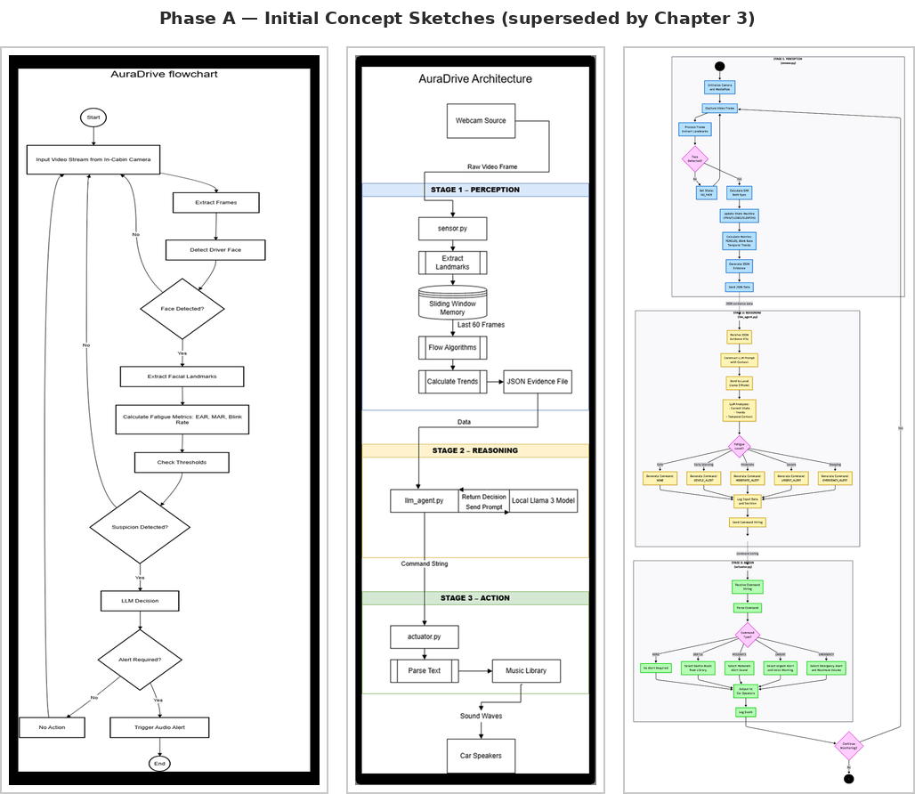
Figure 9 — Phase A initial design concepts (historical), superseded by the architecture in Chapter 3.

