Selection

The scissor test is a per-object processing operation that discards fragments that

fall outside of a certain rectangular portion of the screen. To pick an object, we reduce the size of the window to 1x1 pixels and move it along with the mouse

pointer. We obtain the color information while rendering in "Select"-mode. We render the objects in select mode, however, we clear the buffer again after we

obtain the color information. Thus, the objects in select mode never show up on screen.

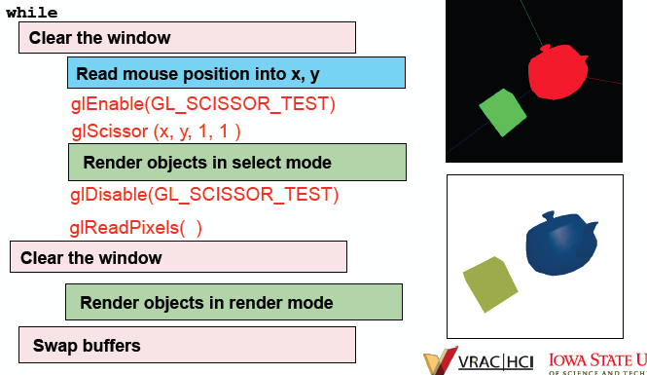

Animation

Morphing is a technique that facilitates natural looking motion. It deforms the mesh of a 3D model during runtime using one or multiple deformation models.