ME 557

Homework 4: Problem 1

Group Members: Adam R. Kohl, Jiazhong Zhou

The code has been modified are: Main_multi_texture.cpp

Texture.cpp Texture.h

GLApperance.cpp GLApperance.h

The code has been created are: Triple_texture.fs Triple_texture.vs

The three images used for problem 1 are doge, rainbow color gradient, and a universal landscape as shown in the below figures.

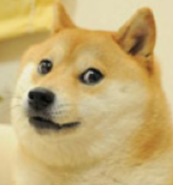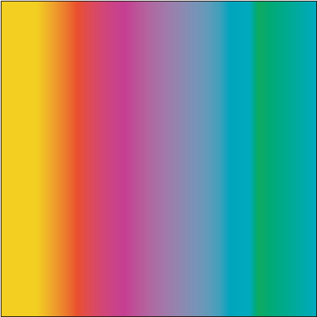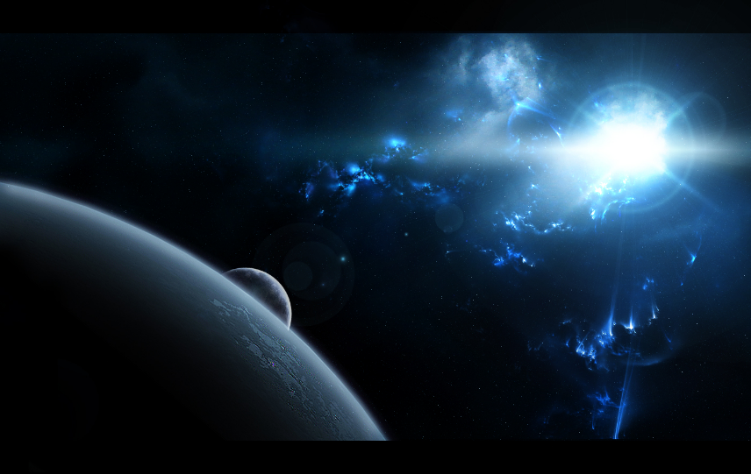

The first blend model has a highlight on those three images, therefore the blend function is defined as:

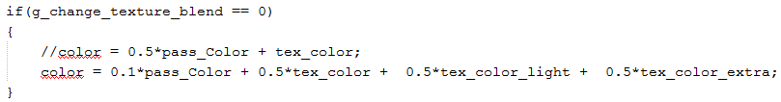

The image generated by the program is:

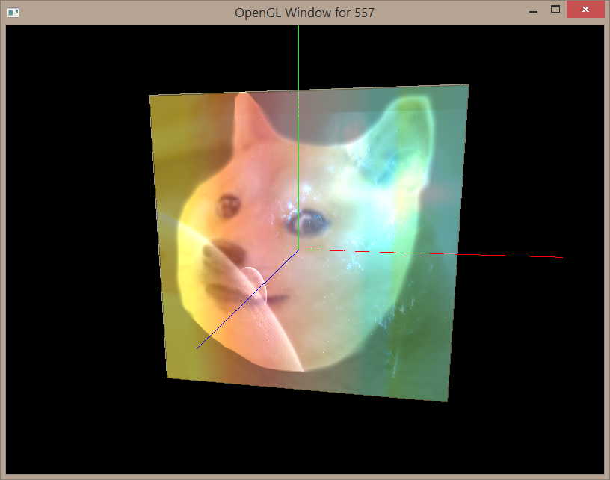

The second blend mode has a highlight on the background color, therefore the blend function is defined as:

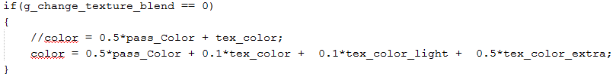

The image generated from the program is:

