## Introduction

This exercise requires you to know the following aspects of SQL:

|  |  |
| --- | --- |
| CREATE TABLE | Concatenation |
| SQL Data Types | Formatting dates and numbers |
| INSERT INTO | Column aliases |
| SELECT | Simple JOIN statements |
| WHERE clause | Complex JOIN statements |
| LIKE and wildcards | Subquery |

## Exercise 1 – Northwind Queries (40 marks: 5 for each question)

* 1. Write a query that lists all Customers in either Paris or London. Include Customer ID, Company Name and all address fields.

*SELECT CustomerID, CompanyName, Address FROM Customers  
WHERE City = 'Paris' OR City = 'London' ;*

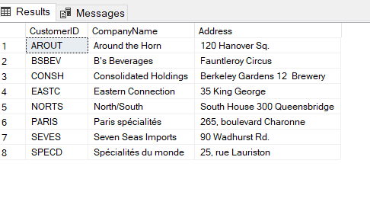

I first looked into the customer table to see what information was available and typed out the code to the left.

* 1. List all products stored in bottles.

*SELECT P.ProductID, QuantityPerUnit AS 'Stored in bottles' FROM Products p*

*WHERE p.QuantityPerUnit LIKE '%bottles%'*

I went into the products table and looked into the QuantityPerUnit table to look for any products with 'bottles'. I found that many of the string had bottles inside it. I used the wildcard on both sides to search all strings using the word.

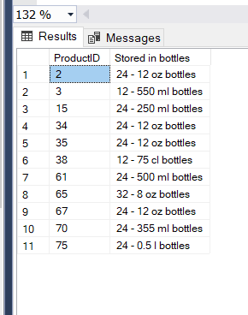

* 1. Repeat question above, but add in the Supplier Name and Country.

*SELECT S.ContactName, s.CompanyName, s.Country, QuantityPerUnit AS 'Stored in bottles' FROM Products p*

*JOIN suppliers s ON p.SupplierID = S.SupplierID*

*WHERE p.QuantityPerUnit LIKE '%bottles%'*

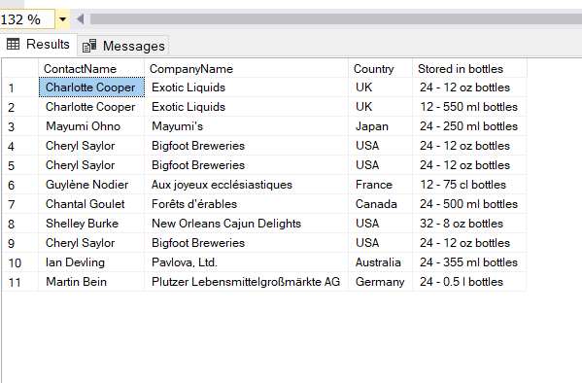

For this question, I used the same syntax and joined the suppliers table with a matching column which was also inside the products table to find all the information needed.

* 1. Write an SQL Statement that shows how many products there are in each category. Include Category Name in result set and list the highest number first.

*SELECT c.CategoryName , COUNT (c.CategoryID) AS 'Total Number of Products'*

*FROM Categories c*

*JOIN products p ON p.CategoryID = c.CategoryID*

*GROUP BY c.CategoryName*

*ORDER BY COUNT (c.CategoryID*

*)DESC;*

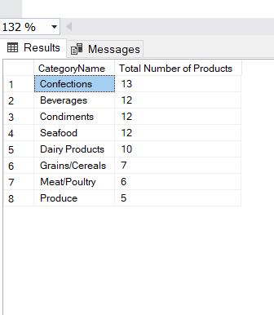

I first searched the categories table to find the first relevant information. I then matched and joined it with the products table. I then counted the repeated category IDs and grouped it on the bottom to give the rounded number of each product in their categories. You need to group it and then order it by the count which you used in the beginning with the DESC in order to get the highest value first

* 1. List all UK employees using concatenation to join their title of courtesy, first name and last name together. Also include their city of residence.

*SELECT TitleOfCourtesy + ' ' +FirstName + ' ' +LastName AS 'Employee Name',City FROM Employees;*

I went to the Employee table to look at the information which I needed to join to get the full name in one column. I used the +' '+ to join the columns and then used the Alias 'AS' to name the column. I then added the city column to the end to show where they live.

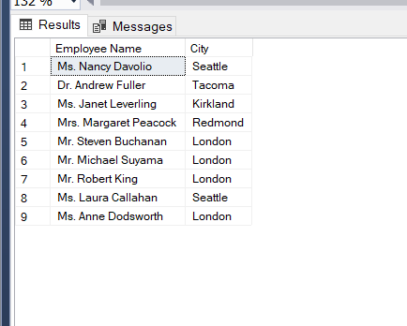

* 1. List Sales Totals for all Sales Regions (via the Territories table using 4 joins) with a Sales Total greater than 1,000,000. Use rounding or FORMAT to present the numbers.
  2. Count how many Orders have a Freight amount greater than 100.00 and either USA or UK as Ship Country.

*SELECT COUNT(*) AS 'Total orders to UK and USA 'FROM Orders*

*WHERE ShipCountry IN ('USA', 'UK') AND Freight>100.00;*

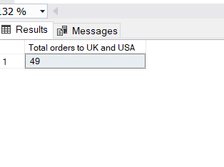

* 1. Write an SQL Statement to identify the Order Number of the Order with the highest amount of discount applied to that order.

This SQL is done assuming that 0.25 is taken away from the unit price. Where the highest amount of discount applied to an order is ORDERID 10595 which has a Total Discount of ‘30’.

*USE Northwind  
SELECT *, ( Discount*Quantity) AS 'Discounted Amount', (Quantity*UnitPrice) AS 'Non Discounted price', ((UnitPrice-discount ) * Quantity) AS 'Price After Discount' FROM [Order Details]  
WHERE Discount IN (0.25 ,0.15) ORDER BY Quantity DESC;*

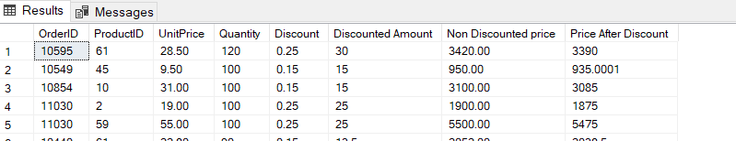

OrderID 10935 has the most discount applied at 0.25 X 120 quantity = 30

## Exercise 2 – Create Spartans Table (20 marks – 10 each)

2.1 Write the correct SQL statement to create the following table:

Spartans Table – include details about all the Spartans on this course. Separate Title, First Name and Last Name into separate columns, and include University attended, course taken and mark achieved. Add any other columns you feel would be appropriate.

1. Create the database

*CREATE DATABASE SPARTANS2019*

1. Create the table with the primary key and by also setting the variable types  
   *CREATE TABLE SpartanEngineering36_37 (   
   ID int IDENTITY (1,1) PRIMARY KEY,  
   Title varchar (8),  
   First_Name varchar (15),  
   Last_Name varchar (15),  
   Room_Name varchar (15),  
   Trainer_Name varchar (30),  
   University_Attended varchar(40),  
   Mark_Achieved varchar (10),  
   Course_Taken_Name varchar (30),  
   Hobbies varchar (40)  
   );*

2.2 Write SQL statements to add the details of the Spartans in your course to the table you have created.

1. I used the insert into syntax and listed the column names. I then inserted the values below it.

*INSERT INTO spartanEngineering36_37  
  
(Title, First_Name,   
Last_Name, Room_Name, Trainer_Name,   
University_Attended, Mark_Achieved,   
University_Course, Hobbies)*

*Values ('Mr', 'Ally',   
'Romeo', 'Room 3', 'Harpi Markson Flilli',   
'Doncaster University', '2:1',   
'Computer Science', 'Archery');*

**A Shorter way to write it out.**

*INSERT INTO SpartanEngineering36_37  
  
VALUES ('Mr', 'Manning',   
'Donde', 'Room 3', 'Harpi Markson Flilli',   
'Pancaster University', '1st',   
'Bio chemistry', 'Fox Hunting')*

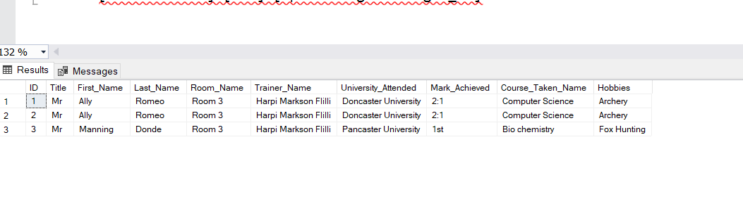

## Exercise 3 – Northwind Data Analysis linked to Excel (30 marks)

Write SQL statements to extract the data required for the following charts (create these in Excel):

3.1 List all Employees from the Employees table and who they report to. No Excel required. (5 Marks)

I listed all the employeesIDs and changed the name of the ‘Reports to ‘ to ‘Reports to EmployeeID’.

SELECT E.EmployeeID , E.Title, E.FirstName , E.LastName, E.ReportsTo AS ' Reports To EmployeeID', R.FirstName, R.Title

FROM Employees E

LEFT JOIN Employees R ON R.EmployeeID = E.ReportsTo;

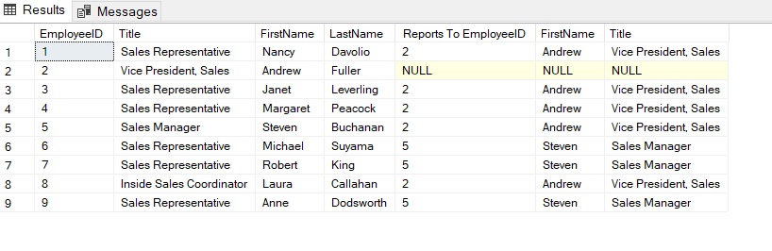

3.2 List all Suppliers with total sales over $10,000 in the Order Details table. Include the Company Name from the Suppliers Table and present as a bar chart as below: (5 Marks)

I tried to find the matching data. However, I only managed to find the first supplier with the correct Sales data.

*SELECT (OD.UnitPrice*Quantity) AS 'Total Sales' ,S.SupplierID , S.CompanyName, * FROM [Order Details] OD*

*JOIN Orders O ON OD.OrderID = O.OrderID*

*JOIN Products P ON P.ProductID = OD.ProductID*

*JOIN Suppliers S ON S.SupplierID = P.SupplierID*

*WHERE OD.OrderID IN ( SELECT OrderID FROM [Order Details] WHERE (UnitPrice*Quantity ) >=10000)*

*--GROUP BY COUNT (OD.UnitPrice*Quantity )*

*ORDER BY (OD.UnitPrice*Quantity ) DESC*

*;*

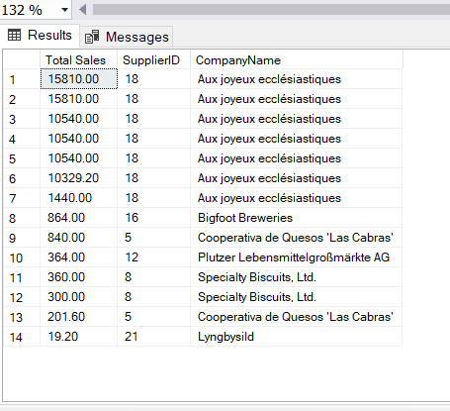

3.3 List the Top 10 Customers YTD for the latest year in the Orders file. Based on total value of orders shipped. No Excel required. (10 Marks) ( GROUP BY ORDER ID ) OR MAX TOP !)

For this chart I need to use the DATEFDIFF syntax

3.4 Plot the Average Ship Time by month for all data in the Orders Table using a line chart as below. (10 Marks)

## Standards (10 marks)

Remember to apply all the following standards:

* Use consistent capitalisation and indentation of SQL Statements
* Use concise and consistent table alias names
* Use column aliases to ensure tidy column headings (spaces and consistent capitalisation)
* Concatenate any closely related columns e.g. First Name and Last Name or Address and City etc
* Put comments throughout