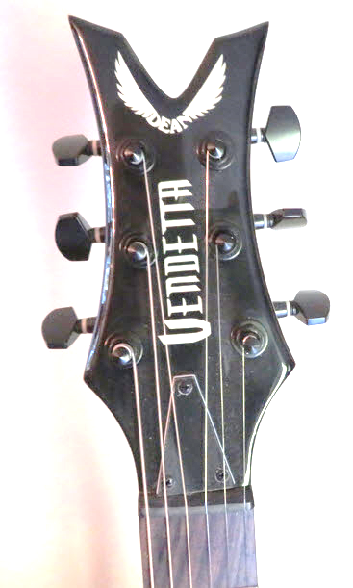Visit TrackOne band's Facebook profile: facebook.com/trackone.band.ct
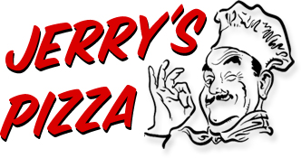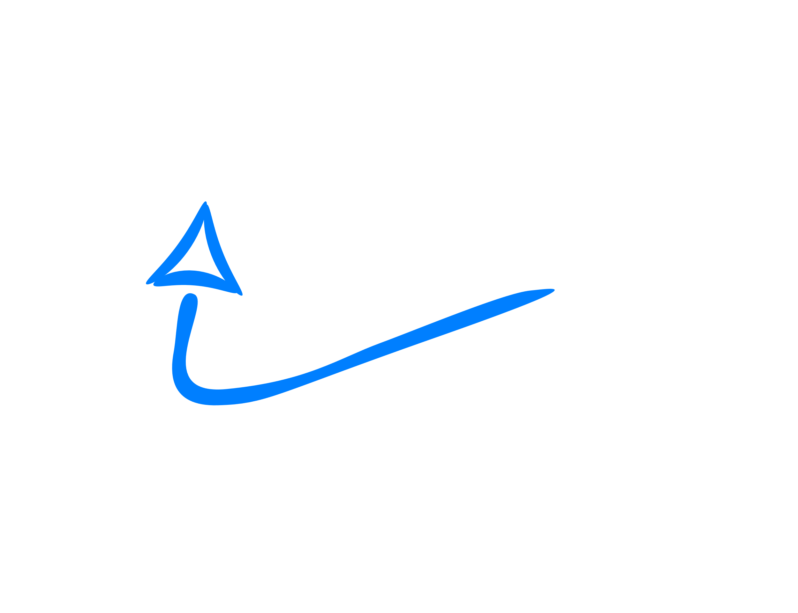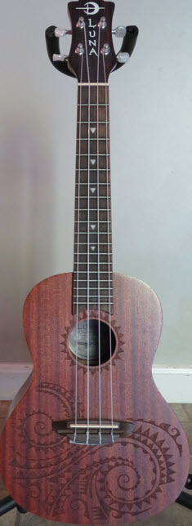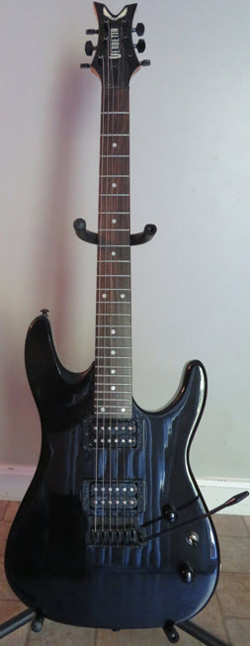

Questions? E-mail [gigs@trackone.band](mailto:gigs@trackone.band)

PRIZES!

* Pizza + Drinks
* Second Prize: **Luna Tattoo Concert Ukulele**
* Top Prize: **Dean Vendetta 6-String Electric Guitar**

*TrackOne Facebook followers get a free raffle ticket for a chance to win!*

Eat pizza!

Follow TrackOne!

Live Music & Free Raffle

22 Sept 2023 7-10pm

Jerry’s Pizza and Bar

635 S Main St, Middletown, CT