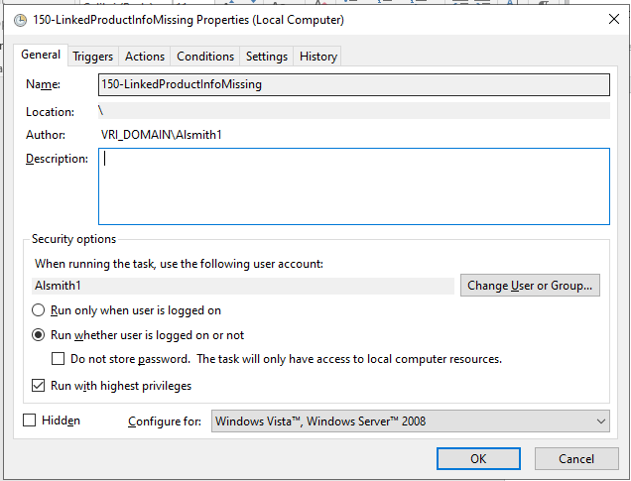

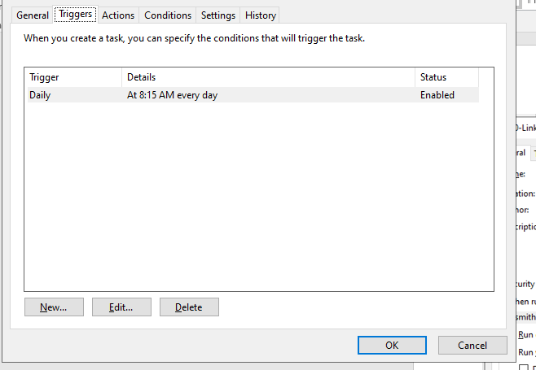

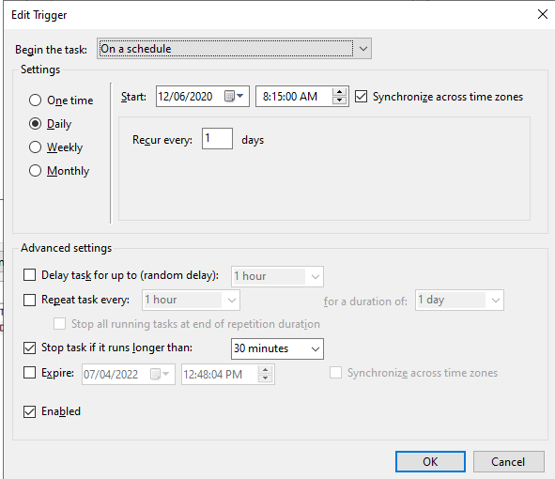

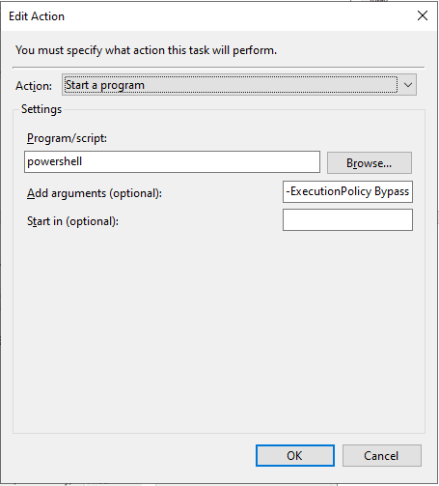

-ExecutionPolicy Bypass -File C:\Users\alsmith1\Desktop\PowershellScripts\150-LinkedProductInfoMissing.ps1

\*Update -ExecutionPolicy unrestricted -noninteractive -File C:\Users\alsmith1\Desktop\PowershellScripts\test.ps1

