**JP Morgan**

**Company Overview**

JPMorgan Chase & Co. was incorporated on October 28, 1968 as a global financial services company firm with 5,413 branches in over 60 nations. It services through four business segments, also corporate segment which are Consumer & Community Banking, Corporate & Investment Bank, Commercial Banking, and Asset Management segments. JP Morgan focused on investment banking, financial services for consumers and small businesses, commercial banking, financial transaction processing and asset management. Furthermore, it offers a range of investment banking products and services in all major capital markets, including advising on corporate strategy and structure, capital-raising in equity and debt markets, sophisticated risk management, market-making in cash securities and derivative instruments, prime brokerage and research. It also offers investment banking, financial services for consumers, small business and commercial banking, financial transaction processing, asset management and private equity

JPMorgan Chase’s leading bank subsidiaries are JPMorgan Chase Bank, National Association (JPMorgan Chase Bank, N.A.), a national banking association with branches in 23 states, and Chase Bank USA, National Association (Chase Bank USA, N.A.), and a national banking association which is the Company's credit card-issuing bank. JPMorgan Chase's principal nonbank subsidiary is J.P. Morgan Securities LLC (JP Morgan Securities); the Company's United States investment banking firm. The bank and nonbank subsidiaries of JPMorgan Chase operate nationally, as well as through oversea branches and subsidiaries, representative offices and subsidiary foreign banks. The Company primary operating subsidiary in the United Kingdom is J.P. Morgan Securities plc, a subsidiary of JPMorgan Chase Bank, N.A.

**Consumer and Community Banking**

Through personal service at bank branches and through ATMs, online, mobile and telephone banking, the Consumer & Community Banking (CCB) segment provide services to consumers and businesses. CCB sub-segments are Consumer & Business Banking, Mortgage Banking (including Mortgage Production, Mortgage Servicing and Real Estate Portfolios) and Card, Merchant Services & Auto (Card). Also, Consumer & Community Banking segment offers deposit and investment products and services; financial solutions to consumers; lending, deposit, and cash management and payment solutions to small businesses. Consumer & Business banking offers deposit and investment products and services to consumers, and lending, deposit, and cash management and payment solutions to small businesses; residential mortgages and home equity loans; and credit cards, payment services, payment processing services, auto loans and leases, and student loans. Mortgage Banking includes mortgage origination and servicing activities, as well as portfolios comprising residential mortgages and home equity loans. Card provides credit cards to consumers and small businesses, provides auto and student loan services, provides payment services to corporate and public sector clients through its commercial card products, and offers payment processing services to merchants.

**Corporate & Investment Bank**

The Company's Corporate & Investment Bank (CIB) segment comprise of treasury and securities products, Banking and Markets & Investor Services, offers research services, prime brokerage, investment banking, market-making, and services to corporations, financial institutions, investors, government and municipal entities. Within Banking, the CIB offers a range of investment banking products and services in capital markets, including advising on corporate strategy and structure, capital-raising in equity and debt markets, as well as loan origination and syndication. Also included in Banking is Treasury Services, which includes transaction services, comprising primarily of cash management and liquidity solutions, and trade finance products. The Markets & Investor Services segment of the CIB is engaged with cash securities and derivative instruments, and also offers risk management solutions, prime brokerage and research. Markets & Investor Services also includes the Securities Services business, which includes custody, fund accounting and administration, and securities lending products sold principally to asset managers, insurance companies and public and private investment funds.  It also offers securities services.

**Commercial Banking**

The Company's Commercial Banking (CB) segment offers financial solutions, including lending, treasury, investment banking, and asset management to corporations, municipalities, financial institutions, and nonprofit entities. It delivers industry knowledge, local expertise and service to the United States multinational clients. CB provides financing to real estate investors and owners. CB provides financial solutions, including lending, treasury services, investment banking and asset management.

**Asset Management**

The Company's Asset Management (AM) segment comprises investment and wealth management. This segment provides investment and wealth management services across various asset classes, such as equities, fixed income, alternatives, and money market funds; multi-asset investment management services; retirement services; and brokerage and banking services comprising trusts, estates, loans, mortgages, and deposits. For Global Wealth Management clients, AM also provides retirement products and services, brokerage and banking services, including trusts and estates, loans, mortgages and deposits. AM's clients include institutions, high-net-worth individuals and retail investors in markets throughout the world.

**Bios of E-Suite**

**Key Executives**

**Mr. James Dimon**, 60  
CEO, President and serves on its Member of Executive Committee, Member of Operating Committee and Member of Stock Committee

Prior to being JP Morgan CEO in December 31, 2005, Mr. James Dimon was Chairman and Chief Executive Officer at Bank One from March 2000 to July 2004. He was President and Chief Operating Officer following JPMorgan Chase’s merger with Bank One Corporation in July 2004. Before joining Bank One, Mr. Dimon held a wide range of executive roles at Citigroup Inc., the Travelers Group, Commercial Credit Company and American Express Company. Mr. James Dimon became Chairman of the Board on December 31, 2006, and has been Chief Executive Officer and President since December 31, 2005.

**Ms. Marianne Lake,** 46  
CFO, Executive VP and Member of Operating Committee  
Ms. Marianne Lake is Chief Financial Officer of JPMorgan Chase & Co. She previously had served as Global Controller of the Investment Bank (now part of Corporate & Investment Bank) from 2007 to 2009. Prior to which she had been Chief Financial Officer of Consumer & Community Banking since 2009.

**Mr. Matthew E. Zames**, 45  
COO and Member of Operating Committee

Mr. Matthew E. Zames is Chief Operating Officer and Head of Mortgage Banking Capital Markets of JPMorgan Chase & Co. He had been Chief Investment Officer from May until September 2012, co-head of the Global Fixed Income business from November 2009 until May 2012 and co-head of Mortgage Banking Capital Markets from July 2011 until January 2012, prior to which he had served in a number of senior Investment Banking Fixed Income management roles. He had been Co-Chief Operating Officer from July 2012 until April 2013.

**Mrs. Mary Callahan Erdoes**, 48  
CEO of Asset Management and Member of Operating Committee

Mrs. Mary Callahan Erdoes is Chief Executive Officer - Asset Management of JPMorgan Chase & Co. From March 2005 to September 2009, she was Chief Executive Officer of Private Banking. Prior to 2005, she was responsible for investment solutions and strategy for private banking clients worldwide. Mrs. Mary started her career with Stein Roe & Farnham to Bankers Trust and then JP Morgan/

**Mr. Daniel E. Pinto**, 53  
CEO of Corporation & Investment Bank and Member of Operating Committee

Mr. Daniel E. Pinto is Chief Executive Office of Corporate & Investment Bank and Europe, the Middle East and Africa of JPMorgan Chase & Co. He had been Co-Chief Executive Officer of the Corporate & Investment Bank since July 2012 till March 2014, prior to which he had been head or co-head of the Global Fixed Income business from November 2009 until July 2012.

**Porters 5 Forces Analysis**

Companies as large and well established like JPMorgan would suffer the consequences should they ignore the trends and patterns happening in the external environment that is beyond their control. Examining the some of the factors and forces of the external environment would a clear view of how the recent changes in trends and events are going to affect not only JPMorgan but the financial industry as a whole.

**Factors Affecting the Financial Industry**

Over the years, the bank had gone through a lot of turbulent times and yet has managed to be outstanding among its competitors. However, even companies as large and well established like JPMorgan would suffer the consequences should they ignore the trends and patterns happening in the external environment that is beyond their control. External factors in the general environment can be divided into five main categories that include the political, governmental, and legal factors, the economic factors, the social, culture, demographic and environmental factors, the technological factors and the competitive events and trends.

**Threats of new entrants**

The threat of new entrants as a significant force within the industry is relatively small. Significant obstacles would face any company attempting to compete directly on the same level with JPMorgan or the other major U.S. money-center banks. The primary obstacles for potential new entrants wishing to offer financial services on a large scale are the massive amount of capital required, the length of time required to establish a significant brand identity, and the numerous and cumbersome government regulations that apply to the operation of banks. Moreover, JP Morgan is likely to face increasingly competitive threats in the industry arising from major banks in developing economies such as China that will eventually compete on a more international scale. As non-bank firms invade the territory previously exclusive to financial institutions. Companies like General Electric, General Motors and Wal-Mart have established their own financial arm to take advantage of their existing customer base (Rose & Hudgins, 2008). Non-bank companies like Wal-Mart could potentially put heavy pressure on prices, costs and profitability as they gain leverage of having thousands of stores that could serve as distribution channels.

**Bargaining power of both suppliers (depositors) and customers**

JPMorgan's approach to dealing with this market force is, again, to work diligently to attract new clients and to increase the extent to which existing depositors hold funds and access services through JPMorgan. In regard to the bargaining power of suppliers of labor, individual suppliers have little bargaining power other than major executive employees. JPMorgan must address its overall bargaining power by offering attractive salary and benefit packages to retain the best employees. Depositors for example, can quickly use the internet to determine the highest interest rates in the market and deposit their money there. Besides that, financial institutions also face more.

**Threat of substitutes**

The threat of substitute products has become increasingly large in the banking industry as companies outside the industry have begun to offer specialized financial services that were traditionally only available from banks. Examples of such substitute products include payment processing and transfer services such as PayPal and Apple Pay, prepaid debit cards and online peer-to-peer lenders such as Prosper.com or LendingClub.com. The intrusion of these substitute services has cost both JPMorgan and the other major banks considerable revenue.

JPMorgan has responded with initiatives that include a division focusing on small business lending, and establishing its own digital wallet service, Chase Pay, which is set to debut in early 2016.

**Rivalry among exiting competitors**

**Rivalry among exiting competitors** is expected to intensify as one of the leading financial institution leader until it becomes more internationally integrated. Besides that, a slowdown in global economic growth is likely to happen which will make financial institutions vie for market share from a smaller pool of customers. Also taken into account should be the recent competitive trends of convergence and consolidation that would mean that bigger financial-service providers with relatively the same size would be invading each other’s territory.

**Competition from Industry Rivals**

Competition within the industry is the strongest of Porter's five forces for JPMorgan Chase. The company faces intense competition domestically from the other three major money-center banks in the United States and globally from other large multinational banking firms, such as HSBC and Barclays. One of the industry elements that intensify the importance of competition is the relatively low [switching costs](http://www.investopedia.com/terms/s/switchingcosts.asp) that consumers face, especially in the retail and commercial banking areas. The major banks, much like the principal cellphone companies, are continually extending offers to draw customers away from other banks.

JPMorgan deals with industry competition in three main ways. It attempts to distinguish itself in the marketplace primarily on the basis of its long, recognized heritage and experience. It aims to stay on the cutting edge of offering customer convenience and low-cost and cutting-edge services. It has a history of acquiring smaller banks, removing some potential competition from the marketplace

**SWOT Analysis**

SWOT Analysis of JPMorgan Chase & Co. includes Strengths adequate capital, consumer and business banking and asset management. Weakness incorporates mortgage banking commercial banking card, Merchant Services & Auto. Meanwhile, Opportunities are Small business banking, Global wealth and Asset management and growing cards payments Channel. Threat focused on US Basel III Norms on Capital Requirements Intense Competition Compliance Costs and Risks

**JPMorgan Chase & Co. - Strengths**

Adequate Capital JPMorgan Chase has a good capital base ensuring capital adequacy to support its organic and inorganic growth with both secured and unsecured natures of its lending. The good capital management initiatives and moderate risk weighted asset (RWA) growth have enabled the bank to strengthen its capital position. Total deposits increased to US$1,363.4 billion in FY2014, indicating an increase of 5.9% from FY2013. Total stockholders’ equity in FY2014 was US$232,065 million reflecting an increase of 9.9% over the previous year. It reported high quality liquid assets of US$600 million. Such a sound capital management initiative strengthens the company’s business profile, which in turn would enable it to carry out new growth and expansion plans.

Consumer and Business Banking The company’s consumer and business banking category within the consumer & community banking segment reported strong performance during the FY2014 accounting for 30.7% of the total segment. The segment reported an increase of 5% in its net revenue comparatively to the previous year. The increase was mainly driven by client investment assets, higher debit card revenue, reflecting an increase in transaction volume and increase in customer accounts. Its consumer & business banking within consumer & community banking was ranked first in deposit growth for the third year in a row and first in customer satisfaction among the largest banks for the third year in a row as measured by The American Customer Satisfaction Index. The company could maintain its growth by focusing on increasing customer accounts.

**Asset Management**

The company’s asset management segment accounted for 12% of the company’s total revenue reported an increase of 5.5% over the previous year. The increase was driven due to net client inflows and the effect of higher market levels, higher loan and deposit balances. The company could grow by focusing on providing retirement products and services, brokerage and banking services.

**JPMorgan Chase & Co. Weaknesses**

Mortgage banking, the company’s mortgage banking category under the community and business banking reported net revenue of US$7,826 in FY2014 reflecting a decrease of 23.5% from its previous year. This decrease was mainly due to the provision for credit losses, spread compression and lower loan balances due to portfolio runoff and lower warehouse balances and lower mortgage fees.

Commercial Banking JPMorgan Chase’s commercial banking segment reported revenue of US$6,882 in FY2014 reflecting a decrease of 3% from its previous year. This decrease was due to the decrease in client segment of middle market banking, real estate banking, the absence of proceeds received in the previous year from a lending-related workout, and lower purchase discounts recognized on loan repayments.

Card, Merchant Services & Auto, the card merchant and auto category under the community and banking segment reported net revenue of US$18,316 million reflecting a decrease of 3% from its previous year. Higher provision for credit losses, spread compression in credit card, and auto and lower average credit card loan balances, higher amortization of new account origination costs and the impact of non-core portfolio exits.

**JPMorgan Chase & Co. - Opportunities**

Small Business Banking According to an in-house research small business segment has a significant opportunity to the US banks with a base of more than 20 million potential customers with a broad range of financial service’s needs. By lending to small businesses, banks help them to expand, create jobs and spur economic growth. Small business and agricultural loans are examples of how banks directly contribute to the economic vitality of their communities by enabling businesses to expand and hire workers.

Global Wealth and Asset Management according to the industry estimates, assuming moderate and stable economic growth, and total household wealth is expected to rise by approximately to US$330 trillion in 2017. The number of high net-worth individuals across the world is expected to increase approximately to 46 million in 2017. The US is forecast to remain the wealthiest country with total wealth of US$89 trillion by 2017. The company generated significant income from its asset management services. For the FY2014, the company reported total net income from asset management segment at US$2,153 million, indicating an increase of 3.4%. Such positive outlook for the global wealth management industry could provide ample growth opportunities for the company.

Growing Cards Payments Channel in the US The bank is likely to benefit from the growing card payments channel in the US. According to in-house research, in terms of the number of cards in circulation, the debit cards category is projected to reach 764.7 million in 2017 and credit cards category is expected to reach 608 million in 2017. In terms of transaction value, the card payments channel is expected to value US$7.0 trillion in 2017. Growth is expected to be driven by more stable economic conditions, an increase in disposable income and the popularity of mobile commerce and online retail. Such growing cards payments channel in the US, may provide ample growth opportunities for JPMorgan Chase, which provides debit and credit cards.

**JPMorgan Chase & Co. - Threats**

Basel III Norms on Capital Requirements are the looming threat on bank solvency as a result of highly leveraged balance sheets prompted a regulatory response, which recommended an increase in capital. Basel III norms by Basel Committee on Banking Supervision (BCBS) are intended to protect the global banking industry from financial meltdowns. The new norms require banks to hold more and better quality capital, carry more liquid assets and limit leverage. These will not only ensure that banks hold more capital on hand, which will limit the amount of money they can lend, but also reduce the risk of insolvency given many loan defaults. Basel III increases the minimum Tier 1 common equity ratio to 4.5%, net of regulatory deductions, and introduces a capital conservation buffer of an additional 2.5% of common equity to risk-weighted assets, raising the target minimum common equity ratio to 7%. This capital conservation buffer also increases the minimum Tier 1 capital ratio from 6% to 8.5% and the minimum total capital ratio from 8% to 10.5%.Such regulations would require financial services companies to incur high costs, exerting increased pressure on banks, which are already in the process of improving their own governance processes.

Intense Competition JPMorgan Chase and its subsidiaries operate in a highly competitive environment. The company competes on the basis of the quality and variety of products and services, transaction execution, innovation, reputation and price. The company faces competition from other banks, brokerage firms, investment banking companies, merchant banks, hedge funds, private equity firms, insurance companies, mutual fund companies, credit card companies, mortgage banking companies, trust companies, securities processing companies, automobile financing companies, leasing companies, ecommerce and other Internet-based companies, and a variety of other financial services and advisory companies. A few of the competitors of the company are The Goldman Sachs Group, Inc., American Express Company, Bank of America Corporation, HSBC Holdings plc, Wells Fargo & Company and Franklin Resources, Inc. among others. Intense competition may pressurize the company on prices of products and services or may cause it to lose market share. Intense competition may have negative impact on the company’s operations as any failure to compete effectively in areas such as pricing, services and quality could negatively impact the revenue and overall performance of the company.

Compliance Costs and Risks Some of the countries in which JPMorgan Chase conducts its wholesale businesses have economies or markets that are less developed and more volatile, and may have legal and regulatory regimes that are less established or predictable, than the U.S. and other developed markets in which the company currently operates. Some of these countries have in the past experienced severe economic disruptions, including extreme currency fluctuations, high inflation, or low or negative growth, among other negative conditions, or have imposed restrictive monetary policies such as currency exchange controls and other laws and restrictions that adversely affect the local and regional business environment. As a result, any such unfavorable conditions or developments could have an adverse impact on the company’s business and results of operations. Meanwhile, Strengths and Opportunities outweigh Weakness and Threats

**P/E**

JPMorgan Chase & Co. (NYSE: [JPM](http://www.investopedia.com/markets/stocks/jpm)) is a bank that investors should consider as a portion of a well-diversified portfolio. As of Dec. 8, 2015, JPMorgan Chase has a year-to-date (YTD) return of 8.09%, while the S&P 500 Index only has a YTD return of 2.23%. JPMorgan Chase has a trailing 12-month price-earnings (P/E) ratio of 11.22. Additionally, as of Sept. 30, 2015, it has a relatively low price-to-book (P/B) ratio of 1.12. JPMorgan Chase has an impressive quarterly earnings growth of 22.3% year over year. It has a forward annual dividend yield of 2.59% and should pay an annual cash dividend of $1.76 in 2016. It had an efficiency ratio of 59% during the second quarter of 2015, which is in line with that of Wells Fargo. The Price/Earnings (P/E) ratio, based on the greater of the current PE or the PE using average earnings over the last 3 fiscal years, must be "moderate", which in this model states is not greater than 15. Stocks with moderate P/Es are more defensive by nature. The company has a P/E ratio of 10.31 below the average industry P/E ratio of 12.43 and is below the S&P 500 P/E ratio of 17.15.

Similar to Wells Fargo, JPMorgan Chase surpassed its minimum tier 1 capital requirement for 2015 and is projected to surpass the minimum in 2016 to the second quarter of 2017. JPMorgan Chase had a [tier 1 common capital ratio](http://www.investopedia.com/terms/t/tier-1-common-capital-ratio.asp) of 11.3%, which was over twice the minimum requirement set by Comprehensive Capital Analysis and Review (CCAR), which is the Fed’s primary supervisory system for assessing the capital adequacy of large bank holding companies. JPMorgan Chase expects to have a tier 1 common capital ratio of 8.4% between the second quarter of 2015 and the second quarter of 2017. It's projected to have a minimum tier 1 common capital of 7.6% over this period, which is still higher than the minimum requirement of 5%.

Since JPMorgan Chase offers an attractive dividend yield and is expected to be robust if adverse economic scenarios arise, investors should consider a long position in this stock. The potential increase in interest rates may also help boost its earnings in 2016, and its stock price may also rise. It increased its earnings by 21.61% last year and by 12.64% this year. JPMorgan Chase is expected to grow its earnings by an average annual 8.96% over the next five years.

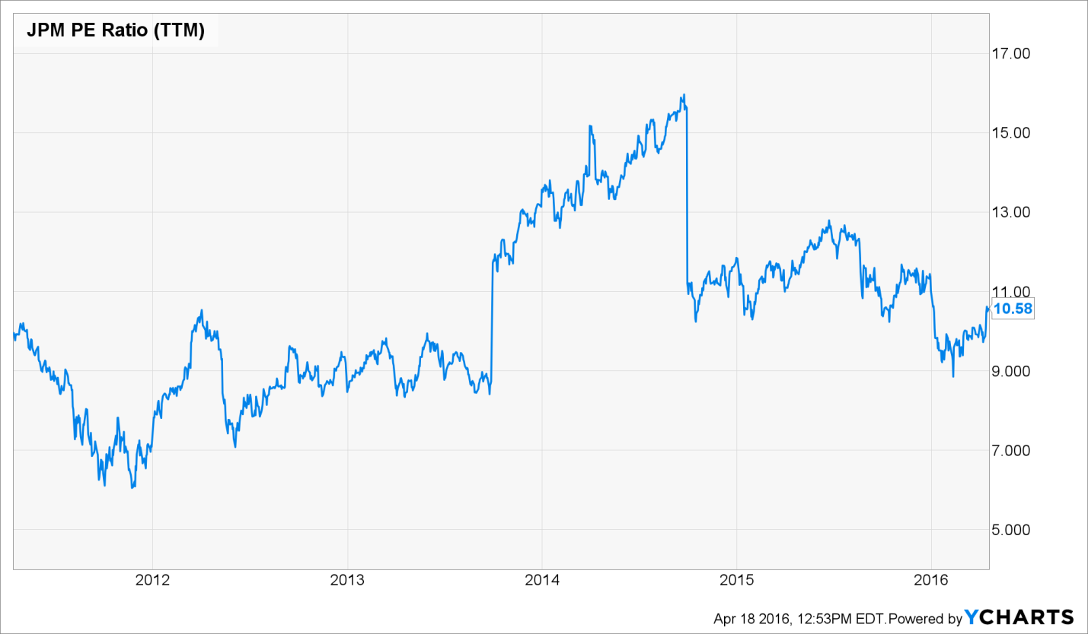

**JP Profit Margin**

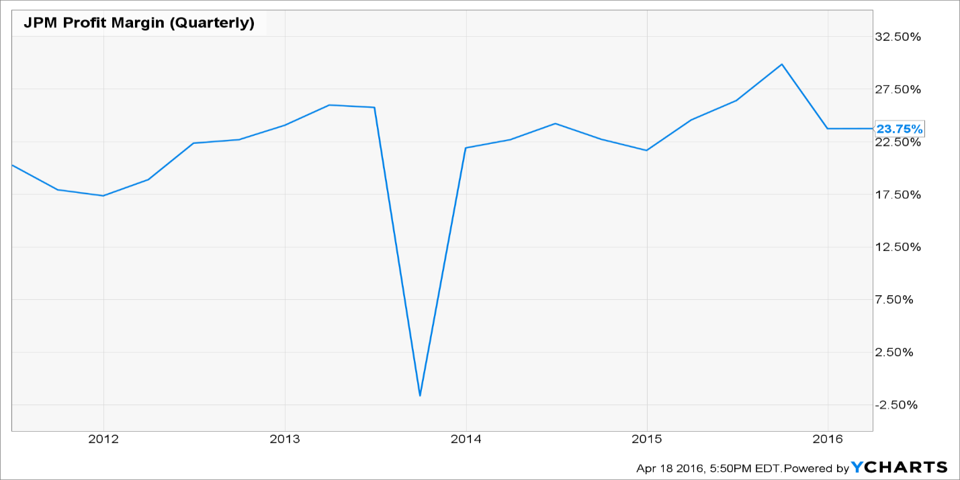

**JP Morgan Debt to Equity Ratio**

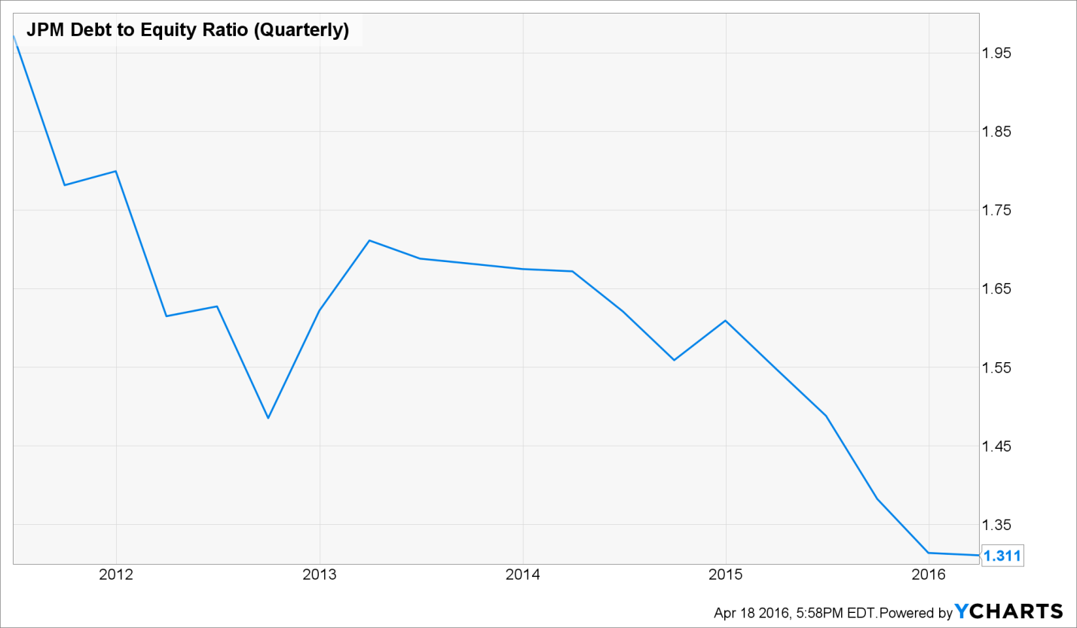

**Total Debt/Equity**

The company must have a low Debt/Equity ratio, which indicates a strong balance sheet. The Debt/Equity ratio should not be greater than 25% or should be less than the average Debt/Equity for its industry. JPM’s have total debt/equity ratio of 193.07 which is negative.

Analyzing JPMorgan Chase's increasing free cash flow and total assets, along with its steady revenue stream and earnings per share (EPS), indicate it is likely to continue paying dividends. Based on trailing three-year data, JPMorgan Chase experienced an average annual EPS growth rate of 5.7%; earnings before interest, taxes, depreciation and amortization (EBITDA) growth rate of 3.8%; and a dividend growth rate of 16.5%.

JPMorgan Chase generated a positive free cash flow of $61.41 billion and had $728.11 billion in cash and cash equivalents for the fiscal year ending on Dec. 31, 2014. It generated total revenue of $91.07 billion, a net income of $21.76 billion and an EPS of $5.29 over the same fiscal year. JPMorgan Chase paid out an annual dividend of $1.58 per share to its shareholders during the 2014 fiscal year.

JPMorgan Chase had total revenue of $93.65 billion; free cash flow of $28.62 billion; cash and cash equivalents of $603.94 billion; total assets of approximately $2.4 trillion; an EPS of $4.35; and it paid out an annual dividend of $1.44 per share for the fiscal year ending in December 2013. Moreover, it had total revenue of $93.65 billion; free cash flow of $25.08 billion; cash and cash equivalents of $471.83 billion; a full-year EPS of $5.20; and total assets of $2.36 trillion for the 2012 fiscal year. Additionally, it paid out an annual dividend of $1.20 per share.

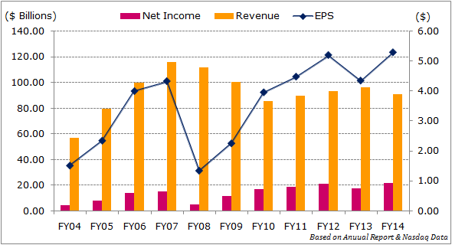

According to Barron’s, JPMorgan Chase reported a net income of $21.8 billion for fiscal-year 2014, an increase of almost 22% year-on-year. Its consumer and community banking segment generated 42% of the total net income while the corporate and investment bank segment contributed a significant 32%. The remaining three business segments- commercial banking, asset management and corporate - made a contribution of 12%, 10% and 4%, respectively. During the current fiscal year, its net income for the first quarter was $5.9 billion, while it was $6.3 billion for the second quarter.

**Profit Margin**

Meanwhile JP Morgan Chase faces stiff competition from the wide of array banking institutions in the U.S. and globally, it continues to command market share and remains the biggest bank in terms of consolidated assets, according to Federal Reserve statistics. According to statistics released in August 2015, JPMorgan Chase had assets worth $2.10 trillion, compared to those of Bank of America Corporation (BAC) at $1.6 trillion, Wells Fargo and Co. with $1.57 trillion (WFC) and Citigroup Inc. (C), with $1.34 trillion. Other banks on the top ten list were US Bancorp (USB), PNC Financial Services Group Inc. (PNC), Bank of New York Mellon Corp. (BK), State Street Corp. (STT), Capital One Financial Corp. (COF) and the Toronto-Dominion Bank (TD).

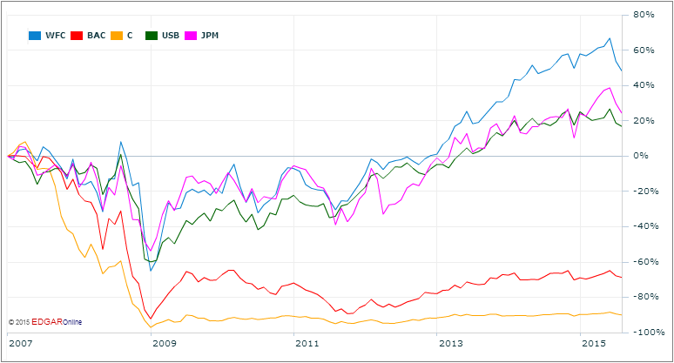

**Current Price Level**

Investors should keep an eye open for stocks that are trading within 10% of their 52-week highs, as it is likely to continue in its upward trend. JPM's 52 week high is $70.61 current price is 61.87, is 14.12% below the 52 week high.

Annual Earnings Growth

An article ”JPMorgan Chase: Too Big (And Profitable) To Fail” stated that JPM’s annual earnings growth rate over the past five years is 8.65%, below the target growth rate. JPMorgan Chase’s earnings per share, rising net income and comfortable operating cash flow, dividend payments, solid assets and sound stock price movement make it a good buy from the US financial sector. Based on the quarterly results, analysts project the bank’s earnings per share at $5.86 for 2015, $6.46 for 2016 and $7.26 for 2017.

**FINAL RECOMMENDATION**

According to my Stock Valuation, I strongly recommend that JP Morgan is a quality company to consider for investment; it currently trades at $60.48, because it is undervalued by 14.8%-20%. Based on its SWOT Analysis and key statistics and as earlier mentioned in the previous tasks, out of the 6 different companies that was carefully chosen, JPM emerged as first based on Price to Free Cash Flow, profit margin, net worth & total equity which indicate its significant performance relative to other 6 companies within the Financial Sector. Following the previous task, JPM was again ranked first, considering Key Statistics (relative to previous years) like PE ratio, Capital Structure, debt, preferred, equity, revenue, Profit margin, market capital, operating cash flow and current Beta.

Also considering the fact that JPM SWOT analysis has better strength and opportunities unlike threats, compared to its competitors? In the past months, JPM outperformed other stocks in the Banking sector thus its stock price rose by 2.94%, March 21, 2016. Meanwhile JPM historical prices and annual earnings growth have remained increasingly steady.

**Statistics, Headlines, and Trends**

* JPMorgan Follows Up Strong Q1 Results with Plans to Tap Into ETF Industry
* Why JPMorgan Chase’s Trading Business Beat Expectations

http://finance.yahoo.com/news/why-jpmorgan-chase-trading-business-150736875.html

* J.P. Morgan Outlines Trends Driving Investment Decisions for Endowments and Foundations

http://www.prnewswire.com/news-releases/jp-morgan-outlines-trends-driving-investment-decisions-for-endowments-and-foundations-300133515.html

* Three Regional Banks Dinged by JPMorgan Trends

http://www.barrons.com/articles/three-regional-banks-dinged-by-jpmorgan-trends-1460645614

* J.P. Morgan Asset Management - Global Real Assets Appoints George Ahl as Managing Director and Client Portfolio Manager for Real Estate Americas

<http://www.wsj.com/articles/PR-CO-20160418-908071>

* J.P. Morgan launches diversified Asian local markets Index
* JPMorgan Chase reports first-quarter 2016 net income of $5.5 billion, or $1.35 per share, on revenue of $24.1 billion
* JP Morgan announces $75 Million global initiative to address economic opportunity crisis facing young people
* Understand that of the big three that we have had so far, JPMorgan (JPM - Get Report) truly did outperform. Some of that is because it had set a low bar at a mid-quarter analyst meeting and it was pretty much all up from there.
* The Top 4 Large-Cap Bank Stocks for 2016 (WFC, JPM) http://www.investopedia.com/articles/markets/122315/top-4-largecap-bank-stocks-2016-wfc-jpm.asp#ixzz46CHQTeO2

