**Biotechnology Subsector Overview**

**Definition**

The [United Nations](https://en.wikipedia.org/wiki/United_Nations) [Convention on Biological Diversity](https://en.wikipedia.org/wiki/Convention_on_Biological_Diversity) defines 'biotechnology' as: "Any technological application that uses biological systems, living organisms, or derivatives thereof, to make or modify products or processes for specific use." In other words, biotechnology can be defined as the mere application of technical advances in life science to develop commercial products

Modern biotechnology provides breakthrough products and technologies to combat debilitating and rare diseases, reduce our environmental footprint, feed the hungry, use less and cleaner energy, and have safer, cleaner and more efficient industrial manufacturing processes.

Currently, there are more than 250 biotechnology health care products and vaccines available to patients, many for previously untreatable diseases.

Perhaps the biggest development in the biotechnology field (as far as investors go) occurred when, in the 1980s, the U.S. Supreme Court ruled to allow for patenting of genetically modified life forms. This means that intellectual property will always be at the forefront of biotechnology - some argue that the scope of patent protection actually defines the industry.

Because of extremely high [research and development](http://www.investopedia.com/terms/r/randd.asp) costs coupled with very little revenue in the years of development, many biotechnology companies must partner with larger firms to complete product development.

|  |  |
| --- | --- |
| **Common Applications of Biotechnology** | |
| **Agriculture**  Improved foods, pest control, plant and animal disease control, improved food production. | **Industry**  Oil/mineral recovery, environmental protection, waste reduction. Improved detergents, chemicals, stronger textiles. |
| **Health Care**  Drugs, vaccines, gene therapy, tissue replacements. | **Research**  Understanding the human genome and better detection of diseases. |

Because drug development is an important aspect of biotechnology, understanding the process of approval of drugs for sale to the problem is also an important part of investing in the biotech industry.

**Food and Drug Approval (FDA) Process**

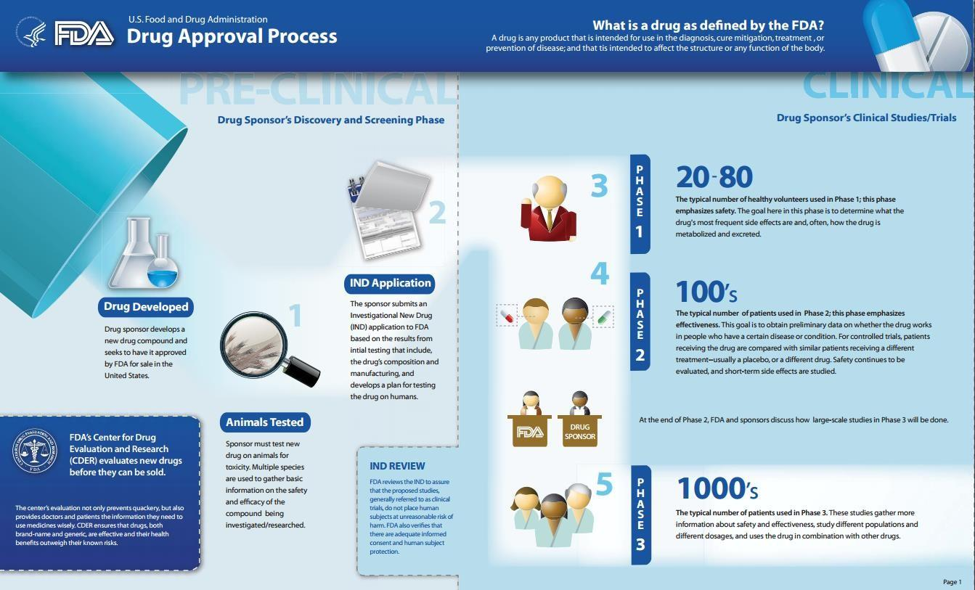

**Key Players**

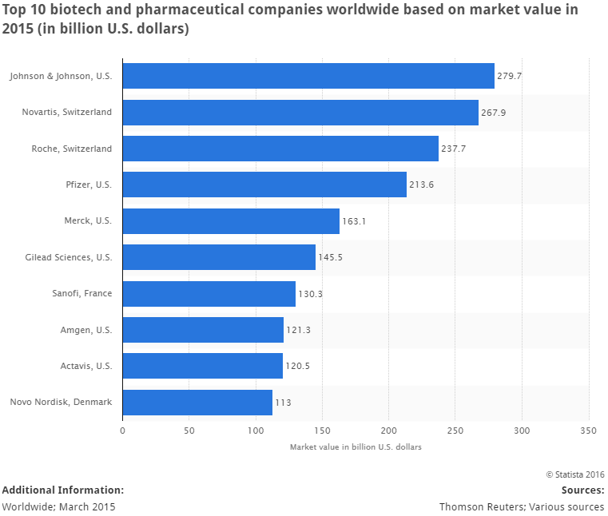

# Porter's Five Forces Threat of New Entrants

**The industry has limited competition and a low threat of new entrants. Biotech firms require huge amounts of funding to finance their large R&D budgets. Not having ample cash is one of the biggest barriers. Specialization also creates barriers. For instance, knowledge about cancer and heart disease is quite high therefore a there are very few experts in this field. Last but not least it can take up to 10 years to bring a biologic drug to the market.**

Because the biotech industry is filled with lots of small companies trying to hit the jackpot, the barriers to enter this industry are enough to scare away all but the serious companies. Biotech firms require huge amounts of funding to finance their large R&D budgets. Having ample cash is one of the biggest barriers, so when interest rates are low, or the equity markets are receptive to [initial public offerings](http://www.investopedia.com/terms/i/ipo.asp), the [barriers](http://www.investopedia.com/terms/b/barrierstoentry.asp) are lower. Specialization also creates barriers. For instance, knowledge about cancer and heart disease is quite high, whereas a company focusing on something more obscure would likely have a low threat of new entrants because there are very few experts in this field.

# Power of Suppliers

**Biotech companies are unique because most of their value is driven by intellectual property. Unlike in other industries, the nature of their business does not force them to rely on suppliers. Scientific tools, materials, computers, and testing equipment are highly specialized, but the likelihood of these companies invading on biotech companies’ line of business is not very high.**

Biotech companies are unique because most of their value is driven by [intellectual](http://www.investopedia.com/terms/i/intellectualproperty.asp) [property](http://www.investopedia.com/terms/i/intellectualproperty.asp). The nature of their business does not force them, unlike other industries, to rely on suppliers. Scientific tools, materials, computers and testing equipment is highly

specialized, but the likelihood of these companies invading on their line of business is not very high. One snag is that marketing alliances have often proved to be problematic. Small biotech firms don't have the distribution capabilities to promote their new drugs, so they are forced to license their drugs to other suppliers.

# Power of Buyers

**Biotech firms sell highly specialized products to governments and hospitals. Despite the power of these large organizations, the bargaining power of buyers is low. These drugs are usually innovative molecules for unmet needs; therefore, payers and patients are less sensitive to price.**

The bargaining power of customers has different levels in the biotech arena. For example, a company that sells pharmaceutical drugs has thousands of individual customers and doesn't need to worry too much about a buyer revolt. After all, when is the last time you were able to bargain with the pharmacist for a better deal? On the other side are the biotech firms, which sell highly specialized products to governments and hospitals. These large organizations have a lot more bargaining power with biotech companies.

# Threat of New Entrants

**The threat of substitutes in the biotechnology field is low, driven by patent protection. Even after the patents expire, only a few companies are capable of copying biologic products. Because these copied drugs will never be equal to the originator molecule, they are called biosimilars. Biosimilars are not identical and are not easy to reproduce and requires from 8 to10 years and $100M–$200M to develop.**

In the biotechnology field, threat of substitutes really depends on the area. While patent protection might stop the threat of alternative drugs and chemicals for a period of time, eventually there will be a company that can produce a similar product at a cheaper price.

Generic drugs, for instance, are a problem: a company that spends millions of dollars on the creation of a new drug must sell it at a high price to recoup the R&D costs, but then along comes a generic drug maker, which simply copies the formula and sells it for a fraction of the cost. This is a big problem in foreign countries where there is a lack of government control. Organizations will illegally produce patent protected drugs and sell them at much lower prices.

# Competitive Rivalry

**The rivalry within the biotechnology industry is somewhat intense. Many small biotech companies are operating in the world, but only few make a majority of the revenue.**

There are more than 1,000 biotech companies operating in North America. With the top 1% of these companies making up a majority of the revenue, it's a tough industry in which to make a mark. The fight to see who can cure a disease or condition has researchers working day and night. Trade secrets are also extremely valuable. In short, the rivalry is extremely intense.

**WHY BIOTECH INVESTING?**

**Biotech investing is a risky endeavor with the possibility of high payoffs. That's largely because most biotech companies are involved in the creation of products that remain in development for years and sometimes decades. Those long timelines create unpredictability for investors — for better or for worse.**

“Because the timelines are so long, you’re looking at a 10- to 15-year investment. There are other places you could take your money and get a fairly quick return.” Andrew Casey, president and CEO of Canadian industry association BIOTECanada.

**When to invest**

The success or failure of clinical trials has an enormous impact on stock values. Good results can cause stocks to soar, while disappointing results often immediately erode value, making it much riskier to invest in a product before clinical trials are undertaken.

⇒ when analyzing the news, emphasize have to be put into the anticipated products in the pipeline that are currently undergoing FDA testing. If a product has been largely publicized and anticipated, the success/failure on one of the FDA testing stage will directly impact of the stock price regarding the R&D investment.

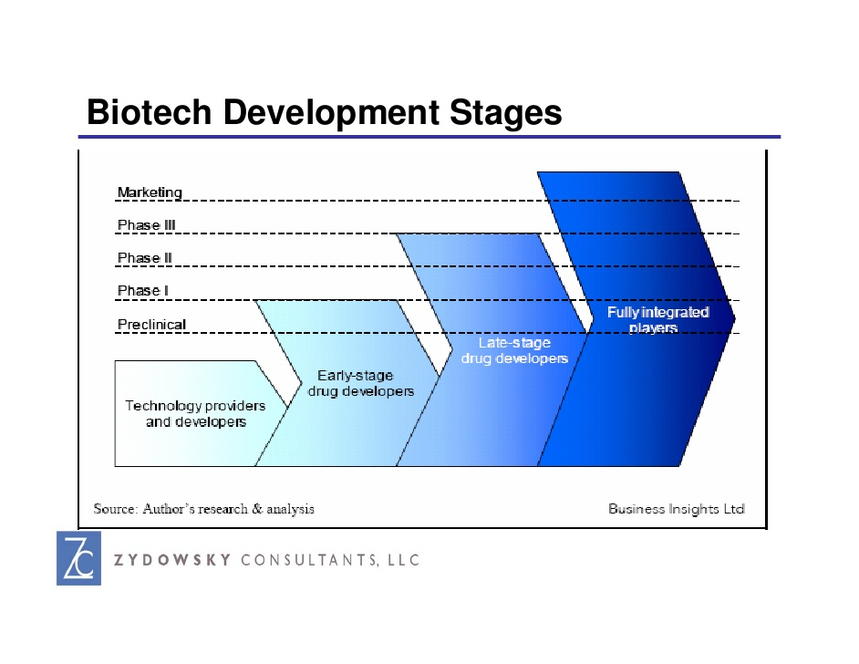

That of course means that investing later in the research and development process reduces the risks involved in biotech investing. And at the moment, that is what investors appear to be doing — the current market reflects a trend towards increased conservatism, with the number of IPOs dropping. In the first quarter of 2015, 10 deals valued at $789 million took place. That’s less than half the dollar value of the same period last year, when 30 deals took place in the first quarter.

⇒ the timing is a key in investing: it all depends on the product development cycle.   
Our level of risk appetite will lead our decision to investment on the stok a different level of product development stage, and will also have impact on stock’s riskiness/implied volatility. For example, if Sanofi announce that they have tested a prototype drug that will cure leucemia and we invest on it, the level of risk we take is high. If that same drug is reaching the last stage of the FDA process, we are taking much less risk because the product is nearer to the launch phase.

**Investment Trend**

Funding for biotechnology and medical devices Biotechnology captured 71% of all life sciences investments during the fourth quarter of 2015. This share ranks lower than the fourth quarter of 2014 and marginally lower compared to the third quarter of 2015. For the fourth quarter of 2015, the share of the medical device and equipment sector increased to 29% from 27% when compared to the same quarter of last year, and rose marginally compared to 28% in the third quarter of 2015. "2015 has been the year of biotechnology with the highest ever funding received,” said Vlahos, “Convergence of technologies bodes well for the biotech industry and interest will remain strong in the long-term despite shortterm challenges due to global economic uncertainties.”

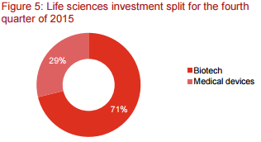

**Biotechnology funding by subsegments**

The biotech-human subsegment led the life sciences venture capital funding with $1.1 billion during the fourth quarter of 2015. For the full year, the biotech

human subsegment received $6 billion, an increase of 14% compared to the full year 2014. Year-on-year, funding for the subsegment decreased 38%, and 36% from the third quarter of 2015. When compared with the fourth quarter of 2014, two subsegments witnessed a surge in quarter four investments during 2015:

human subsegment received $6 billion, an increase of  
14% compared to the full year 2014.  
Year-on-year, funding for the subsegment decreased  
38%, and 36% from the third quarter of 2015.  
When compared with the fourth quarter of 2014, two  
subsegments witnessed a surge in quarter four  
investments during 2015:  
 Biotech research: +161% to $99 million  
 Pharmaceutical: +151% to $255 million  
For the fourth quarter of 2015, five biotechnology subsegments received less funding compared with the same period in 2014:  
 Biotech Human: -38% to $1.1 billion  
 Biosensors: -43% to $16 million  
 Biotech Equipment: -90% to $11 million  
 Biotech Industrial: -95% to $0.35 million  
 Biotech Animal: -99% to $0.15 million

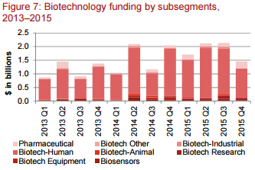

**Biotech Trends**

**Bubble?**

As mentioned, the biotech industry has been experiencing an unprecedented period of capital

investment. A recent report from Credit Suisse (NYSE:CS) states that biotech stocks have

continued to outperform for the past five years — a feat that has never been seen before in any

other sector.

Specifically, analyst Ravi Mehrotra and his team at Credit Suisse state that biotech stocks have seen returns of 204 percent. That is vastly out of proportion with the S&P 500's (INDEXSP:.INX) return of 64 percent.

In summary, the firm states, “we do not think we are in a ‘biotech bubble’ per se (ok maybe the pendulum has over-swung a little!), but rather in a new era for biotech driven by fundamental changes in large and SMID cap biotech.”

**IPO**

Biotech investing news: A turn from IPOs Looking more closely at the second trend of decreasing investment in IPOs, data shows that compared to Q1 2014, investment in IPOs dropped by more than during Q1 2015, only hitting $789 million. However, market watchers have been quick to point out that the decline doesn't indicate an overall cooling in the market, as the biotech industry continues to achieve record-breaking numbers.

Nonetheless, companies in the early stages of development continue to search for investors, particularly in this hot market. Vaird found that in 2014, 10 companies went public with drugs in the early stages of development. That's a significant increase from the four companies that went public at early stages of development in 2013. It seems that investors and companies at all stages of development are seeking to benefit from the biotech industry’s incredible capital growth.

**2. Rightsizing and innovative pricing models**  
Kiran Mazumdar Shaw, chairman and managing director of Biocon Limited  
“Global Trends are moving towards containing healthcare costs and enabling affordable access. Given that the cost of many new drugs is unsustainable for even the wealthiest countries in the world, I foresee new pricing models such as the one introduced by Gilead in the developing world for the Hepatitis C drug, Sovaldi. I predict that this will be adopted by other innovator companies. National formularies are likely to demand ‘Pay for Performance’ models as in the J&J case for Velcade, the blood cancer drug. Finally, economies of scale will drive the future of drug pricing aimed at providing affordable access to new drugs for larger patient populations.”  
  
Gilead Sciences has three pricing tiers for its hepatitis C drug Sovaldi, based on a country’s per capita income and hepatitis C prevalence. The result: the drug that has been criticized in the U.S. for its staggering $84,000 treatment price is selling for a shocking 99% discount in India, just $900. Now if we can just get them to do something about that U.S. price tag.  
  
The Johnson & Johnson case is even more intriguing. In order to get the United Kingdom’s National Institute for Clinical Excellence to allow Velcade to be used by the National Health Service, Johnson & Johnson had to offer an unprecedented money-back guarantee: for patients who didn’t respond to Velcade, J&J refunds the drug’s cost to the NHS. It will be interesting to see if Shaw’s prediction pans out, and other nations start demanding similar guarantees.

#### 1. A record-setting pace of industry consolidation

To list some of the most recent developments and data: M&A activity in the life sciences sector for Q1 2015 exceeded the entire total value of 2014 deals, according to the most recent biopharma and life sciences deals insight [report](https://www.pwc.com/us/en/health-industries/pharma-life-sciences/publications/assets/pwc-pharma-deals-insight-q2-2015.pdf) from PwC.

"Q2 2015 saw a continued trend of deal activity with closed deal value of $72.2 billion from 46 transactions," wrote the report authors. "Announced deals exceeded the prior quarter by 41% in value and 17% in volume."

The industry wide consolidation trend is driven by several factors, including many companies' interests in diversifying their drug pipelines via acquisition; a cheap interest rate environment that makes M&As attractive; and changes in the U.S. regulatory environment. And as the PwC report states, "M&A activity in the [pharmaceutical and life sciences] industry is expected to continue to be robust for the remainder of the year."

It's important to note that there are plenty of worries surrounding this behavior, too. Increasing industry consolidation in both the biopharma and insurance sectors is likely to exacerbate the already-contentious fight over drug prices. And some observers point out that some companies are being acquired despite having few proven assets. At the moment, however, M&As seem to be the name of the game.

#### 2. Expensive new drugs and widespread price hikes are giving the industry a black eye

Consumers and the media are starting to catch on to the industry's practice of snapping up older generic drugs from competitors and hiking their prices, as well as raising the prices of older branded medications. As the Wall Street Journal pointed out earlier this year, companies like Valeant, Mallinckrodt, and Horizon Pharma have bought up CVD and pain medications and hiked their prices anywhere from 200% to 1,000%.

According to Bloomberg News, 27 branded drugs showed "price gains of at least 20 percent in typical dosages since the first quarter of 2014," and over the past five years, "prices of dozens of drugs doubled or more while the Consumer Price Index rose only 9 percent

Again, the companies involved in developing these drugs assert that they were incredibly expensive to study and manufacture, and that they are ultimately a good bargain given the fact that the combined costs of treating CVD events exceeds $400 billion in the U.S. alone. But for payers and patients, the question often boils down to: If I (or my planholders) can't afford this medication, irrespective of how amazing it is, then how does its existence even matter?

Perhaps particularly worrisome for the industry is that doctors have also begun questioning drug prices at a time when pharma's access to physicians has plunged and the power of payers has grown. Cancer drug prices in particular have caught doctors' attention and elicited major pushback.

#### 9. The FDA is approving a record number of drugs—and that's likely to persist

An excellent Forbes [post](http://www.forbes.com/sites/matthewherper/2015/08/20/the-fda-is-basically-approving-everything-heres-the-data-to-prove-it/) from Matt Herper earlier this summer proclaimed that the FDA "is basically approving everything." As he points out, the agency has approved 89% of applications for uses of new chemical entities (and by some accounts, as much as 96%). In fact, former FDA Commissioner Margaret Hamburg touted her record in her farewell speech this year by noting that the FDA had approved the most new drugs in 2014 in 20 years.

Critics point out that this "approve everything" dynamic could lead to negative externalities, including finding out down the line that a drug isn't quite as safe as once thought. But others say that having more drugs on the market is one way to ensure that prices come down to some extent, since payers can increase their negotiating power. 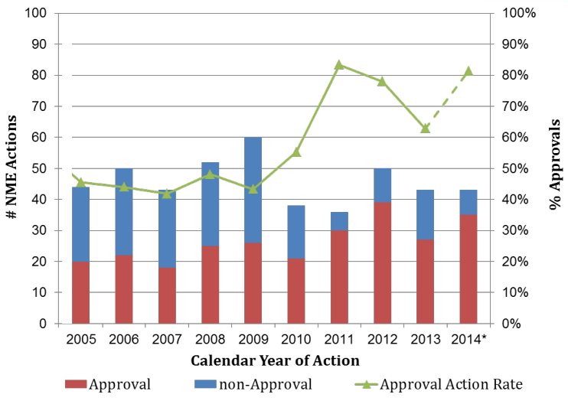

#### 8. Big legislative and regulatory changes are coming to the industry

The 1,000 pound gorilla known as the 21st Century Cures Act has been steadily winding its way through Congress. It easily passed the House of Representatives earlier this summer on a 344-77 vote. And if the bill ultimately winds up passing both chambers and heading to President Barack Obama's desk, he's likely to sign it—which would be a massive boon the biopharma companies.

The legislation, as it currently stands, would speed up drug development efforts, provide more funding to the NIH and FDA, grant exclusivity to orphan drug products, make it easier for pharma companies to make the economic, value-based case for their drugs to providers, integrate patient voices into the regulatory and drug development process, allow for the use of surrogate endpoints to expedite the clinical trial process, and much more.

Cures has enjoyed both bipartisan and cross-industry support by attracting a powerful coalition of players to its defense, including pharmaceutical companies, patient advocacy groups, and even federal regulatory and research agencies.

But not everybody is quite that excited about the prospect of 21st Century Cures. In fact, some have argued that the bill could actually be dangerous from a patient safety perspective by relaxing certain FDA regulatory hurdles (such as allowing for the use of surrogate endpoints and antibiotic approvals based on early-stage clinical trials).

The big question now is: What will the Senate's version of the legislation look like? And will the recent focus on pharma's pricing practices make it less likely that Cures will keep sailing through Congress? It's already widely expected that the Senate will water down major components of the bill. But if Senate Democrats insist on infusing pharma price check measures into the legislation in exchange for enhanced exclusivity, it could wind up running a buzzsaw into the bill.

#### 4. Record IPOs are stoking fears of over speculation and a biotech bubble

"Between 2008 and 2011, there was not a single Preclinical/Phase I IPO in the US, but in the following three years 22 made it onto public exchanges. The average amount raised for a R&D-stage company since the start of 2012 is $72 million, significantly higher than the $50 million average in the earlier three year window of 2005 to 2007. In total, $7.0 billion was raised by R&D-stage emerging therapeutics companies between 2012 and 2014, vs just $2.1 billion between 2005 and 2007. The percent change in dollars over these periods is far greater for IPOs than that seen with venture capital."

For a more complete analysis of how venture capital funding and IPOs in biotech has shifted, and some of the ensuing concerns—including the possibility that investments in the industry aren't as diversified among therapeutic categories as they should be and that seed capital for the youngest, most experimental biotechs is lagging—read BioPharma Dive's in-depth look at VC funding in the industry.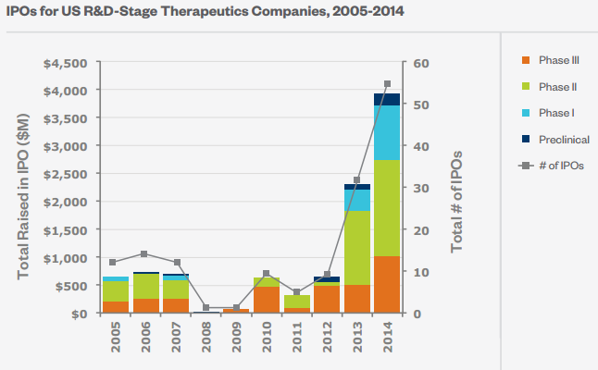

Mature markets will push major pharmaceutical companies to seek more deals.

The world's pharmaceutical giants struggle to generate additional revenue at the rate investors expect, and are projected to lose $17 billion from expired patents in 2016, [according to PricewaterhouseCoopers](http://www.pwc.com/gx/en/pharma-life-sciences/pharma2020/assets/pwc-pharma-success-strategies.pdf). As a result, executives are eager to acquire fast-growing businesses to show growth. In 2015, pharmaceutical and biotech companies set a new record for the value of the deals they struck in a single year at $462.2 billion. The sheer volume of deals also grew by 21.5 percent, up to 768 deals, from 632 in 2014, [according to EY.](http://www.ey.com/US/en/Newsroom/News-releases/news-deal-values-soar-to-record-highs-as-markets-continue-to-reward-dealmaking-says-EY)

“I don't think a week goes by that you don't see an M&A, and I think that just underscores that companies are thirsty for new medicines or innovation that allow them to grow their business,” [J. Alan Butcher](http://www.purduepharma.com/about/leadership-team/j-alan-butcher/), head of business development at Purdue Pharma in Stamford, Connecticut, said. “I think the fever and the temperament of that environment isn't going to cool off anytime soon.”

**Industry earnings**

**Stock pricing trends in the past 5 years:**

**Bubble?**

As mentioned, the biotech industry has been experiencing an unprecedented period of capital

investment. A recent report from Credit Suisse (NYSE:CS) states that biotech stocks have

continued to outperform for the past five years — a feat that has never been seen before in any

other sector.

Specifically, analyst Ravi Mehrotra and his team at Credit Suisse state that biotech stocks have seen returns of 204 percent. That is vastly out of proportion with the S&P 500's (INDEXSP:.INX) return of 64 percent.

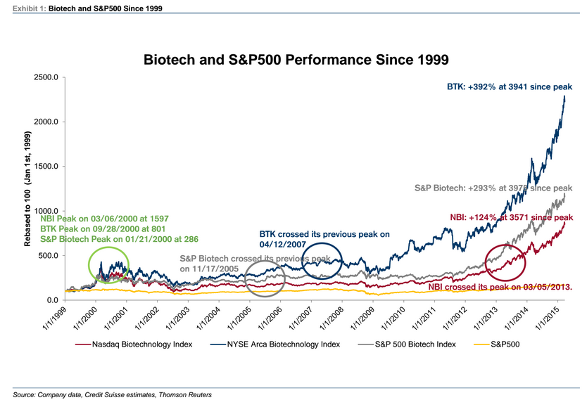

In summary, the firm states, “we do not think we are in a ‘biotech bubble’ per se (ok maybe the pendulum has over-swung a little!), but rather in a new era for biotech driven by fundamental changes in large and SMID cap biotech.”

**Financial Performance 2014**

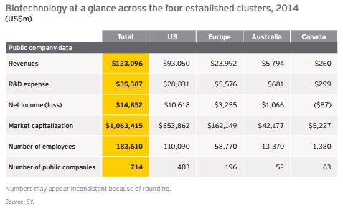

This was a year for the record books. On almost every measure we track — revenues, profitability, capital raised and more — the industry reached new heights in 2014, spurred by a confluence of positive trends. Sustained sales of high-profile products continued to boost investor sentiment.

It was also a landmark year for new product approvals, as a more supportive U.S. Food and Drug Administration (FDA) clarified the use of new expedited approval channels for breakthrough medicines. Against a backdrop of booming stock markets and expansionary monetary policies, these product successes helped propel the biotech industry’s market capitalization above the US$1 trillion threshold, a new high.

The news-making product successes of 2014 had an outsized impact on the industry’s financial results. In particular, the rapid ramp-up of Gilead Science’s hepatitis C products significantly boosted the revenues and net income of the sector. Financial performance was also affected by the large number of initial public offerings (IPOs), which increased revenues and R&D while lowering net income.

Net income increased by a very healthy 199%, to US$3.3 billion. This percentage increase didn’t match the steep growth rate of 2013, when net income soared by 462%. Adjusted for the US$1.6 billion breakup fee Shire received when AbbVie called off the proposed merger between the two companies, net income growth still would have been an impressive 52%.

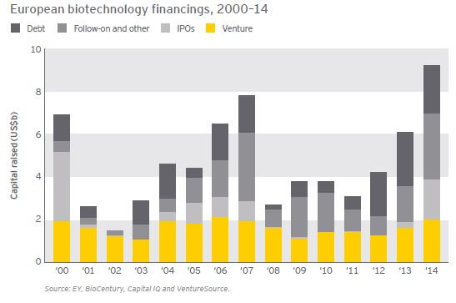

The European biotech sector racked up its strongest financing performance in the history of the industry and posted the second-strongest performance in each individual financing category. Overall, the sector raised US$9.2 billion — 53% more than in 2013, and a whopping 97% more than the previous 10-year average. IPOs raised US$1.9 billion. That is more than in the prior seven years combined, but well below the US$3.3 billion raised in 2000.

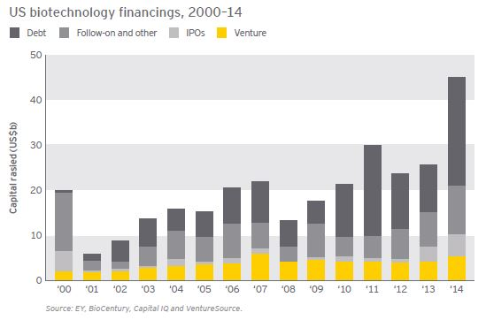

US biotechnology recorded a colossal year in 2014, setting a new all-time record in total capital raised (US$45.1 billion) as well as funds raised through IPOs (US$4.9 billion) and debt (US$23.3 billion). The amounts raised in the two other financing categories represented the second-highest totals in the industry’s history: venture capital generated US$5.6 billion (second to the US$6.1 billion raised in 2007) and follow-on financing raised US$10.7 billion (behind the almost US$13 billion raised in 2000).

The sector’s strong overall performance was underpinned by successful launches of well-differentiated products that could attract premium prices, supported by a more accommodating FDA, especially in areas of high unmet need. Meanwhile, big pharma’s increasing need to fill its growth gap also drew investors in anticipation of acquisitions of biotech assets at significant premiums, such as Roche’s US$8.3 billion purchase of InterMune and Merck & Co.’s two multibillion-dollar offers, for Cubist Pharmaceuticals (US$9.5 billion) and Idenix Pharmaceuticals (US$3.9 billion). (See accompanying “Deals, 2014” article).

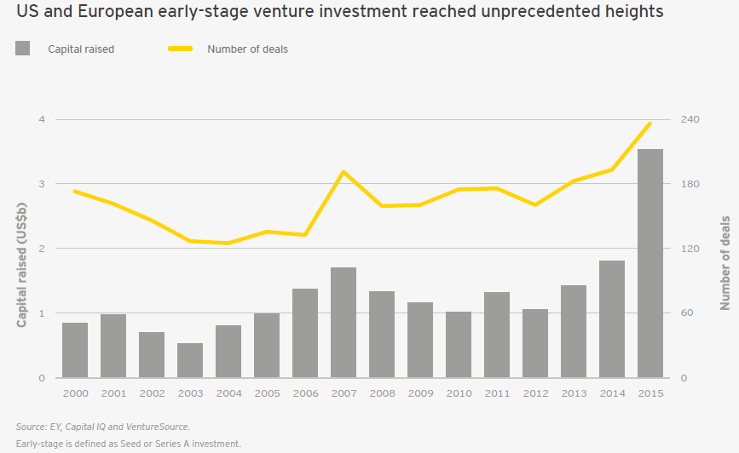

That burst of early-stage financing meant the proportion of venture funds going to early-stage biotech companies was greater than in any year this millennium, topping 30% for the first time since 2001 (up from 25% in 2014; the 15- year average is 24%).

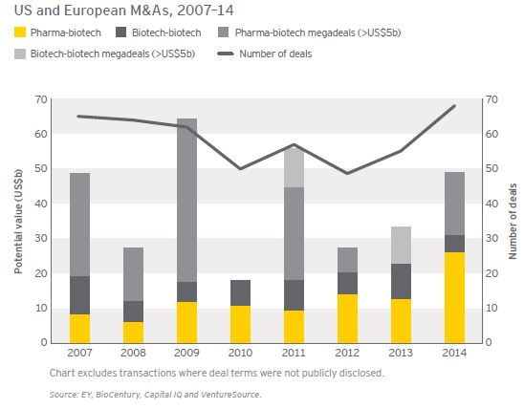

2014 was a breakout year for both M&A and licensing, as biopharma companies used transactions to jump-start or shift business strategies in a sector where the dynamics are rapidly changing. Indeed, M&A activity in the biotechnology sector reached an eight-year high in both deal number and value (excluding megadeals, valued at US$5 billion or more). In all, the industry notched 68 biotechnology deals totaling US$49 billion, a 46% increase over 2013.

Biotech-biotech deal values also retreated, with the total dollars spent in 2014 dipping 51% year over year to one of the lowest levels in the past decade. Smaller biotechs, as opposed to the commercial leaders, accounted for most of the year’s M&A activity. Like their pharma brethren, the data suggest the biotechs that were buying were most interested in acquiring products or platforms in their core therapeutic areas.

That the biotech commercial leaders eschewed M&A in 2014 isn’t too surprising. As we noted in Firepower fireworks, EY’s 2015 Firepower Index and Growth Gap Report, strong product launches in recent years mean the bigger biotechs have not felt pressured to do deals to fill revenue growth gaps.