* So far we didn`t split women at all. Check to see if class (Pclass) makes it less likely for a woman to survive. It does – those in class 3 are much less likely to survive, however chance is 50% so it doesn't help with the classification.

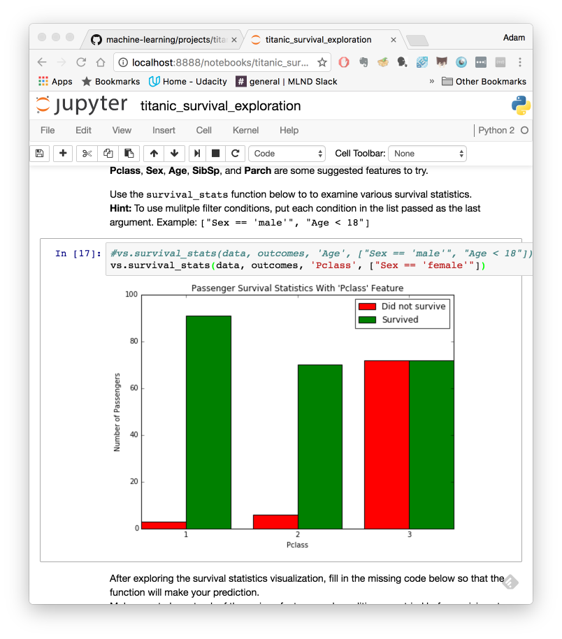

* Also check Pclass for men. Again Pclass = 3 is much less likely to survive, but doesn't change default prediction of not survive.

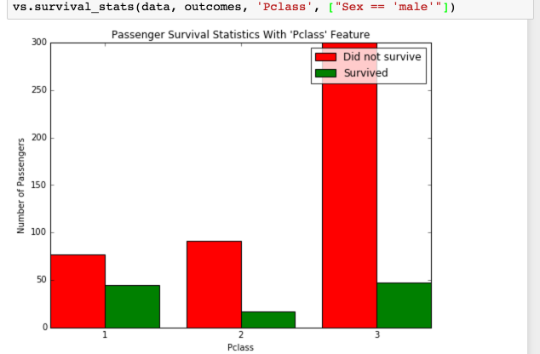

* Male > 18 also gives similar results – no help to prediction
* For Male number of siblings (SibSp) nor Parch (parent/children) makes no difference to default
* For female less likely to survive if SibSp >3
  + add to criteria -> brings up score to 80.02%

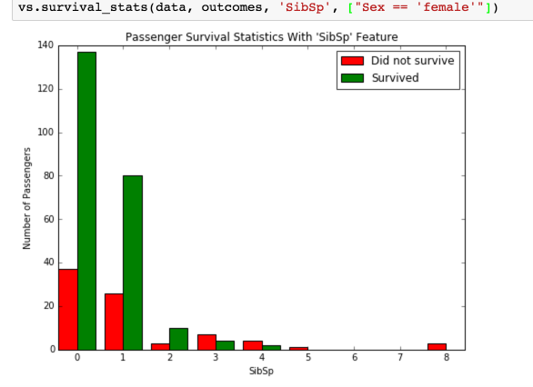

* Female less likely to survive if Parch > 4
  + Add to criteria -> brings up score to 80.36%
* 