animation
noun
⁴ Graphic Arts
ª a dynamic visual medium produced from static drawings, models, or objects posed in a series of incremental movements that are then rapidly sequenced to give the illusion of lifelike motion.

for flutes (concert flute in c, bass flute), contrabass paetzold recorder in F, synthesizer, harp and harpsichord

Duration ca. 10’

Notes on performance

Tuning
The oscillators in the recorded samples were tuned to a’=440Hz

Dynamics
There are just four dynamic levels used in the piece
ppp – at the limits of audibility, a mixture of white noise and tone
pp – very quiet tone, clear and delicate
p – soft and clear
fp – quick, loud attack becoming immediately quieter
Generally, I’ve kept the notation of dynamics to a minimum, there should however be a natural ebb and flow to the loudness of the instruments.

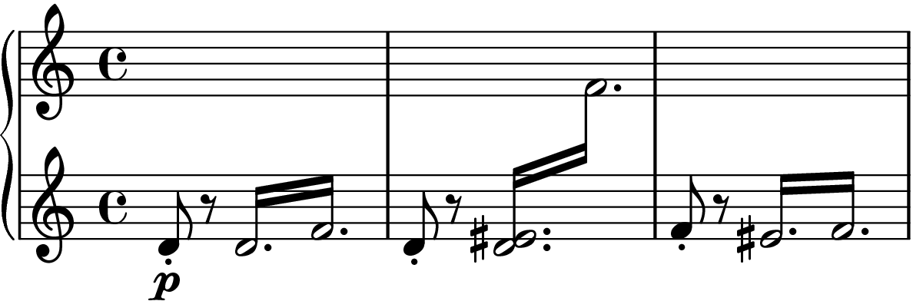
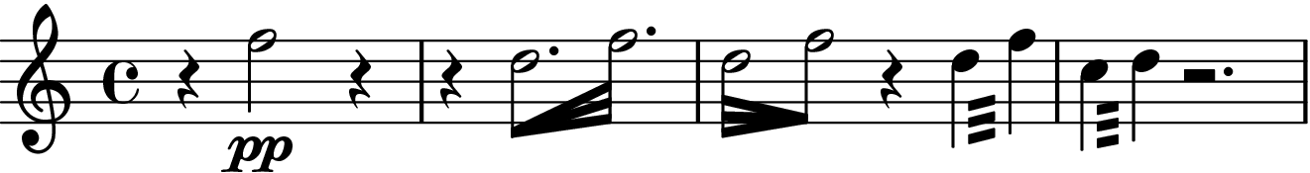

Flutes and Recorders
Tremolo
The wind parts feature a type of figure that involves playing tremolo figures at either with an accelerando and deccelerando or at a constant velocity for the notated duration. These figures will be notated using feathered beams or tremolo lines, respectively.

Harp and Harpsichord
Tremolo
Both of these parts also feature tremolo figures that are notated with a type of cross staff notation, this indicates that the figures can be played with both hands as a type of bisbigliando – meaning that they are not merely an ornament to some particular note, but an important musical figure in their own right.

Synthesizer / Sampler

The electronic part can be played either with modular synthesizer or sampler. Pre-recorded parts are available with the score distribution on https://github.com/adammccartney/animation.git

As well as the pre-recorded parts, there is a patch for max8 that provides a simple sampler to play them back. This sampler should be relatively intuitive to use. There are two “modes”, these are accessed using the letters “j” and “k” on your keyboard. Mode “j” has a total of 10 samples (0-9). Mode “k” has a total of 5 samples (1-5). The notated part in the score indicates when each sample should be played.

Dynamics are not pre-programmed and should be interpreted by the performer during the live performance.

Modular patch diagram (for reference):

