animation
noun
⁴ Graphic Arts
ª a dynamic visual medium produced from static drawings, models, or objects posed in a series of incremental movements that are then rapidly sequenced to give the illusion of lifelike motion.

for flutes (piccolo, flute, alto, bass), recorders (soprano, tenor, contrabass paetzold in F), modular synthesizer, harp and harpsichord

Duration ca. 13’

Notes on performance

Tuning
The piece is well suited to either 12 tone equal temperament or the Vallotti temperament where each of the fifths B – F#, F# – C#, C# – G#, G# – D#, D# – Bb and Bb – F are tuned as just fifths with the ratio of 3:2, and the fifths F – C, C – G, G – D, D – A, A – E and E – B are each 1/6 of a Pythagorean comma narrower than just.

Major Third | F-A, C-E,  G-B | D-F#,  Bb-D | A-C#,  Eb-G | E-G#,  G#-C | B-Eb, F#-Bb,  C#-F
Deviation from just | +5.9 | +9.8 | +13.7 | +17.6 | +21.5

The choice of temperament will most likely be informed by certain practical necessities that usually go along with concert performance and the context that the piece is performed will determine to a large degree what temperament is selected. This choice is totally flexible and left up to the discretion of the performers.
Dynamics
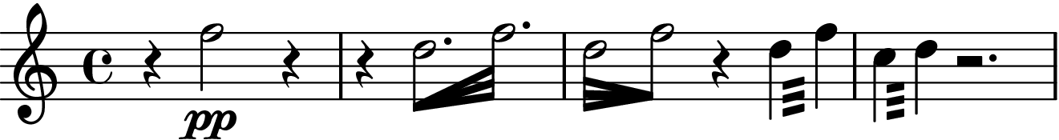
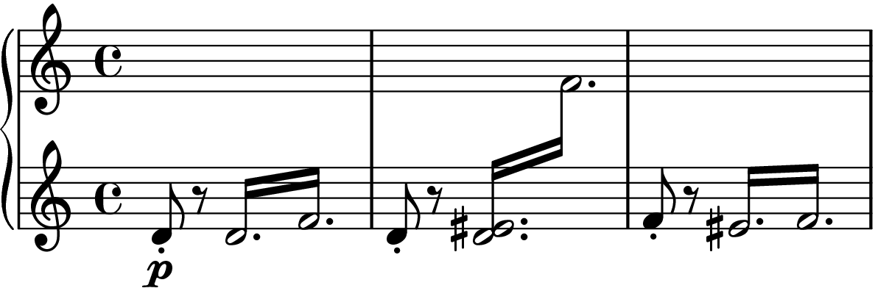
There are just four dynamic levels used in the piece
ppp – at the limits of audibility, a mixture of white noise and tone
pp – very quiet tone, clear and delicate
p – soft and clear
mp – full tone, to the fore of the sound
fp – quick, loud attack becoming immediately quieter
Generally, I’ve kept the notation of dynamics to a minimum, there should however be a natural ebb and flow to the loudness of the instruments.

Structure
The piece is divided into four sections, these are clearly marked with the numbers 1 – 4. Because multiple simultaneous time-signatures are used, the bars are not numbered. Instead, a series of rehearsal marks A – K are used as a way to keep the individual voices coordinated and moving along at the same rate. These marks should be used as general points of orientation and musicians should wait at each one of these marks for all five musicians to arrive at the same point before giving a clear indication and moving on together.

Flutes and Recorders
Tremolo
The wind parts feature a type of figure that involves playing tremolo figures at either with an accelerando and deccelerando or at a constant velocity for the notated duration. These figures will be notated using feathered beams or tremolo lines, respectively.

Harp and Harpsichord
Tremolo
Both of these parts also feature tremolo figures that are notated with a type of cross staff notation, this indicates that the figures can be played with both hands as a type of bisbigliando – meaning that they are not merely an ornament to some particular note, but an important musical figure in their own right.

Synthesizer
[detailed patch diagram to follow]
3 x VCOs tuned in unison
5 x VCAs
2 x EG
3 x VCFs
1 Sequencer
1 Clock
1 Digital Delay
1 Digital Reverb
2 x Quantizer
1 S&H
3 x Mixers
Sequencer Program
The type of instrument referred to here is a modular synthesizer that is sequenced using a cartesian sequencer the notated melody is the sequence to be programmed and the changing rhythms indicate the speed of the clock signal. While the notated music appears to represent a static sound, the result will be a type of generative musical texture that produces a number of significant rhythmic variations on the original theme. Because the nature of sequencers is such that the rhythms they produce are persistent,
Quantization and Harmonization
The control voltage used to drive the three oscillators will be quantized by the first on board quantizer of the sequencer. Harmonization in thirds and fifths is achieved using the diatonic offset generator on the second quantizer.
Timbre and Modulation
The patch is focused on achieving a “string” sound – the attacks of the individual tones should be gradual with a moderate sustain and quick decay time. In terms of overall instrumental balance, the synthesizer should focus on sustaining the otherwise quickly fading resonances produced by the other instruments.

