Memoirs of the old sound

For Violin, Cello and Piano

Duration ca. 8’

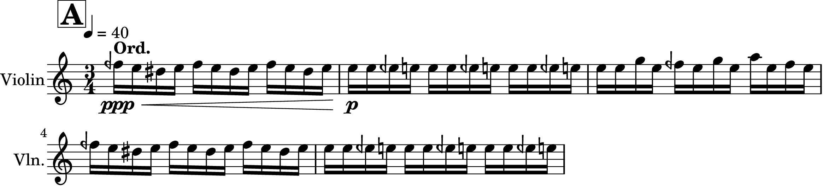
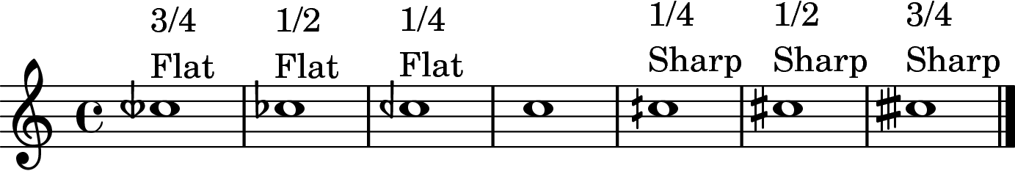
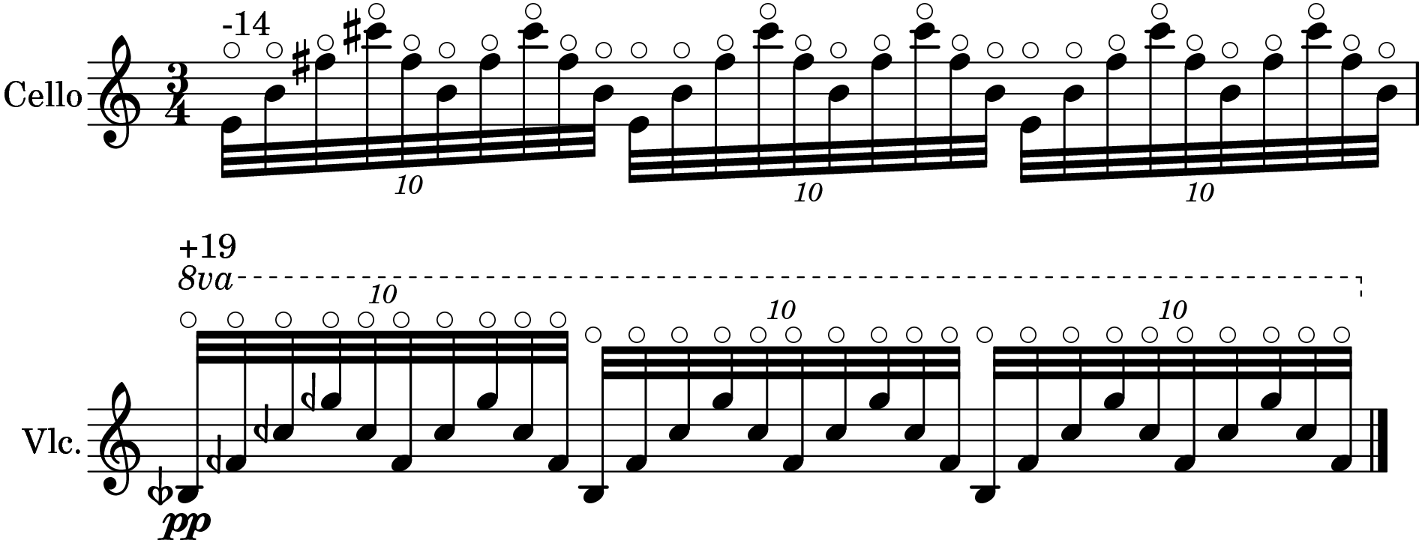

Notes on performance

Tuning
The piece uses a combination of 12/24-tone equal temperament and just intonation.
Piano is tuned in 12-tone equal temperament. This is extended to 24-tone equal temperament by the violin at specific sections for instance:

Standard quarter-tone notation is used

The overtone series of C, G, D A are produced by playing natural harmonics on the cello. The notation used to represent these pitches is not totally accurate and deviates considerably at two points namely, at the 5th and 7th partials. The 5th partial sounds 14cent lower and the 7th partial sounds 19cent higher than notated. The 3rd and 6th partials sound 2cent higher than notated.

Dynamics
There are just four dynamic levels used in the piece
ppp – at the limits of audibility, a mixture of white noise and tone
pp – very quiet tone, clear and delicate
p – soft and clear
mp – full tone, to the fore of the sound

Violin and Cello
Bowing
Flautando indicates a rapid bow movement with very little pressure, producing an airy sound
Ord. is shorthand for ordinario, and indicates a neutral bowing position that produces a balanced tone
Sul Pont. is an abbreviation for sul ponticello and indicates a bowing position that is very close to the bridge, producing a tone that emphasises the higher partials

Piano
Pedal
Use of the sustain pedal is indicated at specific points using brackets below the staff. The una corda pedal can be used at the discretion of the pianist to articulate some of the quieter dynamics.

