I dream with my eyes open
– Jules Verne, Journey to the Center of the Earth

Instrumentation
flute
clarinet
trombone
percussion (crotales & vibraphone)
piano
electric guitar
violin
cello
contrabass

Duration ca. 7’

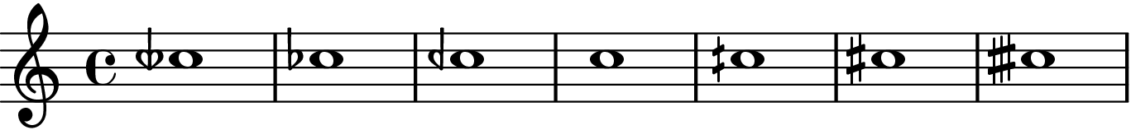

Notes on performance

Tuning
24 tone equal temperament is used throughout the piece. The following accidentals are used to indicate pitches in quarter tone steps from ¾ flat – ¾ sharp

Dynamics
There are just five dynamic levels used in the piece, the distribution of dynamics between the instruments is one of the primary ways that the three different colours are distinguished from one another.

ppp – at the limits of audibility, a mixture of white noise and tone
pp – very quiet tone, clear and delicate
p – soft and clear
mp – full tone, to the fore of the sound
mf – loud clear tone, clearly in the foreground

Structure
The piece is written as a series of rhythmic modules, there are three distinct types of modules – for ease of description here, I’ll call them red, green and blue.
The first two types are always three bars long and the third type (blue) is six bars. The piece is constantly playing to shift the focus between sounds in the foreground and sounds in the background. The idea is to remove any notion of distinction between the two.

Green

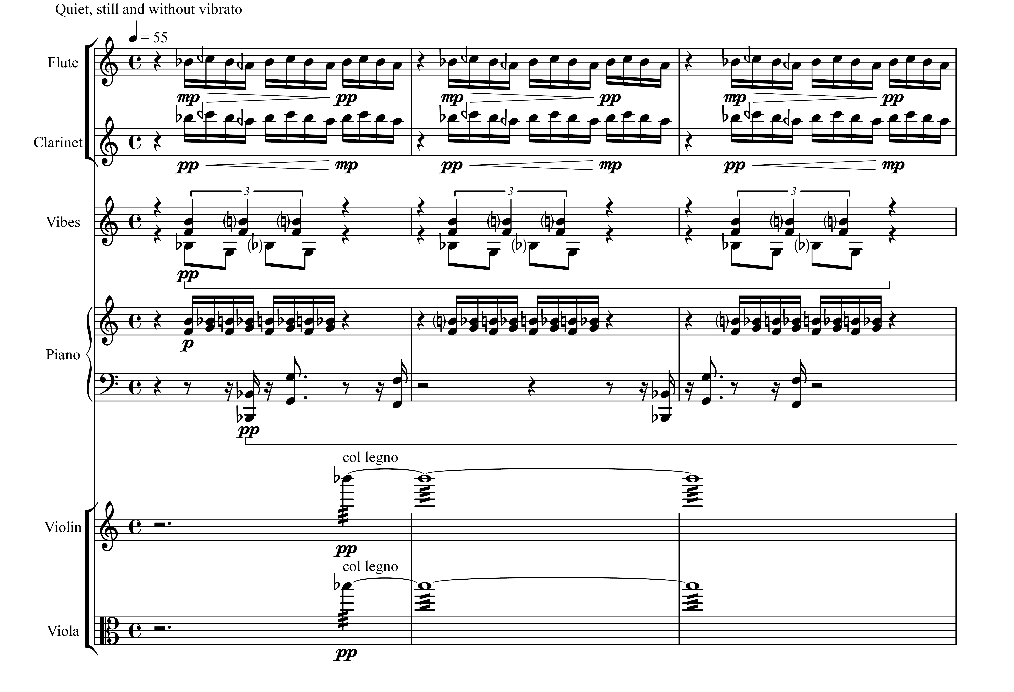

Blue
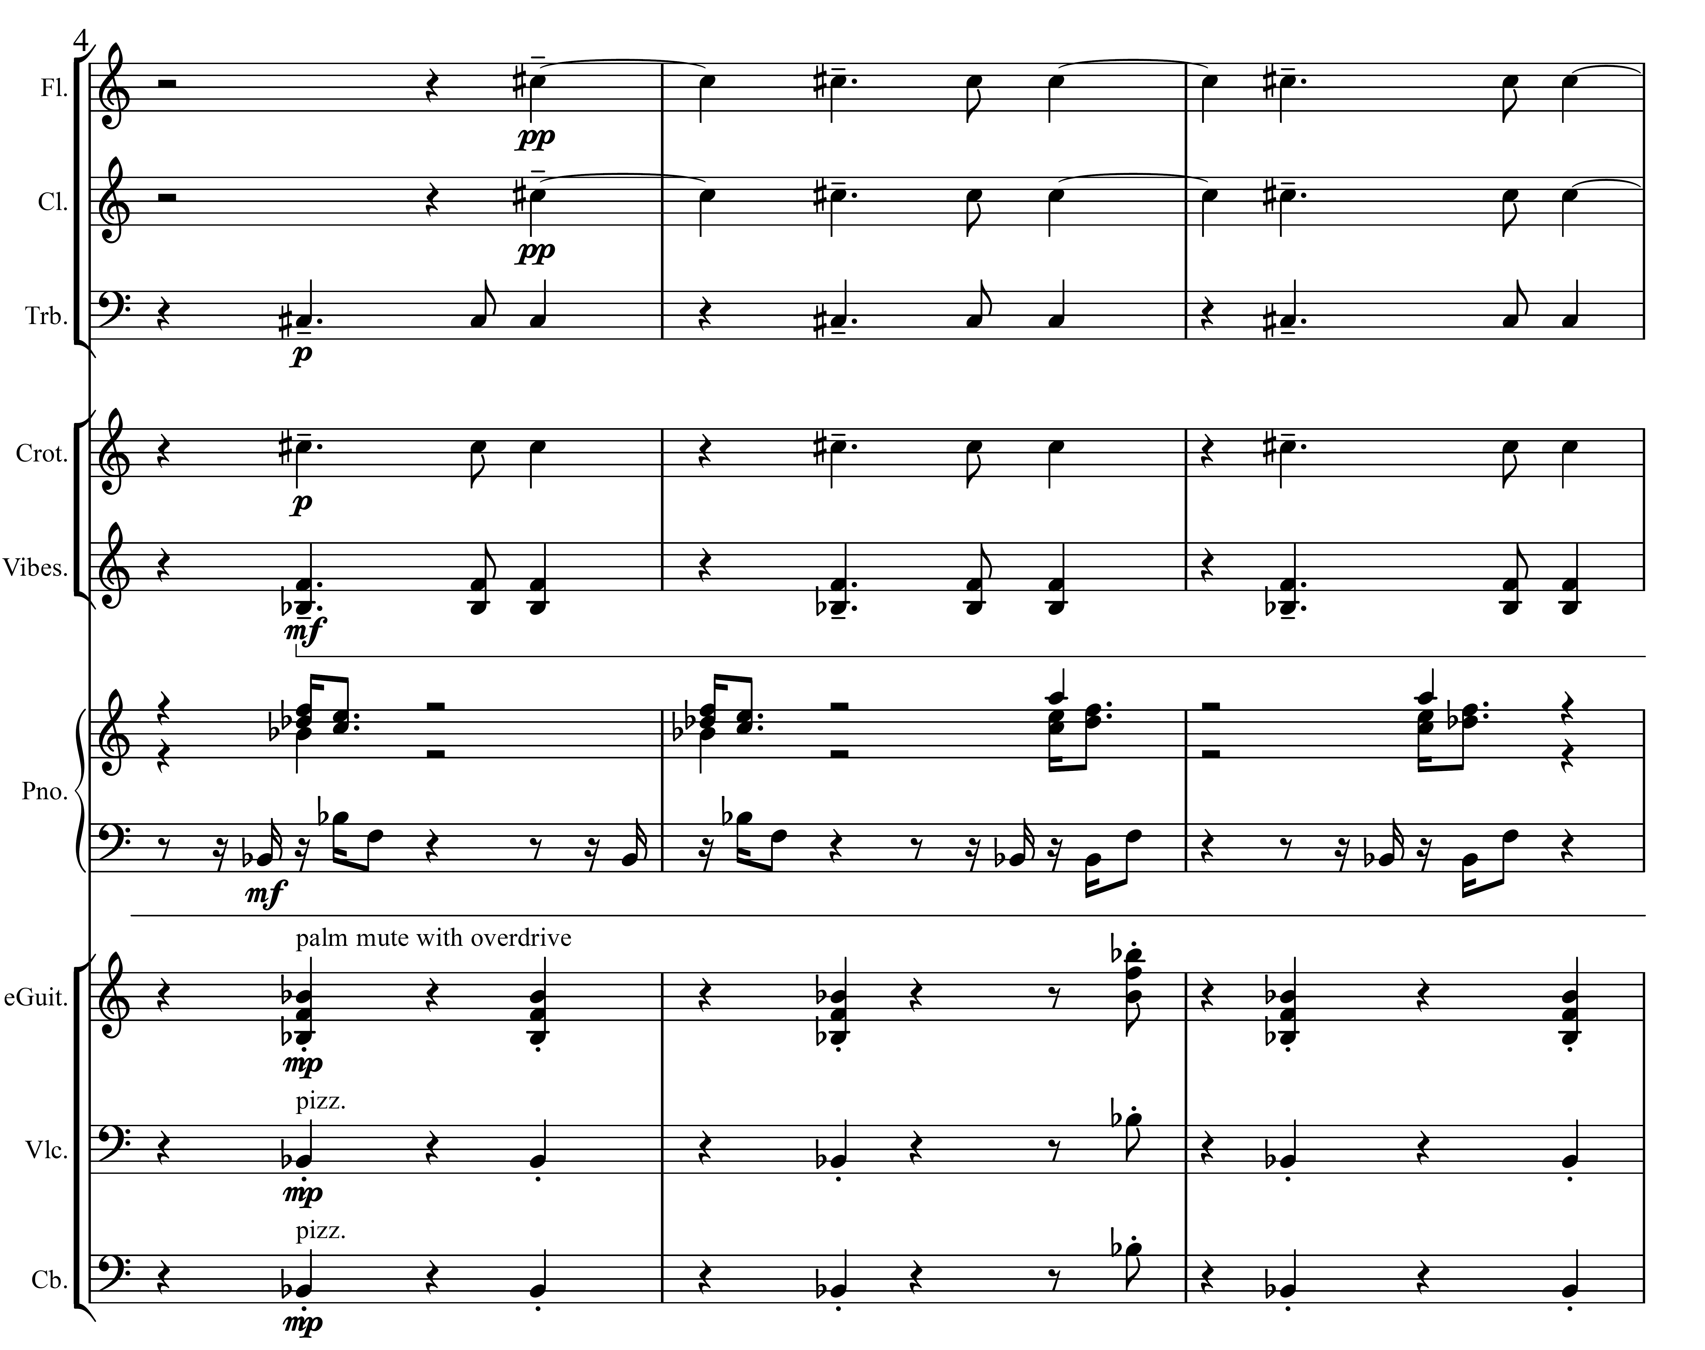

Red

