
Department of
Computer Science

DirtPros: Data Collection and Management System
Alejandro Fernandez
Christian Gonzalez
Alexis Guerra
Adamm Hockman

CSC531 Software Engineering
Software Design Projects
Spring 2013
May 2013

Table of Contents
Table of Contents 2
Executive Summary 3
1. Problem Statement 4
a. Scenario 1: Employee collects recyclable materials at facility 6
b. Scenario 2: Supervisor approves data collection log on web application 7
c. Scenario 3: Administrator accesses information on web application and generates a data report. 8
2. System Diagram 9
3. Analysis: Use Case Diagram 10
a. Use Case Template 1: Submit On Site Form 11
b. Use Case Template 2: Manage Submission 11
c. Use Case Template 3: Review Aggregate Data 12
4. Structural and Functional Design: Class Diagram and Sequence Models 13
Database Schema 13
Class Diagram Overview: 13
Sequence Diagram 1: Input Collection Log 16
Sequence Diagram 2: Approve Collection Log 17
Sequence Diagram 3: Generate Administrative Data Report 18
5. Behavioral Model: State Diagram of MobileApplicationController Class 19
6. Behavioral Model: State Diagram of WebApplicationController Class 20
7. Cost Estimation and Project Management Description 21
8. Prototype Description and Lessons Learned 22
9. Appendix 23

Executive Summary

Dirt Pros is a fast growing recyclables collection company that increasingly relies on efficient data management to produce exemplary results. Their process in use is both outdated and inefficient. Our approach involves an aggressive overhaul of their paper-based system to that of a digital system, redefining the data management process from bottom to top.

At the lowest level, we have developed a simple android application to be used by employees on site to submit the data produced. This process involves secure employee identification information as well as geographic confirmation. In addition, we have incorporated administrative procedures relying on a supervisor hierarchy for managing these on-site submissions.

At the highest level, we have integrated a web-based application for administrators and executives to log on and manage the aggregated data. This process is both secure and portable. Each administrator will have a level of security that permits them to view various depths of data within the database. The database we have implemented is an SQL approach and allows for easy data viewing across regions, site, and even employees.

The process of presenting data to clients has also been simplified by allowing administrators to enter specific options and generate reports based on aggregated data. We have integrated various statistical analytic models to produce information previously unavailable.

The cost model for this project is fairly modest and if DirtPros is going to thrive as a growing company that relies on efficient data management, it is recommended the company make the decision to upgrade their system now while the transition is reasonable.

Problem Statement
DirtPros is a company that is responsible for the collection, sorting, and processing of recycled material. Currently, the information from the various work sites regarding the recyclable materials is obtained by an employee that is on site using a paper form. At the end of the day, all the forms that were filled out at the work site must be faxed to a central location, where an employee at the other end is responsible for manually inserting this information into an excel spreadsheet. This method of gathering data has become difficult to sustain as the company has grown and is susceptible to mistakes during the translation from the paper form to the excel spreadsheet. The goal of this project is to create a mobile application for the Android operating system that will replace the paper forms that are currently used at the worksite. In addition to creating a mobile application, DirtPros would like to move away from using an Excel spreadsheet as their primary means of data storage. As a result, the project will involve integrating the Android application with a database, since it provides more scalability compared to the spreadsheet approach currently being used. A web application is also to be developed that would allow DirtPros employees to view the data from the database from a web browser.

The mobile component of this project will involve the creation of an Android application. The Android application must be able to gather all the information that is currently stored on the paper forms. In addition to receiving form data from the user, the application must also obtain the location of the employee using the phone’s GPS capabilities as soon as the user presses the submit button on the form. When the employee finishes entering all the information for a particular set of recycled materials, the information must be sent to the central database, along with the credentials of the employee that filled out the form. The application is responsible for storing the form data entered by the employee on the device’s local storage until it receives confirmation that the information has been uploaded to the database. In the event that the employee is in an area that there is limited network connectivity, the application must keep the form data on the device and must attempt to upload the information when a network connection is available via Wi-Fi or from the wireless phone provider.

The web application will also be able to communicate with the database. The web application will allow administrators and managers to directly make changes to the database, assuming they have the correct credentials for these operations. Managers will also be able to approve or deny new data collection logs received from the worksite within the web application. The web application will also be capable of creating sustainability reports for a client based on the information in the database. This includes the generation of tables and graphs on demand.

The database component of the project will consist of a SQL server. The web and Android applications will then be able to update and view content from the database using a set of API calls that will be implemented as part of the project. These API calls will ensure the security of sensitive information, as users must be authenticated before any changes or reads are made to the database. The database must be scalable to accommodate the growth of both the company and the amount of data being gathered from the various job sites. The database must also provide a mechanism for managers to approve new collection information, before the data is used for the generation of reports for clients.

The implementation of this project will now be given in detail and time estimates are listed based on the assumption that a small to medium sized fulltime software development team will be used for the implementation of the project. The database component of the application is expected to take 3.5 months to implement. It is expected to take about 2 weeks for the purchase of server hardware and the installation of database management software. The next 3 weeks would involve the development and implementation of the database schema for the company. The final part of the database component involves the creation of an API to authenticate users and to allow the web and Android application to access and make changes to the database. The API is expected to take no more than 9 weeks to design, implement, and test. The Android application is expected to take 2.5 months to implement. The design of a consistent user interface for form data collection is expected to take 3 weeks. It is expected that the business logic to verify this form data and store it on the device will take 3 weeks to implement. The networking aspect of the Android application, which involves authenticating the user and sending form information to the server using the API is expected to take another 4 weeks. The remaining week is left for testing and bug fixing. The web component is expected to take 15 weeks total to implement. The creation of a clean user interface for managers and administers to view and modify the contents of the database is expected to take 5 weeks. The implementation of the sustainability report generator is expected to take 3 weeks. It is expected that 5 weeks will be spent on using the API to allow the web application to effectively communicate with the database server for logging in and obtaining the required data. The final 2 weeks are left for testing and debugging the web application.

The database is responsible for containing several key pieces of information. The database should contain a list of all sites for which DirtPros is conducting surveys. For each site, there will be a set of collection records, organized by date and bag number for that date. Each bag will then contain a weight (in pounds) and the estimated percentages of the contents for the following categories: wet trash, paper, cardboard, plastic, glass, and cans. Based on these estimated content percentages and the total bag weight, the web application will be able to derive the weight in pounds of each component for each bag. This information could then be sued to calculate aggregate information for the entire site, such as the pounds of paper collected at the site.

The goal of this project is to offer a solution that is easy to adopt and saves time and resources for DirtPros. The user interface of the Android application must be intuitive for the employees. It should take the average employee no more time to fill out a form electronically using the Android application than it would if they filled out a paper form. The web application must also be capable of producing sustainability reports that are of equal or greater quality than those generated from the Excel spreadsheet approach currently in use.

Scenario 1: Employee collects recyclable materials at facility

- Employee arrives at collection location.
- Employee launches Android application to insert collection data.
- The application launches and prompts the employee for his/her login information.
- The employee enters his/her login credentials and waits for the application’s confirmation.
- The application evaluates the entered information, checking it with the employee’s stored information in the company database, and provides the employee with a set of options as buttons on the screen (Record Collection Information, Logout).
- The employee selects the Record Collection Information option and waits for the application’s response.
- The application prompts the user for the collection site name, region, facility type, and solid waste removal partner associated with the collection location.
- The employee enters the required information and waits for the application’s response.
- The application records the information and then provides the employee with a set of options as buttons on the screen (Add Bag, Submit Data for Approval).
- The employee selects the Add Bag option and waits for the application’s response.
- The application prompts the user for the weight of the bag in pounds and provides a button labeled Record Weight.
- The employee enters the weight of the bag, presses the Record Weight button, and waits for the application’s response.
- The application then asks the employee to enter the composition of the bag (wet trash, paper, cardboard, plastic, glass, cans) in percentages, presenting a number of text fields to enter the information as well as a button labeled Record Bag Composition.
- The employee enters the bag composition, presses the Record Bag Composition button, and waits for the application’s response.
- The application records the data and returns to the screen presenting the options (Add Bag, Submit Data for Approval).
- The employee selects the Submit Data for Approval option and waits for the application’s response.
- The application asks the employee to confirm the submission of the data presenting a set of options as buttons (Confirm Submission, Cancel Submission).
- The employee selects the Confirm Submission option and waits for the application’s response.
- The application uses the device’s GPS capabilities to record the device’s current location together with the time and date of submission. It then attempts to connect to the company database.
- The application proceeds to calculate the composition of the bag (wet trash, paper, cardboard, plastic, glass, cans) in pounds and transmit all of the necessary information associated with the collected materials before returning to the screen presenting the set of options (Record Collection Information, Logout), thus ending the transaction.

Scenario 2: Supervisor approves data collection log on web application

- Supervisor accesses the web application site.
- The application launches and prompts the supervisor for his/her login information.
- The supervisor enters his/her login credentials and waits for the application’s confirmation.
- The application evaluates the entered information, checking it with the supervisor’s stored information in the company database, and provides the supervisor with a set of options on the screen (View Outstanding Collection Logs, View Approved Collection Statistics, Logout).
- The supervisor selects the View Outstanding Collection Logs option and waits for the application’s response.
- The application then displays a new page with a list of the outstanding collections logs assigned to the supervisor that have not been approved, giving the supervisor the option to view each individual collection log as well as a set of view options for the logs (Sort by Date, Sort by Employee, Sort by Facility, Sort by Facility Type, Sort by Region, Sort by Solid Waste Removal Partner).
- The supervisor selects the view option for the first available collection log and waits for the application’s response.
- The application displays a new page with the data submitted for the selected location. This includes a list of numbered bags with their respective estimated material compositions as well as the date, time and location where the data submission took place. There is also a set of options available as actions on the data (Modify, Approve, Flag).
- The supervisor analyzes the data for the collection log, selects the Approve option, and waits for the application’s response.
- The application records the supervisor’s selection and marks the collection log as approved. It then proceeds to switch back to the page with the remaining outstanding collection logs.

Scenario 3: Administrator accesses information on web application and generates a data report.

- Administrator accesses the web application site.
- The application launches and prompts the administrator for his/her login information.
- The administrator enters his/her login credentials and waits for the application’s confirmation.
- The application evaluates the entered information, checking it with the administrator’s stored information in the company database, and provides the administrator with a set of options on the screen (View Outstanding Collection Logs, View Approved Collection Statistics, Logout).
- The administrator selects the View Approved Collection Statistics option and waits for the application’s response.
- The application displays a new page with a list of sorted dates (most recent to furthest removed), each with a link to the data that corresponds to that day as well as the Generate Report option.
- The user selects the Generate Report option and waits for the application’s response.
- The application records the administrator’s selection and displays a selection window with the instruction Select Start Date together with a date selector. Below this lies the instruction Select Time Interval together with a drop-down list with the options (1 day, 1 week, 1 month, 3 months, 6 months, 1 year, All-time, Custom). This allows the administrator to select a range of dates to analyze extending from the selected day.
- The administrator selects the current date together with an interval of 1 year in order to generate a year-to-date report and waits for the application’s response.
- The application records the administrator’s selections and proceeds to make a series of database queries, extracting information and performing the requisite calculations before displaying a new page containing information such as the total amount of collected recyclable materials, the breakdown of the total collected materials, etc. This information is provided both textually and graphically through the use of charts and graphs. At the end of the report the Exit Report and Download Report options are provided to the user.
- The administrator analyzes the data and, when finished, selects the Exit Report option.
- The application records the administrator’s selection and switches back to the page containing dates linked to collection logs.

System Diagram

Figure 1. System Diagram
Our project consists of three components that ultimately communicate with one another. Our Android application is used by field employees to submit data. This application connects to three systems: a GPS satellite to obtain the employee’s current coordinates, a cell tower, and a router providing internet access. The latter two systems allow our Android application to connect with our central database where new data can be stored and sent out. In addition to the Android application, the database can be accessed using a web-based application that uses a computer’s internet browser. This web application can be used by supervisors to confirm data that has been sent by field employees and by administrators to view all the data in the database.

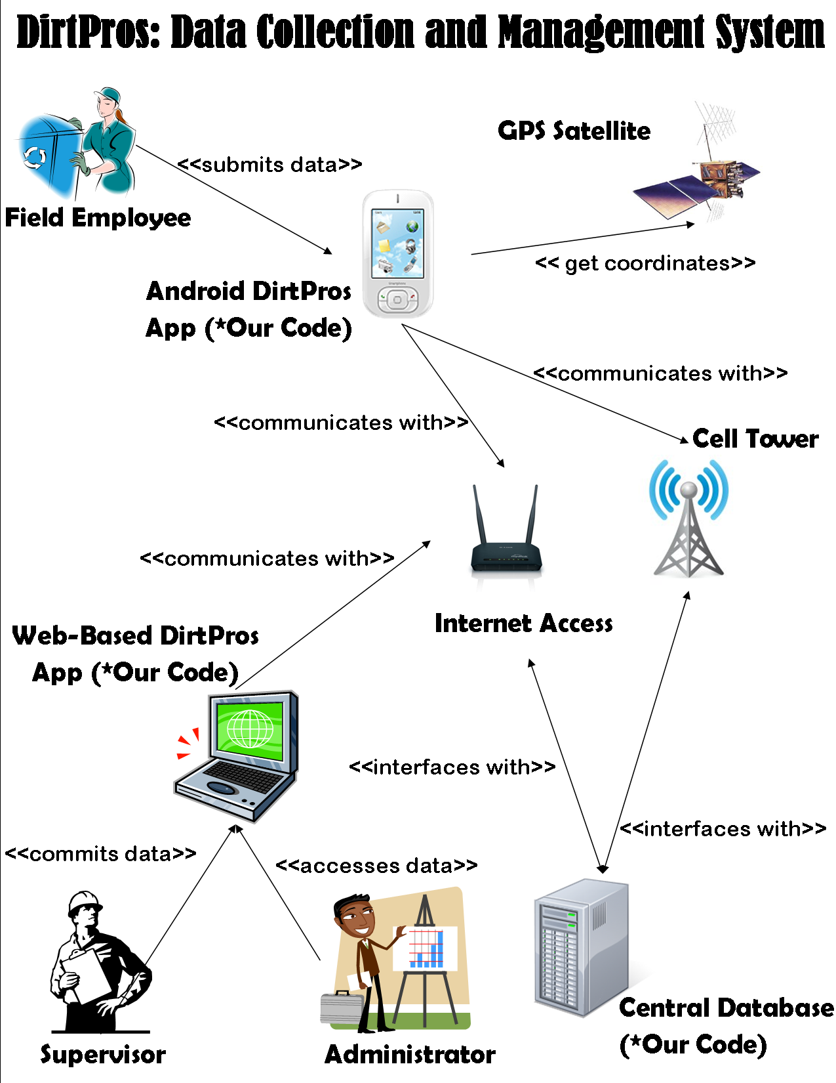

Analysis: Use Case Diagram

Figure 2. Use Case Diagram

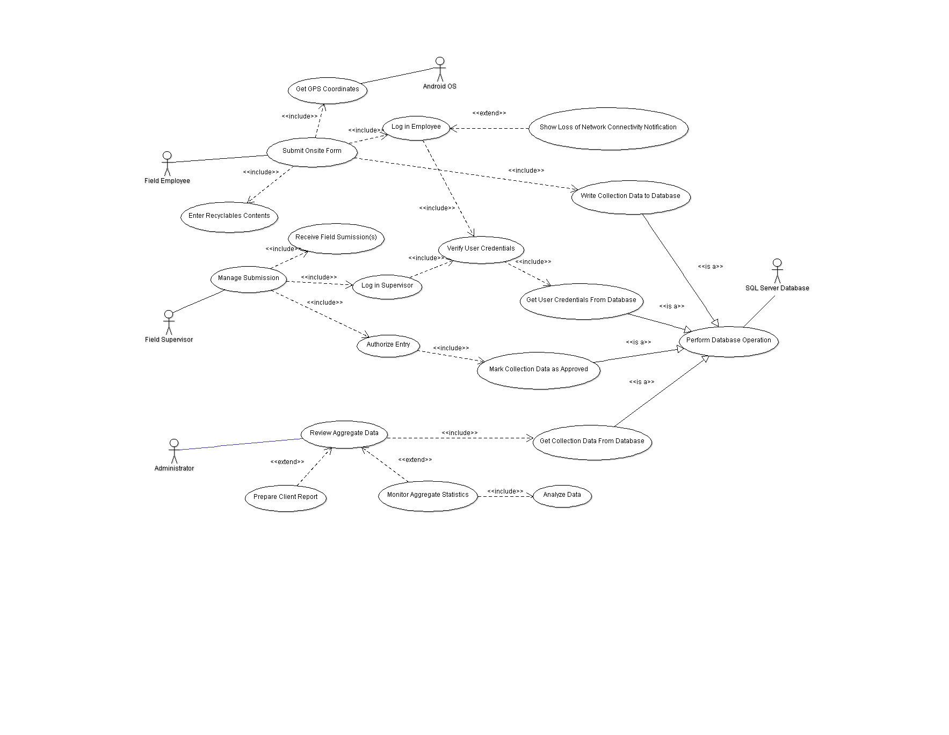

Use Case Template 1: Submit On Site Form

Use Case: Submit On Site Form

Actors: Initiated by FieldEmployee
Communicates with SQL Server Database
Communicates with Field Supervisor
Interacts with Android OS

Preconditions: An on-site employee has access to his/her Android OS mobile device and is prepared to submit an on-site form.

Descriptions: 1. The FieldEmployee logs in to the DirtPros On-Site Management application from his/her Android OS device.

2. The FieldEmployee submits the contents of each bag via the application interface.

3. The FieldEmployee finishes his/her submission and submits it for approval.

4. The form is then stored in a temporary database to await approval from the corresponding FieldSupervisor.

Exceptions: If internet connectivity is lost, then the form is stored locally until it is able to send via network.

Postconditions: The FieldSupervisor has submitted all of his/her bags’ contents for the site and the forms are now waiting for approval from the Field Supervisor.

Use Case Template 2: Manage Submission

Use Case: Manage Submission

Actors: Initiated by Field Supervisor
Communicates with Field Employee
Communicates with SQL Server Database

Preconditions: Field employee(s) has submitted on-site form(s) and the forms are waiting for approval from field supervisor.

Descriptions: 1. The Field Supervisor logs into the web-based application using a supported browser.

2. The Field Supervisor is then prompted to review each form awaiting approval.

3. The Field Supervisor selects approve/deny for each form, upon which the form is either submitted to the central database to be aggregated, or opened up for editing.

4. The Field Supervisor logs out of the web application.

Exceptions: If a supervisor denies a form for approval then he/she may select the option to edit the form his/herself or request additional information from the FieldEmployee who submitted it.

Postconditions: All forms awaiting approval have been processed by the FieldSupervisor and are now aggregated in the central database.

Use Case Template 3: Review Aggregate Data

Use Case: Review Aggregate Data

Actors: Initiated by Administrator
Communicates with SQL Server Database

Preconditions: An administrator needs to access aggregate data from database in a concise and efficient manner.

Descriptions: 1. An Administrator logs into the web-based application using an appropriate browser.

2. The Administrator is then given the option of monitoring the raw aggregated data in the database or of preparing an executive report based on custom configurations.

3. The Administrator prepares the report using custom defined statistical measures as well as presentation preferences and downloads a copy of the report to the local machine.

4. The Administrator logs out of the application and the aggregate data is unaffected.

Exceptions: If the Administrator requests options that are not available, additional protocols are implemented to resolve the inconsistency.

Postconditions: The data in the database is maintained and unaltered by the viewing of an Administrator.

Structural and Functional Design: Class Diagram and Sequence Models

Database Schema

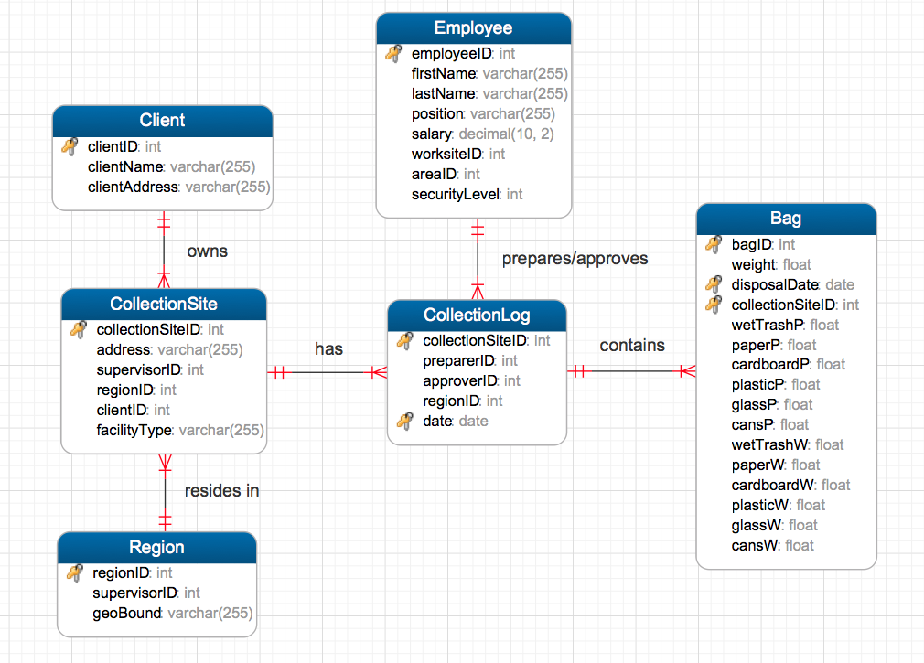

Class Diagram Overview:

The class diagram gives a description of the various components of our system. The class diagram also provides a basic model of the relationships between these components. The focal points of the diagram are the MoblieApplicationController and WebApplicationController classes, as they are the central classes for the Android Application and the Web application, respectively. Since data collection is a key component of the system, the SQLDatabaseManager and the AndroidDatabaseManager are two vital classes in the system. These two classes are responsible for inserting, updating, and removing elements from the two databases used in the system. As is demonstrated in the class diagram, the main database has a table for clients, employees, collection sites, regions, collection logs, and individual bags. The Android database is only responsible for maintaining a subset of this database, namely just the collection logs and bags that have not yet been uploaded from the device to the server. Each database entry also has a corresponding class in the diagram that encapsulates the data contained by that entry. For example, a database entry containing information for a particular field employee in the employee table can be represented by a FieldEmployee object in the class diagram. It is also important to note that some of the classes that correspond to database entries are also capable of displaying UI elements, such as forms, in order to get the user to populate some of the key attributes of the class. This can be seen in the CollectionLog class, which contains the createDataCollectionForm() and captureUserFormData() in order to get the site and a list of bags from the user.

The DataAggregator class is another major component of the system, as it is responsible for interacting with the central database in order to generate a report based on the input from the user.

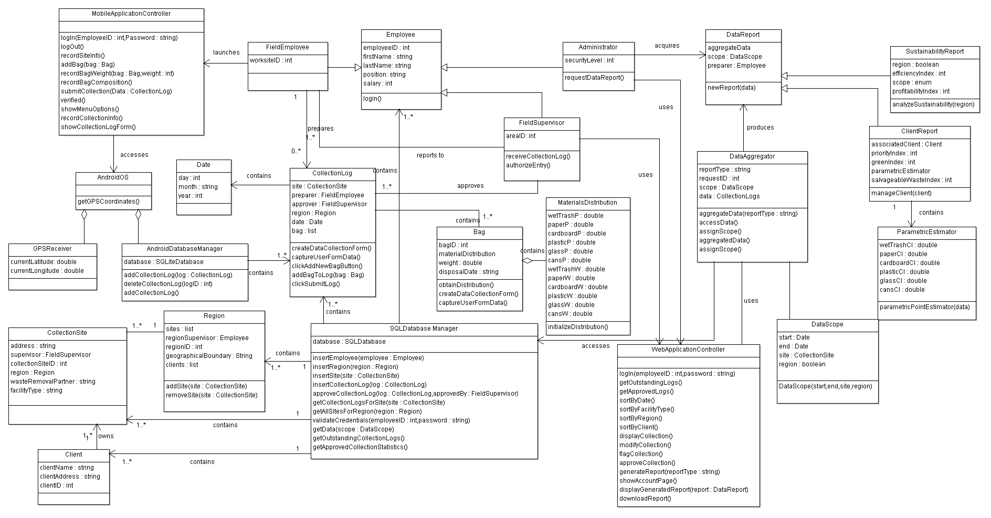

Sequence Diagram 1: Input Collection Log
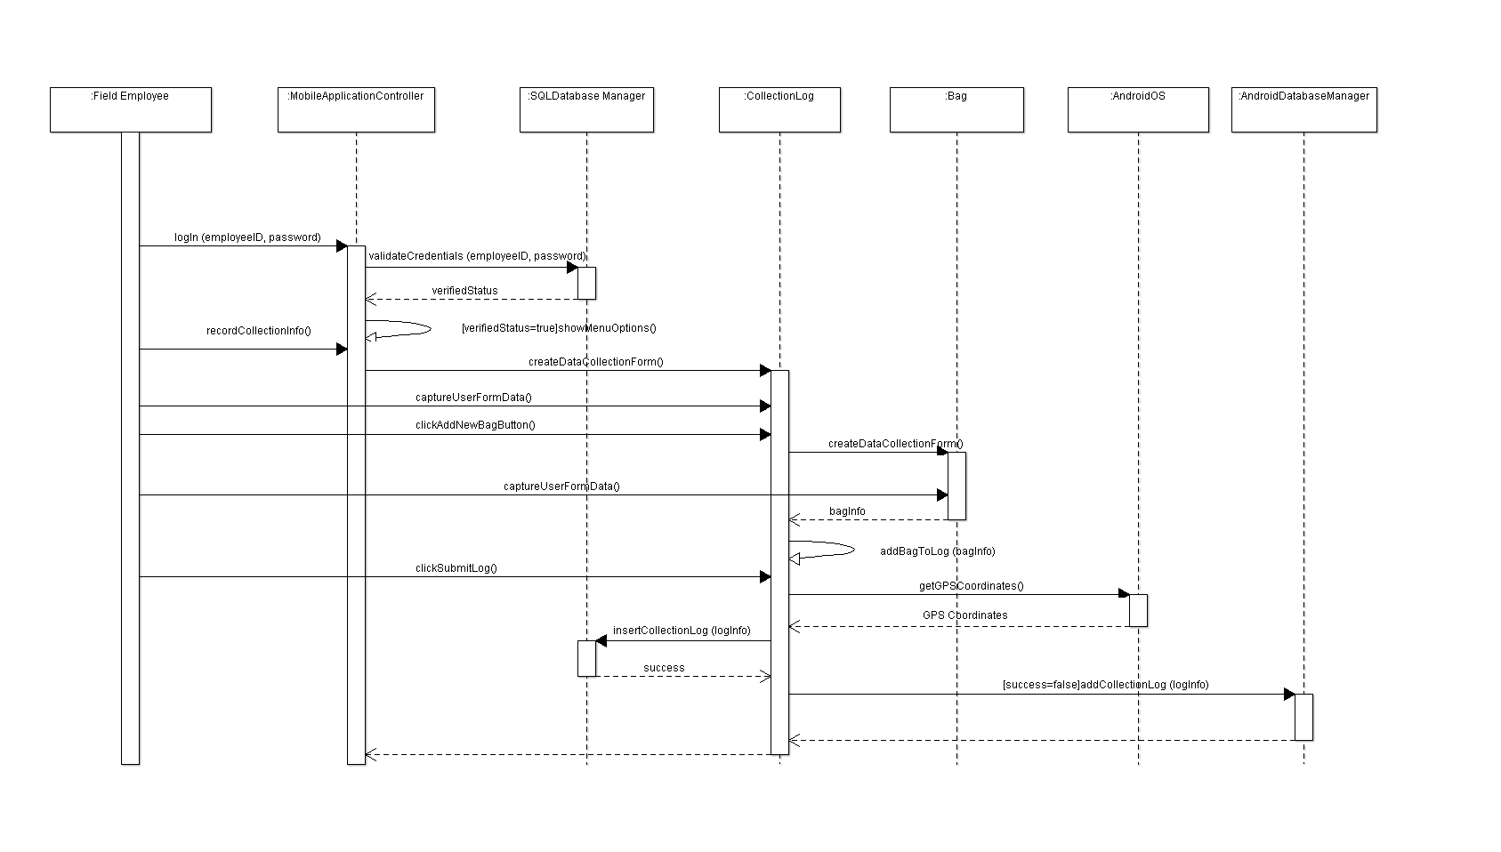

A field employee has a bag of waste that he wants to add to the collection log. The employee begins by logging into the mobile application. He then navigates the menus until he reaches the screens to input his new data. After inputting data, the application checks the employee’s current location using the Android phone’s GPS and tries to send this information along with the new data to the central database for storage over the internet. If this is not possible, the data is stored temporarily on the phone.

Sequence Diagram 2: Approve Collection Log
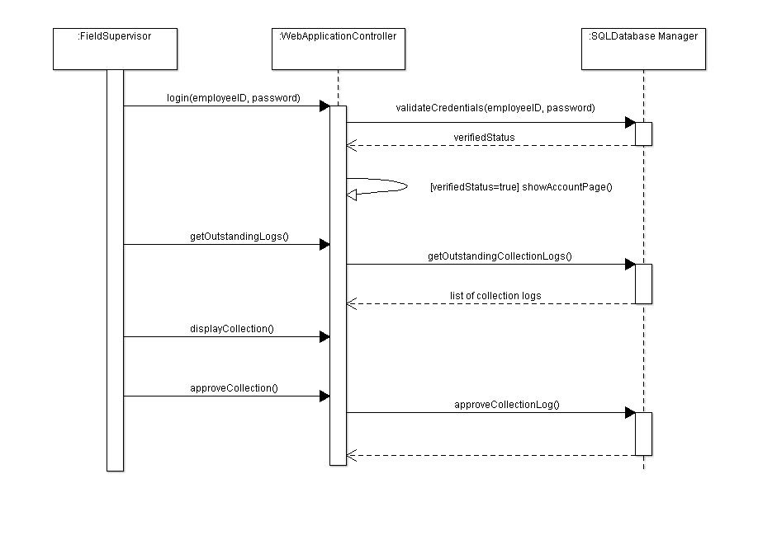

A field supervisor wants to look at outstanding collection logs to approve them. The supervisor first logs into the web application. From here, the supervisor can navigate the menus to display the current outstanding collection logs. The application retrieves the logs from the database. Finally, the supervisor can use the application to approve the collection logs after viewing them and update the database.

Sequence Diagram 3: Generate Administrative Data Report
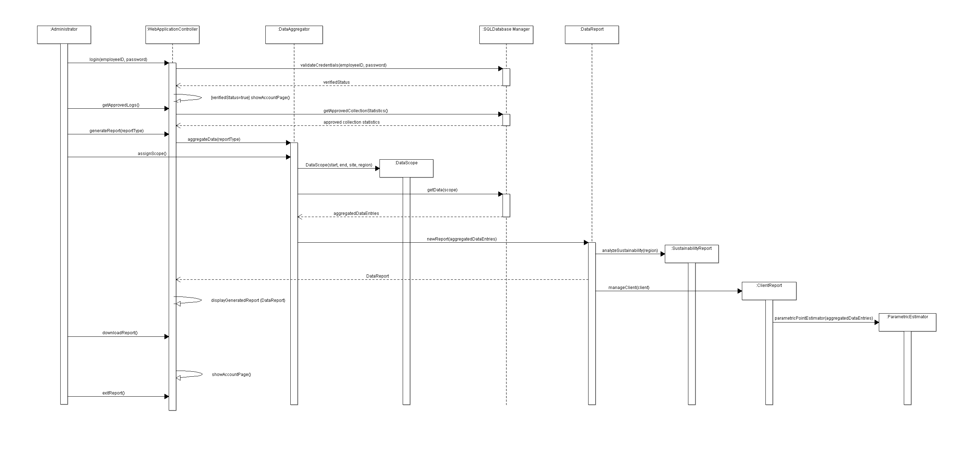
An administrator wishes to create a data report. The administrator logs into the web application using his/her credentials. Upon successful login, the web application allows the administrator to create a report or to view statistics within the browser. The administrator selects the option to create a data report and provides a specific site and an indication of whether he/she would like to include an associated region. The administrator is prompted to enter a scope. The report is prepared and the administrator may download and export the report.

Behavioral Model: State Diagram of MobileApplicationController Class

The MobileApplicationController class manages all of the operations performed by the mobile application. In particular, it manages the login, data collection, and data transmission procedures performed by the Android application.

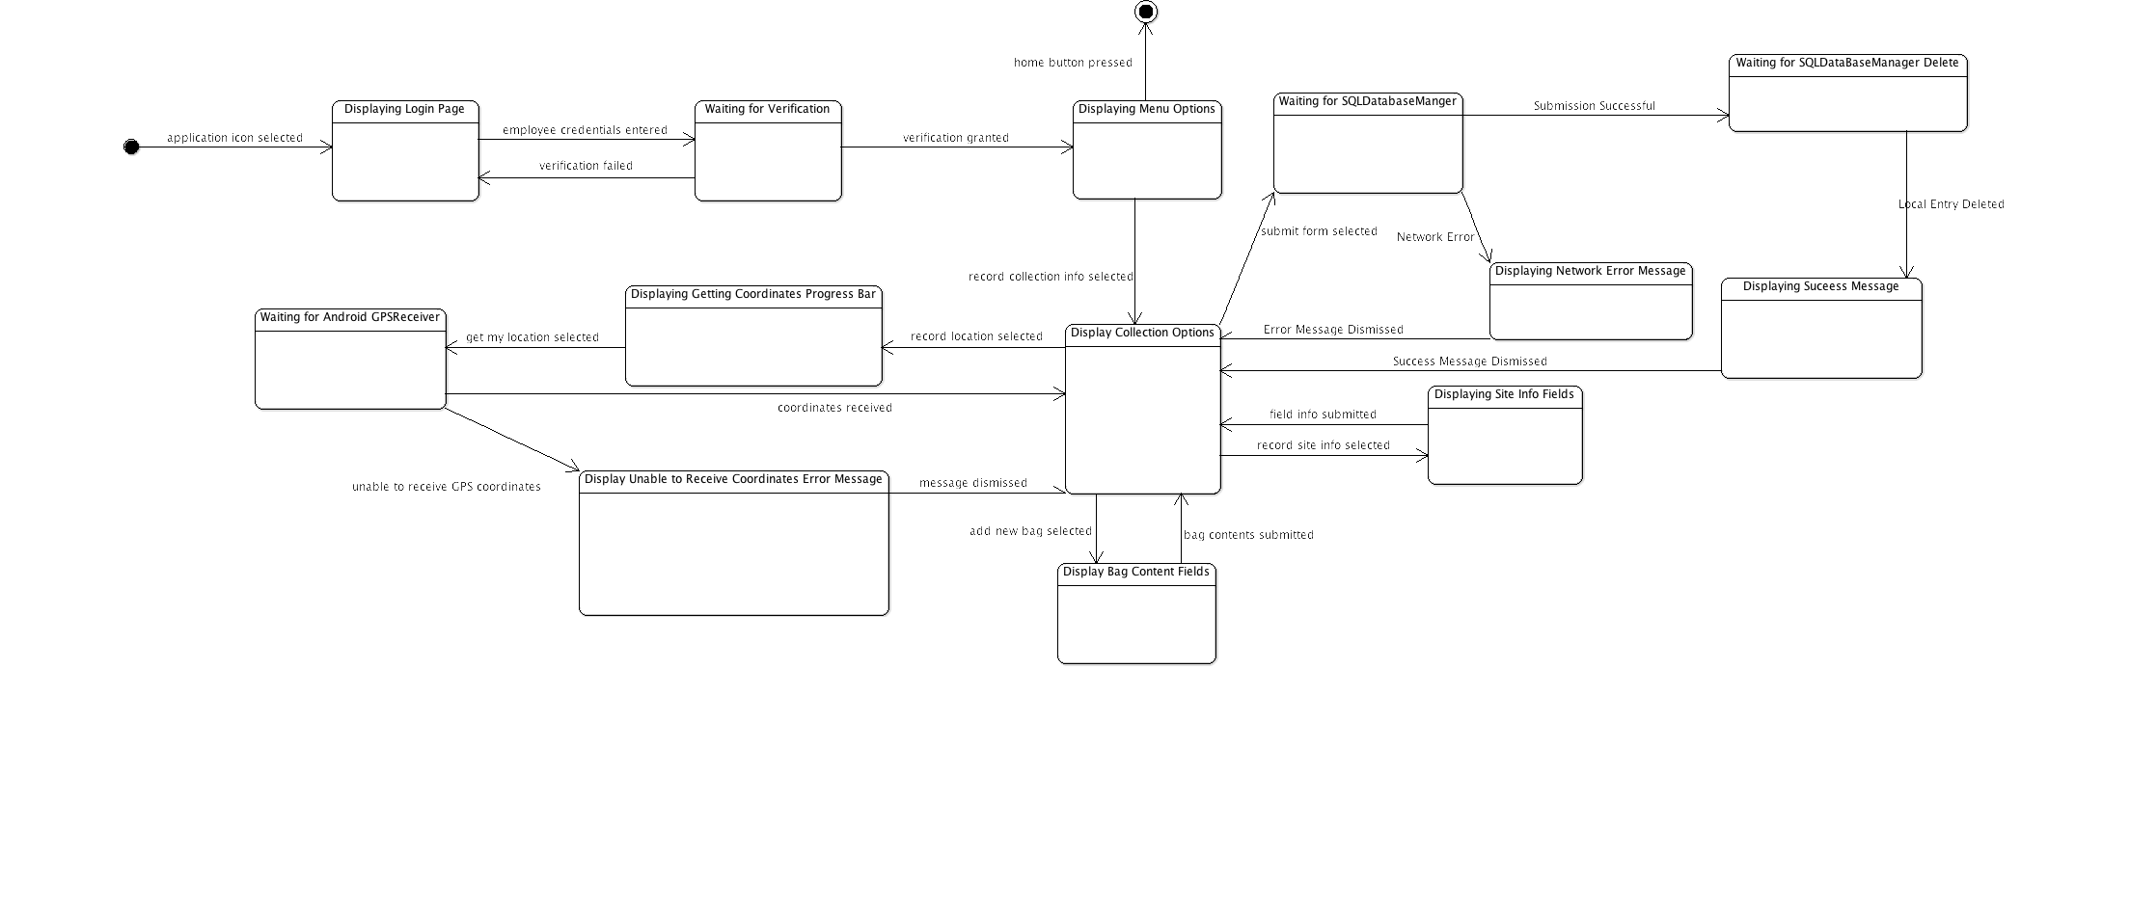

Behavioral Model: State Diagram of WebApplicationController Class

The WebApplicationController class manages all of the operations performed by the web application. In particular, it manages the login, collection approval, and report generation procedures performed by the web application.

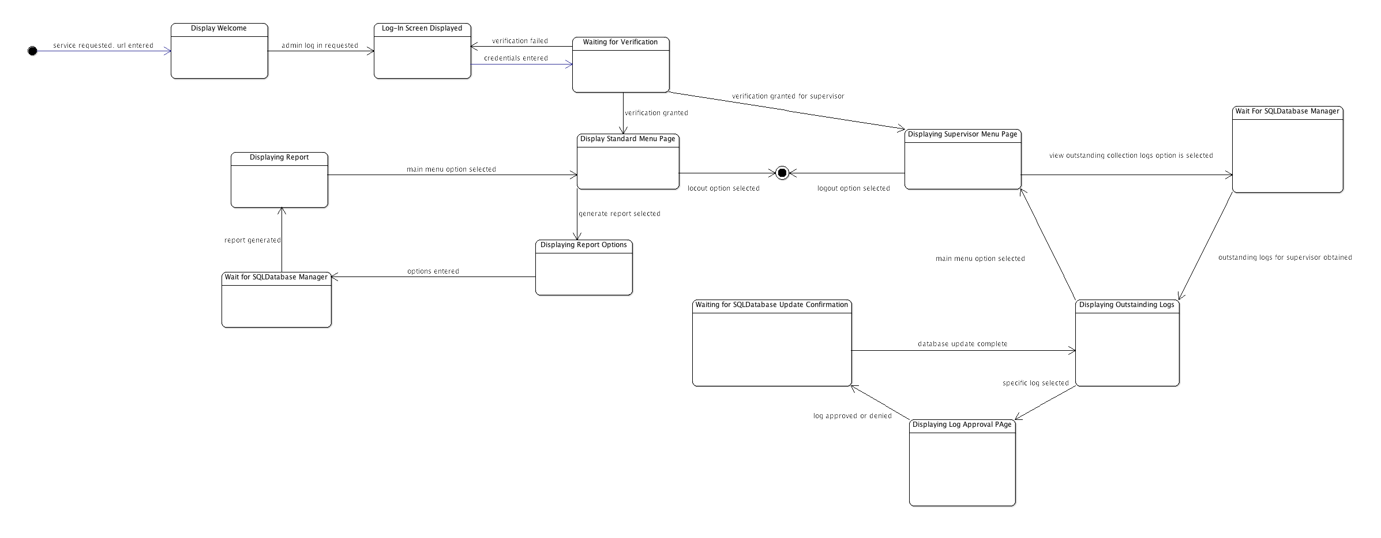

Cost Estimation and Project Management Description

Final Project Management Discussion (How long to build the software systems, how many resources, projected schedule, identification of unknowns and risks, total project cost)

Database Implementation: 3 months (1 database administrator, 1 software engineer)
5 Weeks of Database Administrator for setting up database
9 Weeks of Software Engineer designing/implementing API and testing
Android Application: 2 months (1 software engineer, 1 UI designer/developer)
3 Weeks UI designer/developer
7 Weeks of Software engineer
Web Application: 2 months (1 software engineer, 1 UI designer/developer)
5 Weeks for Web Designer
10 Weeks for software engineer

Software Engineer Median Salary: $69,131
Database Administrator Median Salary: $69,263
Web Designer and Developer Median Salary: $44,984
User Interface Designer Median Salary: $62,137
Cite PayScale.com

Costs:
Android phones for employees (not included in cost estimation)
Buying Dev Machines 6 x $750 (used Dell Inspiron 660 as a reference)

Buying Android phones for developers: 2 x $349.00 (Nexus 4 off contract) https://play.google.com/store/devices/details?id=nexus_4_16gb&feature=home-mt-0#?t=W251bGwsMSwyLDcwMywiZGV2aWNlLW5leHVzXzRfMTZnYiJd

Buying server hardware for database and web application: Server Computer $1,129
http://www.newegg.com/Product/Product.aspx?Item=N82E16859107066&nm_mc=KNC-GoogleAdwords&cm_mmc=KNC-GoogleAdwords-_-pla-_-Server%2fWorkstation+Systems-_-N82E16859107066&gclid=CKKY3JGr5LYCFUTd4Aod6TcApg

1 TB Hard Drive $220
https://www.serversupply.com/products/part_search/pid_find.asp?pid=127984&
Buying database software $17,500 for Oracle DB standard edition

Something Here about Total Lines of Code Estimate (From COCOMO?).

Prototype Description and Lessons Learned

SQL Database:

Here is a description of the prototype SQL Database.

Android Application:

Here is a description of the prototype Android application.

Web Application:

Here is a description of the prototype web application.

Risk Assessment and Lessons Learned:
Here is a discussion of the risks/problems discovered during the prototype process. This section shall include a thorough description of how much work went into the prototypes.

Here is an overall discussion of the software development process including SVN/group interaction.

One of the lessons learned should be how the prototype phase showed us that our initial estimates were a bit aggressive, deadlines were expanded as a result.

Appendix

- Section 1: Cost Estimation Models
  - Figure 1.1. Data Estimates Table
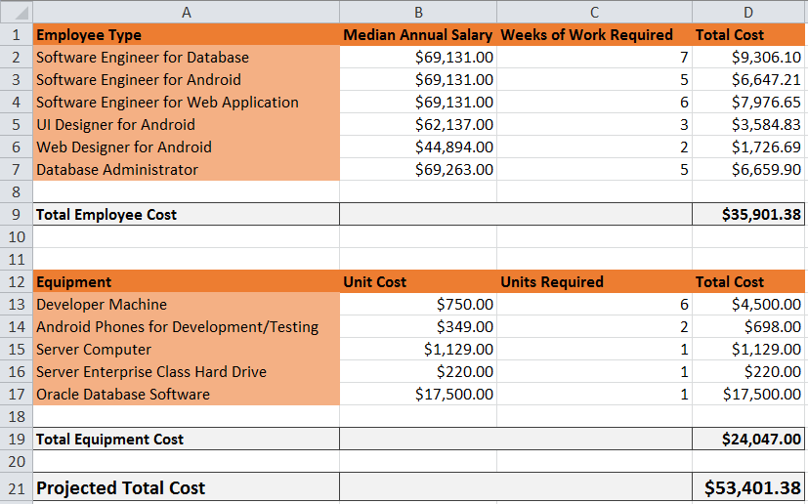
  - Figure 1.2. COCOMO Model

- Section 2: Prototypes and Mockups
  - Section 2.1. Android Application
    - Figure 2.1.1. Login Screen
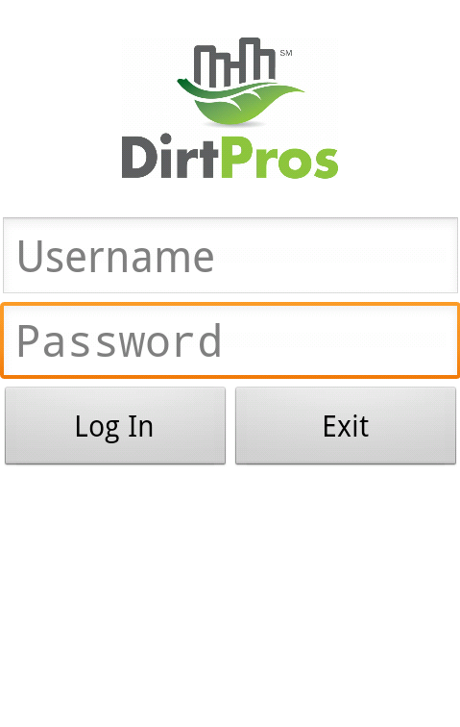
    - Figure 2.1.2. Main Menu Screen
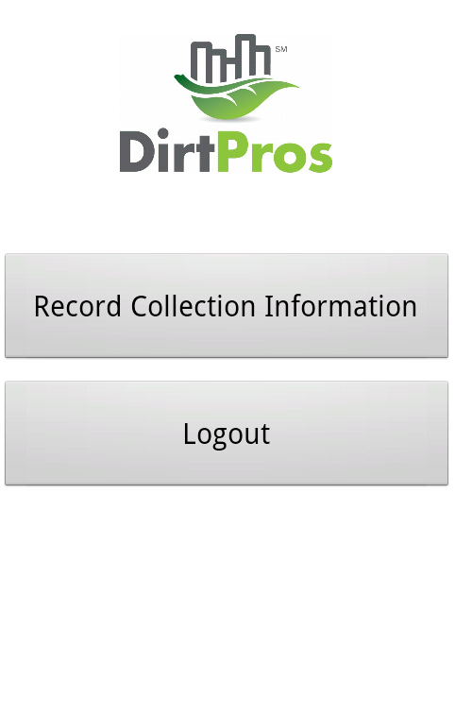

    - Figure 2.1.3. Record Collection Log Screen
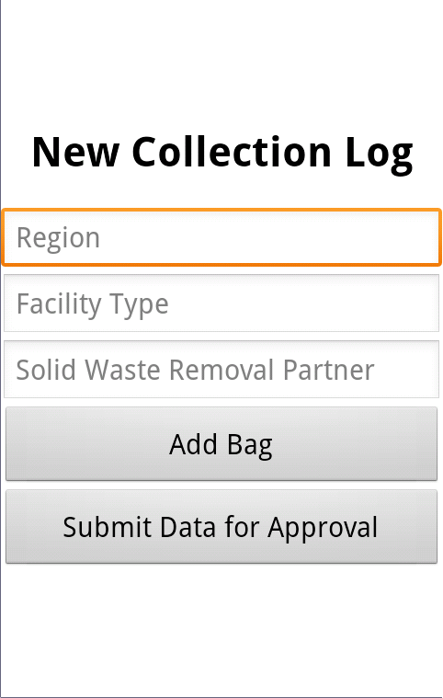

    - Figure 2.1.4. Add New Bag Screen 1
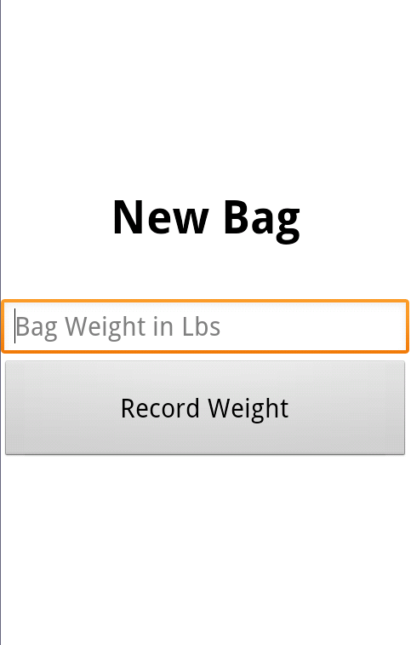

    - Figure 2.1.5. Add New Bag Screen 2
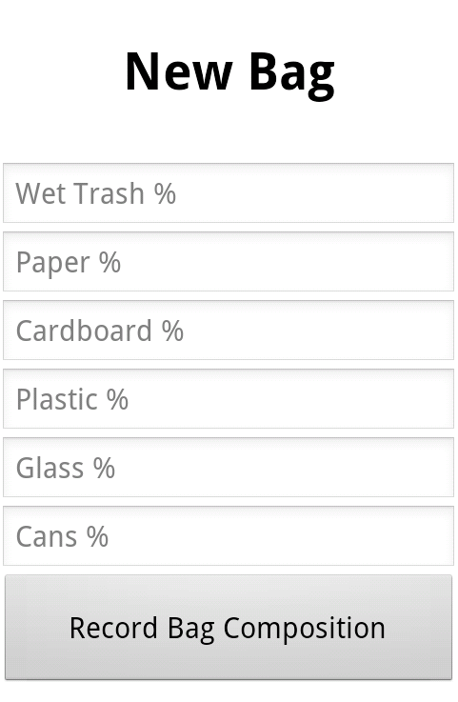
    - Figure 2.1.6. Submission Confirmation Screen
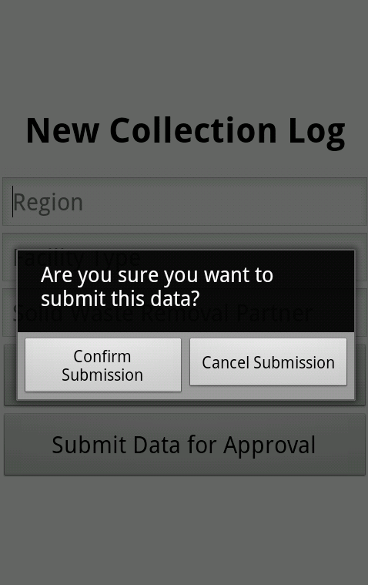

  - Section 2.2. SQL Database
    - Figure 2.2.1. Collection Log DB View

  - Section 2.3. Web Application
    - Figure 2.3.1. User Log-In Page

    - Figure 2.3.2. User Menu Page

    - Figure 2.3.3. Display Collection Logs Example

- Section 3: Additional Information
  - Section 3.1. Presentation Materials
    - Link 3.1.1 Link to PREZI Final Presentation http://prezi.com/uphi4ln7i5tk/dirtpros-final-presentation/?kw=view-uphi4ln7i5tk&rc=ref-38698447

