
Department of
Computer Science

DirtPros: Data Collection and Management System
Alejandro Fernandez
Christian Gonzalez
Alexis Guerra
Adamm Hockman

CSC531 Software Engineering
Software Design Projects
Spring 2013
May 2013

Table of Contents
Table of Contents 2
Executive Summary 3
1. Problem Statement 4
a. Scenario 1: Employee collects recyclable materials at facility 5
b. Scenario 2: Supervisor approves data collection log on web application 6
c. Scenario 3: Administrator accesses information on web application and generates a report. 7
2. System Diagram 8
3. Analysis: Use Case Diagram 10
a. Use Case Template 1: Submit On Site Form 10
b. Use Case Template 2: Approving a Form 10
c. Use Case Template 3: Accessing Aggregate Data 11
4. Structural and Functional Design: Class Diagram and Sequence Models 13
Sequence Diagram 1: Add the Sequence Diagram Title 13
Sequence Diagram 2: Add the Sequence Diagram Title 13
Sequence Diagram 3: Add the Sequence Diagram Title 13
5. Behavioral Model: State Diagram of XXXX Class 14
6. Cost Estimation and Project Management Description 15
7. Prototype Description and Lessons Learned 16

Executive Summary

Insert a 250 word or less introduction to your project. Please use block justification.

Problem Statement
DirtPros is a company that is responsible for the collection, sorting, and processing of recycled material. Currently, the information from the various work sites regarding the recyclable materials is obtained by an employee that is on site using a paper form. At the end of the day, all the forms that were filled out at the work site must be faxed to a central location, where an employee at the other end is responsible for manually inserting this information into an excel spreadsheet. This method of gathering data has become difficult to sustain as the company has grown and is susceptible to mistakes during the translation from the paper form to the excel spreadsheet. The goal of this project is to create a mobile application for the Android operating system that will replace the paper forms that are currently used at the worksite. In addition to creating a mobile application, DirtPros would like to move away from using an Excel spreadsheet as their primary means of data storage. As a result, the project will involve integrating the Android application with a database, since it provides more scalability compared to the spreadsheet approach currently being used. A web application is also to be developed that would allow DirtPros employees to view the data from the database from a web browser.

The mobile component of this project will involve the creation of an Android application. The Android application must be able to gather all the information that is currently stored on the paper forms. In addition to receiving form data from the user, the application must also obtain the location of the employee using the phone’s GPS capabilities as soon as the user presses the submit button on the form. When the employee finishes entering all the information for a particular set of recycled materials, the information must be sent to the central database, along with the credentials of the employee that filled out the form. The application is responsible for storing the form data entered by the employee on the device’s local storage until it receives confirmation that the information has been uploaded to the database. In the event that the employee is in an area that there is limited network connectivity, the application must keep the form data on the device and must attempt to upload the information when a network connection is available via Wi-Fi or from the wireless phone provider.

The web application will also be able to communicate with the database. The web application will allow administrators and managers to directly make changes to the database, assuming they have the correct credentials for these operations. Managers will also be able to approve or deny new data collection logs received from the worksite within the web application. The web application will also be capable of creating sustainability reports for a client based on the information in the database. This includes the generation of tables and graphs on demand.

The database component of the project will consist of a SQL server. The web and Android applications will then be able to update and view content from the database using a set of API calls that will be implemented as part of the project. These API calls will ensure the security of sensitive information, as users must be authenticated before any changes or reads are made to the database. The database must be scalable to accommodate the growth of both the company and the amount of data being gathered from the various job sites. The database must also provide a mechanism for managers to approve new collection information, before the data is used for the generation of reports for clients.

The implementation of this project will now be given in detail and time estimates are listed based on the assumption that a small to medium sized fulltime software development team will be used for the implementation of the project. The database component of the application is expected to take 3 months to implement. It is expected to take about 2 weeks for the purchase of server hardware and the installation of database management software. The next 3 weeks would involve the development and implementation of the database schema for the company. The final part of the database component involves the creation of an API to authenticate users and to allow the web and Android application to access and make changes to the database. The API is expected to take no more than 7 weeks to design, implement, and test. The Android application is expected to take 2 months to implement. The design of a consistent user interface for form data collection is expected to take 3 weeks. It is expected that the business logic to verify this form data and store it on the device will take 2 weeks to implement. The networking aspect of the Android application, which involves authenticating the user and sending form information to the server using the API is expected to take another 2 weeks. The remaining week is left for testing and bug fixing. The web component is also expected to take 2 months to implement. The creation of a clean user interface for managers and administers to view and modify the contents of the database is expected to take 2 weeks. The implementation of the sustainability report generator is expected to take 3 weeks. It is expected that 2 weeks will be spent on using the API to allow the web application to effectively communicate with the database server. The final week is left for testing and debugging the web application.

The goal of this project is to offer a solution that is easy to adopt and saves time and resources for DirtPros. The user interface of the Android application must be intuitive for the employees. It should take the average employee no more time to fill out a form electronically using the Android application than it would if they filled out a paper form. The web application must also be capable of producing sustainability reports that are of equal or greater quality than those generated from the Excel spreadsheet approach currently in use.

Scenario 1: Employee collects recyclable materials at facility

- Employee arrives at collection location.
- Employee launches Android application to insert collection data.
- The application launches and prompts the employee for his/her login information.
- The employee enters his/her login credentials and waits for the application’s confirmation.
- The application evaluates the entered information, checking it with the employee’s stored information in the company database, and provides the employee with a set of options on the screen (Record Collection Information, Logout).
- The employee selects the Record Collection Information option and waits for the application’s response.
- The application prompts the user for the region, facility type, and solid waste removal partner associated with the collection location.
- The employee enters the required information and waits for the application’s response.
- The application records the information and then provides the employee with a set of options on the screen (Add Bag, Submit Data for Approval).
- The employee selects the Add Bag option and waits for the application’s response.
- The application then asks the employee to enter the composition of the bag (paper, cardboard, plastic, glass, cans) in percentages, presenting a number of text fields to enter the information as well as button labeled Record Bag Composition.
- The employee enters the bag composition, presses the Record Bag Composition button, and waits for the application’s response.
- The application records the data and returns to screen presenting the options (Add Bag, Submit Data for Approval).
- The employee selects the Submit Data for Approval option and waits for the application’s response.
- The application asks the employee to confirm the submission of the data presenting a set of option (Confirm Submission, Cancel Submission).
- The employee selects the Confirm Submission option and waits for the application’s response.
- The application uses the device’s GPS capabilities to record the device’s current location together with the time of submission. It then attempts to connect to the company database and transmit the information for all of the bags entered together with the device’s recorded location and additional administrative information provided by the user beforehand.
- If the application is able to establish a steady connection to the company database, it proceeds to transmit all of the necessary information associated with the collected materials and returns to the screen presenting the set of options (Record Collection Information, Logout) ending the transaction.

Scenario 2: Supervisor approves data collection log on web application

- Supervisor accesses the web application site.
- The application launches and prompts the supervisor for his/her login information.
- The supervisor enters his/her login credentials and waits for the application’s confirmation.
- The application evaluates the entered information, checking it with the supervisor’s stored information in the company database, and provides the supervisor with a set of options on the screen (View Outstanding Collection Logs, View Approved Collection Statistics, Logout).
- The supervisor selects the View Outstanding Collection Logs option and waits for the application’s response.
- The application then displays a new page with a list of the outstanding collections logs assigned to the supervisor that have not been approved, giving the supervisor the option to view each individual collection log as well as a set of view options for the logs (Sort by Date, Sort by Employee, Sort by Facility, Sort by Facility Type, Sort by Region, Sort by Solid Waste Removal Partner).
- The supervisor selects the view option for the first available collection log and waits for the application’s response.
- The application displays a new page with the data submitted for the selected location. This includes a list of numbered bags with their respective estimated material compositions as well as the time and location where the data submission took place. There is also a set of options available as actions on the data (Modify, Approve, Flag).
- The supervisor analyzes the data for the collection log, selects the Approve option, and waits for the application’s response.
- The application records the supervisor’s selection and marks the collection log as approved. It then proceeds to switch back to the page with the remaining outstanding collection logs.

Scenario 3: Administrator accesses information on web application and generates a report.

- Administrator accesses the web application site.
- The application launches and prompts the administrator for his/her login information.
- The administrator enters his/her login credentials and waits for the application’s confirmation.
- The application evaluates the entered information, checking it with the administrator’s stored information in the company database, and provides the administrator with a set of options on the screen (View Outstanding Collection Logs, View Approved Collection Statistics, Logout).
- The administrator selects the View Approved Collection Statistics option and waits for the application’s response.
- The application displays a new page with a list of sorted dates (most recent to furthest), each with a link to the data that corresponds to that day.
- The user selects the first date listed and waits for the application’s response.
- The application records the administrator’s selection and displays a new page that displays the collection logs for the date chosen, giving the administrator the

System Diagram

Figure 1. System Diagram
Our project consists of three components that ultimately communicate with one another. Our Android application is used by field employees to submit data. This application connects to three systems: a GPS satellite to obtain the employee’s current coordinates, a cell tower, and a router providing internet access. The latter two systems allow our Android application to connect with our central database where new data can be stored and sent out. In addition to the Android application, the database can be accessed using a web-based application that uses a computer’s internet browser. This web application can be used by supervisors to confirm data that has been sent by field employees and by administrators to view all the data in the database.
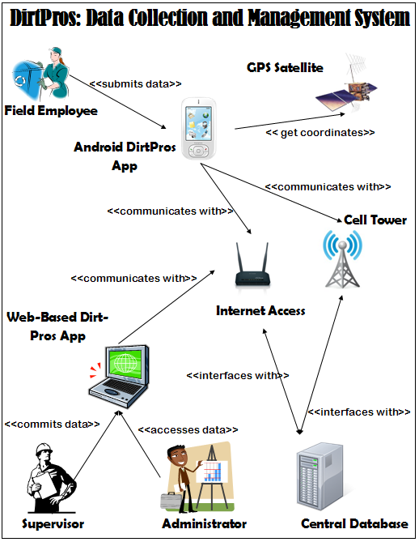

Analysis: Use Case Diagram

Figure 2. Use Case Diagram

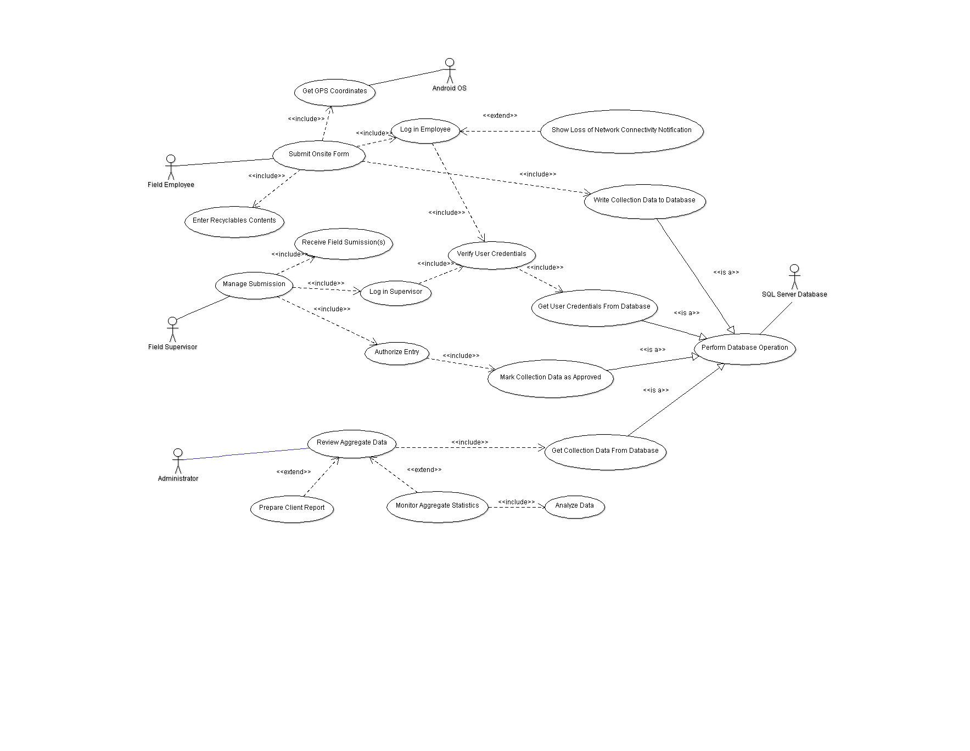

Use Case Template 1: Submit On Site Form

Use Case: OnSiteFormSubmission

Actors: Initiated by FieldEmployee
Communicates with SQL Server Database
Communicates with FieldSupervisor

Preconditions: An on-site employee has access to his/her Android OS mobile device and is prepared to submit an on-site form.

Descriptions: 1. The FieldEmployee logins into the DirtPros On-Site Management application from his/her Android OS device.

2. The FieldEmployee submits the contents of each bag via the application interface.

3. The FieldEmployee finishes his/her submission and submits it for approval.

4. The form is then stored in a temporary database to await approval from the corresponding FieldSupervisor.

Exceptions: If internet connectivity is lost, then the form is stored locally until it is able to send via network.

Postconditions: The FieldSupervisor has submitted all of his/her bags’ contents for the site and the forms are now waiting for approval from the FieldSupervisor.

Use Case Template 2: Approving a Form

Use Case: FormApproval

Actors: Initiated by FieldSupervisor
Communicates with FieldEmployee
Communicates with SQL Server Database

Preconditions: Field employee(s) has submitted on-site form(s) and the forms are waiting for approval from field supervisor.

Descriptions: 1. The FieldSupervisor logs into the web-based application using a supported browser.

2. The FieldSupervisor is then prompted to review each form awaiting approval.

3. The FieldSupervisor selects approve/deny for each form, upon which the form is either submitted to the central database to be aggregated, or opened up for editing.

4. The FieldSupervisor logs out of the web application.

Exceptions: If a supervisor denies a form for approval then he/she may select the option to edit the form his/herself or request additional information from the FieldEmployee who submitted it.

Postconditions: All forms awaiting approval have been processed by the FieldSupervisor and are now aggregated in the central database.

Use Case Template 3: Accessing Aggregate Data

Use Case: AccessAggregateData

Actors: Initiated by Administrator
Communicates with SQL Server Database

Preconditions: An administrator needs to access aggregate data from database in a concise and efficient manner.

Descriptions: 1. An Administrator logs into the web-based application using an appropriate browser.

2. The Administrator is then given the option of monitoring the raw aggregated data in the database or of preparing an executive report based on custom configurations.

3. The Administrator prepares the report using custom defined statistical measures as well as presentation preferences and downloads a copy of the report to the local machine.

4. The Administrator logs out of the application and the aggregate data is unaffected.

Exceptions: If the Administrator requests options that are not available, additional protocols are implemented to resolve the inconsistency.

Postconditions: The data in the database is maintained and unaltered by the viewing of an Administrator.

Structural and Functional Design: Class Diagram and Sequence Models

Insert an overview of your classes and add your class diagram. Below add your sequence diagram with a brief description.

Sequence Diagram 1: Add the Sequence Diagram Title

Sequence Diagram 2: Add the Sequence Diagram Title

Sequence Diagram 3: Add the Sequence Diagram Title

Behavioral Model: State Diagram of XXXX Class

Insert an overview of your control class and add your state diagram.

Cost Estimation and Project Management Description

Insert details from your cost estimation analysis. Might want to cut-and-paste COCOMO model into the appendix

Prototype Description and Lessons Learned

Describe your mock-up and prototype activities. Discuss risks and problems that were uncovered. Describe how much effort was put into the prototype. More details on final project worksheet for this section.

