SHARE-RECIPROCATE GAME (w/ -1.5 to 1.5)

No stealth or mutation:

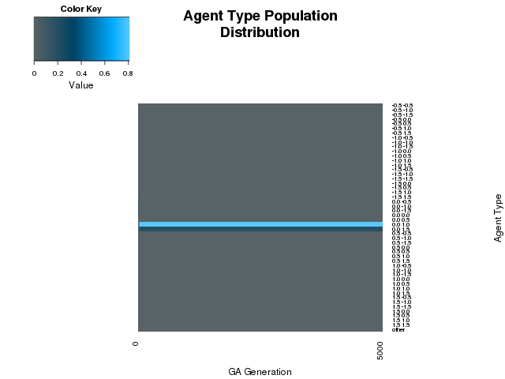

Varying mutation rate (w/ no stealth):

Rate = .25
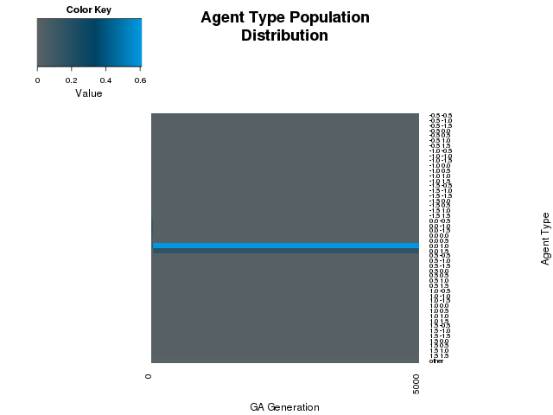

Rate = .5

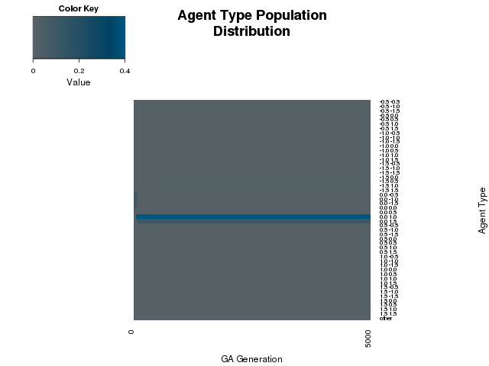

Varying stealth (w/ no mutation):

ProbBackTurned = .05

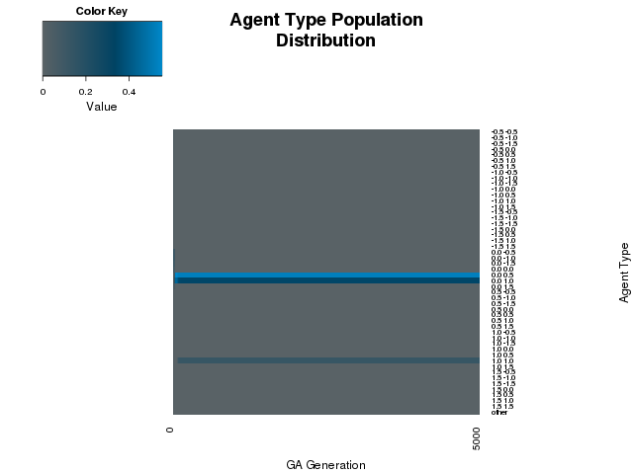

ProbBackTurned = .1

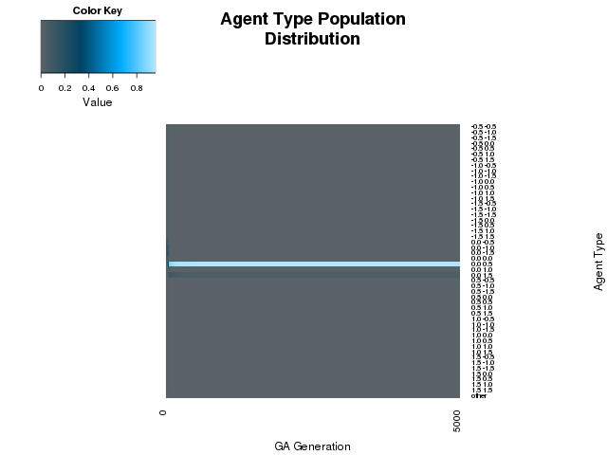

ProbBackTurned = .15

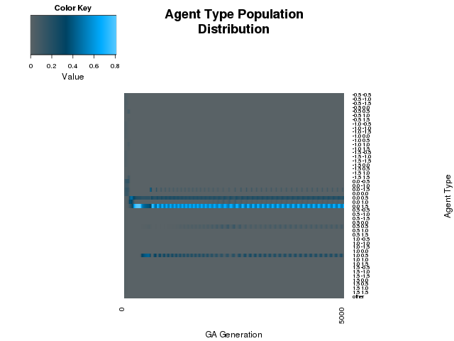

ProbBackTurned = .2

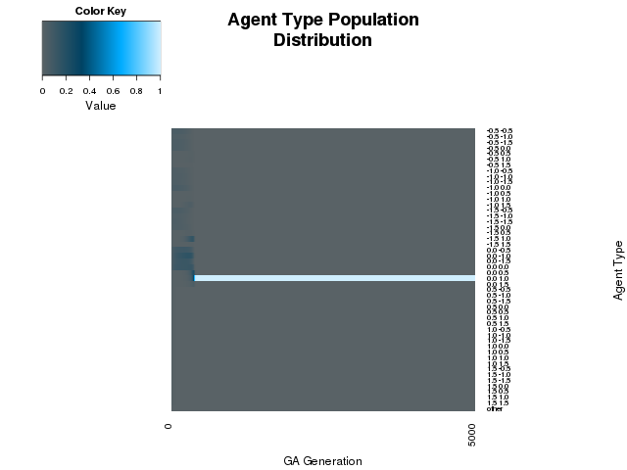
ProbBackTurned = .25

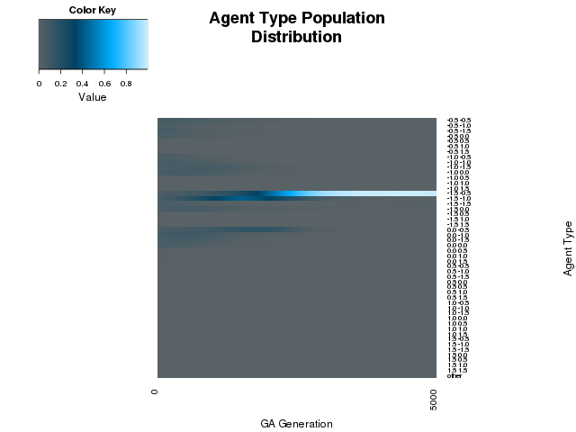
ProbBackTurned = .5

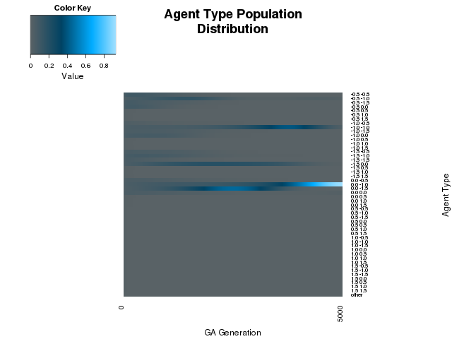

SHARE-RECIPROCATE GAME (w/ -1.5 to 2.0)

No stealth or mutation:

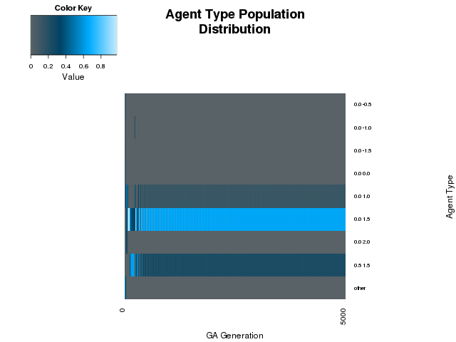
Varying mutation (w/ no stealth):

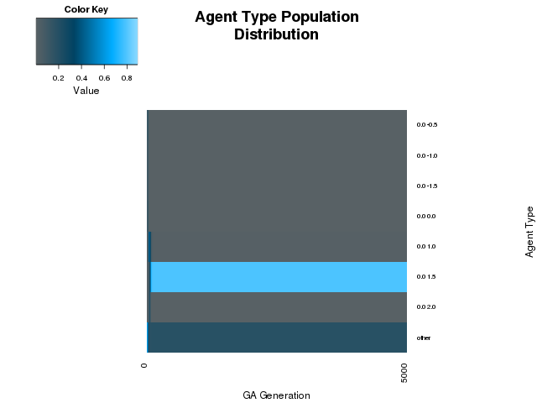
Rate = .2

Varying stealth (w/ no mutation):

ProbBackTurned = .2

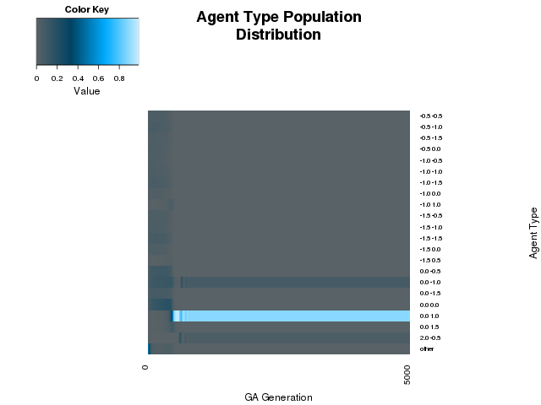

STEAL-PUNISH GAME (w/ -1.5 to 2.0)

No stealth or mutation:

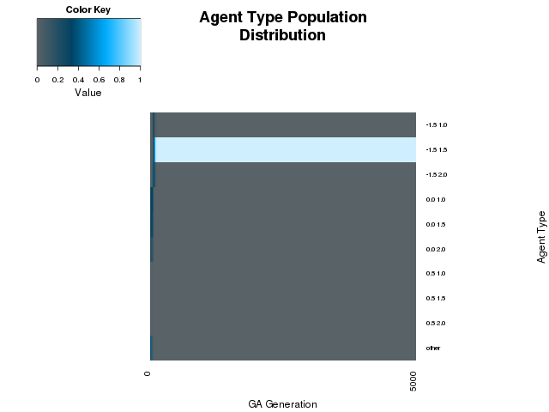
Varying mutation rate (w/ no stealth):

Rate = .05

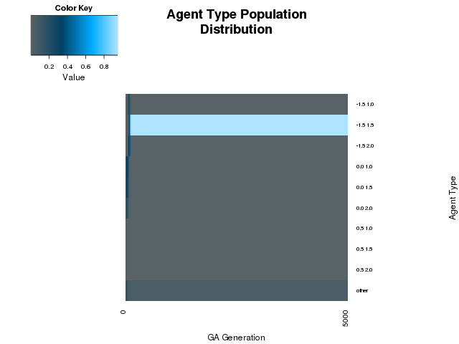

Rate = .1

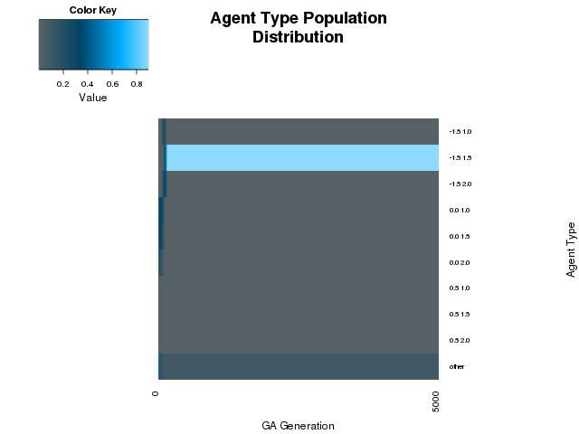
Rate = .15

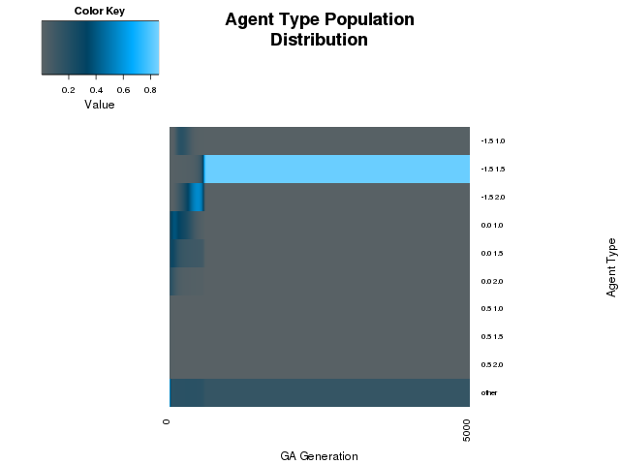

Rate = .2 ***

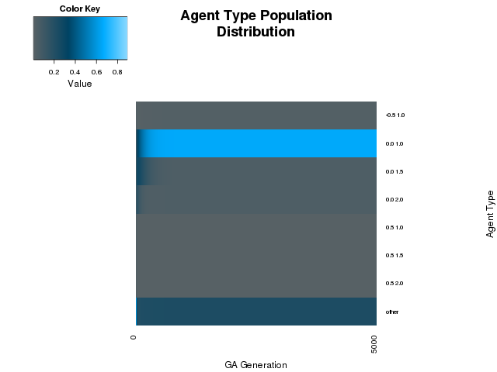
Rate = .25

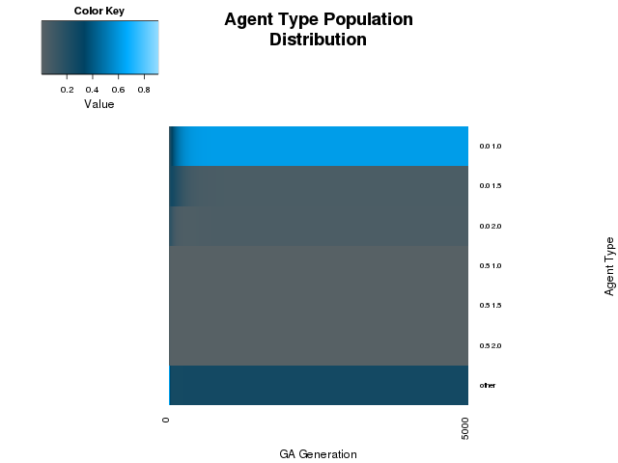

Rate = .3

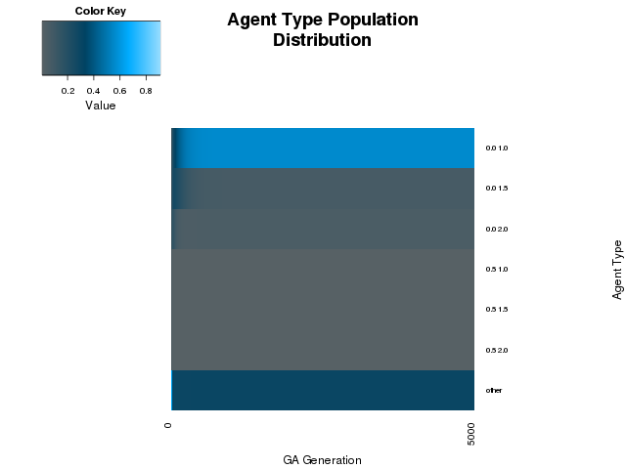
Rate = .4

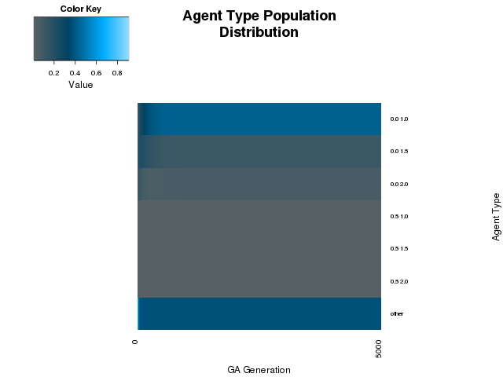
Varying stealth (w/ no mutation):

ProbBackTurned = .05

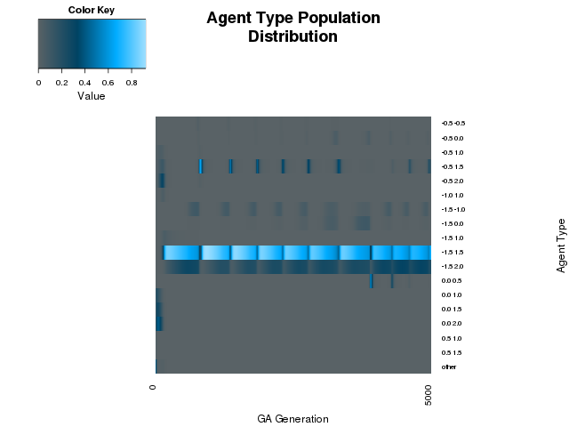

ProbBackTurned = .1

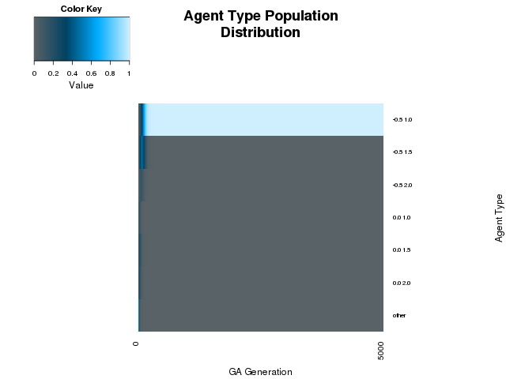

ProbBackTurned = .15

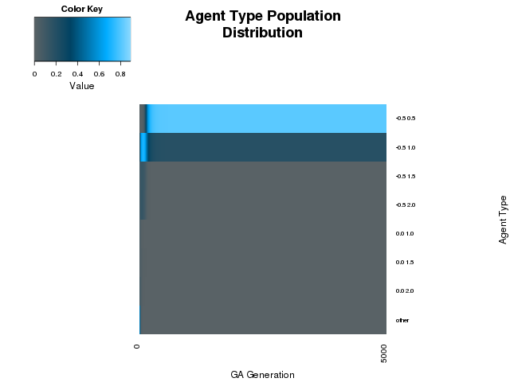
ProbBackTurned = .2 ***

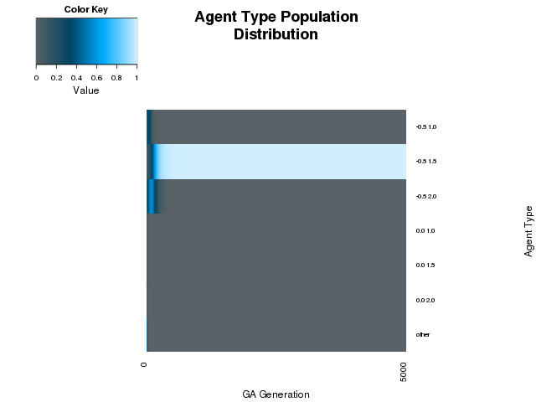
ProbBackTurned = .25

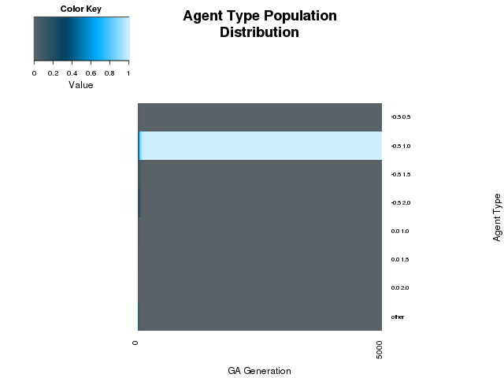
ProbBackTurned = .3

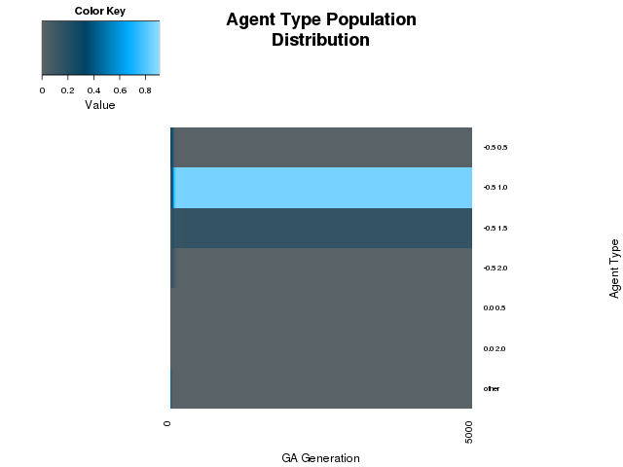

ProbBackTurned = .4

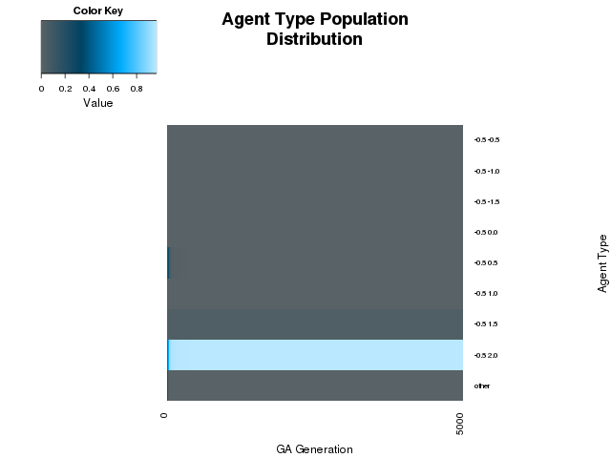

ProbBackTurned = .5

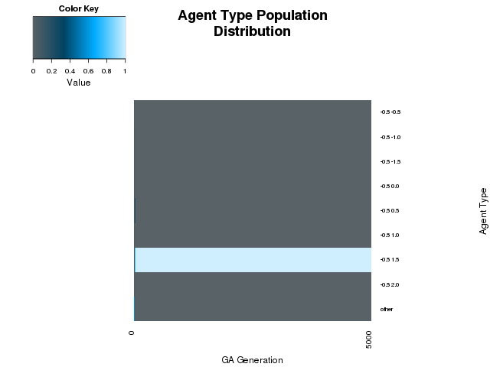

STEAL-PUNISH GAME (w/ -2.0 to 2.0)

No stealth or mutation:

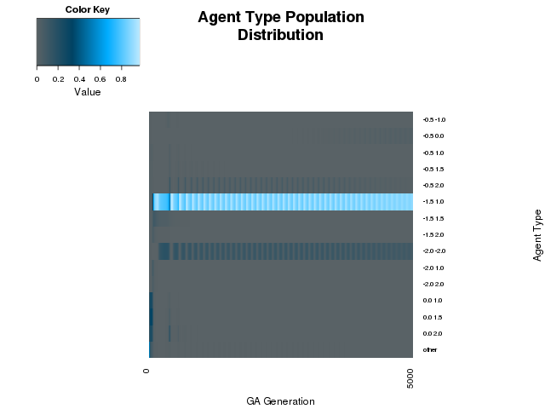
Varying mutation rate (w/ no stealth):

Rate = .2

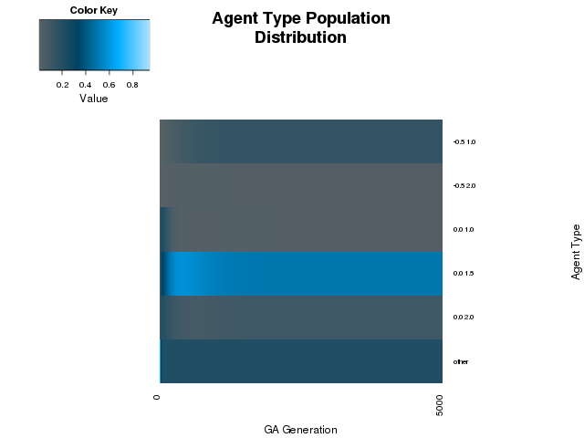

Varying stealth (w/ no mutation):

ProbBackTurned = .2

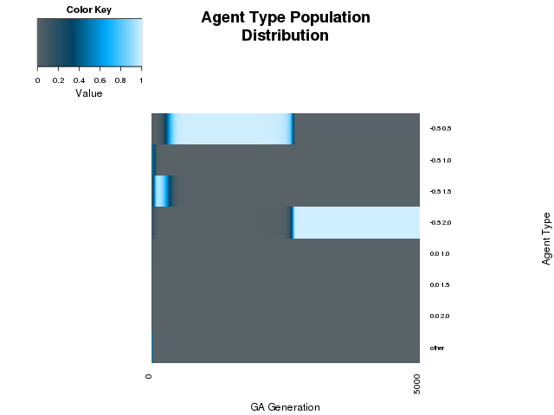

STEAL-PUNISH GAME (w/ -1.5 to 2.5)

No stealth or mutation:

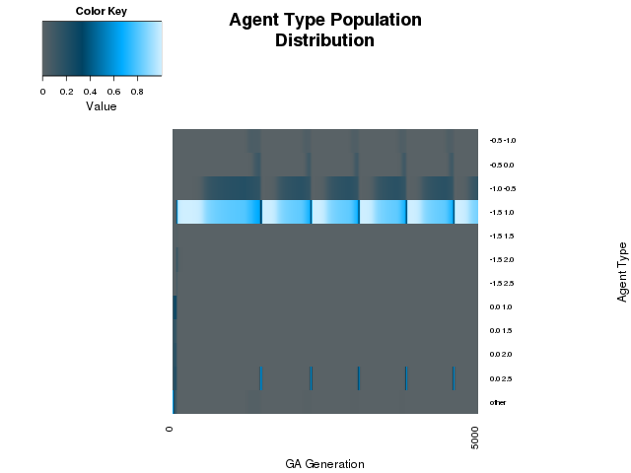
Varying mutation (w/ no stealth):

Rate = .2

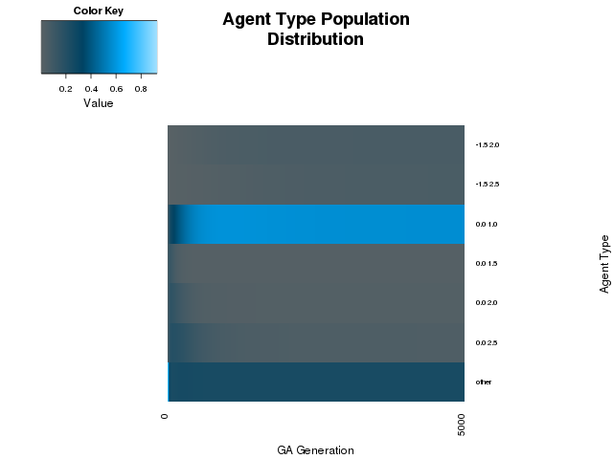

Varying stealth (w/ no mutation):

ProbBackTurned = .2

