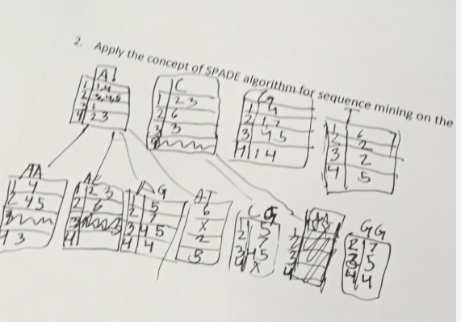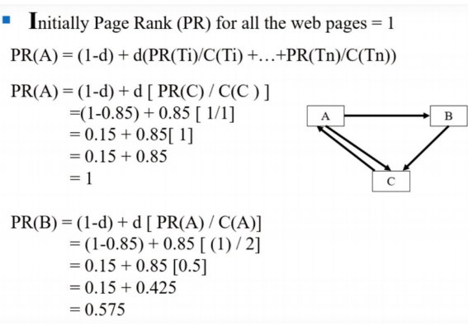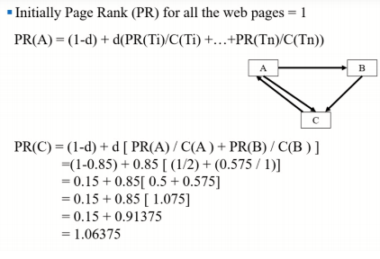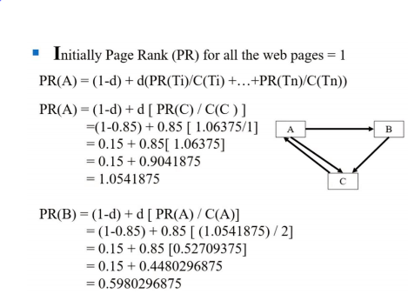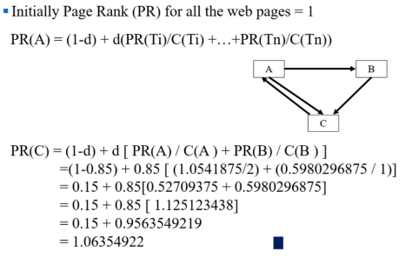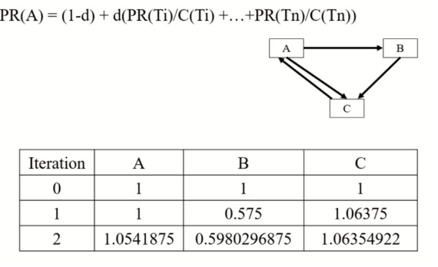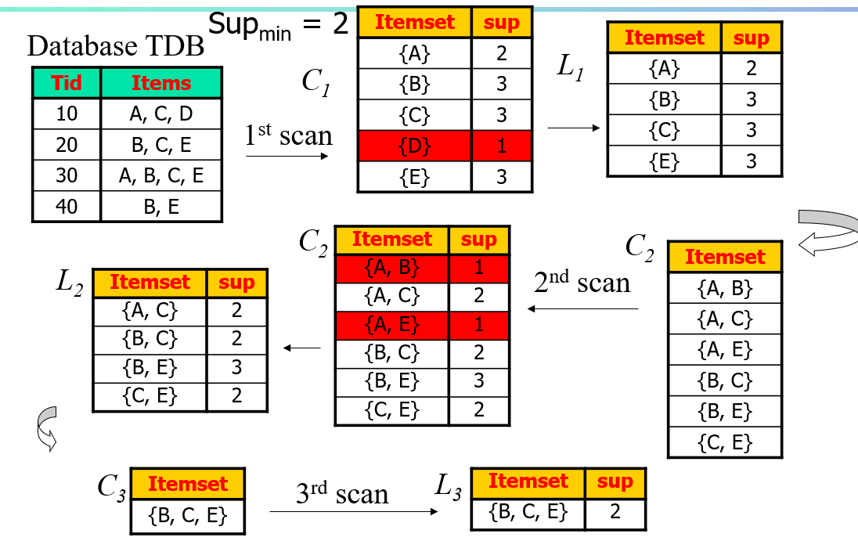

Enterprise-wide data warehouses;

They are huge projects requiring massive investment of time and resources.

Virtual data warehouses;

They provide views of operational databases that are materialized for efficient access.

Logical Data Warehouses;

Use data federation, distribution and virtualization techniques

Data marts;

These are generally targeted to a subset of organization, such as a department, and are more tightly focused.