Time frames

- Definition
  - A time frame (TF) is the bar interval on which you measure features, label regimes, and bind a policy. Each TF has its own regime because behavior is scale-dependent.

- Hierarchy (L0 → L4)
  - L0 — Cycle (Monthly or Quarterly)
    - Purpose: long-horizon backdrop, “build or harvest”.
    - Typical inputs: 24–48 month MAs or 200-week slope, drawdown from ATH, 6–12M realized vol percentile, broad breadth proxies.
    - Decisions: net exposure caps, max leverage, pyramiding allowed or not, rebalance cadence.
    - Persistence: very slow, require 2 monthly closes to flip.
    - Data requirement: ≥ 60 monthly bars (≈ 5 years). If less, skip L0.

  - L1 — Macro (Weekly)
    - Purpose: primary trend and volatility lane.
    - Inputs: weekly EMA stack (20/50/200), ADX(14w), weekly ATR% percentile, liquidity stress vs 26w medians.
    - Decisions: base position size, stop multiple on daily risk, setup whitelist (trend vs mean-revert).
    - Persistence: slow, require 2 weekly closes or ADX persistence.
    - Data requirement: ≥ 100 weekly bars ideal; 52–100 use reduced features; < 52 collapse into Daily macro-lite.

  - L2 — Meso (Daily)
    - Purpose: choose the playbook inside the weekly lane.
    - Inputs: 20/50/100D EMAs, HH/HL structure, Bollinger width percentile, daily ATR% percentile.
    - Decisions: breakout vs pullback vs range fade, target style (trail vs structure), frequency cap, stacking rules.
    - Persistence: moderate, confirm with 2 daily closes.
    - Data requirement: ≥ 250 daily bars ideal; 120–250 use trimmed features; < 120 run simplified rules.

  - L3 — Micro (4H/1H)
    - Purpose: find the moment, assess local context.
    - Inputs: 34/89 EMA, pullback depth, compression and expansion markers, short-horizon ATR%, intraday event risk.
    - Decisions: exact trigger logic, add-on rules, pre-filter by liquidity.
    - Persistence: short, require at least 2–3 bars to confirm state.
    - Data requirement: a few months of bars is enough.

  - L4 — Execution (15–60m)
    - Purpose: get filled well, control cost.
    - Inputs: spread, slippage, depth, intraday ATR%, upcoming headlines.
    - Decisions: order type (limit ladder, stop-limit, IOC), order rate limits, minimum spacing, cancel-replace behavior.
    - Persistence: very short, reacts bar-to-bar.
    - Data requirement: minimal; fall back to conservative defaults if sparse.

  - Inheritance and governance
    - Tighten-only rule: higher layers can only tighten risk set by lower layers, never loosen it.
    - Alignment gates: example, do not take Daily longs if Weekly trend is Down; if Cycle is Contraction, cap gross regardless of lower-TF signals.
    - Hysteresis: slower TFs need slower confirmations; L0 months, L1 weeks, L2 days.
    - Data-aware enablement: turn layers on only if the asset meets the bar minimums; otherwise use proxy context to tighten caps, not to add risk.

  - Quick reference table:

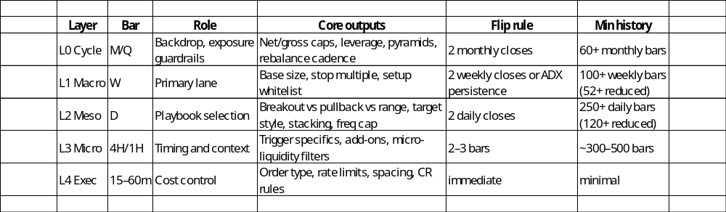
- Minimal API sketch for your codebase:
  - Python:
# assess what layers we can run
ctx = assess_data_budget(symbol, dfs_by_tf) # returns enabled_layers, feature_tier

# label per enabled TF
labels = compute_labels(dfs_by_tf, mode=ctx.feature_tier) # dict {tf: regime_key}

# apply hysteresis and inheritance
labels = confirm_and_align(labels, prev_labels)
policy = resolve_policy(labels, enabled_layers=ctx.enabled_layers)

# policy -> size, stops, allowed setups, order types, caps

  - That’s the hierarchy in one place: what each time frame means, what it decides, how sticky it is, and when to enable it based on history.

