- Pulled historical data from https://coinmarketcap.com/currencies/bitcoin/historical-data/ for BTC_USD at a daily granularity in .csv – currently the file is from:2016_01_01 to:2025_10_26
  - Located @ C:\Users\asafi\Downloads\ta_lab2\data\Bitcoin_01_1_2016-10_26_2025_historical_data_coinmarketcap.csv
  - Fields:
    - timeOpen
    - timeClose
    - timeHigh
    - timeLow
    - name
    - open
    - high
    - low
    - close
    - volume
    - marketCap
    - timestamp
- I then worked on developing two python files BTC Price Analysis.py and Data_Analysis_Functions.py
  - Located @C:\Users\asafi\Downloads\ta_lab\Old\BTC Price Analysis.py and C:\Users\asafi\Downloads\ta_lab\Old\Data_Analysis_Functions.py
  - BTC Price Analysis.py is an end-to-end analysis script that:
    - Loads your BTC OHLCV CSV, cleans column names, and duplicates it to a working df2.
    - Expands timestamp columns (timeopen, timeclose, timehigh, timelow) into rich date/time features.
    - Computes simple % returns and log returns (bar-to-bar + intraday).
    - Builds multiple volatility measures (rolling stdev of log returns; Parkinson, Garman-Klass, Rogers–Satchell; ATR).
    - Adds EMAs for open/high/low/close at 21/50/100/200, plus first (slope) and second (curvature) derivatives, and helper flags like slope sign “flips.”
    - Produces plots (per-EMA panels and consolidated views), and computes/plots EMA comovement regimes and flip-segment stats (durations, returns, histos).
  - Data_Analysis_Functions.py is a reusable library your script imports that provides:
    - Cleaning & time features: drop duplicate timestamp column; expand timestamps to year/month/day, weekday, quarters, optional season and moon phase.
    - Return math: bar-to-bar simple and log deltas (incl. intraday), with rounding and orientation control (newest-on-top vs oldest-on-top).
    - Volatility toolset: rolling log-ret stdev (annualized), Parkinson, Garman-Klass, Rogers–Satchell, and ATR (Wilder/SMA/EMA), all orientation-safe.
    - EMA utilities: add EMAs in batch; compute d1 (slope) and d2 (curvature); scale slopes (bps/percent); detect trend flips with alignment options (“older/newer/actionable”).
    - Regime & segment analytics: build flip segments (with duration, returns, max drawdown/run-up, slope stats), compute EMA comovement regimes (ALL_UP / ALL_DOWN / detailed MIXED strings) and summarize hit rates/returns, plus plotting helpers for regimes and EMA views.
- After standing up and working on these two files for a few weeks, it became clear that continuing to work on just two files was unmanageable for the functionality and complexity of what I was trying to develop, so I developed ta_lab as a package to better develop the project. ta_lab was quickly replaced with tab_lab2
  - Located at C:\Users\asafi\Downloads\ta_lab2

List of ta_lib2 Commits
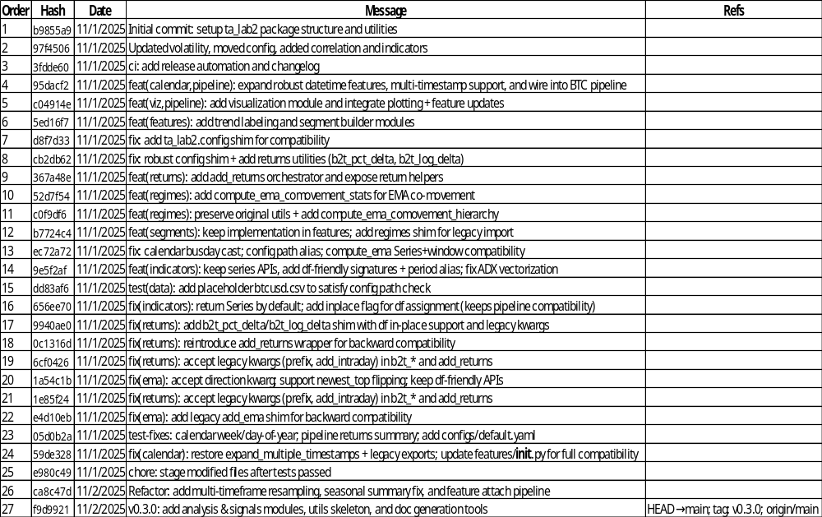
- Once ta_lib2 was in an okay spot, I wanted to shift focus to complete a POC for:
  - Pulling data from an API on my local machine and saving it to a database table, this became known as fedtools2
    - Located at C:\Users\asafi\Downloads\fedtools2
  - This also led to the creation of the following directories:
    - C:\Users\asafi\Downloads\Data_Tools
    - C:\Users\asafi\Downloads\ETL
    - C:\Users\asafi\Downloads\FinancialData
    - C:\Users\asafi\Downloads\FinancialData\FedData

  - Using the cloud
    - Creating a VM
    - Creating a database in the VM
    - Writing a script to pull data from an API and then saving it into a database
    - Writing a set of timers to automate hitting the API and updating the database
    - Connecting to the database from my local machine
- There are still open items, but this project be

