BAGSENSE
Design Pack - FYP1, Week 5
Ahmad Adam Hakimi bin Naeman (2418711) · Amru Hazem bin Ahmad Tarmizi (2419467)
BICS 4321 Final Year Project 1
What this document is
The three artefacts a supervisor normally asks for at this stage - storyboard, wireframe and system architecture - plus the scan sequence that ties them together. It is written so that each drawing can be dropped straight into the FYP1 report as a numbered figure, and so that the build order for the next seven weeks is unambiguous.
Nothing here depends on hardware arriving. That is deliberate: the parts are on order and this is the work that can be finished while they ship.
Contents
• Figure 1 - System architecture
• Figure 2 - Scan sequence (zipper close to status update)
• Figure 3 - Wireframes (app screens and E-paper panel)
• Figure 4 - Storyboard (one packing cycle)
• Design decisions locked, open questions, and report mapping
Scope rule behind all four figures
The bag must work with the phone switched off. The E-paper is the primary status channel; the app only adds checklist editing and history. Anything that does not serve “zip closes, bag knows what is inside, user sees it at a glance” is deferred to FYP2.
This week
• Confirm the RFID module is the 919-923 MHz variant before paying (MCMC SRSP 530; 865-868 MHz cannot be field-tested in Malaysia).
• Place the order - local Malaysian stock, not a 3-4 week import.
• PlatformIO + ESP-IDF installed; blink, read a Hall sensor, write text to the E-paper.
• Confirm 3D-printer access and book a lab slot.
• Send these four figures to the supervisor with three closed questions (scope, what week 13 assesses, 15 minutes).
• Update the proposal: objectives already cut to four, band corrected, category set to IoT / Embedded Systems.

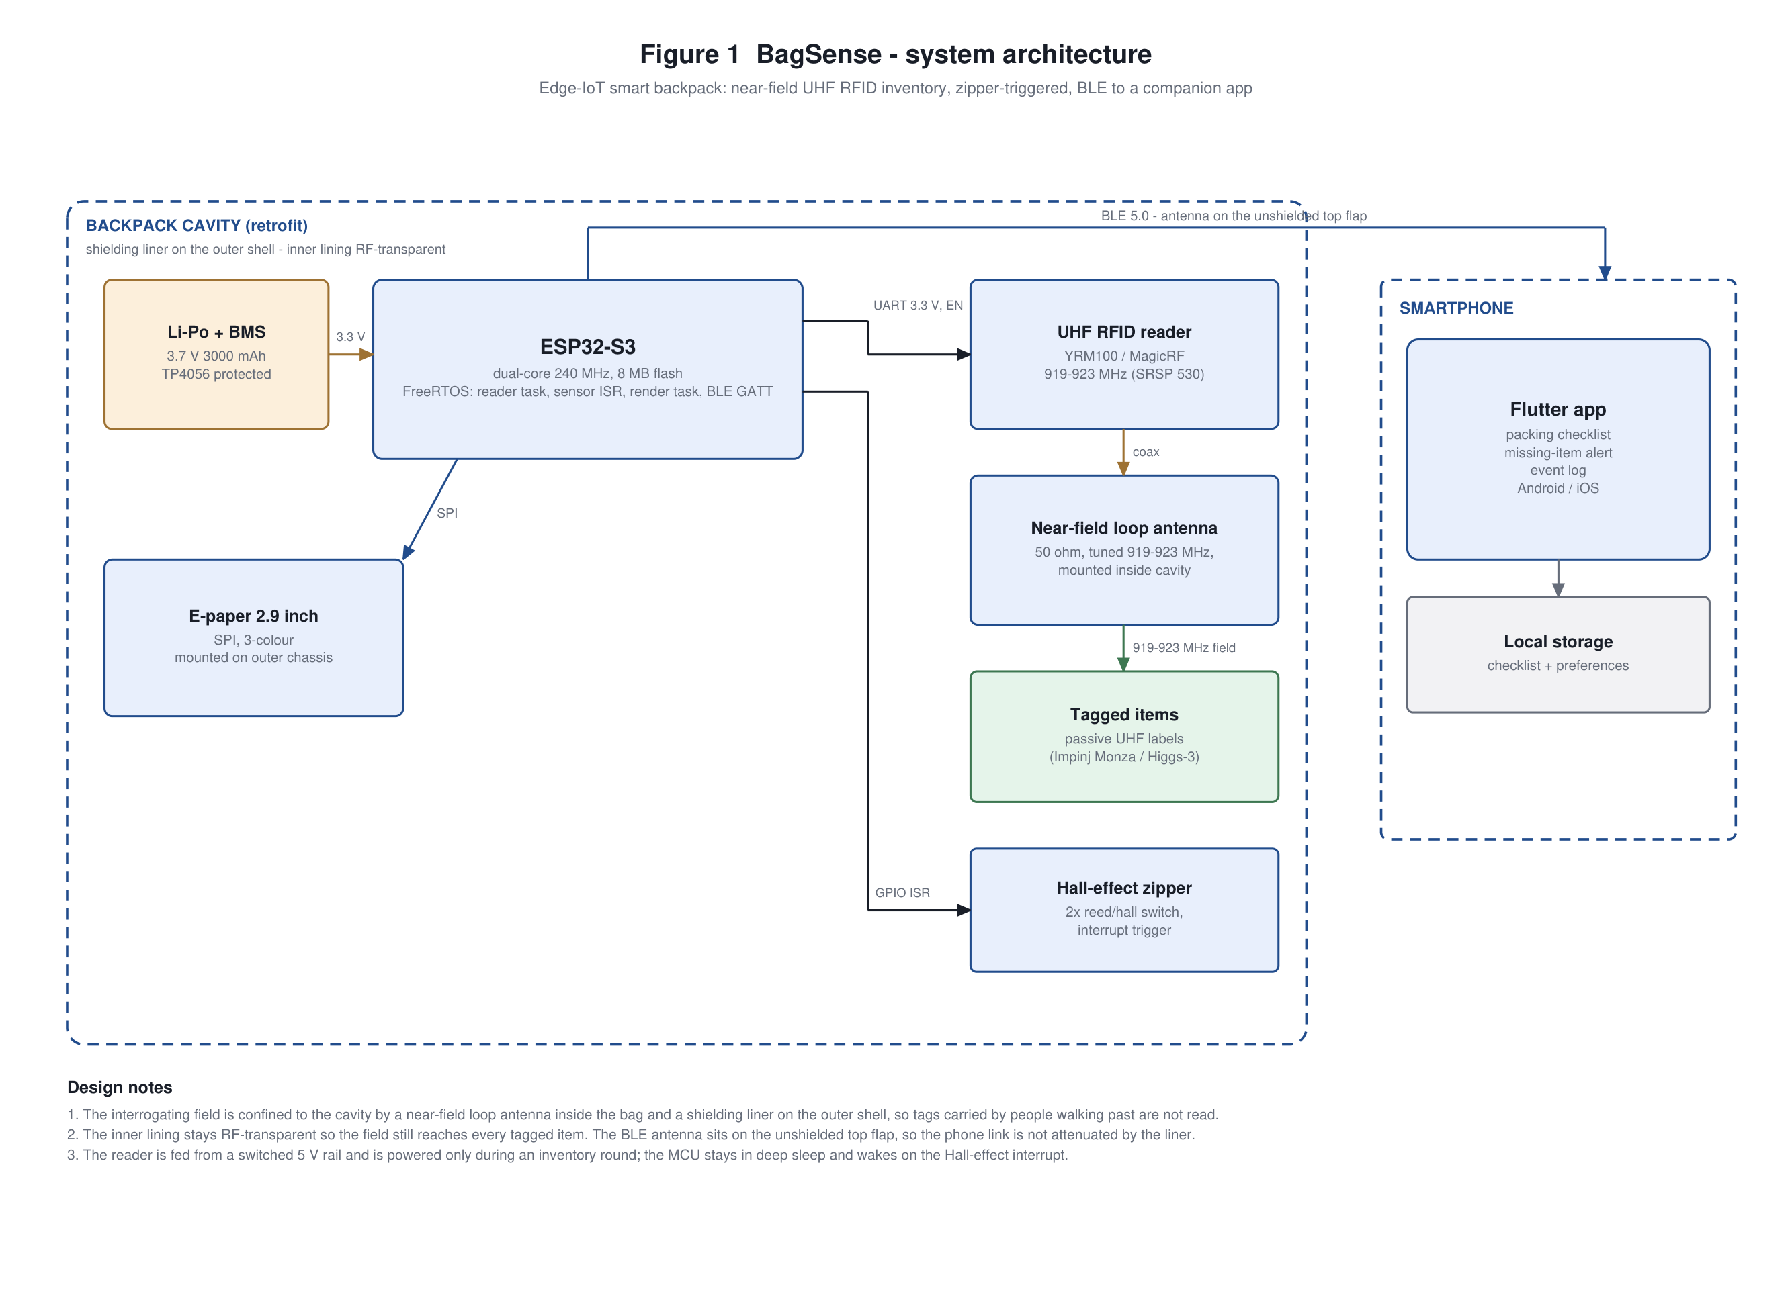
Figure 1. System architecture. The interrogating field is confined to the cavity by a near-field loop antenna inside the bag and a shielding liner on the outer shell; the inner lining stays RF-transparent and the BLE antenna sits on the unshielded top flap.
What this fixes: the original draft asked for a Faraday-lined cavity and, in the same breath, for reading 15 tags inside it plus a BLE link to the phone. A fully shielded cavity kills both. Lining the outer shell only - and keeping the antenna in the same volume as the tags - is the version that can actually work. This is the first question an examiner will ask, so it is answered on the diagram.
Build implications
• The reader is a 5 V peripheral on a switched rail and the ESP32 only talks to it over UART. A reader fault can therefore be isolated and swapped without rebuilding the board - useful when there is one module and no spare.
• The antenna has to face the cavity while the liner stays on the outside. That mechanical constraint sets the CAD task in week 6, not in week 9, because the enclosure cannot be designed until the liner placement is fixed.
• The BLE antenna is the only element that must sit outside the liner. It is the first thing to test on the printed enclosure, because a dead phone link makes the app look broken when the hardware is fine.

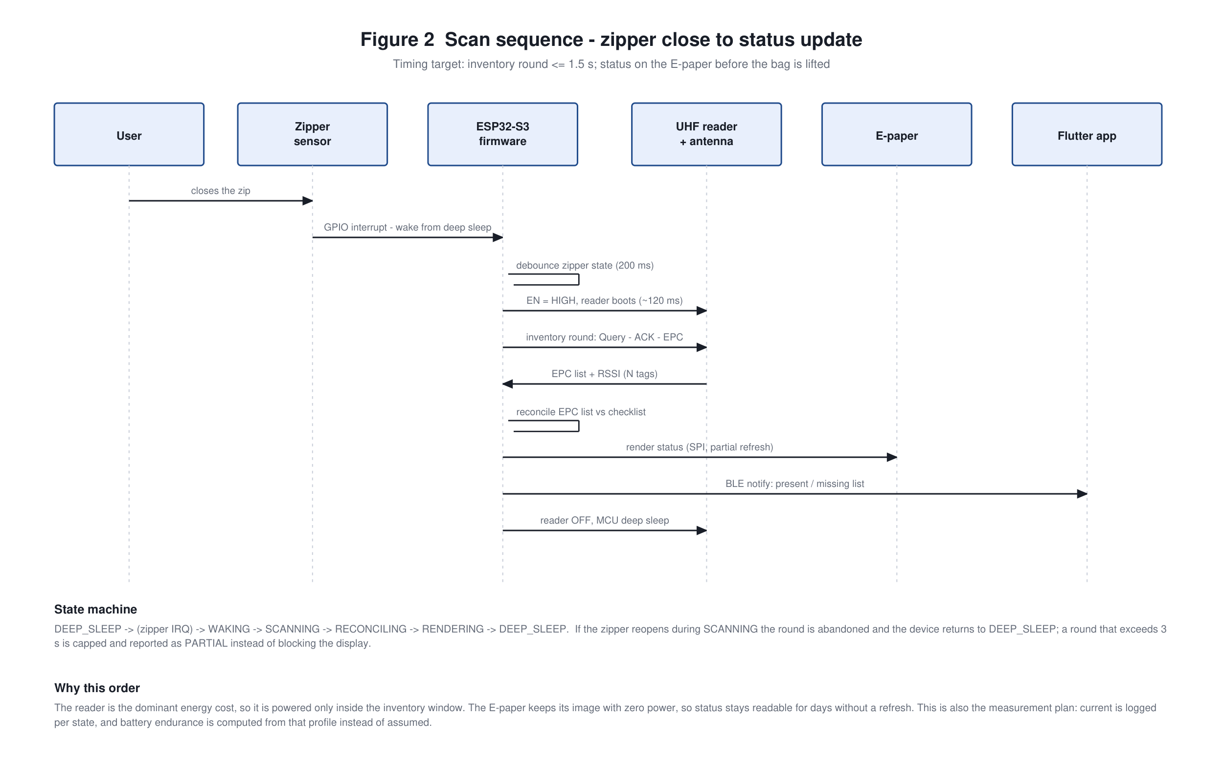
Figure 2. Scan sequence from zipper close to status update, with the firmware state machine and the reason for the ordering.
What this gives you in the report: the timing target (inventory round ≤ 1.5 s), the deep-sleep behaviour, and the measurement plan. Current is logged per state, so battery endurance is computed from the measured profile rather than assumed - which is how the “5 days” claim becomes defensible in week 11 instead of a guess in week 12.
Build implications
• Three FreeRTOS tasks, one owner each: reader, render, BLE. Everything else hangs off the zipper interrupt, which keeps the firmware small enough to finish in the time available.
• Partial refresh matters: a full E-paper refresh takes seconds and flashes the panel. Partial refresh keeps the latency target reachable - prove it in week 6, before the enclosure is printed around it.
• The same states double as the measurement points in week 11. Sleep current, scan current and events per day are logged from this diagram, so the endurance figure has an evidence trail.

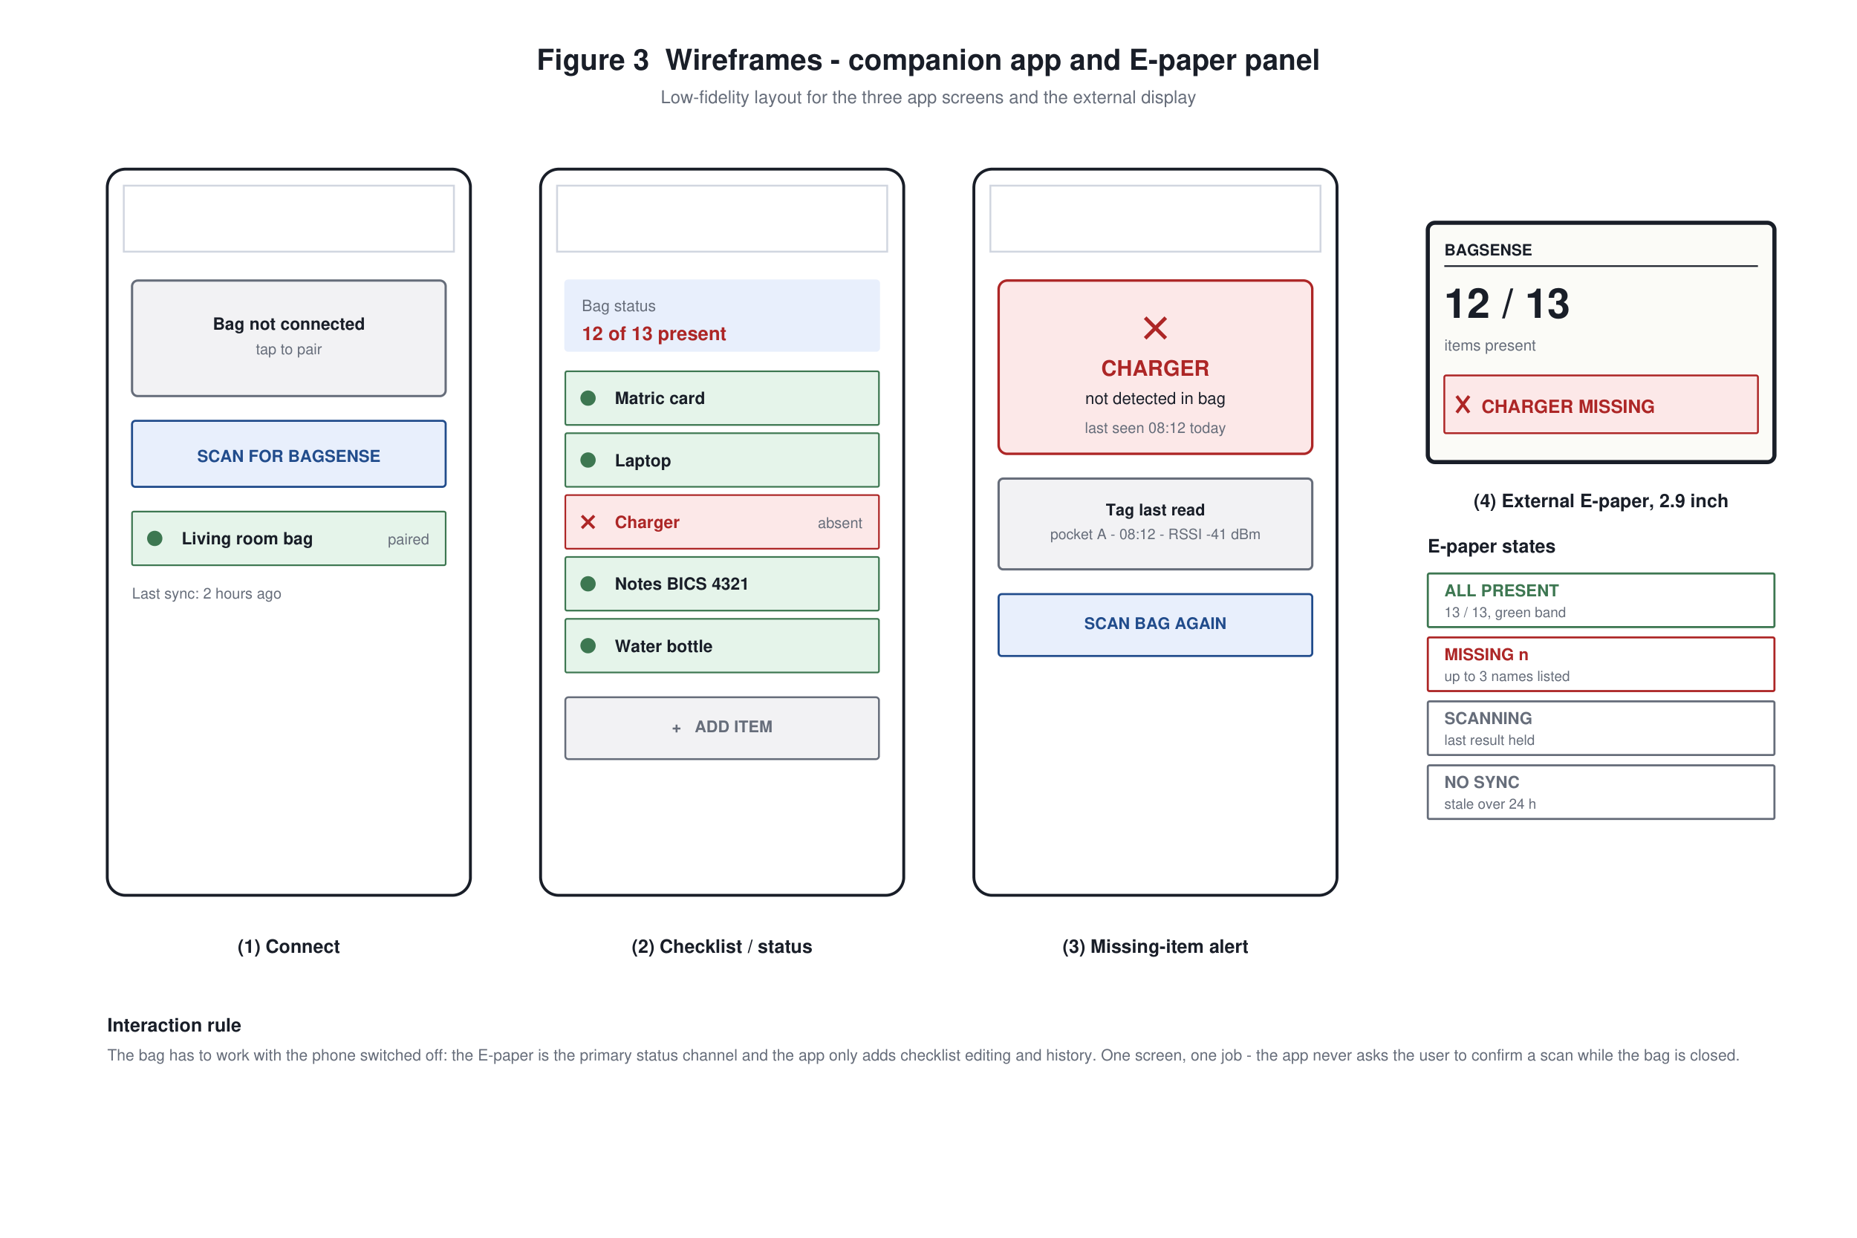
Figure 3. Low-fidelity wireframes for the three app screens and the external E-paper panel, with the four display states.
Note the third screen: the alert names the item and shows when it was last read. That detail is what makes the demo convincing - it turns “it says missing” into “it was in the bag at 08:12 and now it is not”.
Build implications
• Three screens and one display: no settings page, no onboarding flow, no account. Every extra screen is a day that does not go into the inventory engine.
• The four E-paper states cover every condition the panel can be in, so the render task is a switch statement rather than a layout engine. Cheap to write, cheap to test.
• The last-read timestamp in screen 3 is only possible if the app stores history. That is one extra table in local storage - decide it now, not after the demo.

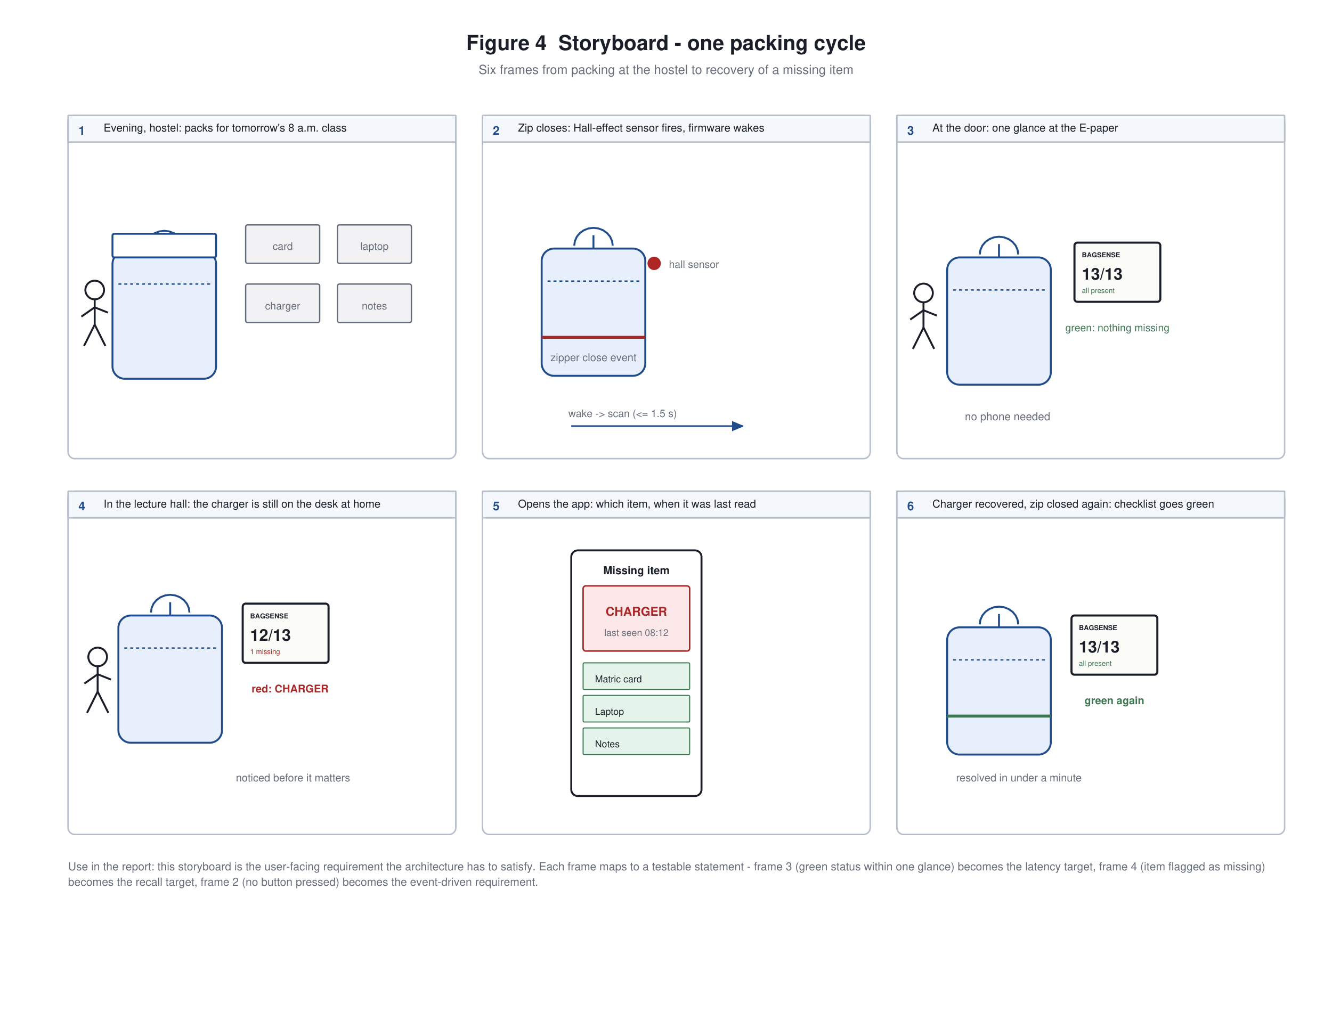
Figure 4. Storyboard of one packing cycle: packing, zip close, glance at the door, missing item noticed, app detail, recovery.
Each frame converts into a testable requirement (frame 3 → latency, frame 4 → recall, frame 2 → event-driven, no button press). Use it as the opening two slides of the week-13 presentation.
Build implications
• Frames 2, 3 and 6 are the live demo path: zip, wait for the panel, read the result. Rehearse exactly that sequence - nothing else has to work on stage.
• Frame 4 is the frame that sells the project. If the demo fails on the day, this is the slide you fall back to, and the recorded video covers the rest.
• Frames 5 and 6 are app-only. If the schedule slips, they can be dropped from FYP1 without weakening the core claim that the bag knows what is inside it.

Design decisions locked
Decision | Choice and reason
RF band | 919-923 MHz (MCMC SRSP 530). Below 2 W ERP is Class Assignment: no application, no fee. The 865-868 MHz variant sold by default cannot be field-tested in Malaysia.
Antenna type | Near-field loop antenna inside the cavity, not a patch. A patch is a far-field radiator and will leak out of the bag.
Confinement | Shielding liner on the outer shell only; inner lining RF-transparent; antenna co-located with the tags; BLE antenna on the unshielded top flap.
Reader duty cycle | Powered only during an inventory round (switched 5 V rail). This is the dominant energy cost and the main design lever for endurance.
Primary status channel | E-paper. The system must be useful with the phone off.
App scope | One screen of checklist, one alert screen, BLE sync. No notifications scheduling, no category filters in FYP1.
Targets | 15 tags, ≤ 1.5 s, ≥ 98% recall, 5 days. Held as targets to be confirmed by the week-8 pilot, not as commitments.
Open questions for the supervisor
Question | Why it matters
Is the scope right for FYP1? | Four objectives, one working chain. If more is expected, it has to be scheduled into FYP2 now, not in week 11.
Is week 13 a proposal presentation or a prototype demo? | Decides whether weeks 9-11 go into polish or into measurement.
Is 10 participants acceptable for the usability test? | Needed to size the evaluation in week 11.
Where each figure goes in the report
Figure | Report section
Figure 1 - Architecture | Chapter 3, Logical Design: system analysis and design diagram
Figure 2 - Sequence | Chapter 3, Logical Design: process / data flow
Figure 3 - Wireframes | Chapter 3, Prototype or wireframes
Figure 4 - Storyboard | Chapter 1, Scope and target users (user requirement narrative)
Design decisions table | Chapter 3, justification of design choice
Files: all four figures are also saved individually as PNG in Week05_26Oct-01Nov\Output\figures\ so they can be dropped into the report or into slides without the surrounding document.

