BAGSENSE
Detailed storyboard, version 2
18 frames across one packing day, plus three edge cases
Ahmad Adam Hakimi bin Naeman (2418711) · Amru Hazem bin Ahmad Tarmizi (2419467) · BICS 4321 FYP1 · Week 5
Why this version exists
Version 1 was a six-frame sketch that showed the happy path. It answered “what does it do” but not “what does it do when something goes wrong, and which requirement does each moment come from”. This version keeps every frame of v1 (frames 1-6 here are the same story) and adds the middle of the day, the recovery, and three edge cases that decide whether the project reads as thought-through or as a demo.
How to read a frame
Each panel carries five lines. SCENE is the situation, USER is what the person does, SYSTEM is what the firmware does, PANEL is what the E-paper shows, APP is what the phone shows, and REQ names the requirement the frame justifies. If a frame cannot name a requirement, it is decoration and should be cut.
The four channels
Panel (E-paper) - primary channel, works with the phone off, zero power to hold an image.
Bag (firmware) - the only thing that acts. It never asks the user a question.
App (Flutter) - optional channel: checklist editing, history, nothing the bag depends on.
Silence - the default state. No buzzers, no LEDs flashing in a lecture hall.
Act structure
ACT 1 (F1-F6) packing and leaving - the happy path. ACT 2 (F7-F12) the day goes wrong - detection and decision. ACT 3 (F13-F15) recovery - closing the loop. ACT 4 (F16-F18) edge cases - what an honest system does when it cannot answer.
Requirements extracted from the frames
R1 The bag reports its own contents; the phone is not required. | R2 The checklist in the app is the reference the scan is compared against.
R3 A zip close is the only trigger; no button, no app action. | R4 Up to 15 tags inventoried in <= 1.5 s; recall target >= 98%, measured not assumed.
R5 Status readable in a single glance, from outside the bag. | R6 All core function works with the phone off.
R7 Opening the bag does not trigger a scan. | R8 Every close triggers a fresh check, never a cached result.
R9 A shortfall is named per item, not reported as a bare count. | R10 Alerts are silent and glanceable; nothing audible in a lecture hall.
R11 History records when each item was last read. | R12 Low battery degrades honestly (no false ALL PRESENT).
R13 An unzipped bag does not create a scan loop. | R14 A shielded tag is reported as missing - the limitation is documented, not hidden.

Sheet 1 of 3
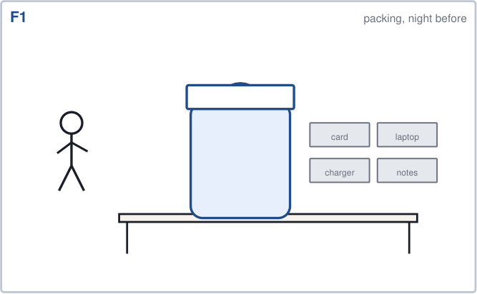  F1 Packing, the night before  Scene: Student lays out the next day's kit on the desk: matric card, laptop, charger, notes.  User: Decides what goes in the bag. No interaction with the system at all.  System: Idle. Reader off, MCU in deep sleep, E-paper holding the last rendered status.  Panel: Last known status. If it is older than 24 h it shows NO SYNC, not a stale green.  App: Not open.  R1 - the bag must know what is inside without the phone. | 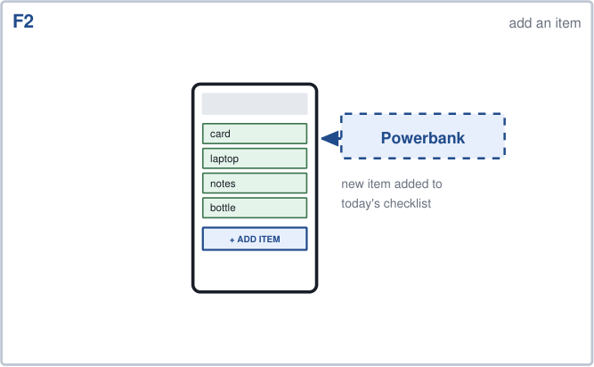  F2 Adding an item to the checklist  Scene: Student adds a powerbank to today's checklist in the app.  User: Types an item name and taps ADD ITEM.  System: Writes to local storage, syncs the checklist to the bag over BLE. No scan is triggered by an edit.  Panel: Unchanged - checklist edits never start a scan.  App: Checklist screen, new row, sync indicator.  R2 - the checklist is the reference the scan is compared against. | 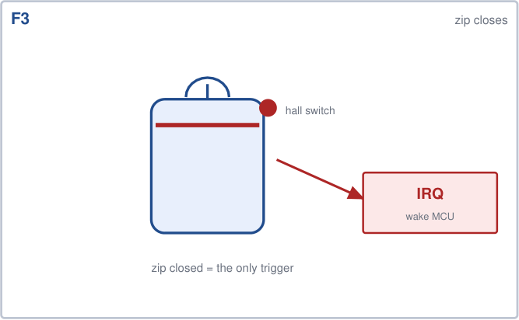  F3 Zip closes  Scene: Bag is zipped shut and lifted off the desk.  User: Zips the bag. This is the whole interface for triggering a check.  System: Hall-effect interrupt wakes the MCU (200 ms debounce to ignore zipper chatter).  Panel: Holds the previous result - no flicker until there is something to say.  App: If connected: SCANNING.  R3 - no button, no app action needed to start a scan.
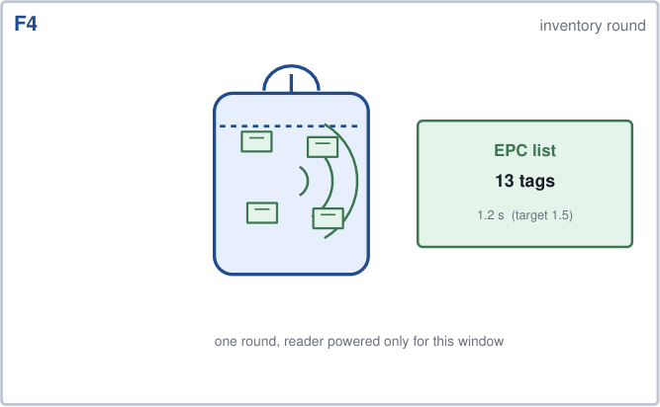  F4 Inventory round inside the cavity  Scene: Bag on the shoulder, field confined inside. Reader interrogates every tag.  User: Does nothing.  System: Reader powered for one round only: anti-collision query, EPC list + RSSI collected.  Panel: SCANNING indicator only if the round runs longer than ~800 ms.  App: Spinner, if open.  R4 - up to 15 tags in <= 1.5 s, recall target >= 98% (measured in week 8). | 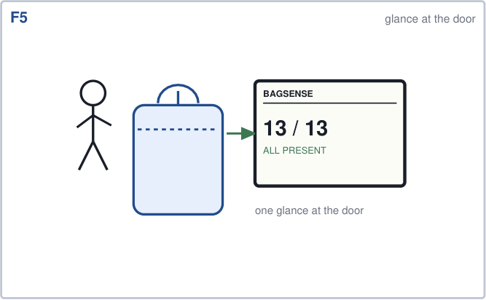  F5 One glance at the door  Scene: Student pauses at the door and looks at the E-paper on the outer flap.  User: Reads the panel without opening the bag or touching a phone.  System: Reconciled list rendered: 13 of 13 present.  Panel: Green band, 13 / 13, ALL PRESENT.  App: Not needed.  R5 - status must be readable in one glance. | 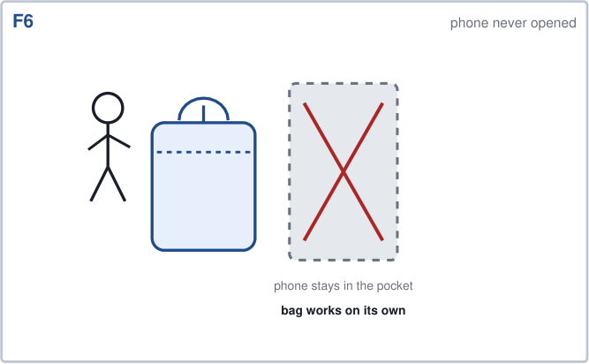  F6 Leaving with the phone in the pocket  Scene: Out of the hostel, walking. Phone stays in the pocket, app never opened.  User: Walks away, no interaction.  System: Reader off, MCU back to deep sleep, BLE advertising paused.  Panel: Holds the green status at zero power.  App: Closed the whole time.  R6 - the bag is the primary interface; the app is optional.

Sheet 2 of 3
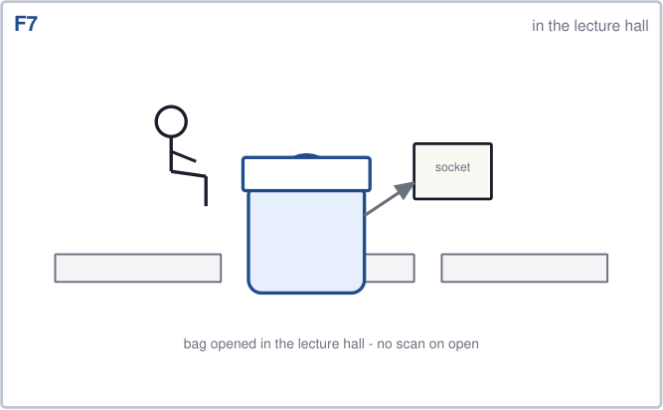  F7 In the lecture hall  Scene: Student sits down, opens the bag, takes out notes and plugs the charger into the wall socket.  User: Opens the bag; later plugs the charger in and forgets it there.  System: Zipper open detected, but no scan. Open means intent to pack, close means packing finished.  Panel: Unchanged.  App: -  R7 - opening the bag must not trigger a scan. | 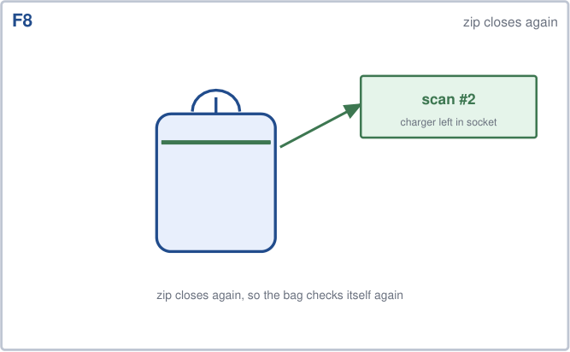  F8 Zip closes again  Scene: Lecture over, notes back in, zip closed. The charger is still in the wall.  User: Zips the bag and stands up.  System: Second scan of the day, same path as F3-F4.  Panel: SCANNING briefly, then the result.  App: If connected: SCANNING.  R8 - every close is a fresh check, not a cached one. | 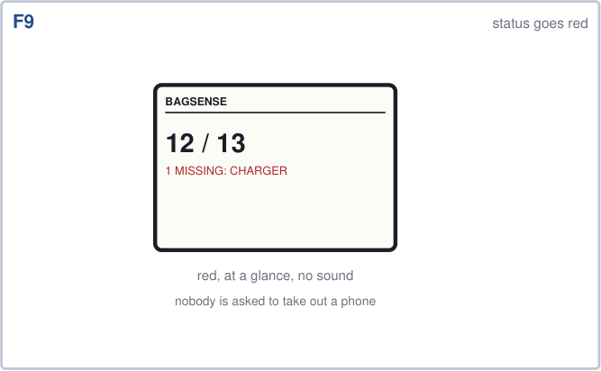  F9 Status goes red  Scene: Panel now reports 12 of 13 and names the missing item.  User: Glances at the panel on the way out.  System: Reconciliation against the checklist produces a named deficit, not just a count.  Panel: Red band: 12 / 13, 1 MISSING: CHARGER.  App: Mirror of the same state.  R9 - a missing item must be named, not merely counted.
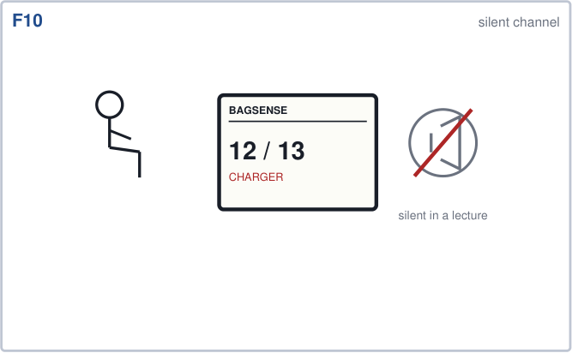  F10 Silent channel  Scene: Still in the lecture hall. A buzzer here would be antisocial and would be switched off.  User: Notices the red band without any sound.  System: No audible alert by design. Visual only.  Panel: Red band persists until the next scan.  App: Optional notification, silent.  R10 - the alert must be glanceable and silent. | 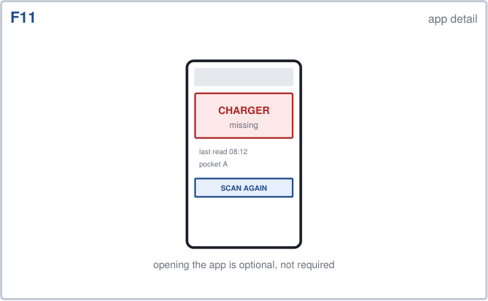  F11 App detail, if the user wants it  Scene: Student opens the app because the panel raised a question: which item, when, where.  User: Opens the app and taps the missing row.  System: Serves the last-read record from local history.  Panel: Unchanged.  App: CHARGER missing, last read 08:12, pocket A, RSSI -41 dBm.  R11 - history answers “when did it last see it”, not just “it is gone”. | 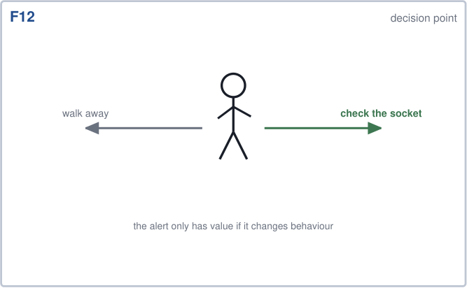  F12 Decision point  Scene: Two legitimate responses: walk away, or walk back.  User: Chooses. The system has done its job either way.  System: No further action; the bag keeps the last state.  Panel: Red band stays.  App: -  R10 (behaviour) - the alert only has value if it changes what the user does.

Sheet 3 of 3
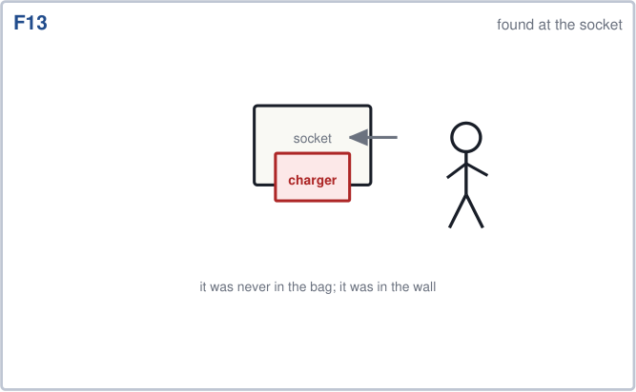  F13 Found at the socket  Scene: Student walks back to the lecture hall and finds the charger still plugged into the wall.  User: Unplugs it. The bag was right: the item never came back in.  System: Nothing yet - the bag has not been zipped since.  Panel: Red band, stale but honest.  App: -  R9 - no false green. A wrong item in the panel would have been worse than a gap. | 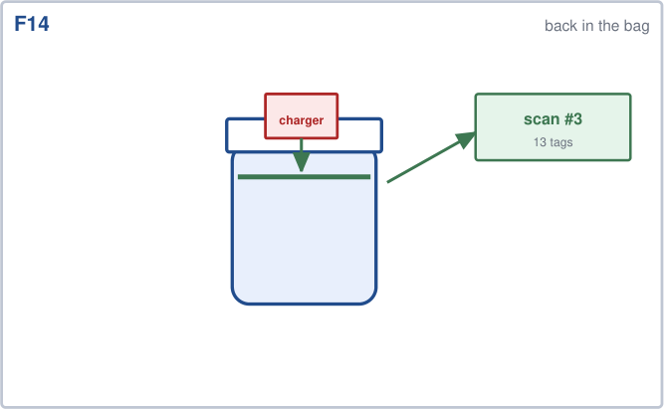  F14 Back in the bag  Scene: Charger goes into the cavity, zip closes.  User: Zips the bag.  System: Third scan of the day.  Panel: SCANNING, then 13 / 13.  App: SCANNING, then green.  R8 - the same trigger that raised the alarm clears it. | 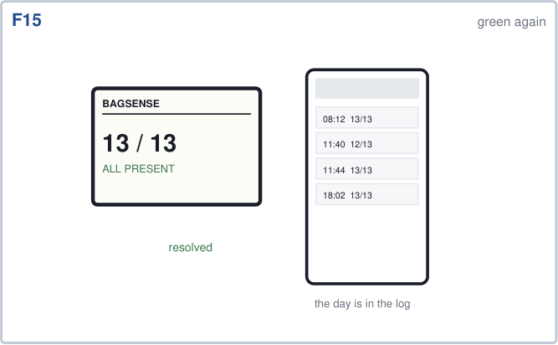  F15 Green again, and the day is logged  Scene: Panel green; app shows the whole sequence: 08:12 green, 11:40 red, 11:44 green.  User: Confirm in one glance, no action needed.  System: Writes the event log; panel back to green.  Panel: 13 / 13, ALL PRESENT.  App: Event log with timestamps.  R11 - the log is also the evaluation evidence for week 11.
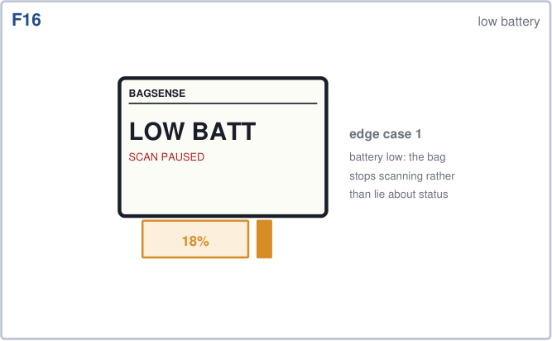  F16 Edge case 1 - low battery  Scene: Charge drops below the reserve needed to run a full round.  User: Notices LOW BATT on the panel.  System: Scanning paused rather than reporting a result it cannot trust.  Panel: LOW BATT, SCAN PAUSED, battery percentage.  App: Same message, with a charge reminder.  R12 - a low battery must degrade honestly, never show a false ALL PRESENT. | 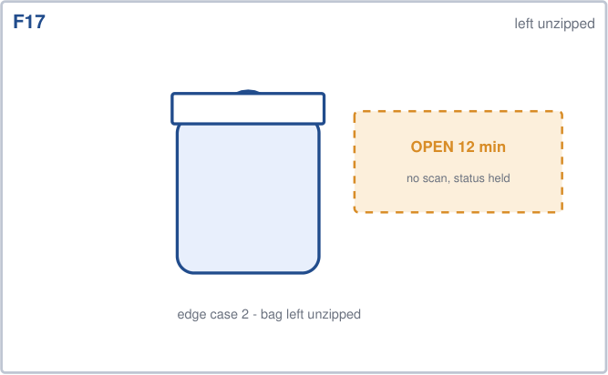  F17 Edge case 2 - bag left unzipped  Scene: Student leaves the bag open on the desk for the afternoon.  User: Does nothing; the bag stays open.  System: Open state detected and held. No repeat scans, no power wasted.  Panel: OPEN 12 min - status held from the last completed scan.  App: Optional: bag-open reminder.  R13 - an unzipped bag must not create a scan loop. | 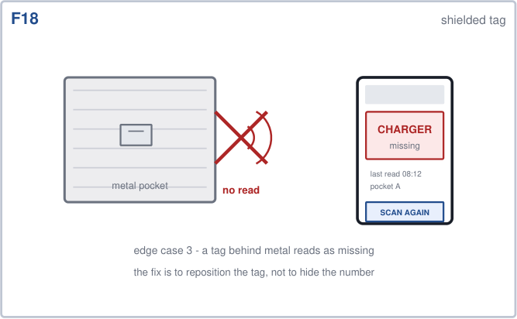  F18 Edge case 3 - tag behind metal  Scene: A tag sits in a metal-lined pocket; the field cannot reach it.  User: Sees CHARGER missing even though the charger is in the bag.  System: Reports the true measurement, not the expected answer.  Panel: Red band for that item.  App: Last read 08:12, with a note that the tag is shielded.  R14 - the measured limitation is documented and reported, not hidden.

From frame to test
Every frame above converts into something measurable in week 11. This is the table that connects the storyboard to the evaluation chapter, so the storyboard is not decoration.
Frames | Requirement | How it is tested in week 11
F3, F8, F14 | R3, R8 | Close the zip 30 times; every close must produce a scan and a logged event.
F4 | R4 | 15 tags, 3 positions, 20 trials each: report recall and median/max latency.
F5, F9 | R5, R9 | Timed glance test: 10 participants state the status correctly within 2 s.
F6 | R6 | Full day with the phone switched off; log every scan and its result.
F7 | R7 | Open and close the bag 20 times while taking notes out; count unintended scans (target 0).
F10 | R10 | Usability session in a quiet room: confirm no audible output and no LED visible.
F11, F15 | R11 | Export the event log for one day; every state change has a timestamp.
F16 | R12 | Discharge test: at the threshold the panel must show LOW BATT, never a stale green.
F17 | R13 | Leave the bag open 30 min; measure current draw and count scans (target 0).
F18 | R14 | Place a tag behind metal; record the false-negative rate and report it as a limit.
What is deliberately not in the storyboard
No push-notification scheduling, no category filters, no cloud sync, no multi-bag profiles. Those were in the first proposal and were cut for FYP1: each is a feature nobody misses on the showcase day, and each one costs days that the inventory engine needs. They belong in the FYP2 scope list.
Files
The 18 panels are also saved individually as PNG in Week05_26Oct-01Nov\Output\storyboard_v2\ so any frame can be dropped into the report or into slides. Version 1 (six frames, Figure 4 of the design pack) is kept unchanged in the same folder.

