CSC3320 System Level Programming

Lab Assignment 1 - Part 2 (Post-Lab)

Instructor: Fil Rondel

Due at 11:59 pm on Friday Jan. 13th, 2021

Purpose: Know how to install a Unix system in a virtual machine. Part A: Environment Configuration for Unix system.

Install a virtual machine and Ubuntu in your operating system. x For Windows users, please follow guide VirtualBox and Vmware Player. x For Mac users, please follow guide VirtualBox

Note:

You can also refer to the video under link below

For Mac OS https://www.youtube.com/watch?v=_42JLz2izBU

For Windows https://www.youtube.com/watch?v=ncA85gRAJxk

Part B: Test your SSH connection in Ubuntu

(1) Log in to your Ubuntu system, and open “Terminal”.

Click Dash Home and search “Terminal”. Then select “Terminal” and open it.

In “Terminal”, use command ssh to connect server snowball.cs.gsu.edu. Ssh campusId@snowball.cs.gsu.edu

E.g. my camps Id is frondel1, so I use ssh frondel1@snowball.cs.gsu.edu

Note:

1. Your password for camps Id should be the password for this server.

2. If the server warns you that the authenticity of host cannot be established and ask you if you want to continue connecting, please enter “yes”.

3. Remember to hit “Enter” once you input the command after the prompt ‘$’.

(3) Attach a screen shot like following figure in your report. Name your screenshot file as L1_P2_ FirstnameLastname.png (or .jpg). E.g. L1_P2_FilRondel.png

This figure includes your “terminal” and ssh connection.

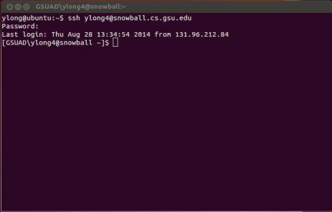Note : Screen shot short cut in Mac OS, command + shift + 4; in windows, use key PrintScreen.

Screenshot:

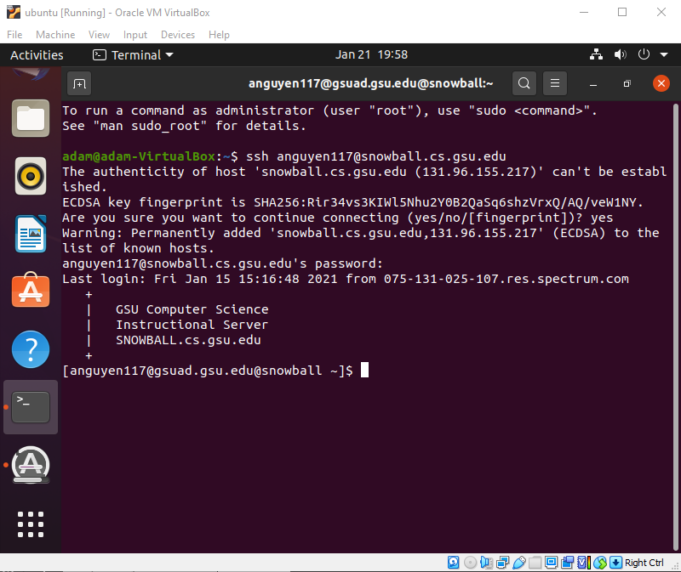

Submission:

• Upload the screenshots required in Part B to folder "Lab1_Part2" of the Dropbox in the iCollege.

Appendix:

To check the ssh connection

x For a Mac user, you can also try the utility “Terminal” in Mac OS.

x For a Windows user, you can also try the terminal emulators, e.g. PuTTY, Xshell . Note: In the connection configuration, host name is snowball.cs.gsu.edu, login account name is your campus Id, protocol is ssh, and port is usually 22.

Useful links:

1. Download Xshell

https://www.netsarang.com/download/free_license.html

2. Xshell Tutorial https://www.netsarang.com/tutorial/xshell/1004