# A VERY Short GitHub Tutorial

1. [Apply for a student developer pack](https://education.github.com/pack) with your Binghamton email. Here are detail [steps](https://help.github.com/articles/applying-for-a-student-developer-pack/) of how to apply for a student developer pack on GitHub.
2. We will create a remote repository on GitHub. We will clone the remote repository and develop the project locally on our computers.
3. Create a private repository using a student’s GitHub account.   
   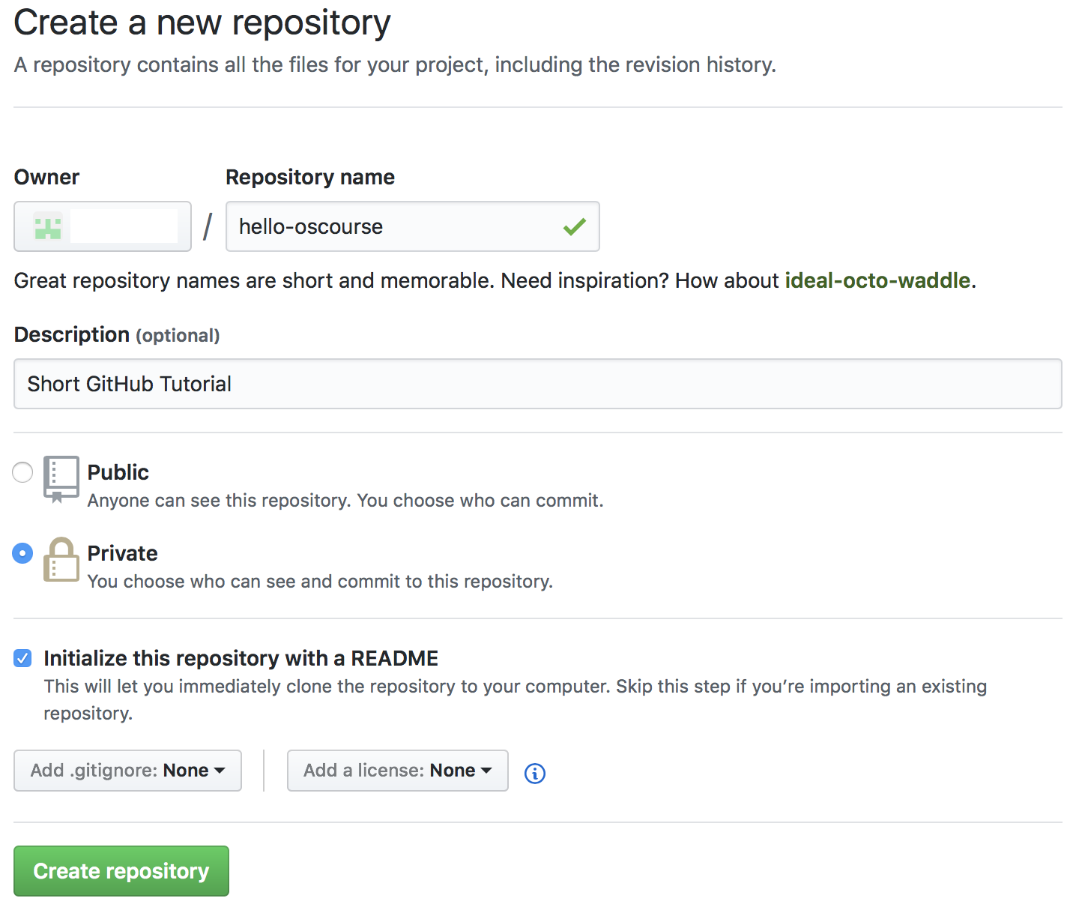
4. If your local machine does not have Git on your Linux machine, please install Git.
   * $ sudo apt install git
5. Clone the private repository from the GitHub to the local machine.
   * $ git clone https://github.com/<owner>/hello-oscourse.git
   * $ cd hello-oscourse/
6. Check the development branch.
   * $ git branch
7. Develop the project.
8. Check the current status of the repository.
   * $ git status
9. Add the changes for the commitment.
   * $ git add <file01> <file02> …
10. Commit the changes to the local repository.
    * $ git commit
11. Push the changes in the local repository to the remote repository on GitHub.
    * $ git push origin <your-development-branch>
12. Check your commit history.
    * $ git log