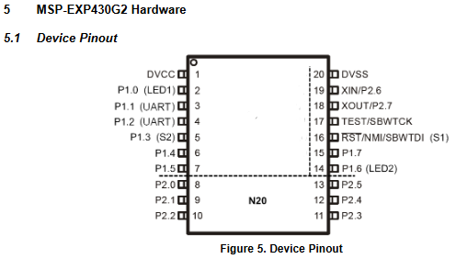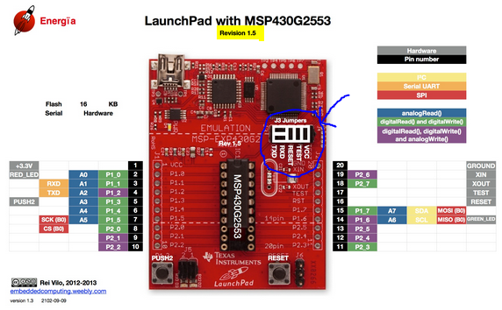

**RED_LED**

**PUSH2**

**GREEN_LED**

* All pins operate at 3.3V.
* The **black** boxes correspond to the actual physical pins on the board.
* The **grey** boxes correspond to the peripherals already present on the board, such as push buttons and LEDs.
* The **blue** boxes show which pins can be used for analogue inputs, for example, from a pot.
* The **green** boxes show which pins can be used for digital inputs, such as from a pushbutton, or digital outputs, such as to an LED.
* The **purple** boxes show additional pins which can be used for digital inputs or outputs, but in addition, may also serve to write an analogue value to the pin using PWM.
* The remaining boxes, being yellow, orange and red refer to different types of communications supported by the board, however, these do not need to be considered for the purpose of this workshop.

## Header file “pins_energia.h”

