**Communication project**

AM modulation with AD633

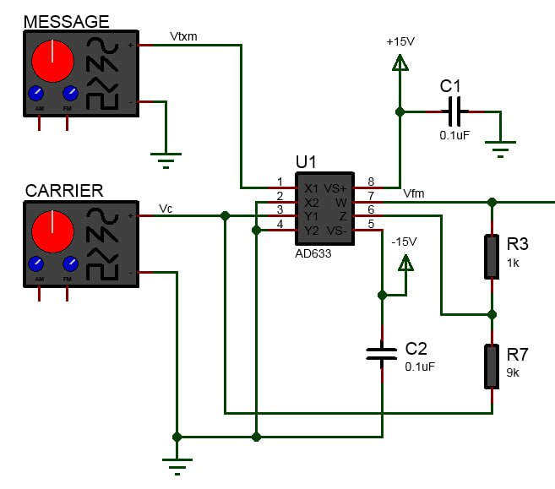

**Circuit at transmitter** generate baseband signal with 19 KHZ and amplitude 2v peak to peak and carrier signal with 19 MHZ with amplitude 10v peak to peak then passed through AD633 which is analog multiplier used for DSB-WC in this expirment

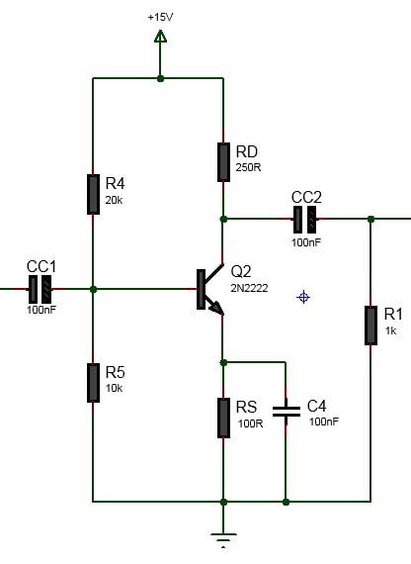

**Amplifier circuit** which is used to increase the power of modulated signal to be transmitted over long distance without significant loss it is like the repeater

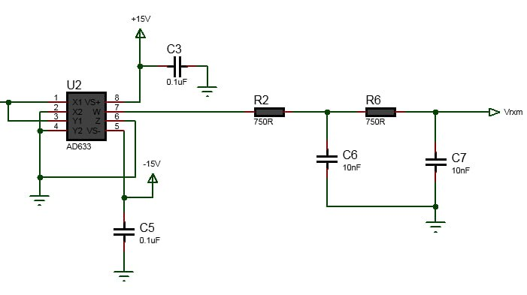

**Circuit at receiver** to demodulate the signal using square law method which include path the modulated signal into nonlinear device multiplying by cosine wave then apply low path filter to recover the baseband signal

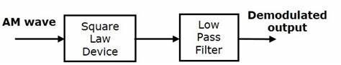

**Square law demodulation diagram**

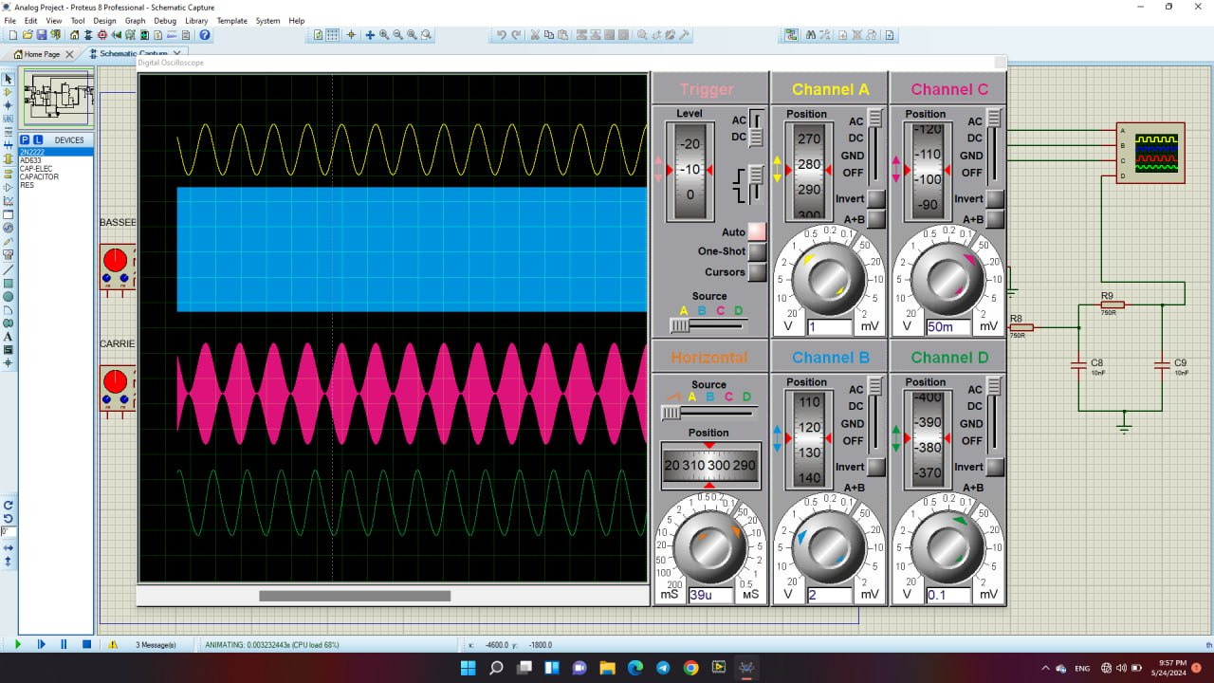

**Final result of simulated** circuit on proteus those are the baseband signal , carrier signal , modulated signal and demodulated signal in order

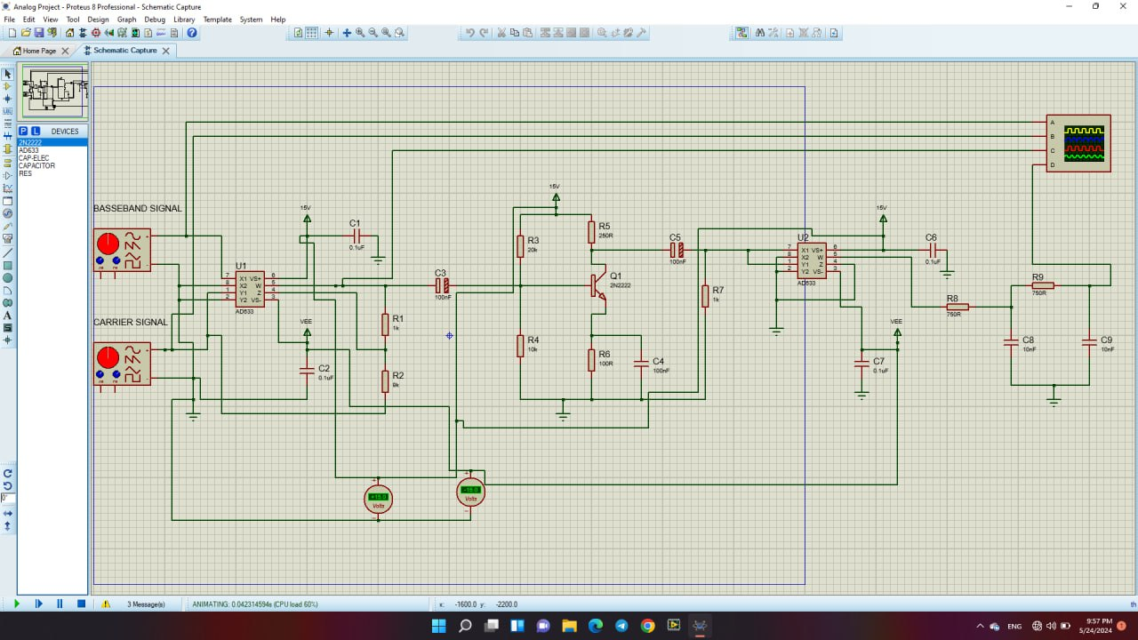

Simulated circuit