**OUD Audit files automation script**

**README file**

**Execution Instructions:**

**Normally this script should be called by executing ../../** **auto_audit_retrieval.bat. If this is the case, ignore this paragraph and move to *edit configuration file* on the final page. If for some reason manual execution is needed, follow the instructions bellow:**

* Open *Command Prompt* ( + R , type *cmd* on dialog and click *OK*)

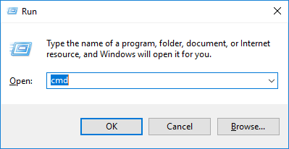

* Navigate to scripts folder using *cd* command

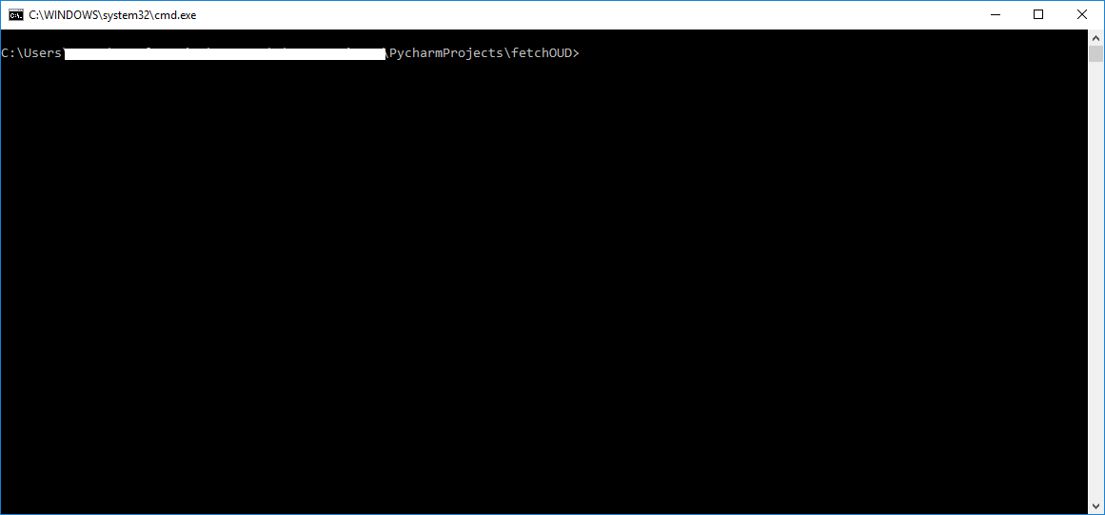

The folder should contain :

**./auto.bat** , **./fetchOUD.conf** , **./fetchOUD.py** , **./prints.txt**

You can check if every file exists using *dir* command.

* Run the script :type **auto.bat** on cmd and press enter

**fetchOUD.py** will be executed according to the given configuration. All needed Audit files will be fetched from the hosts’ remote paths and downloaded to **local path**. After files are completely fetched, they will transformed to csv and finally will be consolidated to 3 files. Information messages are printed during the procedure. This procedure will be executed for every host.

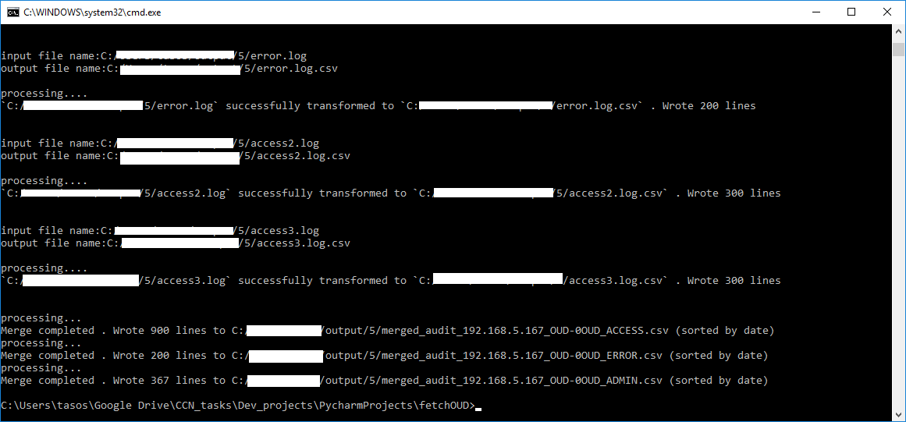

By the time the procedure has finished, the output file name will be printed for every host

Final file name patterns : *merged_audit_<host_name>_OUD_<host_number>OUD_ACCESS.csv*

*merged_audit_<host_name>_OUD_<host_number>OUD_ERROR.csv*

*merged_audit_<host_name>_OUD_<host_number>OUD_ADMIN.csv*

* Edit configuration file : **fetchOUD.conf**

Using your desired Text Editor, open fetchOUD.conf and edit the needed parameters :

* + - The **Time Period** that Audit files were created
    - **Number** of hosts
    - **Host Name** / **Host IP**
    - **Cots** **type** (OUD)
    - An existing remote connection **User** for the selected host
    - Correct **Password** for this **User**
    - Remote Connection **Port** for Host’s SSH Server (default : 22)
    - **Remote Path**, where OUD Audit files exist (default path: **/u01/app/ldap_instance/OUD/logs/** )
    - **Local Path,** were fetched files will be saved

Assume that there 4 OAG instances. Edit the configuration file like :

* + *Set Number of Hosts :* **4**
  + Copy and paste Host Block 4 times
  + Put the correct parameters for every host

[](fetchOUD_4_hosts_example.conf)

(double click or Ctrl+c to open)