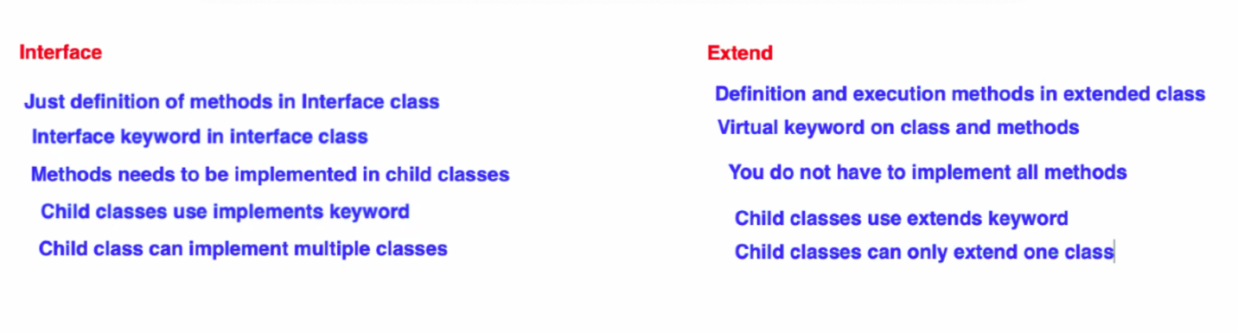

public class SumCalculation {

public void sumMethod(Integer number1, Integer number2){

System.debug(‘Sum of two number is: ’ + (number1+number2));

}

public void sumMethod(Decimal number1, Decimal number2){

System.debug(‘Sum of two number is: ’ + (number1+number2));

}

}

SumCalculation newSum = new SumCalculation();

newSum..sumMethod(2,3);

newSum..sumMethod(5,3);

newSum..sumMethod(5.5,3.4);