Proposed Timeline

Project Kickoff date 11/09/2022

Project Start date 11/12/2022

First Project meeting 11/12/2022

Second meeting 11/16/2022

First check in meeting 11/29/2022

Second check in meeting 12/6/2022

All parts due 12/10/2022

Put project together 12/11/2022

Documentation and Project due 12/12/2022

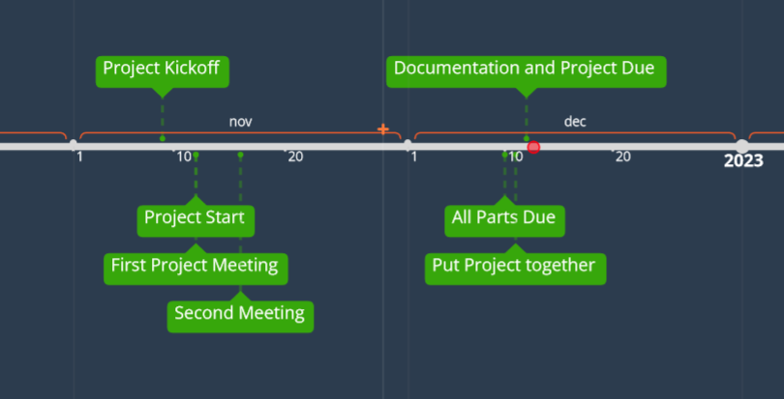

Actual Timeline

Project Kickoff date 11/09/2022

Project Start date 11/12/2022

First Project meeting 11/12/2022

Second meeting 11/16/2022

First check in meeting 11/29/2022

Second check in meeting 12/6/2022

First floor plan with extra rooms due 12/6/2022

Second floor plan with extra rooms due 12/10/2022

Enemies, game objects, health bar, and regenerate bed due 12/10/2022

Put project and documentation together 12/11/2022

Project due 12/12/2022

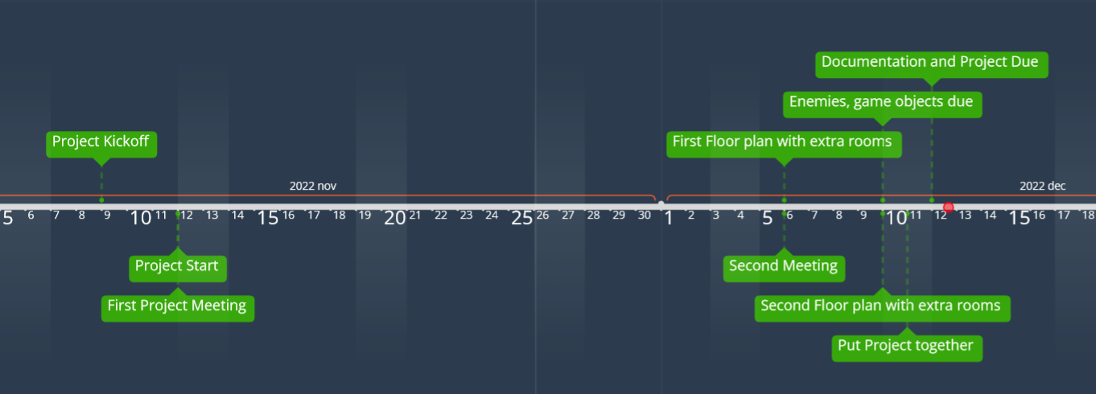

Milestones

12/6/2022 - First floor with constituent rooms finished

This is so that everyone else has a basic floor plan to go off of when they start to create the enemies, objects, health bar, etc. This is only half of the background. There will be a second floor that has more rooms and the boss.

12/10/2022 - All other code finished

This will give us enough time to debug and test our code so that it’s good enough. It will also allow us to get all of the documentation written.

12/12/2022 - All Documentation Finished and Project Finished

This is just making sure that all of the paperwork is in order.